Reprinted 5/11/17
LIONFISH
Reference SOURCE NOAA and article https://lionfish.co/ author Scott Harrell

VIDEO:

Lionfish dissection tutorial by Dr. Michelle Johnston, NOAA Flower Gardens Bank National Marine Sanctuary
https://lionfish.co/lionfish-dissection/
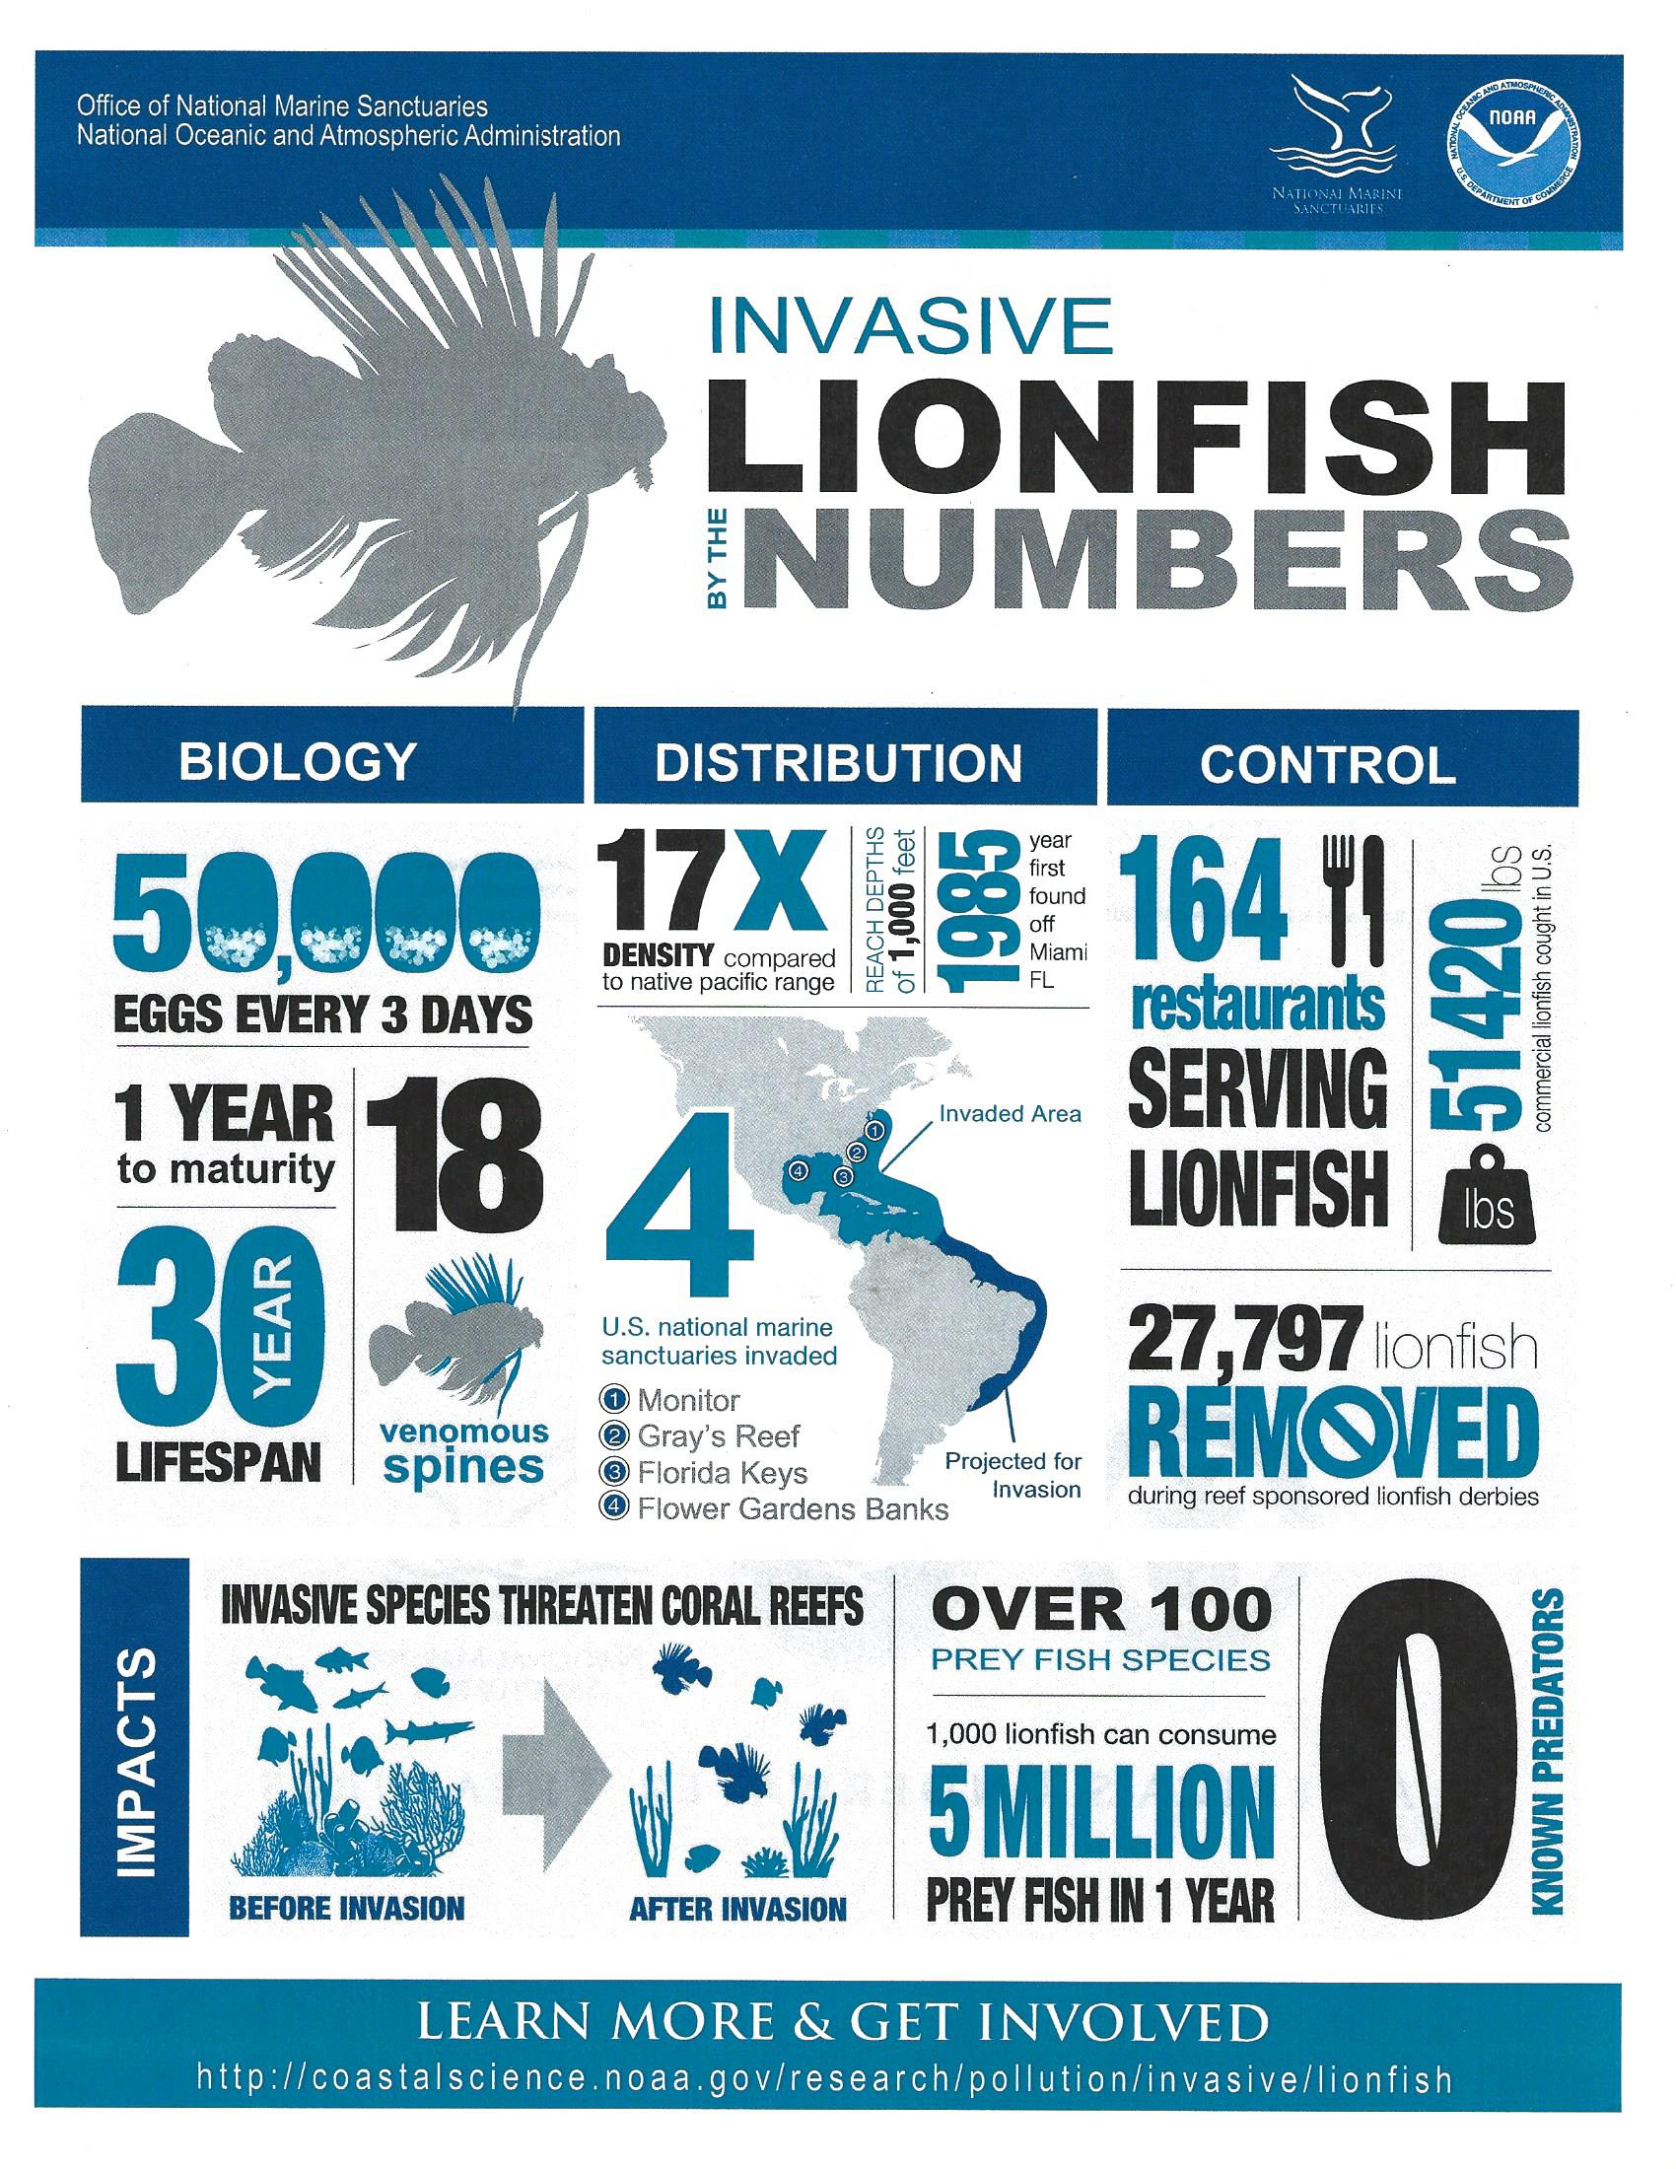
Lionfish facts : Lionfish are native to the Indo-Pacifc region and the Red Sea.
Lionfish are not native in the Western Atlantic Basin, which includes the Western Atlantic Ocean, Gulf of Mexico and Caribbean Sea, or the Mediterranean Sea where they are considered an invasive species.
Intentional and unintentional releases from home aquariums is the most likely cause for the invasion in the Western Atlantic Basin, while lionfish migrating through the Suez Canal is the most likely cause for their establishment in the Mediterranean Sea.
The current global lionfish invasion is made up two species, Pterois volitans and Pterois miles, which are nearly indistinguishable outside of the lab. P. volitans accounts for nearly 93% of the total non-native, invasive lionfish population in the Western Atlantic Basin. The invasive lionfish population in the Mediterranean Sea almost entirely consists of P. miles.
It is entirely unlikely that we will ever eradicate either population from the invaded areas. They are here to stay and we must all get involved to manage their population until nature finds a way to reach some balance.
Lionfish belong in the Scorpaenidae family. Commonly called scorpionfishes the family includes approximately 500 different species.
The genus name “Pterois” is from the Ancient Greek word for “feathered” or “winged.” There are 10 species of lionfish in the genus.
The species name “volitans” is Latin for “flying” or “hovering” and “miles” is Latin for “soldiering.”
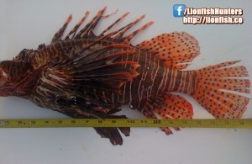
Adult-sized invasive P. volitans and P. miles average between 13 – 16 inches (33 – 40 cm) in length. The red lionfish and devil firefish is almost always striped in white, dark red, brown and black with dark spots found in orange fin rays and caudal fin (tail). It is not uncommon to find these fish turning almost entirely black.
Lionfish reach adult size in approximately 2 years.
The largest record lionfish measured a little over 47.7cm or 19.5 inches and was speared near Islamorada, Florida in the United States.
In lab studies, lionfish die when water temperatures reach 50 degrees Fahrenheit or 10 degrees Celsius.
Using water temperature as the limiting factor of it’s potential non-native range, lionfish could theoretically live during the summer months as far north as Rhode Island, United States (where there are documented sightings) and as far south as Buenos Aires, Argentina (no known sightings yet).
Lionfish have been visually sighted down to depths of 1000 feet or 305 meters.
Another interesting lionfish fact is that lionfish have no known predators outside of its native habitat, though there are reports that grouper, gray triggerfish and large eels have eaten healthy, uninjured lionfish in the Caribbean Sea.
Predators known to hunt lionfish in their native habitat include cornetfish, grouper, large eels, bobbit worms, frog fish, other scorpionfish, sharks and others.
Female lionfish are sexually mature and will release eggs when they reach 7 to 8 inches in length, or approximately one year old.
A female lionfish can release between 10,000 and 30,000 unfertilized eggs every 4 days year around, approximately 2 MILLION eggs per year, in South Florida and warmer Caribbean waters but possibly only spawn 3 to 4 months a year in colder waters. She will typically release 2 egg sacs that are between 1 and 2 inches long every spawn.
It has been reported that the egg sac contains a chemical deterrent that discourages other fish from eating the eggs.
The eggs sacs and larvae are distributed by ocean currents.
Once its territory is established, a lionfish will not usually travel very far from its home.
A lionfish’s stomach can expand up to 30 times it’s normal volume.
Lionfish primarily hunt during the twilight hours of dawn and dusk. They have also been described as active hunters during periods of dim ambient light such as on overcast or notably cloudy days.
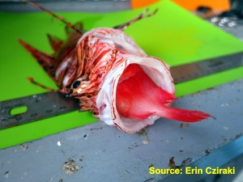Lionfish can eat prey just over 1/2 its own body size as long as it can get its mouth around the prey.
Lionfish are known to eat just about every marine creature in its range, by some estimates that includes over 70 different fish, invertebrates and mollusks. (There’s been no known instances of them eating juvenile sea turtles… yet.)
A single small lionfish may reduce the number of juvenile native fish on any given reef by approximately 79% in just 5 weeks.
Interesting lionfish fact : One lionfish was recently found to have over 60 prey in its stomach.
Controlled studies have shown that a lionfish can go up to 3 months or longer without eating and only lose 10% of their body mass.
Lionfish have 18 venomous spines that are capable of easily penetrating human skin and delivering a very painful sting; 13 of these spines are located along the spine in the dorsal fins, there is one short spine in the leading edge of each of the pelvic fins and 3 short spines in the leading edge of the anal fin.
The venom is a protein-based combination of a neuromuscular toxin and a neurotransmitter called acetylcholine. The venom can be denatured (or rendered inert) by applying heat or freezing.
Recommended first aid for lionfish stings and envenomation include surfacing safely from a dive, removing any broken spines and disinfecting the wound then applying non-scalding hot water for 30 to 90 minutes. Monitor for signs of allergic reaction or shock and react accordingly. Seek medical treatment immediately. Click here for more information about first aid treatment for lionfish stings.
There have been no known human fatalities as a result of a lionfish envenomation.
Yes, you can eat lionfish, they are not poisonous.
Ciguatoxins, the cause of Ciguatera Food Poisoning (CFP), have been found in a small sample of lionfish in VERY SPECIFIC AREAS where other reef predators are known to also carry the risk of ciguatera, however there have been no known cases of ciguatera food poisoning having been caused by eating lionfish to date.
Additional Information:
Our Most Frequently Asked Question About Lionfish
10 Most Common Lionfish Myths – Busted!

About the Author: admin
L. Scott Harrell is the co-founder of the World Lionfish Hunters Association. He now owns a scuba diving marketing consultancy in Cozumel, Mexico and offers expert PADI scuba instruction and private divemaster services. You can hunt lionfish in Cozumel, too!

