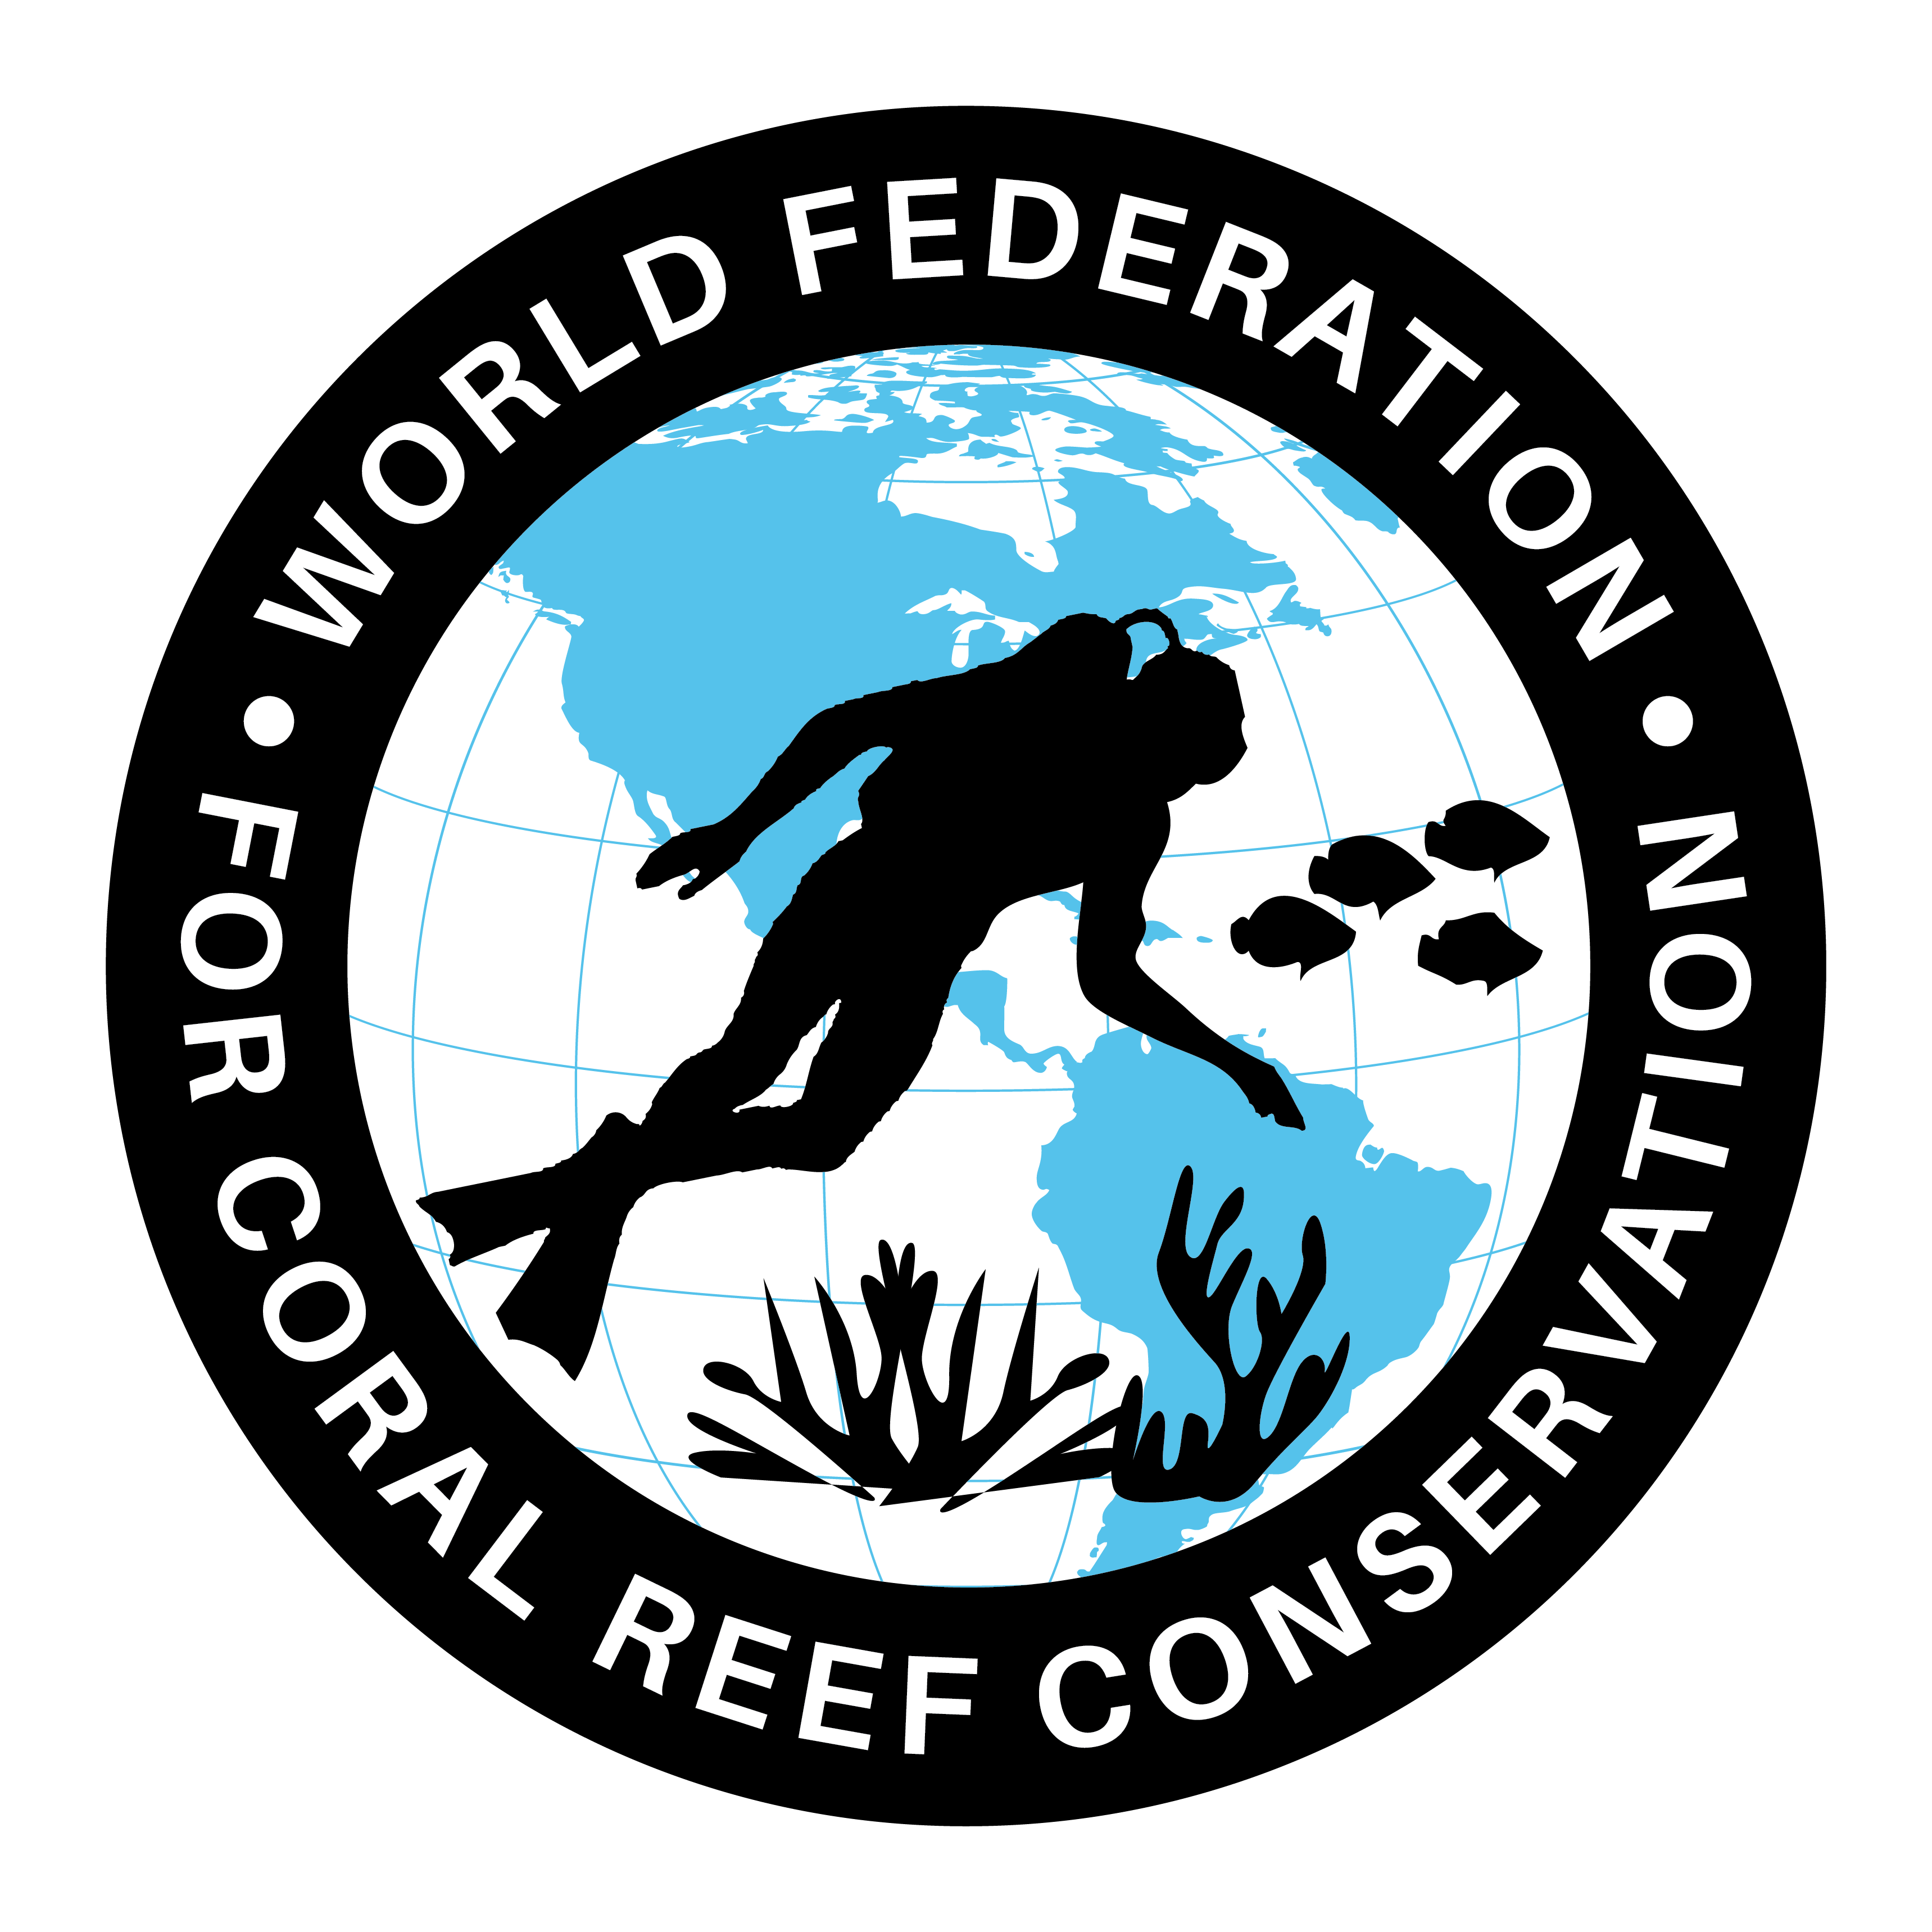
MLA-046-Red Paper Lantern Jelly- Japan
Join WFCRC

The World Federation for Coral Reef Conservation 281.971.7703 P.O. Box 311117 Houston, TX 77231
Vic Ferguson Executive Director 512.986.1902 vic.ferguson@wfcrc.org info@wfcrc.org
Reprinted 5/26/17

Red Paper Lantern Jelly

Source: One Species at a Time/Ari Daniel - May 26, 2017 in Radio
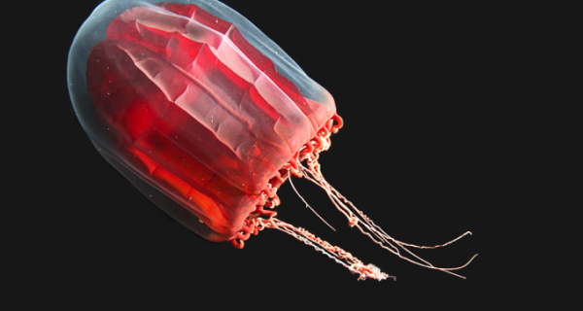
Photo: Karen Osborn/Smithsonian Institution

Vacuumed up from its habitat a mile down in the ocean, the red paper lantern jelly may not look like much. Mostly water, it’s so fragile that once brought to the surface it’s reduced to a tattered blob in a jar. But this unassuming jellyfish has lessons for scientists. It’s teaching researchers in Japan how intricately life is connected down in the ocean’s deep, dark depths—and how the fate of this small red lantern sheds light on the fragility of life close to home.

Transcript:
Ari: From the Encyclopedia of Life, this is: One Species at a Time. I’m Ari Daniel.
<Sounds of jars moving around>
At the JAMSTEC marine research center just south of Tokyo, Dhugal Lindsay’s looking for a specimen.
Lindsay: Ah, here it is.
Ari: He’s found it. Lindsay holds up a jar the size of a beer pint. A preserved brown blob’s settled to the bottom.
Lindsay: I’ve called it the red paper lantern jelly.
Ari: It’s a type of jellyfish. But when Lindsay used his underwater robot – kind of like a marine vacuum cleaner – to capture the specimen – taking it from almost half a mile deep and bringing it to the surface – it didn’t hold up.
Lindsay: It was still ripped in half, the stomach is almost gone. And this is an animal that we were very careful in collecting. Their bodies are like 95% water, which means if you try and catch them – pchoo! – they blow up. There’s not much of them left.
Ari: The brown blob doesn’t look like much. <sound of door opening> But then Lindsay takes me down the hall to his video lab.
Lindsay: It’s where we analyze the videotapes from the robots and submersibles.
Ari: It’s like a broadcast television studio. Thirty monitors of all sizes line the walls. Lindsay pops a cassette into a tape deck, and cues up a floating jellyfish.
Lindsay: Here we go. This is Pandea rubra – the red paper lantern jelly.
Ari: It appears to be a completely different animal from the one in the jar.
Lindsay: It’s so graceful and it’s just floating there like a dream.
Ari: When I see it, the name makes sense. The jellyfish has a clear bell. Tentacles dangle beneath it awaiting prey. But inside it, there’s what looks like a tiny red paper lantern.
Yoshiko Takeoka is an administrator at JAMSTEC. She’s been watching the video too, and she’s fond of the name red paper lantern jelly.
Takeoka: Yes, lantern, just like we can find outside in Tokyo at the place where we drink alcohol. In Japan, there’s an akechochin outside of the bar telling there is alcohol here.
Ari: The akechochin is a lantern, red lantern?
Takeoka: Yes.
Ari: Ok, and this is ake–
Takeoka: Akekochin kurage.
Ari: Akekochin kurage, which is red lantern jelly. I see.
Takeoka: Yes, I love it very much.
Ari: Lindsay gave the jelly its common name. One reason: the haiku poetry that he writes.
Lindsay: When I think of Japanese names for these jellyfish, I always make sure they fit in either 5, 7 or 5 syllables and that they’d be good for writing poems about.
Ari: So this one has how many syllables?
Lindsay: The first five syllables is akechochin. Kurage is part of the middle 7, and then you can keep on going from there. If it was akecho, it would only be four and you kind of lose the rhythm there.
Ari: Lindsay had another motive for naming the jellyfish after the red lanterns hanging outside Japanese bars.
Lindsay: Because of all the animals that come to visit. It’s just like a bar where you have all these different people coming in. Everyone wants to live on this jellyfish.
Ari: In the deep sea where it’s just water everywhere – there’s nothing to hold onto – not even the seafloor. Often the only option for settling down is on or in another creature. And Lindsay’s found that the akekochin kurage are important places for other animals to live.
Lindsay: We were noticing – oh, look, there’s a pair of sea spiders, a male and a female. And the male is carrying the eggs on its back, so they’re obviously reproducing there. We had another animal, which had a little amphipod sitting on the surface of the jellyfish. We had another animal that we caught – there’s a whole group of other little jellyfish that were living inside it. And looking through them we saw there are many amphipods and other animals that live on them as well.
Ari: It goes the other way too. At a different stage of its development, a jellyfish looks like a sea anemone. It’s called a polyp.
Lindsay: Polyps, they need a substrate to attach to – they can’t swim or float by themselves. They need to be attached to something.
Ari: For the red paper lantern jellyfish, that something is the shell of a particular species of snail. It won’t attach to anything else – not a different animal, not another kind of snail, not even a dead snail of the right species. But this underwater ballet of animals living on and in each other as they float through the water … is in danger.
The culprit: increasing levels of carbon dioxide in our atmosphere. A good amount of that CO2 ends up dissolving in the ocean and forming carbonic acid.
Lindsay: This is the stuff in your coke that melts your teeth. It not only melts your teeth – it also melts anything made of calcium carbonate.
Ari: Which includes snail shells. Ocean acidification – this process of carbon dioxide dissolving in the ocean and making it more acidic – is bad news for lots of species.
Lindsay: So if the snails get taken out by acidification of the ocean, the jellyfish gets taken out. The jellyfish gets taken out – the sea fleas and the sea spiders and the other baby jellyfishes get taken out. And so it’s just a cascade of bad effects right from the surface layers all the way into the deep sea.
<beat>
Ari: Here’s a haiku Lindsay wrote aboard a research vessel one night.
Lindsay: <Japanese> A shooting star // The ocean floor too far below // To drop anchor
Ari: Lindsay was thinking about the space we occupy between the atmosphere and the ocean floor – two realms beyond our reach. But his science shows him otherwise – that our actions can affect the fragile worlds both far above us and deep below.
<music>
Ari: You can visit eol.org to see a video of akekochin kurage.
We’re also interested in getting your photographs and videos of jellyfish and, for that matter, your haiku as well. You can submit them at eol.org.
Our series, One Species at a Time, is produced by Atlantic Public Media in Woods Hole, Massachusetts. I’m Ari Daniel Shapiro.
For the web: Listen to our story about the red paper lantern jellyfish, and then send us your underwater photos and videos of jellyfish. While you’re at it, send us a haiku. You can upload them at eol.org.
Also, Dhugal Lindsay got the naming rights to the red paper lantern jellyfish because he brought it to fame. Let’s say you could rename any species…what names would you change?

The Encyclopedia of Life has gathered information from all over the world to create the largest repository of species known to science. Their mission is to increase awareness and understanding of living nature through an Encyclopedia of Life that gathers, generates, and shares knowledge in an open, freely accessible and trusted digital resource.

