
MLA-049-Coral Reef Shark-AU
Join WFCRC

The World Federation for Coral Reef Conservation 281.971.7703 P.O. Box 311117 Houston, TX 77231

Reprinted 7/14/17
16, 2314–2319, December 5, 2006 ª2006 Elsevier Ltd All rights reserved DOI 10.1016/j.cub.2006.09.044
Ongoing Collapse of Coral-Reef Shark Populations
William D. Robbins,^{1,}* Mizue Hisano,^{1,2}
Sean R. Connolly,^{1,2} and J. Howard Choat¹ 1
School of Marine and Tropical Biology
James Cook University
Townsville, Queensland 4811
Australia 2 Australian Research Council
Centre of Excellence for Coral Reef Studies
James Cook University
Townsville, Queensland 4811
Australia
Summary
Marine ecosystems are suffering severe depletion of apex predators worldwide [1–4]; shark declines are principally due to conservative life-histories and fisheries overexploitation [5–8]. On coral reefs, sharks are strongly interacting apex predators and play a key role in maintaining healthy reef ecosystems [9– 11]. Despite increasing fishing pressure, reef shark catches are rarely subject to specific limits, with management approaches typically depending upon no take marine reserves to maintain populations [12–14]. Here, we reveal that this approach is failing by documenting an ongoing collapse in two of the most abundant reef shark species on the Great Barrier Reef (Australia). We find an order of magnitude fewer sharks on fished reefs compared to no-entry management zones that encompass only 1% of reefs. No-takezones, which are more difficult to enforce than no-entry zones, offer almost no protection for shark populations. Population viability models of whitetip and gray reef sharks project ongoing steep declines in abundance of 7% and 17% per annum, respectively. These findings indicate that current management of no-take areas is inadequate for protecting reef sharks, even in one of the world’s most-well-managed reef ecosystems. Further steps are urgently required for protecting this critical functional group from ecological extinction.
Results and Discussion
The Australian Great Barrier Reef (GBR) is widely regarded as one of the least-degraded reefs in the world [15,16].It is regulated by a hierarchical series of management zones, the aim of which is to balance conservation with sustainable use [17]. The status of shark populations in this system should therefore provide a conservative picture of the vulnerability of reef sharks worldwide as well as yield valuable insights into the efficacy of no take zones as a management tool for high-trophic-level predators. By using fisheries-independent underwater visual censuses, we surveyed populations of the two
*Correspondence: will.robbins@jcu.edu.au
most-abundant reef shark species, the whitetip reef shark (Triaenodon obesus) and the gray reef shark (Carcharhinus amblyrhynchos), in four levels of coral reef management zones. These zones represent a gradient in fishing pressures because (1) no-entry zones are aerially-surveyed, strictly-enforced exclusion areas (1% of total reef area on the GBR). (2) No-take zones cannot legally be fished, although fishing boats are permitted to be present (30% of total reef area); moderate levels of illegal fishing have been documented in these zones [18]. (3) Limited-fishing zones have tight restrictions on the type and quantity of fishing gear permitted (4% of reef area). (4) Open-fishing zones have fewer gear restrictions on line fishing (60% of reef area) (Figure 1). We contrast reef shark abundances in these zones with those we found through comparative sampling at the southern atoll of the Cocos (Keeling) Islands in the Indian Ocean. This isolated Australasian atoll may be one of the last pristine reefs in the world [19], with no recorded history of commercial shark fishing and negligible recreational shark fishing. Its inclusion allows for an additional estimate of reef shark abundance under minimal exploitation, to complement our estimates from no-entry zones.
We find substantially lower numbers of reef sharks outside no-entry zones than within them (Figure 2). No entry reefs sustain shark abundances similar to the minimally fished shark populations in the Cocos (Keeling) Islands. Compared to the no-entry reefs, abundances on reefs with the fewest fishing restrictions (open-fishing zones) are reduced by 80% for whitetip reef sharks and 97% for gray reef sharks on the Great Barrier Reef (Figure 2). Abundances on limited-fishing reefs are nearly identical to those of open-fishing reefs. Surprisingly, abundances on no-take reefs, where fishing boats may anchor but fishing is illegal, were also heavily depleted and remarkably similar to the legally fished zones. These results indicate that not only are reef shark populations heavily depleted on fished reefs but also that there is a dramatic difference in the effectiveness of no-entry zones and no-take zones. Indeed, it is striking that the abundance differences that we observe between no-entry and fished reefs are comparable in magnitude to differences in reef shark biomass documented between lightly and heavily fished islands in Hawaii [10]. One possible explanation for the marked difference in abundance between no-take and no-entry zones is that sharks move from no-take to fished zones (where they are caught) more frequently than they move from no entry to fished zones. However, although movements of sharks may occur between reefs zoned for different fishing levels [20], it is unlikely that reef sharks preferentially move out from areas of lower density (no-take zones) at greater rates than from areas of higher density (no-entry zones). No-take and no-entry zones are often similar in size and similarly interspersed among open fishing and limited-fishing zones (Figure 1). Indeed, no entry reefs may be found within 1–2 km of open-fishing
reefs, yet we still find higher abundance levels on the no entry zone reefs. Moreover, the movements of reef sharks such as the whitetip reef shark are limited (0–3 km) [21], suggesting a high level of site fidelity. Consequently, the most likely explanation for the discrepancy between no-entry and no-take reefs is that illegal fishing in no-take zones, which has been documented even on comparatively well-policed inshore reefs [18], has a highly deleterious effect on reef shark abundances. Similar poaching problems appear to be common to many coral-reef marine reserve systems worldwide [22].
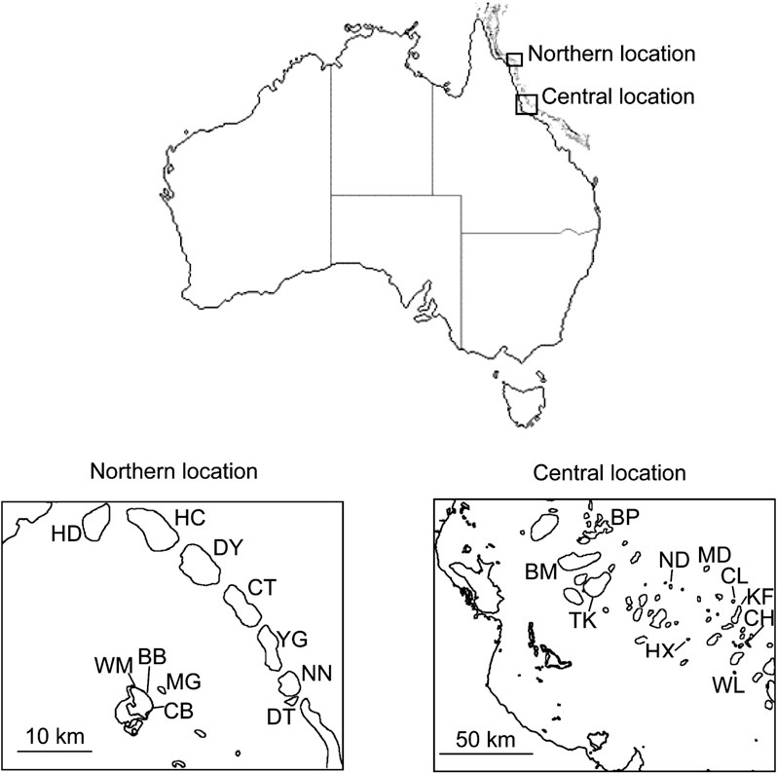Figure 1. Location of Great Barrier Reef Underwater Visual Censuses
No-entry zone reefs surveyed were Carter (CT) and Hilder (HD) reefs; no-take zone reefs were Barnett Patches (BP), Coil (CL), Detached (DT), MacGillivray (MG), No Name (NN), and Wheeler (WL) reefs; limited-fishing zone reefs were Bommie Bay (BB), Crystal Beach (CB), Myrmidon (MD), Needle (ND), Trunk (TK), and Washing Machine (WM) reefs; open-fishing zone reefs were Britomart (BM), Chicken (CH), Day (DY), Helix (HX), Hicks (HC), Knife (KF), and Yonge (YG) reefs. Current zonation of BB, CB, MG, and WM reefs was implemented in 1983; other listed northern reef zones were implemented in 1992. All listed central reef zones were implemented in 1987.
In principle, there are two ways in which fishing pressure may produce the differences observed in shark abundance between no-entry and fished reefs: directly, through overfishing of sharks and indirectly, through fishing of prey species, forcing sharks to seek prey on unfished reefs. However, it is unlikely that indirect fishing pressures are responsible for the patterns we observe in these reef sharks. The preferred prey of both shark species includes benthic fishes (Scaridae and Acanthuridae), cephalopods, and eels (Muraenidae) [21, 23], but with the exception of cephalopods, these species are neither commercially nor recreationally fished on the Great Barrier Reef. We conclude, therefore, that the most likely explanation for the differences in abundance between no-entry and fished zones is because of the direct capture and removal of sharks.
To determine the sustainability of the two reef shark species, we conducted population viability analyses by using independently obtained biological parameters from the same populations. Annual survival estimates were calculated from the age-frequency distribution of each species, and age-specific fecundities were calculated with both the survival and maturity parameters (Table 1). Our results indicate very high probabilities of population decline, with 98% and 100% of simulations yielding negative population growth for whitetip and gray reef sharks, respectively. Moreover, the magnitude of estimated population decline is severe: Median rates of population decline are 7% per annum for whitetip reef sharks and 17% for gray reef sharks (Figure 3). If current population trends continue unabated, the abundance of whitetip reef sharks and gray reef sharks present on legally fished reefs will be reduced to only 5% and 0.1%, respectively, of their present-day no-entry abundance levels within 20 years. The potential for further reductions in population growth rates at such low population densities (e.g., difficulty finding mates or other such Allee effects [24]) may well make this population collapse increasingly difficult to reverse as time progresses.
The minimum change in mortality necessary to produce a median estimated population growth rate of 1.0 (i.e., population stability) was calculated for each species. Analyses indicate that reductions in annual mortality by one-third (36%) for the whitetip reef shark and one half (49%) for the gray reef shark would be required to halt these ongoing declines. However, with commercial catches of sharks nearly quadrupling on the Great Barrier Reef between 1994 and 2003 [13] and recreational fishing also removing large numbers of sharks in Australia [25], the trend is strongly in the opposite direction. Recent attempts to quantify rates of shark population decline [6, 7] have been criticized as overly pessimistic because of their reliance on trends in catch rates recorded in logbooks [26, 27]. Management plans have called for more comprehensive data before drawing conclusions about population status [28]. The results we present here allow us to address these issues because
2316
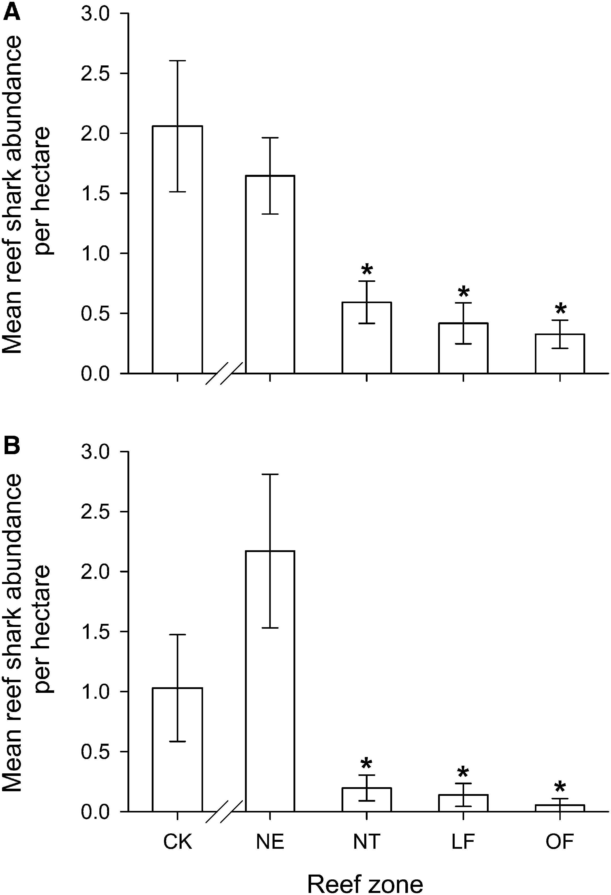
Figure 2. Abundance of Reef Shark on Coral-Reef Fronts
Mean abundance of whitetip reef sharks (A) and gray reef sharks (B) estimated through underwater visual surveys at the Cocos (Keeling) Islands (CK) and at no-entry (NE), no-take (NT), limited-fishing (LF), and open-fishing (OF) management zones on the Great Barrier Reef, Australia. Error bars represent standard errors. Seventeen surveys were undertaken at the Cocos (Keeling) Islands; 19 were undertaken in each of the NE, NT, and LF zones, and 23 were undertaken in OF zones. Asterisks denote management zones that significantly differ from no-entry (NE) zones; *p < 0.005. Reef shark abundances do not significantly differ among no-take, limited-fishing, and open fishing zones; p > 0.7 for each comparison.
they are based on a unique combination of data that incorporates direct estimates of demographic rates with fisheries-independent abundance estimates. The rates of population decline that we obtain are consistent with the hypothesis that sharks are suffering worldwide population reductions [6].
The existence of severely depleted population sizes, by itself, need not indicate imminent extinction risk when the causes of population decline are no longer present [8]. However, for our study species, severe population depletion is coupled with estimates of ongoing, rapid population decline. Together, these findings indicate that extirpation of these species from fished coral reef systems is an imminent likelihood in the absence of substantial changes to coral-reef management. Indeed, our findings on the population status and ongoing decline of reef sharks, when coupled with fisheries data showing that the fishing pressure on Great Barrier Reef sharks continues to increase [13], highlight the urgent need for review of the threat status of these species.
Inferred and projected declines such as ours appear sufficient to warrant ‘‘Critically Endangered’’ status under IUCN Red List (A3d) criteria for this study area, for both species [29]. This would constitute a substantial change from the current classification of‘‘ lower risk(Near Threatened)’’ globally [30]. Substantial reductions in shark mortality would be required for the declines documented in our study to be reversed, even on the comparatively highly regulated Great Barrier Reef. This situation is likely to be much worse on reef systems lacking such stringent management.
Recognition that oceanic sharks are under threat has led to international calls for the reduction of overfishing of oceanic species [5]. It appears that reef sharks are facing a similar level of threat. Because reef sharks are strongly interacting apex predators, the loss of this functional group has potentially large implications for marine tropho dynamics. For instance, on coral reefs, food-web models indicate that trophic cascades initiated by overfishing of sharks may have contributed to the collapse of Caribbean coral-reef ecosystems [9].
Despite the precariousness of the current status of reef shark populations, there is some cause for optimism. In particular, the order-of-magnitude-higher abundance on no-entry reefs indicates that high levels of shark abundance can be sustained in reef systems that allow fishing elsewhere, provided that enforcement is effective. Although there are no data on the abundance levels that prevailed on the Great Barrier Reef prior to the commencement of fishing, our findings suggest that exclusion zones can sustain abundances that are comparable to minimally exploited systems found elsewhere. However, given the tiny fraction of the Great Barrier Reef that is designated as no-entry (1% of reef area), it seems unlikely that spillover from these small areas will be adequate for replenishing surrounding reefs. Crucially, the apparent failure of no-take zones to protect sharks makes it clear that the mere legal prohibition of fishing in marine protected areas is inadequate; such prohibitions must be part of statutory or community-based enforcement regimes that achieve nearly universal compliance from reef users [31]. Our data suggest that for coral-reef sharks, immediate and substantial reductions in shark fishing will be required for their ongoing collapse to be reversed.
Experimental Procedures
Visual Censuses
Eighty 400 3 20 m (0.8 hectare) underwater visual censuses were conducted on 21 reefs on the northern and central Great Barrier Reef (Figure 1). To allow comparisons of shark abundance in a minimally-exploited environment, we conducted 17 additional censuses at the Cocos (Keeling) Islands in the Indian Ocean (12!080S, 96!520E). In all surveys, SCUBA divers swam parallel to the reef crest, at a rate of 20 m per min, and maintained visual contact with the substratum. Censuses were conducted during daylight hours, with divers swimming down-current when possible to limit noise and movements. All censuses were conducted with a minimum visibility of 10 m.
Great Barrier Reef shark abundances were natural log transformed prior to analysis. We conducted a mixed model nested analysis, with management zone as a fixed effect and reefs as a random effect nested within zone. The reef effect was not significant (p > 0.9 for both species). Therefore, following standard statistical procedure, we pooled transects across reefs and used one-way ANOVAs and Tukey HSD post hoc tests to test for significant differences among reef management zones. Although major rezoning of this reef system occurred in 2004 [32], only reefs that retained their original management zone were surveyed after this time. All management zones indicated for our study sites had been in place since at least 1992 (northern GBR) or 1987 (central GBR) (Figure 1).
Age | Median (LCI–UCI) | Median (LCI–UCI) | Median (LCI–UCI) | Median (LCI–UCI)
0–1 | 0.835 (0.792–0.883) | 0.000 (0.000–0.000) | 0.076 (0.016–0.227) | 0.000 (0.000–0.000)
1–2 | 0.835 (0.792–0.883) | 0.000 (0.000–0.000) | 0.421 (0.385–0.478) | 0.000 (0.000–0.000)
2–3 | 0.835 (0.792–0.883) | 0.000 (0.000–0.001) | 0.656 (0.616–0.714) | 0.000 (0.000–0.000)
3–4 | 0.835 (0.792–0.883) | 0.000 (0.000–0.003) | 0.784 (0.734–0.847) | 0.000 (0.000–0.000)
4–5 | 0.835 (0.792–0.883) | 0.001 (0.000–0.007) | 0.858 (0.805–0.914) | 0.000 (0.000–0.000)
5–6 | 0.835 (0.792–0.883) | 0.003 (0.000–0.016) | 0.903 (0.852–0.949) | 0.000 (0.000–0.000)
6–7 | 0.835 (0.792–0.883) | 0.010 (0.000–0.039) | 0.932 (0.885–0.970) | 0.000 (0.000–0.000)
7–8 | 0.835 (0.792–0.883) | 0.034 (0.002–0.090) | 0.951 (0.908–0.982) | 0.000 (0.000–0.000)
8–9 | 0.835 (0.792–0.883) | 0.098 (0.016–0.195) | 0.964 (0.926–0.989) | 0.000 (0.000–0.000)
9–10 | 0.835 (0.792–0.883) | 0.215 (0.093–0.344) | 0.974 (0.939–0.993) | 0.000 (0.000–0.000)
10–11 | 0.835 (0.792–0.883) | 0.333 (0.236–0.445) | 0.980 (0.949–0.996) | 0.000 (0.000–0.000)
11–12 | 0.835 (0.792–0.883) | 0.396 (0.312–0.496) | 0.985 (0.958–0.997) | 0.000 (0.000–0.247)
12–13 | 0.835 (0.792–0.883) | 0.419 (0.336–0.516) | 0.989 (0.964–0.998) | 0.147 (0.000–0.388)
13–14 | 0.835 (0.792–0.883) | 0.427 (0.343–0.524) | 0.992 (0.969–0.999) | 0.401 (0.247–0.606)
14–15 | 0.835 (0.792–0.883) | 0.430 (0.346–0.526) | 0.994 (0.974–0.999) | 0.745 (0.369–0.973)
15–16 | 0.835 (0.792–0.883) | 0.430 (0.346–0.527) | 0.995 (0.977–1.000) | 0.827 (0.664–0.988)
16–17 | 0.835 (0.792–0.883) | 0.431 (0.347–0.527) | 0.996 (0.980–1.000) | 0.865 (0.733–1.023)
17–18 | 0.835 (0.792–0.883) | 0.431 (0.347–0.528) | 0.997 (0.983–1.000) | 0.883 (0.745–1.051)
18–19 | 0.835 (0.792–0.883) | 0.431 (0.347–0.528) | 0.998 (0.985–1.000) | 0.895 (0.748–1.077)
Median and lower (LCI) and upper (UCI) 95% percentile confidence intervals of estimated age-specific annual survival probabilities and percapita fecundities (product of maturity and survival probabilities multiplied by number of female pups per given year) were generated from 10,000 bootstrap replicates of the catch-curve, maturity, and fecundity data.

Table
1.
Dem
ographic
Parameters
of
Coral-Reef
Sh
arks
T.
obesus
C.
am
blyrhynchos
Su
rvival
Fecundity
Survival
Fecundi
ty
Matrix Model
To estimate the current population growth rate for the two shark species, we constructed an age-based matrix model for the population dynamics of female sharks with age-specific survival probabilities, s_{i}, and age-specific fertilities, F_{i};
666426 0 F1 / Fn21 Fn ³⁷7775
s₀ 0 0 0
A = 0 s1 1 0 0 (1)
0 0 0 0
0 0 / sn21 0
The leading eigenvalue of this matrix is a function of all demographic rates and provides an estimate of population growth rate [33]. Monte Carlo simulation was used for producing an uncertainty distribution for population growth rate [34], based on uncertainties in our estimates of demographic rates. These uncertainties were calculated by nonparametric bootstrap methods as detailed below. Because our data showed that shark populations were depleted well below unfished densities (Figure 2), we modeled all vital rates as density independent.
Demographic Data
One hundred thirty-four T. obesus and 199 C. amblyrhynchos individuals were obtained through field and commercial collections at multiple reefs at both the northern (14!250S–14!420S) and central (18!020S–19!140S) Great Barrier Reef. This includes both sparsely (northern) and relatively heavily (central) populated regions and thus is likely to be representative of the range of fishing pressures on the GBR. Age and maturity status were determined for a subset of 125 T. obesus and 89 C. amblyrhynchos. Litter size (fecundity) and breeding periodicity were determined from 23 pregnant females. Females of both species reproduced biennially, after approximately 1 year gestation periods (W.D.R., unpublished data). All collections were conducted under James Cook University animalethics approval (#A696). Estimates of demographic parameters used in the matrix model are presented in Table 1.
Fecundity
For each species, a logistic regression analysis was used to estimate the probability of maturity as a function of age. We then shifted this curve upwards by a year to obtain an estimate of the probability of giving birth as a function of age (because of the w1 yr gestation). We estimated the uncertainty distribution for maturity by generating 10,000 bootstrap samples from the maturity data and analyzing each bootstrap by logistic regression.
We estimated mean litter size as the mean number of embryos per pregnant female from the empirical data (assuming [optimistically] that all embryos appearing viable at the time of sampling would be brought successfully to term). Our data showed no evidence of a trend in litter size with age for T. obesus. Therefore, we quantified uncertainty in our estimate of mean litter size by calculating the mean litter sizes for 10,000 bootstrap resamples of the fecundity data, pooled across ages [34]. C. amblyrhynchos had lower average litter sizes in the first reproductive year but not in subsequent years. To characterize this increase in litter size with age, we fit a logistic function to the fecundity data:
npups;i =1+ 1 + 1c01_{ð}2c221iÞ*c3 (2)
where i = age, n_{pups,i} = the number of pups per pregnant female of age i, and c₁, c₂, and c₃ are fitted parameters. This equation produces a curve that increases with age, with a lower asymptote at 1 (the minimum number of pups per litter) and an upper asymptote at c₁. c₂ is the inflection point of the curve. We quantified uncertainty in this estimate by fitting Equation 2 to 10,000 bootstrap replicates of our dataset. We generated these replicates by resampling residuals from the fit of Equation 2 to the data [35].
We obtained age-specific fertility estimates for each Monte Carlo run of the matrix model by first choosing maturity, fecundity, and survival curves from their respective bootstrap distributions, then multiplying their product by 0.25. The factor of 0.25 takes into account the 1:1 sex ratio of gestating pups, and the biennial periodicity of breeding.
Longevity
In keeping with standard approaches in fisheries demography, maximum age was set to the age of the oldest individual observed (19 years for each species). Because these are exploited populations, this approach may underestimate longevity; however, we know of 2318
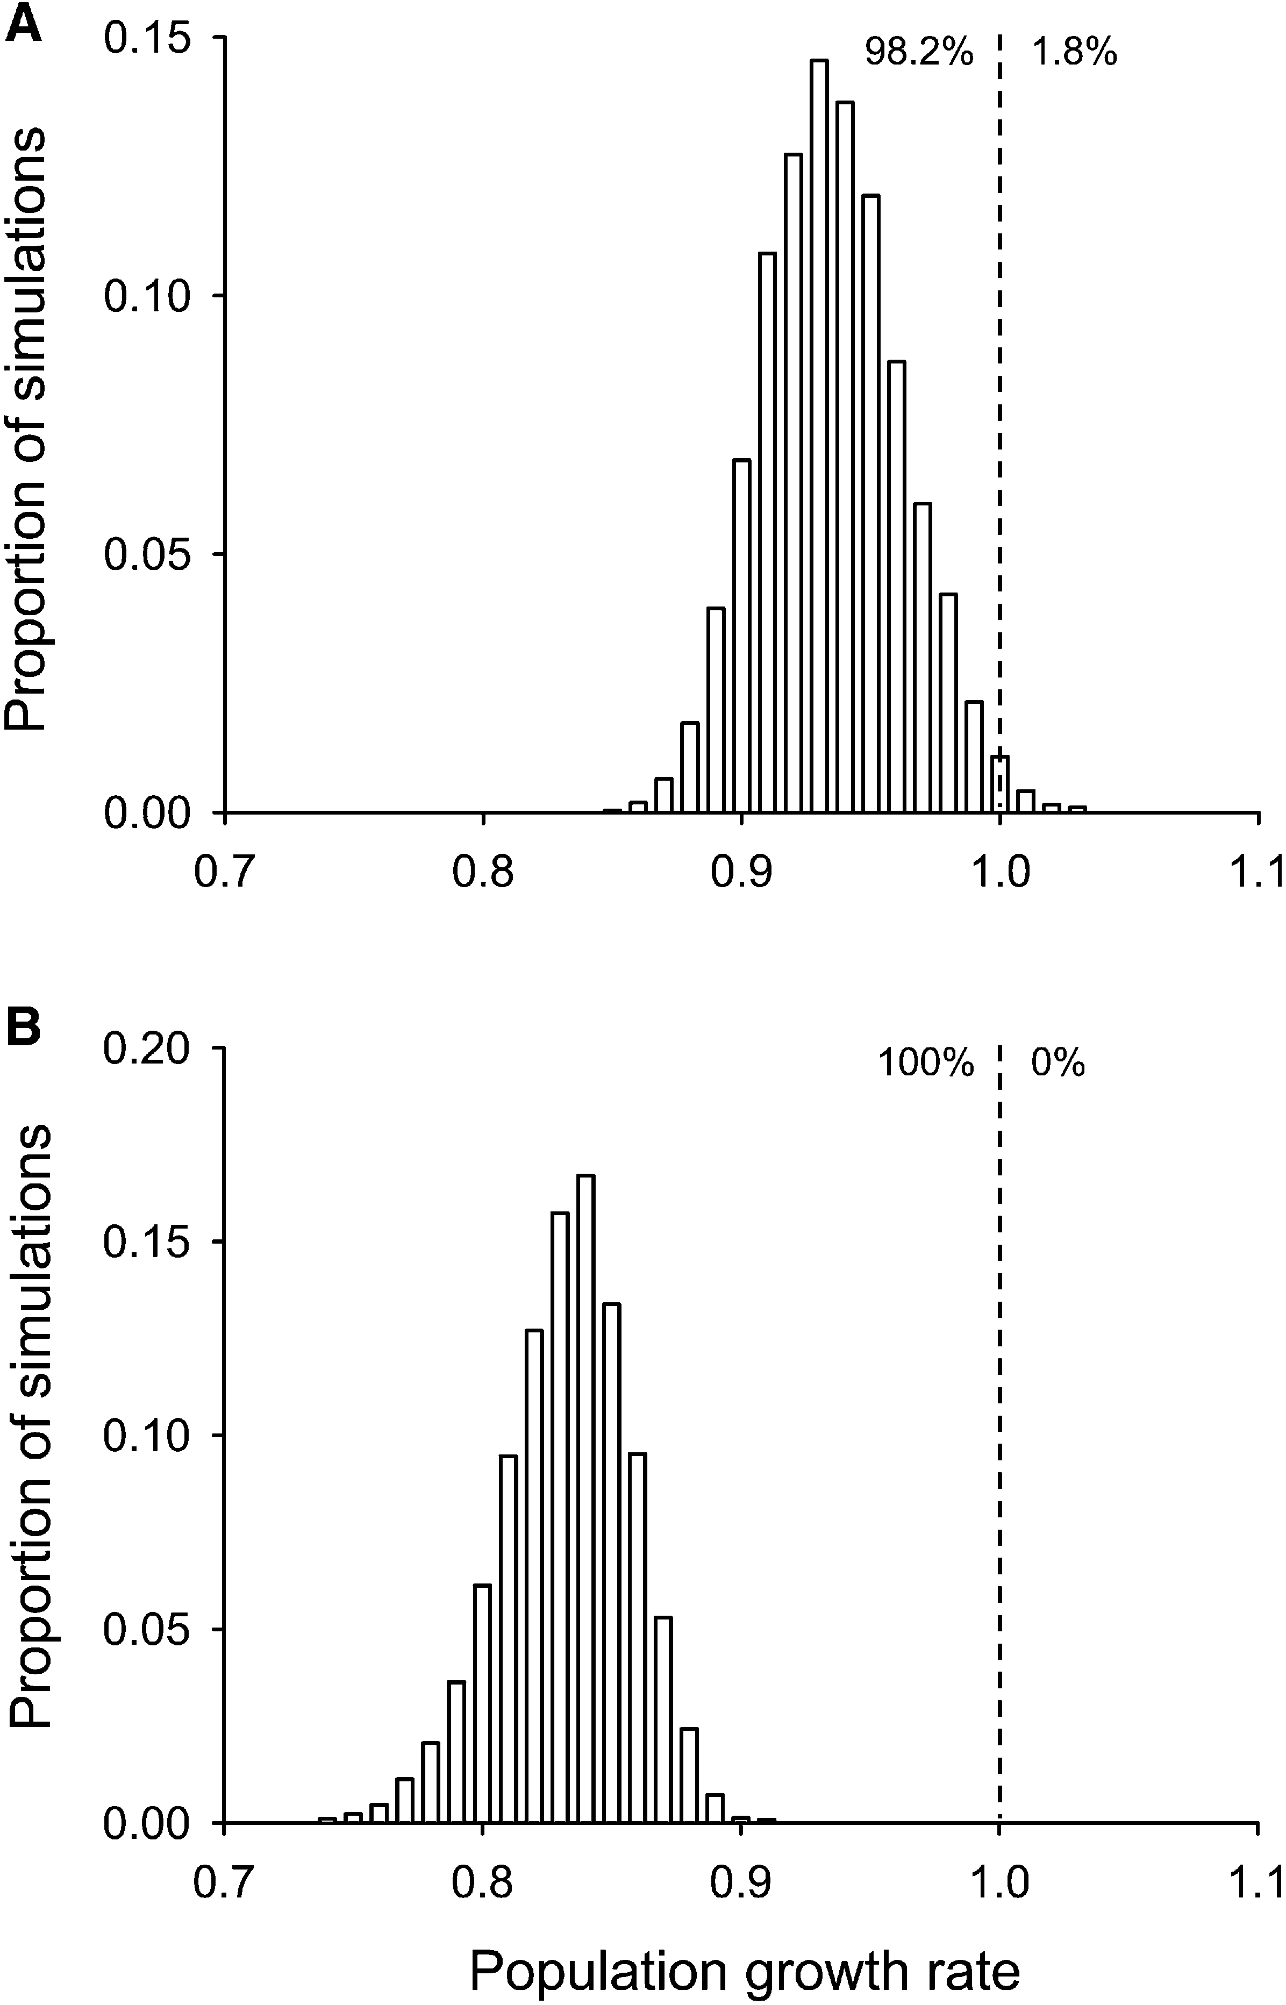
Figure 3. Estimated Population Growth Rates of Reef Sharks
Uncertainty distribution of population growth rates of whitetip reef sharks (A) and gray reef sharks (B) generated from 10,000 replicate Monte Carlo repeated simulations. Percentages indicate the frequency of simulations that project declining (left of dashed line) versus increasing (right of dashed line) populations.
no established demographic methods that explicitly account for this possibility. Therefore, to be conservative, we repeated our analyses with longevities increased by w25% (to 24 years). Even this substantial inflation of estimated lifespan had a minimal effect on our results: For T. obesus and C. amblyrhynchos, population decline still occurred in >95% and 100% of simulations, respectively, and median rates of population decline remained high, at 5% and 12% per annum.
Survival
Survival probability (s_{i}) was estimated from the age-frequency distributions of the total catch data for each species. Age was estimated from each species’ growth curve (W.D.R., unpublished data) for any individual whose age data was not obtained. For T. obesus, we conducted a catch-curve analysis by using standard methods [36]. For C. amblyrhynchos, log-transformed catch frequency data exhibited poor fit to a linear (i.e., type II survivorship) model. However, a typeIII-survivorship curve closely fit the data:
c¹
logðfiÞ = 1+ ðc₂ 2 1Þ*e2 _{c}3*_{i} (3)
where i = age, f_{i} = the frequency of individuals at age i, and c₁, c₂, and c₃ are fitted parameters. Age-specific instantaneous mortality rates of C. amblyrhynchos were then obtained by differentiating the curve at each age. For both species, we estimated the uncertainty distribution for mortality by generating 10,000 bootstrap samples from the catch-frequency data, repeating the catch-curve analysis, and recalculating age-specific mortality as described above. Although the use of a type-III-survivorship curve in the analysis of catch data is unusual, our conclusions are unlikely to be sensitive to it. Even when the C. amblyrhynchos analysis is conducted with the T. obesus survivorship schedule (an optimistic assumption in light of the fact that C. amblyrhynchos exhibits a greater response to fishing in our abundance data [Figure 1] and is known to attack bait more aggressively than T. obesus [37]), we still obtain a median estimate of population decline of 8% per annum, with >99% of simulations indicating negative population growth.
Mortality Reduction Analysis
To determine the reduction immortality necessary for obtaining a median population growth rate of 1.0 (population stability), we reduced the age specific annual mortality by a constant percentage, in steps of 1%, and repeated our Monte Carlo simulations at each step until median population growth rate reached 1.0.
Acknowledgments
We thank R.J. Green and A.M. Ayling for laboratory and field assistance and T.P. Hughes, A.P. Kerswell, M.J. Marnane, P. Munday, and C. Syms for manuscript suggestions. We also thank Lizard Island Research Station and Parks Australia (Cocos-Keeling Islands) for support and use of facilities. This work was supported by grants from the Australian Coral Reef Society, Professional Association of Diving Instructors (PADI) Aware, Great Barrier Reef Marine Park Authority (GBRMPA), the National Geographic Society, the Queensland Government/Smithsonian Institution collaborative research program, and the Nancy Vernon Rankine write up scholarship. Great Barrier Reef collections and entry into no-entry zones were conducted under GBRMPA permit.
Received: July 6, 2006
Revised: September 15, 2006
Accepted: September 15, 2006 Published: December 4, 2006
References
- Myers, R.A., and Worm, B. (2005). Extinction, survival or recovery of large predatory fishes. Philos. Trans. R. Soc. Lond. B. Biol. Sci. 360, 13–20.
- Myers, R.A., and Worm, B. (2003). Rapid worldwide depletion of predatory fish communities. Nature 423, 280–283.
- Pauly, D., Christensen, V., Dalsgaard, J., Froese, R., and Torres, F.J. (1998). Fishing down marine food webs. Science 279, 860–863.
- Jackson, J.B.C., Kirby, M.X., Berger, W.H., Bjorndal, K.A., Botsford, L.W., Bourque, B.J., Bradbury, R.H., Cooke, R., Erlandson, J., Estes, J.A., et al. (2001). Historical overfishing and the recent collapse of coastal ecosystems. Science 293, 629–638.
- ICES. (2006). Report of the working group on elasmobranch fishes (WGEF) 2005. ICES CM 2006/ACFM:03.
- Baum, J.K., Myers, R.A., Kehler, D.G., Worm, B., Harley, S.J., and Doherty, P.A. (2003). Collapse and conservation of shark populations in the northwest Atlantic. Science 299, 389–392.
- Baum, J.K., and Myers, R.A. (2004). Shifting baselines and the decline of pelagic sharks in the Gulf of Mexico. Ecol. Lett. 7, 135–145.
- Reynolds, J.D., Dulvy, N.K., Goodwin, N.B., and Hutchings, J.A. (2005). Biology extinction risk in marine fishes. Proc. Biol. Sci. 272, 2337–2344.
- Bascompte, J., Melian, C.J., and Sala, E. (2005). Interaction strength combinations and the overfishing of a marine food web. Proc. Natl. Acad. Sci. USA 102, 5443–5447.
- Friedlander, A.M., and DeMartini, E.E. (2002). Contrasts in density, size, and biomass of reef fishes between the northwestern and the main Hawaiian islands: The effects of fishing down apex predators. Mar. Ecol. Prog. Ser. 230, 253–265.
- Corte´s, E. (1999). Standardized diet compositions and trophic levels of sharks. ICES J. Mar. Sci. 56, 707–717.
- Anderson, R.C., and Waheed, Z. (1999). Management of shark fisheries in the Maldives. In case studies of the management
of elasmobranch fisheries, FAO Fisheries Technical Paper, Number 378, Part 1, R. Shotton, ed. (Rome, Italy: FAO), pp. 367–401.
- Gribble, N.A., Whybird, O., Williams, L., and Garrett, R. (2005). Fishery assessment update 1988–2003: Queensland east coast shark, (Queensland: Department of Primary Industries and Fisheries, report #QI04070).
- Swamy, K. (1999). Shark fisheries in Fiji: Their management and issues of future concern. In case studies of the management of elasmobranch fisheries, FAO Fisheries Technical Paper, Number 378, Part 2, R. Shotton, ed. (Rome, Italy: FAO), pp. 580–607.
- Bellwood, D.R., Hughes, T.P., Folke, C., and Nystrom, N. (2004). Confronting the coral reef crisis. Nature 429, 827–833.
- Pandolfi, J.M., Bradbury, R.H., Sala, E., Hughes, T.P., Bjorndal,
K.A., Cooke, R.G., McArdle, D., McClenachan, L., Newman, M.J.H., Paredes, G., et al. (2003). Global trajectories of the long-term decline of coral reef ecosystems. Science 301, 955–958.
- Anon. (2004). Great Barrier Reef Marine Park Zoning Plan 2003 (Townsville, Australia: The Great Barrier Reef Marine Park
Authority).
- Davis, K.L.F., Russ, G.R., Williamson, D.H., and Evans, R.D. (2004). Surveillance and poaching on inshore reefs on the Great Barrier Reef Marine Park. Coast. Manage. 32, 373–387.
- Miller, I., and Sweatman, H. (2004). Status of coral reefs in Australia and Papua New Guinea in 2004. In Status of Coral Reefs of the World: 2004, C. Wilkinson, ed. (Townsville, Australia: Australian Institute of Marine Science), pp. 303–335.
- Chapman, D.D., Pikitch, E.K., Babcock, E.A., and Shivji, M.S. (2005). Marine reserve design and evaluation using automated acoustic telemetry: A case study involving coral-reef associated sharks in the Mesoamerican Caribbean. Marine Technology Society Journal 39, 42–56.
- Randall, J.E. (1977). Contribution to the biology of the whitetip reef shark (Triaenodon obesus). Pacific Science 31, 143–164.
- Mora, C., Andre´foue¨t, S., Costello, M.J., Kranenburg, C., Rollo, A., Veron, J., Gaston, K.J., and Myers, R.A. (2006). Coral reefs and the global network of marine protected areas. Science 312, 1750–1751.
- Wetherbee, B.M., Crow, G.L., and Lowe, C.G. (1997). Distribution, reproduction and diet of the gray reef shark Carcharhinus amblyrhynchos in Hawaii. Mar. Ecol. Prog. Ser. 151, 181–189.
- Allee, W.C. (1931). Animal aggregations. A Study in General Sociology (Chicago: University of Chicago Press).
- Henry, G.W., and Lyle, J.M. (2003). The national recreational and indigenous fishing survey (Hobart: Tasmanian Aquaculture and Fisheries Institute).
- Burgess, G.H., Beerkircher, L.R., Cailliet, G.M., Carlson, J.K., Cortes, E., Goldman, K.J., Grubbs, R.D., Musick, J.A., Musyl, M.K., and Simpfendorfer, C.A. (2005). Is the collapse of shark populations in the Northwest Atlantic Ocean and Gulf of Mexico real? Fisheries 30, 19–26.
- Burgess, G.H., Beerkircher, L.R., Cailliet, G.M., Carlson, J.K., Cortes, E., Goldman, K.J., Grubbs, R.D., Musick, J.A., Musyl, M.K., and Simpfendorfer, C.A. (2005). Reply to ‘‘Robust estimates of decline for pelagic shark populations in the Northwest Atlantic and Gulf of Mexico’’. Fisheries 30, 30–31.
- Anon. (2005). Report of the 2004 inter-sessional meeting of the ICCAT subcommittee on bycatches: Shark stock assessment. SCRS/2004/014. Collective Volume of Scientific Papers 58, 799–890.
- IUCN (2001). IUCN Red List Categories and Criteria: Version 3.1. (Cambridge: IUCN Species Survival Commission).
- IUCN. (2006). 2006 IUCN Red List of Threatened Species. www. iucn.org/themes/ssc/redlist2006/redlist2006.htm.
- McClanahan, T.R., Marnane, M.J., Cinner, J.E., and Kiene, W. (2006). A comparison of marine protected areas and alternative approaches to coral-reef management. Curr. Biol. 16, 1408– 1413.
- Anon. (2005). Report on the Great Barrier Reef Marine Park zoning plan 2003, (Townsville, Queensland: The Great Barrier Reef Marine Park Authority).
- Caswell, H. (2001). Matrix population models: Construction, analysis and interpretation, Second Edition, (USA: Sinauer Associates).
- Caswell, H., Brault, S., Read, A.J., and Smith, T.D. (1998). Harbor porpoise and fisheries: An uncertainty analysis of incidental mortality. Ecol. Appl. 8, 1226–1238.
- Efron, B., and Tibshirani, R.J. (1993). An Introduction to the Bootstrap (New York: Chapman & Hall).
- Ricker, W.E. (1975). Computation and interpretation of biological statistics of fish populations, (Ottawa, Canada: Department of the Environment Fisheries and Marine Service).
- Hobson, E.S. (1963). Feeding behavior in three species of sharks. Pacific Science 17, 171–194.

