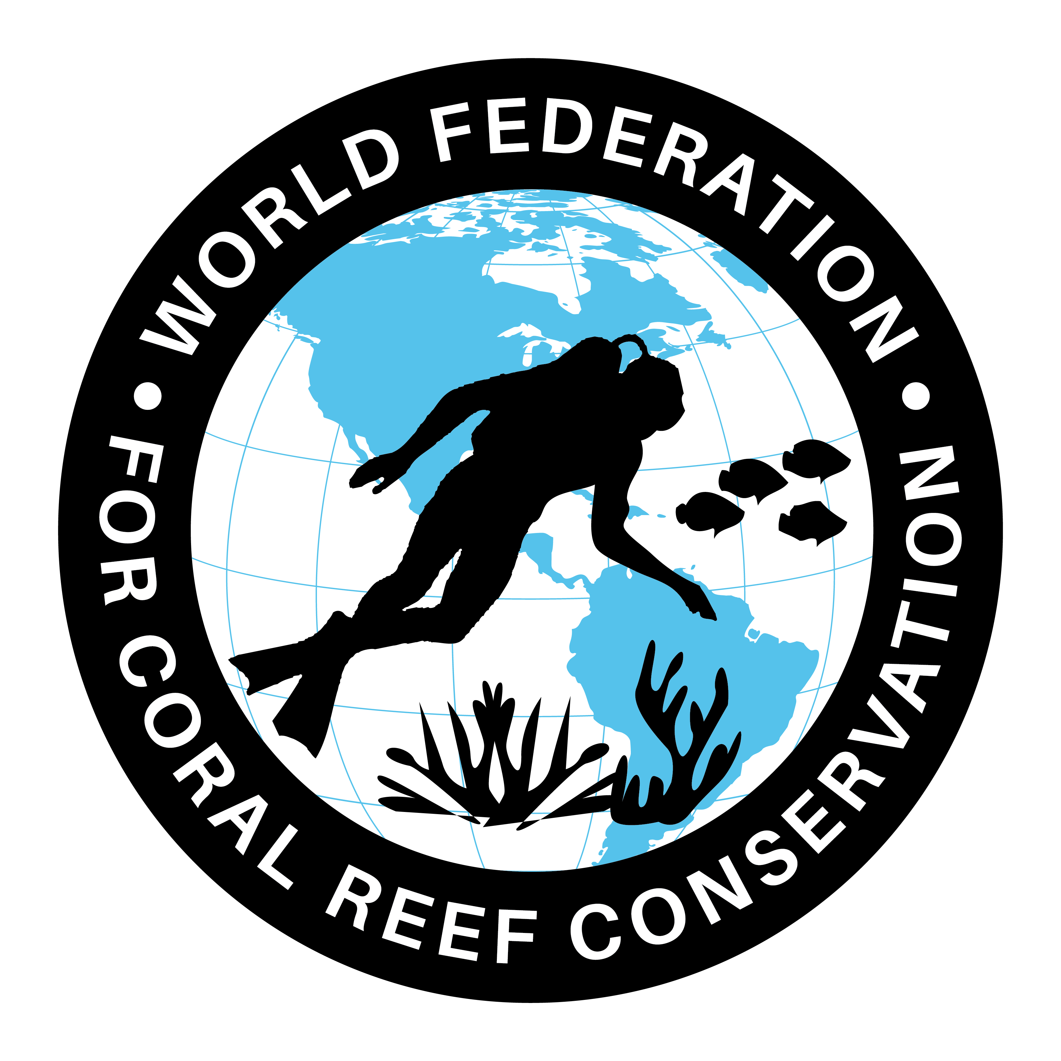
MLA-052-Sea Turtles- Mediterranean
Join WFCRC

The World Federation for Coral Reef Conservation 281.971.7703 P.O. Box 311117 Houston, TX 77231
Vic Ferguson Executive Director 512.986.1902 vic.ferguson@wfcrc.org info@wfcrc.org

Reprinted 8/17/17


Loggerhead and Green Sea Turtles
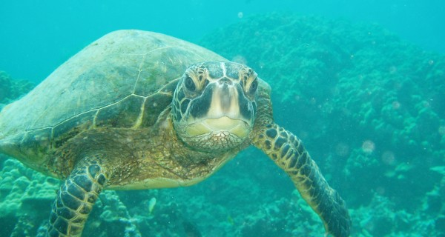
Source: One Species at a Time/Ari Daniel - August 17, 2017 in Radio
Photo: Claire Fackler/CINMS/NOS/NOAA
Cyprus is split in half, with a Turkish sector in the north and a Greek sector in the south. The unofficial division makes scientific collaboration in this Mediterranean island nation all but impossible; it also complicates management of the island’s endangered sea turtles. While the conflict between the Turkish Cypriots and Greek Cypriots dates back centuries, twenty-first century problems such as climate change make it urgent for scientists in the north and south to find ways around the old differences, before the turtles slip across a different kind of dividing line—from living to extinct. Ari Daniel reports.
Audio Player
00:00
00:00
Use Up/Down Arrow keys to increase or decrease volume.

Transcript:
Ari: From the Encyclopedia of Life, this is One Species at a Time. I’m Ari Daniel.
Hadjichristoforou: Ah!
The beaches of Cyprus are hot in June. The sun scorches from above, and the sand burns from below.
For the last hour, Miroula Hadjichristoforou has been walking along Polis/Limni beach, on the west coast of Cyprus. She probes the sand with a long stick.
Ari: She’s found another one. A loggerhead turtle nest – a hollow in the sand, filled with eggs. Hadjichristoforou places a cage above the nest.
Hadjichristoforou: This cage keeps the animals – the foxes away. But the babies, when they come up they are free to go straight away to the sea. And you see, we didn’t disturb nothing.
Ari: Hadjichristoforou’s had a long time to perfect this technique … since 1974 – the year Cyprus broke in two. The Turkish Cypriots living in the south evacuated to the north. And the Greek Cypriots living in the north – including Hadjichristoforou – were ordered south. Shortly afterwards, she was on a beach not far from here, when someone spotted a hole in the sand.
Hadjichristoforou: Suddenly baby turtles started coming out. I was so excited that, ahhh, ahhh – I don’t remember how long I was screaming because I couldn’t believe my eyes.
Ari: That was the beginning. Over the last four decades, almost singlehandedly, she and her husband Andreas Demetropoulos – the former director of the Department of Fisheries and Marine Research have been protecting the nests of both loggerhead and green turtles – Caretta caretta and Chelonia mydas – two species that are in decline. They’ve also managed to secure conservation status for some of the most important beaches. Green turtle numbers vary from year to year, but the caging efforts seem to be helping the loggerheads on the protected beaches. But if you ask the husband and wife duo about the status of turtles in the north, they’re not sure. Back at his home, Demetropoulos says that the north and south rarely work together.
Demetropoulos: It’s difficult because of the political situation to cooperate directly. It falls back to a question of recognition. How do you cooperate with a non-existent country?
Ari: The southern Greek sector doesn’t recognize the legitimacy of the northern Turkish sector. Demetropoulos argues that cooperation isn’t strictly necessary when it comes to turtle conservation, and that’s because of basic turtle biology. A baby female turtle imprints on the beach where she’s born. Meaning that years later, she’ll return to that same beach to lay eggs. Demetropoulos’ conclusion:
Demetropoulos: Management measures by this side will not save turtles on that side. Turtles that are nesting on their beaches is their responsibility only.
Ari: Wayne Fuller disagrees. He’s an ecologist at the European University of Lefke in North Cyprus. He runs a conservation and research program on Alagadi beach in the northern Turkish sector. Fuller sees the lack of cooperation as a missed opportunity.
Fuller: It would be good if everyone could work together on the same issues – pooling the data. Because that would give it much stronger validity if you can all work in the same direction, you know?
Ari: Fuller says it’s hard to get the research funding he needs, since the Turkish sector isn’t recognized internationally. And it’s not just Fuller who’s looking for support.
Munur Hasimoglu is a big guy, and seems especially so aboard his small boat. He’s the head of the fishermen’s union in northern Cyprus. Hasimoglu watches as his wife repairs one of the many nets heaped on the deck.
Hasimoglu: <Turkish translation> Every year, we have more turtles. The turtles – they are getting into our nets, and they are damaging the nets. We try to save their life or put them back to the sea, but it is difficult.
Ari: The growing number of reported encounters suggests that the hatchling protection efforts on the northern beaches are working – moreso for green turtles than loggerheads. Grown turtles are as big as car tires, so they can cause a lot of net damage, and pose big financial drains for the fishermen.
Hasimoglu figures the turtles cost him 4 to 5 thousand dollars a year. Sometimes the fishermen take their frustrations out on the turtles. About 800 turtles die each year from encounters with fishing boats. He wants the EU to do something, but that’s difficult, because although the Greek sector belongs to the EU and receives aid, the Turkish sector does not.
Venizelos: Definitely it’s not a catastrophe, but it’s not the best situation for the sea turtles.
Ari: Lily Venizelos is the president and founder of MEDASSET – a Mediterranean turtle conservation NGO. She says a north-south resolution, and EU membership for both, is the best-case scenario for management. But even then, political concerns tend to dominate environmental issues. Venizelos says that turtle scientists have to rise above the political fray.
Venizelos: The only hope is for researchers to collaborate because unless you know globally what’s happening in a country, how can you protect a species in the sea or on its shore?
Ari: It’s a sentiment that resonates with Miroula Hadjichristoforou. The sun’s setting on the beach now – a purple sky and sea gradually fading to black.
Hadjichristoforou: This small island cannot survive divided. It’s so small to divide people. They have to find a solution to live together.
Ari: She’s hopeful for a future that’s different from the past. One less rooted in division, and more tied to working together. Hadjichristoforou says the environment has no boundaries … something the turtles have known for a long time.
Ari: Visit eol.org to see some photos of my trip to Cyprus.
The One Species at a Time podcast series is supported by the Harvard Museum of Comparative Zoology. Our series, One Species at a Time, is produced by Atlantic Public Media in Woods Hole, Massachusetts.
I’m Ari Daniel Shapiro.
The Encyclopedia of Life has gathered information from all over the world to create the largest repository of species known to science. Their mission is to increase awareness and understanding of living nature through an Encyclopedia of Life that gathers, generates, and shares knowledge in an open, freely accessible and trusted digital resource.

For additional reading see The WFCRC Document Gallery for articles about:
- Public Service Announcements (PSA)
- Coral Alert Network (CAN)
- Emergency Reporting Reports (ERR)
- Call to Action (CTA)
- Marine Protected Areas (MPA)
- Marine Life Alert (MLA)
- Seismic and Oil Production Threats
- Natural Science Reports (NSR)
- Oil Spill Alerts (OSA)
- And other miscellaneous documents

