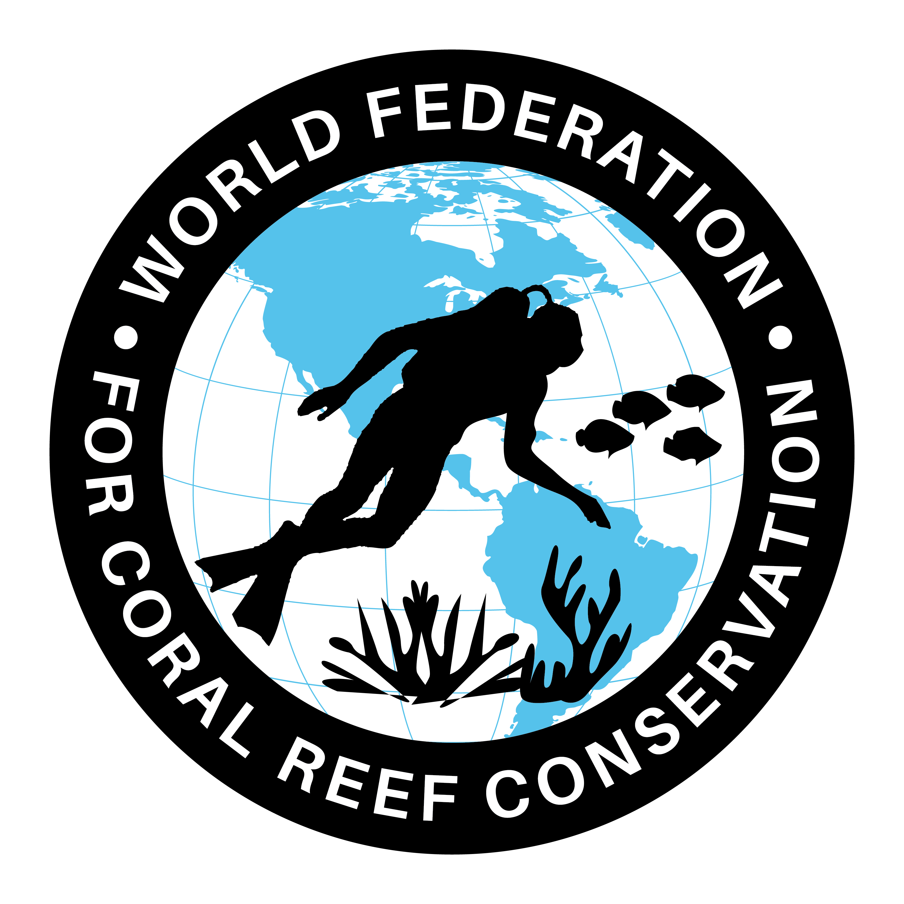
MLA-055-Plastic Threat to Marine Life

The World Federation for Coral Reef Conservation 281.971.7703 P.O. Box 311117 Houston, TX 77231
Vic Ferguson Executive Director 512.986.1902 vic.ferguson@wfcrc.org info@wfcrc.org
Reprinted 10/2/17

'We must recognize plastic as a threat to
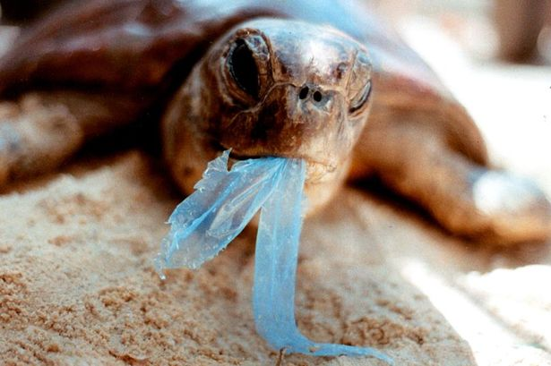
Marine life Alberto Costa

A turtle that has swallowed a plastic bag
I am very proud that this Conservative government is taking a leading role in environmental reform which signals a strong commitment to protecting the UK’s beloved and vibrant eco-system.
Issues such as microbeads, the ivory trade and the sustainability of the bee population are all of crucial importance to my constituents in South Leicestershire and people across the wider county, and I am delighted the Government is taking swift and decisive action in ensuring the environment is savored and protected for future generations.
Greenpeace UK have hailed the microbeads ban as the strongest of its kind in the world, clear recognition of the excellent work of the Secretary of State for the Environment, Food and Rural Affairs, Michael Gove, who has been spearheading much of this legislation.
Recognizing the serious threat posed to wildlife by microbeads and other forms of plastic is crucial to ensuing the future sustainability of the seas surrounding the UK.
The Government’s implementation of the 5p charge on carrier bags has been instrumental in reducing the effects of single use plastics on the environment, with nine billion fewer carrier bags being distributed since the charge was introduced in October 2015.
An extra £95 million has been donated to environmental and local causes across the UK, ensuring the new charges are being put to good use.
The Government has also been working hard with conservationists and organizations such as Stop Ivory to explore plans to impose a ban on ivory sales in the UK.
These plans are currently out for consultation and I would encourage all concerned to make their voices heard on this crucially important matter.
The illegal wildlife trade is estimated to be worth up to £17 billion a year.
However, with the number of wild elephants declining by almost a third in the past decade, there is clearly a price to pay and I am proud the UK will next year be hosting a fourth international conference on illegal wildlife, inviting global leaders to explore what further action can be taken.
For additional reading see The WFCRC Document Gallery for articles about:
- Public Service Announcements (PSA)
- Coral Alert Network (CAN)
- Emergency Reporting Reports (ERR)
- Call to Action (CTA)
- Marine Protected Areas (MPA)
- Marine Life Alert (MLA)
- Seismic and Oil Production Threats
- Natural Science Reports (NSR)
- Oil Spill Alerts (OSA)
- And other miscellaneous documents

