
MLA-057-Animal without a brain-Jellyfish
Join WFCRC

The World Federation for Coral Reef Conservation 281.971.7703 P.O. Box 311117 Houston, TX 77231
Vic Ferguson Executive Director 512.986.1902 vic.ferguson@wfcrc.org info@wfcrc.org
Reprinted 11/8/17
The Animal Without a Brain
That Is Taking Over the Ocean
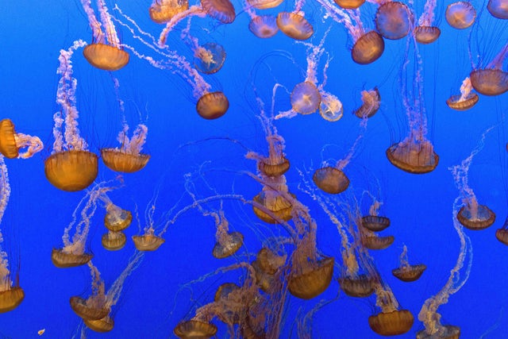
Jellyfish are thriving as warming seas, acidification and deoxygenation threaten other marine life. After long ignoring the beautiful but mysterious creatures, scientists are trying to figure out what makes them such survivors in the age of climate change.
WRITTEN BY Erica Cirino | PUBLISHED ONσ Nov. 2, 2017
Jellyfish on display at the Monterey Bay Aquarium.Carol M. Highsmith/Buyenlarge/Getty Images
MONTEREY, CALIFORNIA – This past summer, kayakers, swimmers, surfers, fishers and boaters observed millions of jellyfish drifting around Monterey Bay, California. There were so many orange sea nettles, yellow egg-yolk jellies, opaque moon jellies and other species that at times the Bay looked like it had turned into a gelatinous soup. The boom in jellyfish even clogged a pipe that transports saltwater from the Bay to display tanks at the Monterey Bay Aquarium, which is well known for its mesmerizing jellyfish exhibit and world-class jellyfish research facilities.
Jellyfish have not been a top priority for scientific research, despite their high ecological value as a main source of food for penguins, bluefin tuna and other marine animals and for their ability to alter entire ocean ecosystems. Now scientists, including those involved in captive breeding and research programs at the Monterey Bay Aquarium and Berlin Zoo, have increasingly focused on revealing jellyfishes’ secrets, such as how they reproduce and why their populations are so variable, to better understand their role in the ocean. Climate change, for instance, could be a factor in the recent Monterey Bay bloom. But scientists are still trying to figure out exactly what makes jellyfish so resilient and how they can quickly multiply into such large regional populations.
Researchers have recently determined jellyfish are an important food source for scores of marine animals, even for some of those that do not consume jellies regularly. They’ve also learned that jellyfish can survive, and often rapidly multiply, in warmer, more acidic and less oxygenated seas – meaning that they’ll likely thrive as climate change makes the oceans uninhabitable for other marine animals.
“There is so much we don’t know,” said Lisa-ann Gershwin, a research scientist in Hobart, Australia, who has written two books about jellyfish. “I would say of the total possible knowledge about jellyfish, we don’t even know 1 percent.”
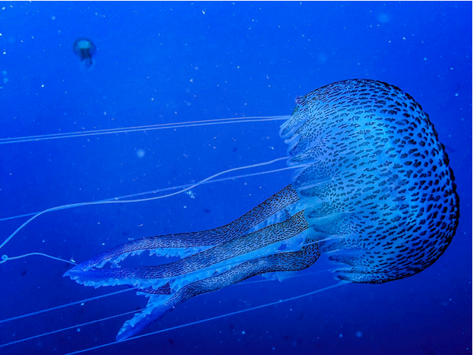
A jellyfish seen during a dive inside the marine reserve of Cinque Terre, Italy. (Alessandro Rota/Getty Images)

Among the knowledge gaps: details about jellyfish life cycles and species’ distribution across the ocean.
During the 1930s, a few aquariums bred jellyfish in captivity but breeding techniques were not reliable enough to produce a steady supply of jellies until the late 1960s, when specialized rounded glass tanks with a gentle water flow were developed to house the animals. Aquariums and laboratories in Germany, Japan and the United States developed some of the earliest captive breeding and research programs and over the years have contributed much to the global understanding of jellyfish.
In recent years, an uptick in research on captive-bred jellies has shed new light onto their lives. Scientists have been able to harness jellyfishes’ bioluminescence for use in biomedical research, study their life cycles, understand their ability to thrive in low-oxygen environments, observe them sleep and determine how they are related to other marine life. But many questions remain.
“Jellyfish have historically been understudied, mostly because they were deemed to be a nuisance with little commercial value, so even through they are relatively simple creatures, we don’t know that much about them,” said Lucas Brotz, a postdoctoral research fellow focused on jellyfish at the Sea Around Us initiative at the University of British Columbia. “We still don’t have a good idea of what controls jellyfish abundance and distribution. Why are jellyfish populations so variable in time and space?”
Over the past decade, scientists and beachgoers alike have noticed an increased frequency and intensity of global jellyfish “blooms.” Brotz said the rise in blooms may be linked to human-caused ecological change, such as overfishing and increased nutrient pollution, as well as warmer sea temperatures and acidification triggered by climate change. Scientists have already observed that jellyfish may thrive in ocean conditions inhospitable to less adaptive marine organisms, and that their growing abundance may be a sign of a changing ocean.
Brotz noted that scientists also don’t fully understand fundamental parts of the jellyfish life cycle – specifically, how microscopic baby jellies, called polyps, transform into adult jellies, or medusa. That’s mainly because polyps are so hard to find and study in the wild.
“I don’t think it matters if they are studied in captivity or the wild,” said Gershwin. “I think some questions, if wild-related, are best studied in the wild. But, for example, you can’t track reproduction in the wild because you can’t watch something grow when it’s free-swimming. But if you’re looking at the ecological distribution of jellies, you’d need to see them in the wild.”
One major benefit to breeding jellies in captivity is that it lets people learn about the animals by getting up close without risk of getting hurt, said Wyatt Patry, senior aquarist at the Monterey Bay Aquarium, which is home to nearly 20 species of jellies displayed in large tanks with dramatic lighting. The aquarium’s work is important in advancing the knowledge of jellyfish as its scientists have helped to develop replicable jellyfish rearing and research protocol, Patry said, and it also helps improve the public’s understanding of jellies’ role in the marine ecosystem.
“Jellyfish don’t have a brain or centralized nervous system, so our understanding of what/how they ‘think’ or ‘feel’ is probably even more distant than it is for other animals,” said Brotz. “I suspect that humanity will reconcile its relationship with mammals and other more closely related organisms before we concern ourselves with the welfare of jellyfish. Any programs that can help to develop knowledge, raise awareness and engage people with the issues facing the ocean are important, especially given the current scale of the threats and the ominous trends we are seeing.”
JELLYFISH MONTEREY BAY AQUARIUM
For additional reading see The WFCRC Document Gallery for articles about:
- Public Service Announcements (PSA)
- Coral Alert Network (CAN)
- Emergency Reporting Reports (ERR)
- Call to Action (CTA)
- Marine Protected Areas (MPA)
- Marine Life Alert (MLA)
- Seismic and Oil Production Threats
- Natural Science Reports (NSR)
- Oil Spill Alerts (OSA)
- And other miscellaneous documents

