
MLA-096-Robotics and Healthy Oceans
Join WFCRC

The World Federation for Coral Reef Conservation 281.971.7703 P.O. Box 311117 Houston, TX 77231
Vic Ferguson Executive Director 512.986.1902 vic.ferguson@wfcrc.org info@wfcrc.org

Reprinted 2/8/18

Robotic Fish to Keep a Fishy Eye on the Health of the Oceans
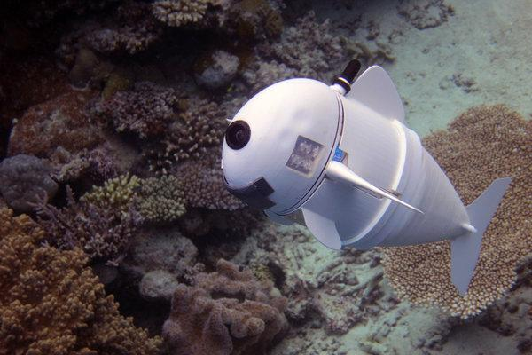
Image

SoFi, a robotic fish designed by M.I.T. scientists to better observe the lives and habitats of ocean fish.CreditRobert Katzschmann/MIT/CSAIL

By JoAnna Klein
March 21, 2018
You’re a fish in the ocean.
It’s 2023 and humans have begun deploying swarms of sentinel robot fish along the reef where you live that will monitor your environment, track pollution and collect intelligence on your behavior. Welcome to the future, my finned fishy friends.

O.K., so you’re not a fish. And this sci-fi fishland doesn’t exist. But it could — not long from now.
Allow me to introduce SoFi — like “Sophie,” but short for “Soft Robotic Fish,” revealed on Wednesday in Science Robotics, by scientists at the Massachusetts Institute of Technology Computer Science and Artificial Intelligence Lab.

They explained how their finned robot was created, and how her first ocean swim on a coral reef outside of Fiji went. Robotic fish like her could be essential to understanding and protecting marine life in danger of disappearing in a fragile ocean environment, threatened by human activity and climate change.

This foot-and-a-half long robot mimics a real fish. She can swim in the ocean at speeds up to half-its-body-length a second and at depths up to 60 feet below the surface. SoFi has a battery that will last 45 minutes before she shuts down.

She’s not quite fish flesh, but she’s not a typical marine robot either. Although critical for studying the ocean, remote operated vehicles and submersibles can be expensive to build and operate. They also can startle the sea creatures they’re supposed to study. But without a line giving her away by connecting her to a boat, a noisy propeller or the big, rigid, awkward or angular body of a metallic land-alien, she doesn’t seem to bother or scare off real fish. Some even swim along with her. Sleek, untethered, relatively inexpensive and well-tolerated, SoFi may provide biologists a fish’s-eye view of animal interactions in changing marine ecosystems.
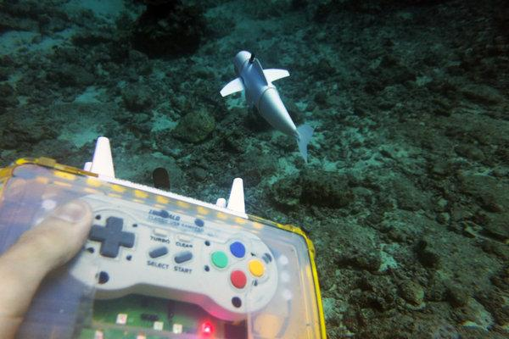
Image
Scientists say robotic fish like SoFi could be essential to understanding and protecting marine life in threatened environments.CreditRobert Katzschmann/MIT/CSAIL

For this group of MIT roboticists, SoFi was a dream, combining their love of diving with their work on soft robots. She was also an engineering challenge.

SoFi started as an nine-inch silicon tail that wiggled with the assistance of a hydraulic pump.

“I was amazed at how well it was working, how well I was able to get this tail to beat back and forth or swim left and right, like a shark or some other fish,” said Robert Katzschmann, a graduate student at MIT who led the team. “But we wanted to show this wasn’t just working on a test bench or table top.”

This meant waterproofing, buoyancy control, tweaking weight distributions and figuring out an unobtrusive way to share information underwater. It also meant compact equipment he can’t be as big as a submarine — unless we wanted to build a whale.”

A couple years later SoFi had a finned body and head equipped with a camera, two-way hydrophone, battery, environmental sensors, operating system and communication system that allowed a diver to issue commands using a souped-up Super Nintendo controller.

The communication system was the biggest challenge, said Mr. Katzschmann, because normally it requires a cable. Common remote signals used for piloting aerial drones don’t travel below water.
But sound waves do.

They built their own language, sending coded messages on high-pitched sound waves between SoFi and the diver. Different bits of information were assigned their own tones, kind of like how numbers are represented by dial tones when you make a phone call. A processing system decoded and relayed the messages to tell the diver things like “SoFi is currently swimming forward” or command her to “turn left, 20 degrees.”

The high-pitched signals only travel about 65 feet and are inaudible to fish, although it’s possible some whales or dolphins could hear them, which may require future research.

“Our primary goal was to make something for biologists,” said Mr. Katzschmann. He envisions a future network of sensor-clad SoFis for studying schooling dynamics or monitoring pollution over time. Currently he’s working on primitive A.I. so SoFi can use her footage to identify and track real fish.

But what if a real fish — or a shark — tracks SoFi instead?

“If a shark would have come and ate our fish, that would have been the most amazing footage,” Mr. Katzschmann said.

For additional reading see The WFCRC Document Gallery for articles about:

- Public Service Announcements (PSA)
- Coral Alert Network (CAN)
- Emergency Reporting Reports (ERR)
- Call to Action (CTA)
- Marine Protected Areas (MPA)
- Marine Life Alert (MLA)
- Seismic and Oil Production Threats
- Natural Science Reports (NSR)
- Oil Spill Alerts (OSA)
- And other miscellaneous documents

