
MLA-103-Big Mass Extinctions
Join WFCRC

The World Federation for Coral Reef Conservation 281.971.7703 642 S. Commerce Sebring, Florida 33870
Vic Ferguson Executive Director 512.986.1902 vic.ferguson@wfcrc.org info@wfcrc.org

Reprinted 1/24/19

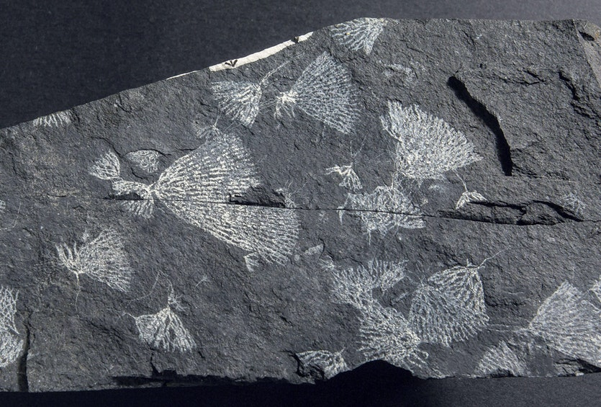
The big five mass extinctions
Biologists suspect we’re living through the sixth major mass extinction. Earth has witnessed five, when more than 75% of species disappeared. Palaeontologists spot them when species go missing from the global fossil record, including the iconic specimens shown here. “We don’t always know what caused them but most had something to do with rapid climate change”, says Melbourne Museum palaeontologist Rolf Schmidt.

End Ordovician, 444 million years ago, 86% of species lost
— Graptolite 2-3 cm length
Graptolites, like most Ordovician life, were sea creatures. They were filter-feeding animals and colony builders. Their demise over about a million years was probably caused by a short, severe ice age that lowered sea levels, possibly triggered by the uplift of the Appalachians. The newly exposed silicate rock sucked CO₂ out of the atmosphere, chilling the planet.
CREDIT: JAIME MURCIA / MUSEUM VICTORIA
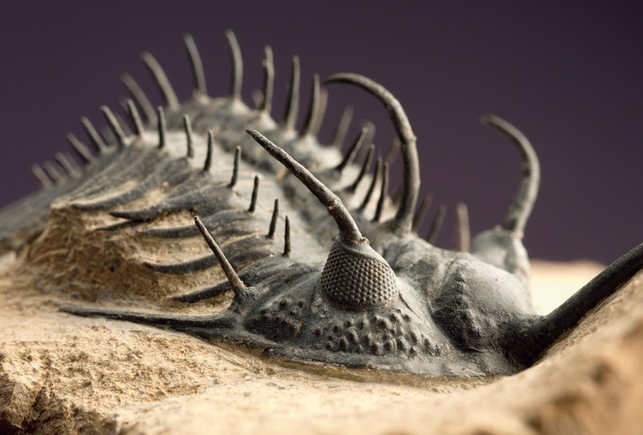
Late Devonian, 375 million years ago, 75% of species lost
— Trilobite, 5 cm length
Trilobites were the most diverse and abundant of the animals that appeared in the Cambrian explosion 550 million years ago. Their great success was helped by their spiky armor and multifaceted eyes. They survived the first great extinction but were nearly wiped out in the second. The likely culprit was the newly evolved land plants that emerged, covering the planet during the Devonian period. Their deep roots stirred up the earth, releasing nutrients into the ocean. This might have triggered algal blooms which sucked oxygen out of the water, suffocating bottom dwellers like the trilobites.
CREDIT: CHIP CLARK / SMITHSONIAN INSTITUTION

E

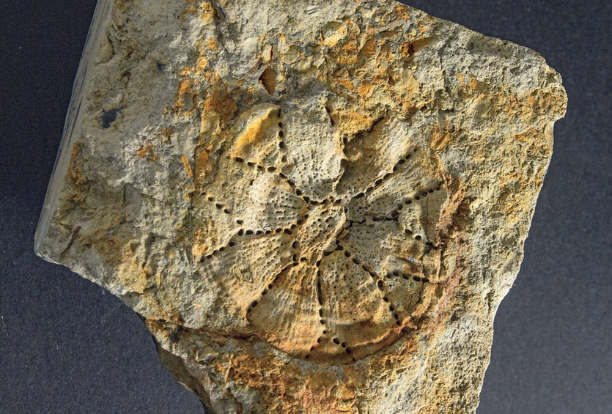

End Permian, 251 million years ago, 96% of species lost
— Tabulate coral, 5 CM
Known as “the great dying”, this was by far the worst extinction event ever seen; it nearly ended life on Earth. The tabulate corals were lost in this period – today’s corals are an entirely different group. What caused it? A perfect storm of natural catastrophes. A cataclysmic eruption near Siberia blasted CO2 into the atmosphere. Methanogenic bacteria responded by belching out methane, a potent greenhouse gas. Global temperatures surged while oceans acidified and stagnated, belching poisonous hydrogen sulfide. “It set life back 300 million years,” says Schmidt. Rocks after this period record no coral reefs or coal deposits.
CREDIT: JAIME MURCIA / MELBOURNE MUSEUM

End Triassic, 200 million years ago, 80% of species lost
— Conodont teeth 1 mm
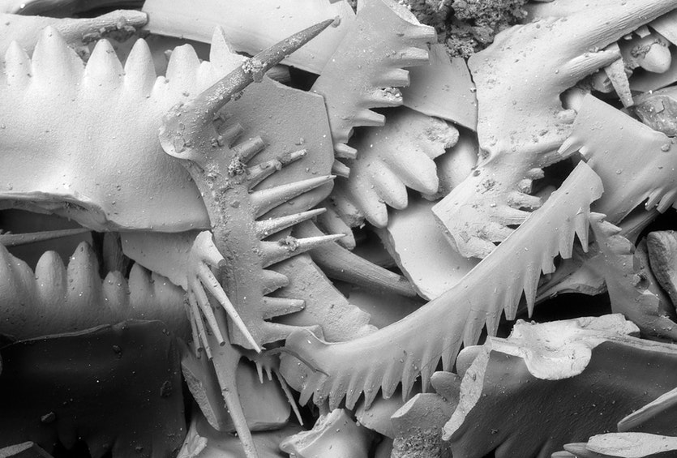
Palaeontologists were baffled about the origin of these toothy fragments, mistaking them for bits of clams or sponges. But the discovery of an intact fossil in Scotland in the 1980s finally revealed their owner – a jawless eel-like vertebrate named the conodont which boasted this remarkable set of teeth lining its mouth and throat. They were one of the first structures built from hydroxyapatite, a calcium-rich mineral that remains a key component of our own bones and teeth today. Of all the great extinctions, the one that ended the Triassic is the most enigmatic. No clear cause has been found.
CREDIT: PAUL TAYLOR / NATURAL HISTORY MUSEUM

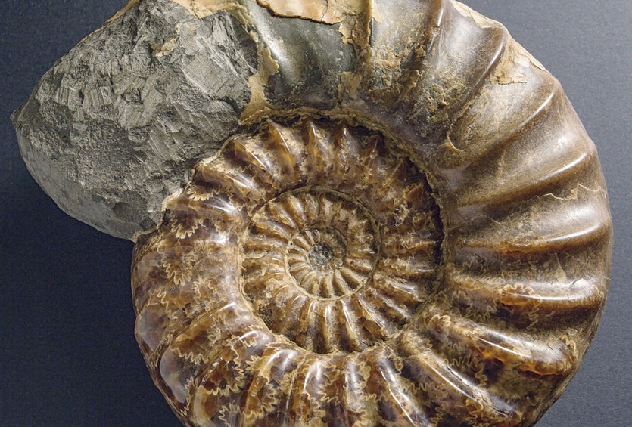
End Cretaceous, 66 million years ago, 76% of all species lost
— Ammonite 15 cm length
The delicate leafy sutures decorating this shell represent some advanced engineering, providing the fortification the squid-like ammonite required to withstand the pressure of deep dives in pursuit of its prey. Dinosaurs may have ruled the land during the Cretaceous period but the oceans belonged to the ammonites. But volcanic activity and climate change already placed the ammonites under stress. The asteroid impact that ended the dinosaurs’ reign provided the final blow. Only a few dwindling species of ammonites survived. Today, the ammonites’ oldest surviving relative is the nautilus. Will it survive the sixth great extinction?
CREDIT: JAIME MURCIA / MUSEUM VICTORIA
EXPLORE #CLIMATE CHANGE #CLIMATE #MASS EXTINCTION #SPECIES#SIXTH MASS EXTINCTION
SHARE TOTOGGLE DROPDOWN

Viviane Richter is a freelance science writer based in Melbourne.
LOOKING FOR MORE SCIENCE?
CLICK HERE TO SEE OUR SUBSCRIPTION OPTIONS.
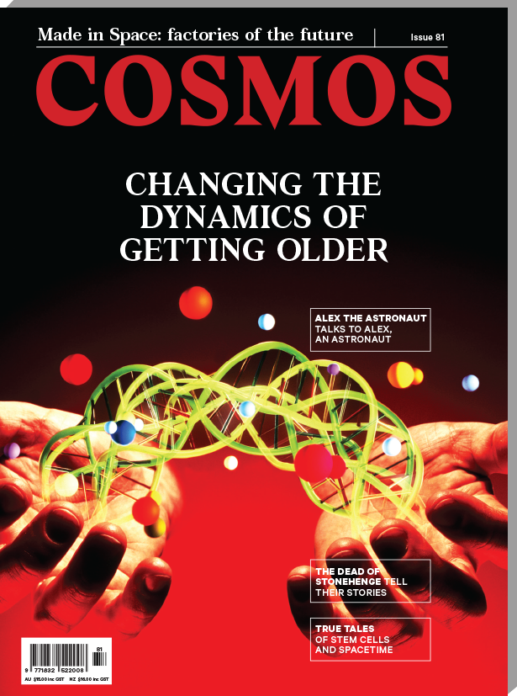
POPULAR TODAY
MORE
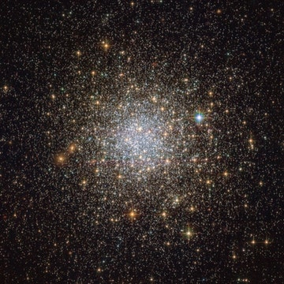

Climbing the cosmic distance ladder

IMAGE OF THE DAY
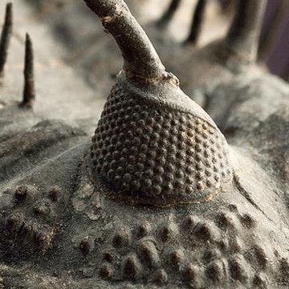

The big five mass extinctions

GALLERY
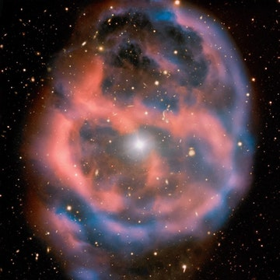

A fleeting moment in time

IMAGE OF THE DAY
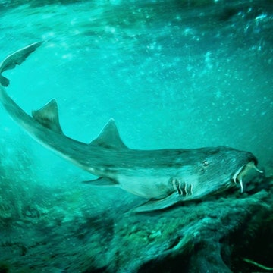

Meet Galagadon, an ancient shark with funny teeth

NEWS
LATEST STORIES
MORE
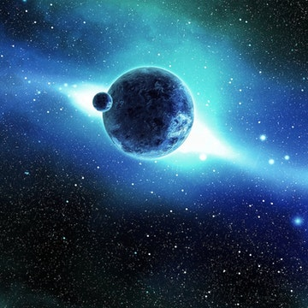

Did a planetary collision make this possible?

NEWS
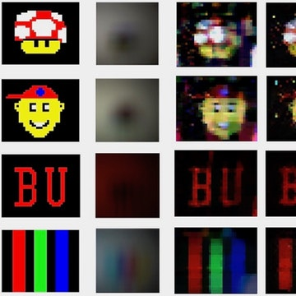

Spying around corners just got easier

NEWS


Cognitive ability looks to be fairly fixed throughout adulthood

NEWS

Climbing the cosmic distance ladder

IMAGE OF THE DAY

- Subscriptions
- Back issues
- Newsletter
- Advertising
- Submissions
- Internships
- Contact us
- About us
- FAQs
- Terms of use
- Privacy policy
- Use of cookies

For additional reading see The WFCRC Document Gallery for articles about:

- Public Service Announcements (PSA)
- Coral Alert Network (CAN)
- Emergency Reporting Reports (ERR)
- Call to Action (CTA)
- Marine Protected Areas (MPA)
- Marine Life Alert (MLA)
- Seismic and Oil Production Threats
- Natural Science Reports (NSR)
- Oil Spill Alerts (OSA)
- And other pertinent documents

