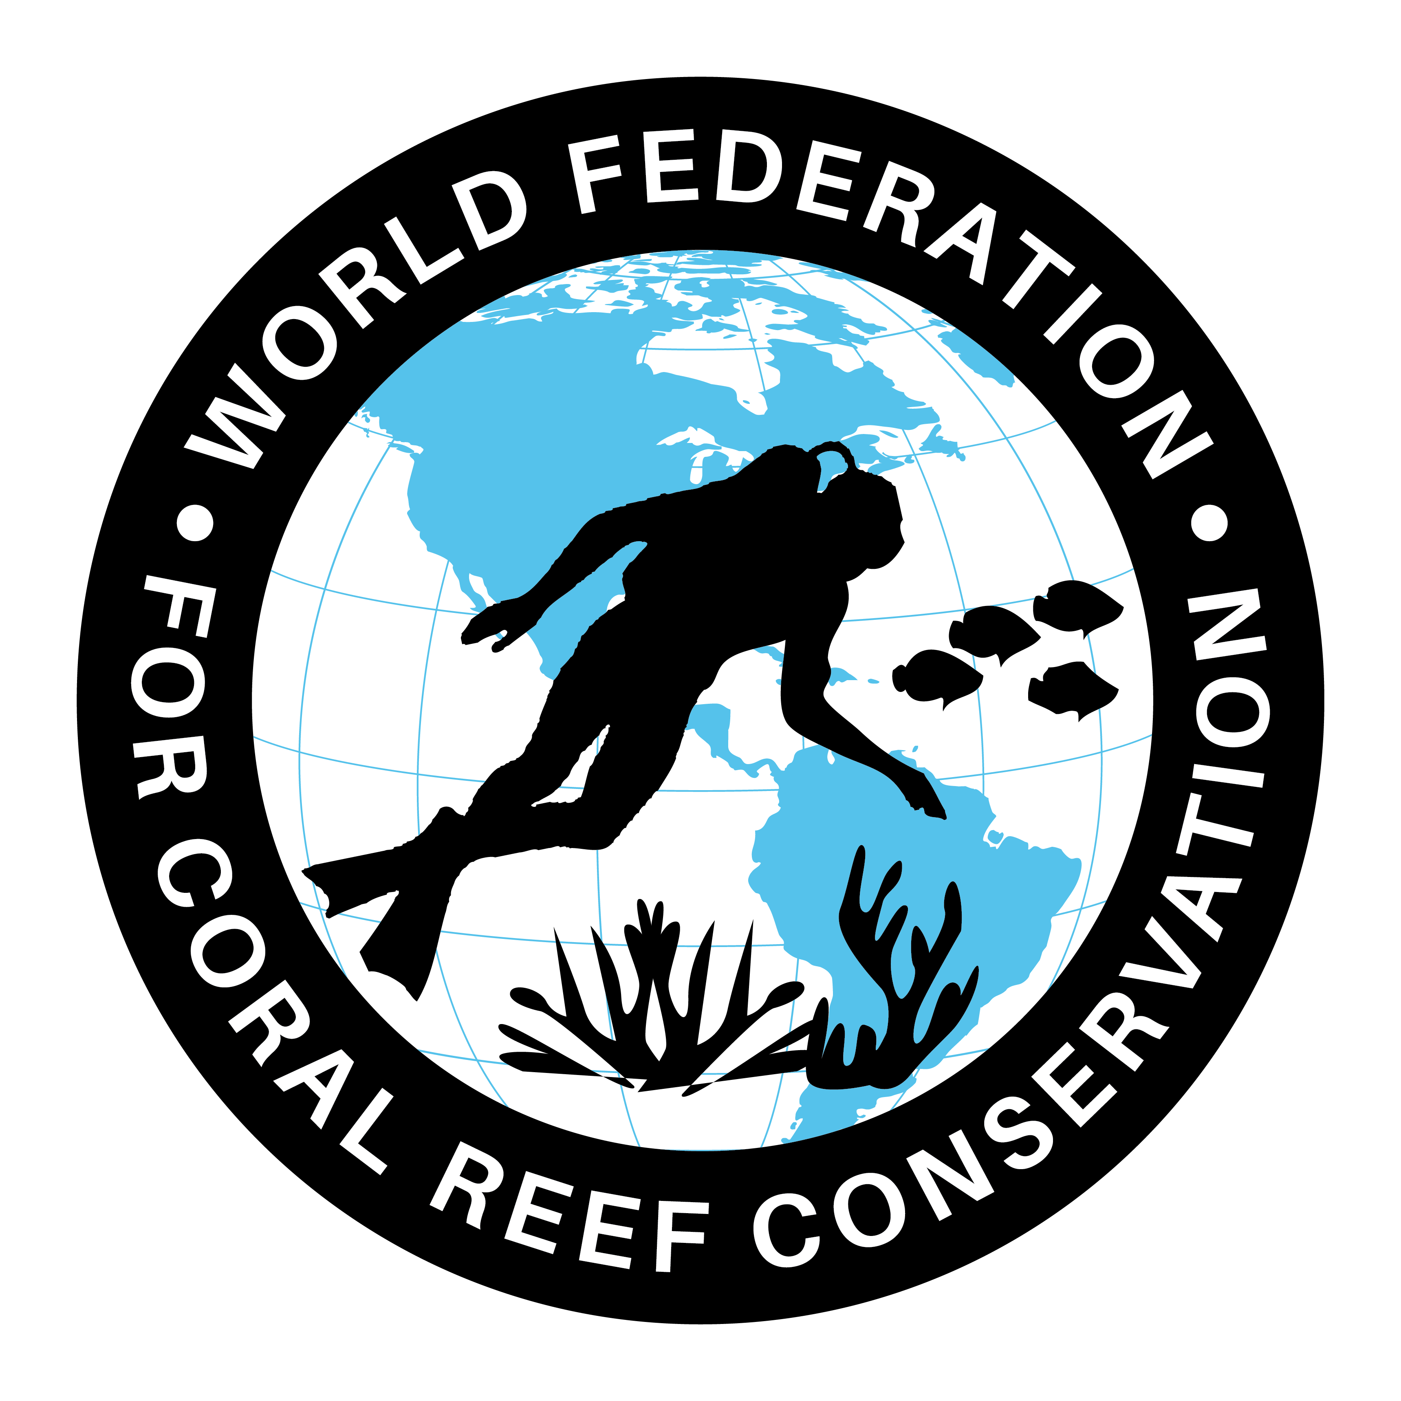
MLA-105-New Turtle Nesting in Georgia
Join WFCRC

The World Federation for Coral Reef Conservation 512.986.1902 642 S. Commerce Sebring, Florida 33870
Vic Ferguson Executive Director/Founder vic.ferguson@wfcrc.org kyle.mathes@wfcrc.org
Reprinted 8/18/19


Once Threatened, Sea Turtle Nests Thrive Along the Georgia Coast
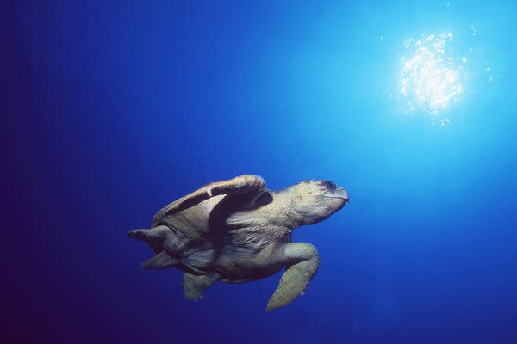
If the early nesting data is any indication, Georgia could see a lot of little loggerhead sea turtles crawling to the sea in the coming months.
Credit Doug Perrine/NPL/Minden Pictures
If the early nesting data is any indication, Georgia could see a lot of little loggerhead sea turtles crawling to the sea in the coming months.
Credit CreditDoug Perrine/NPL/Minden Pictures
By Jacey Fortin

They are not much bigger than silver dollars when they hatch, struggle out of sand and stumble toward the sea, and most do not survive until adulthood.
But if their mothers are any indication, these loggerhead sea turtles, once in such trouble they were designated as “threatened” by the federal government four decades ago, are making a comeback off the coast of Georgia.
And it is beginning to look as if 2019 could be a record-breaking year, in terms of the number of female turtles who nest there.
As of Wednesday evening, 1,779 sea turtle nests had been spotted by researchers along the Georgia coastline this season, which is not yet half-done.
Compare that with last year, when the number of nests counted for the entire season was 1,742. (The length of a season varies, but most nesting occurs between May and September, with a peak in June or July.) The record year was 2016, when nearly 3,300 nests were counted along the Georgia coastline.
“So far it’s pretty comparable to 2016, which was our biggest year on record,” said Doug Hoffman, a wildlife biologist with the National Park Service, of the patrolling efforts on Cumberland Island on the southern end of the coastline.
“I suspect that at the pace we’re going right now, we will probably meet that and possibly break it.”
In Georgia, most of the nesting turtles are loggerheads (the scientific name is Caretta caretta), but a few turtles from other species, like greens and leatherbacks, also nest there.
Decades ago, the loggerhead was in real trouble. The federal government designated it a “threatened” species in 1978. But in Georgia and nearby states, it appears to have recovered — especially over the last decade — in large part because of conservation efforts.
A host of groups have helped sea turtles by advocating environmental protection in places where they live; supporting the regulated use of tools like turtle excluder devices, contraptions that allow larger sea animals to escape from fishers’ and shrimpers’ nets, should they get caught; and sometimes physically relocating nests to move them away from dangerous spots.
Joe Pfaller, the research director for the Caretta Research Project, a conservation group based in Savannah, Ga., pointed to two efforts that may have helped the population.
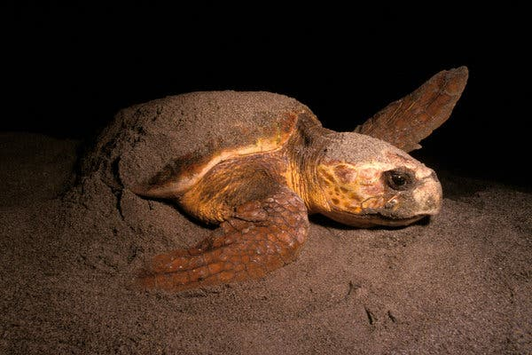
Attempts to protect turtle nests ramped up around 40 years ago, he said, and since loggerheads can take about 30 years to reach sexual maturity, saved hatchlings are getting old enough to mate. (Many adult turtles weigh more than 200 pounds.)
For female loggerhead turtles, it often takes more than an hour to crawl from the ocean, find a suitable nesting spot, dig a pit, lay eggs and crawl back to the water.
Credit Mark Conlin/VW PICS, via UIG, via Getty Image
In addition, he said, the increased use of turtle excluder devices has made coastal waters safer for turtles.
Dr. Pfaller added that while not all species of sea turtles are thriving around the world, the subpopulation of loggerheads that is centered on Georgia, South Carolina and North Carolina is doing well. “I think one of the reasons why sea turtles have something of a success story here is that the community is highly collaborative,” he said.
But when it comes to this year’s encouraging nesting data, it would be best not to count our turtles before they hatch. The nesting season is not over, and there have been years when the nesting rate started off high and then dropped.
For female loggerheads, the nesting process is slow and a little clumsy. (They are much more graceful in the water.) After nightfall, they clamber onto the sand to find a good spot, which can take as long as 45 minutes if the tide is low. Then they settle in and dig a little chamber with their back flippers, into which they may lay more than 100 eggs.
They bury that treasure and fumble their way back to the water, unlikely to ever see their offspring again.
Tracking the nesting is a lot of work. All along the coast, there are 13 outfits — a mix of government entities and other organizations — that monitor the process, and all of them coordinate with the state and enter their data in the same online database.
Mark Dodd, a wildlife biologist with the Georgia Department of Natural Resources, coordinates those groups. He said most people who patrol the loggerhead nests do so in the morning, after the turtles have come and gone.
Mr. Hoffman and his team members on Cumberland Island are among those early risers. “Each morning,” he said, “you’re going to get a beautiful sunrise, that’s for sure.”
For each nest they find, they remove a single egg to use as a DNA sample. That has enabled researchers to build a database that allows them to identify nesting mothers without using tracking devices, Mr. Dodd said.
But other patrollers, like Dr. Pfaller, who works on Wassaw Island at the northern reaches of the state’s coastline, go out at night. He and volunteers approach nesting mothers while they are laying eggs.
Loggerheads go into a trancelike state when they lay eggs, Dr. Pfaller said, adding that if you approach a turtle before that point, it might get spooked. But after the trance sets in, “you can work around them, measure them, collect samples if you need to,” he said. The volunteers attach tracking devices to the loggerheads so they can continue to follow their movements.
These efforts are all part of a larger story about how wildlife conservation can work if it is collaborative and sustained over time, Mr. Hoffman said.
“There’s been a lot of people involved in the last 50 years in turtle conservation in Georgia,” he added. “It’s a big collaborative effort with volunteers, professional biologists and other folks helping out, so we are really hopeful.”

Vic Ferguson
The World Federation for Coral Reef Conservation
Executive Director/Founder
Relief without Borders
March for the Ocean
642 So. Commerce Ave
Sebring, Florida 33870
vic.ferguson@wfcrc.org (best method of contact)
512.986.1902

For additional reading see The WFCRC Document Gallery for articles about:
Public Service Announcements (PSA)Coral Alert Network (CAN)
Emergency Reporting Reports (ERR)
Call to Action (CTA)
Marine Protected Areas (MPA)
Marine Life Alert (MLA)
Seismic and Oil Production Threats
Natural Science Reports (NSR)
Oil Spill Alerts (OSA)
And other miscellaneous documents

