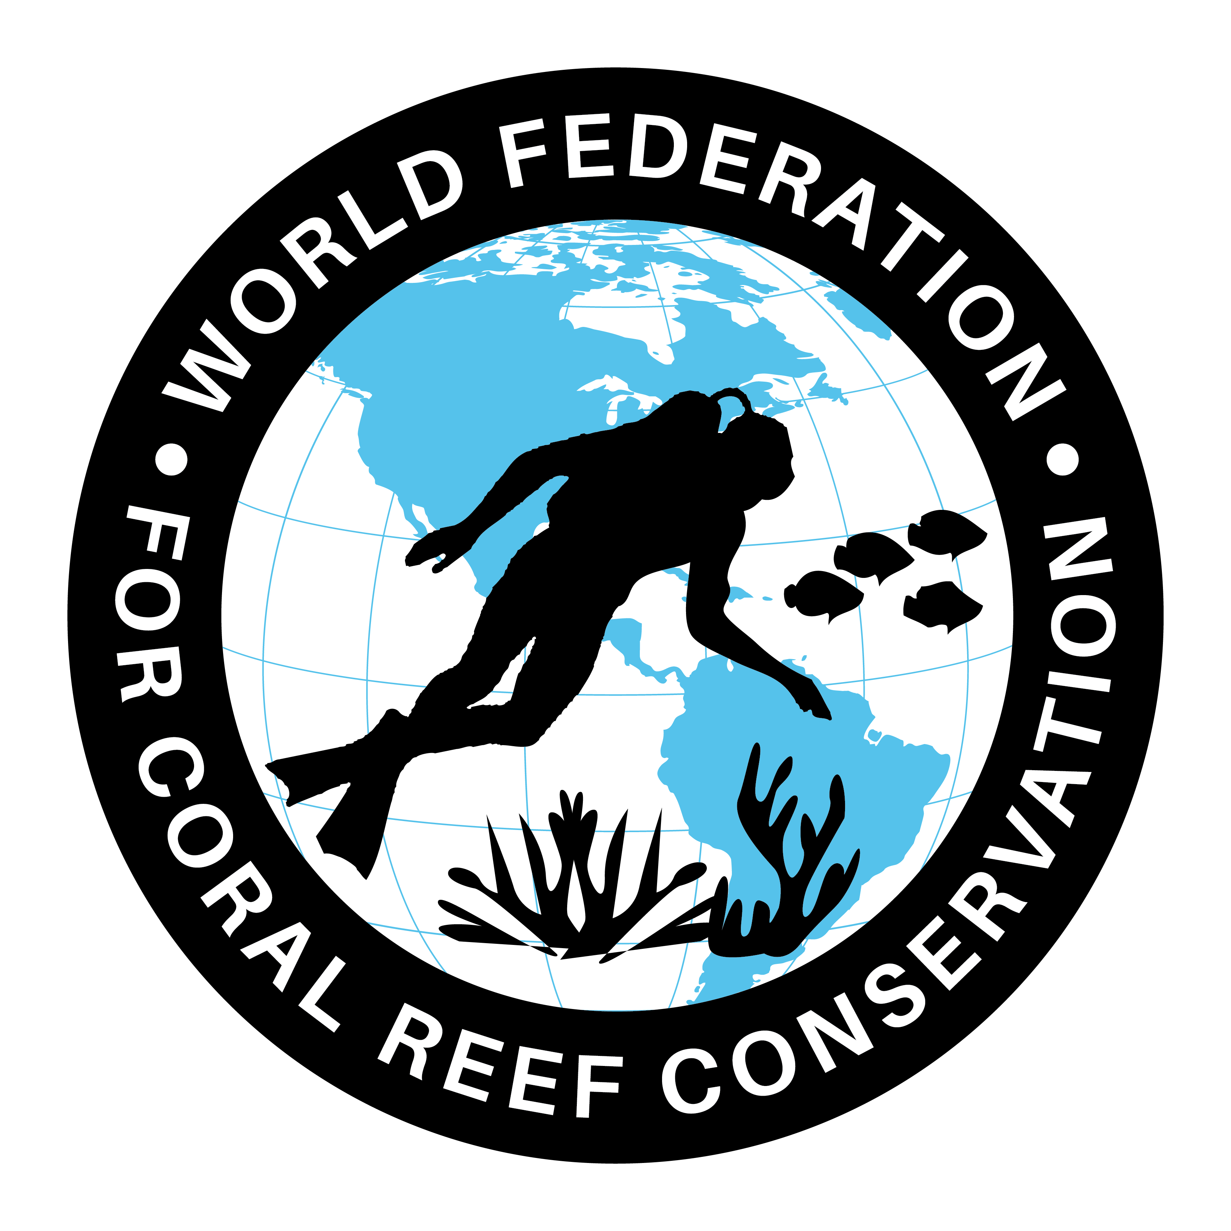
MLA-106-Save Our Turtles
Join WFCRC

The World Federation for Coral Reef Conservation 512.986.1902 642 S. Commerce Sebring, Florida 33870

Vic Ferguson Executive Director/Founder vic.ferguson@wfcrc.org kyle.mathes@wfcrc.org
Reprinted 8/7/19

“Mind Our Trash, Save Our Turtles”
Published on: Sunday, August 04, 2019
By: Winnie Kasmir
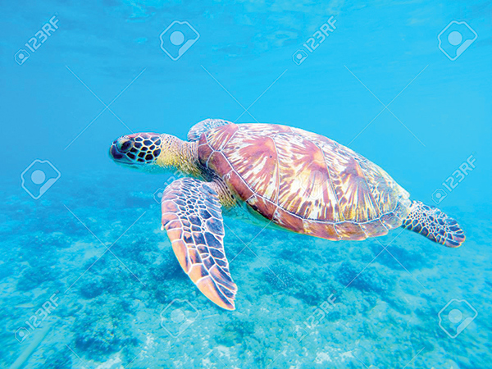

SANDAKAN: “Mind Our Trash, Save Our Turtles” has been chosen as this year’s theme for the Sabah-level World Turtle Day 2019 to shape the way people think about waste management in order to be responsible and protect endangered species from extinction.

World Turtle Day was first held in 2000 by the American Tortoise Rescue with the aim of creating awareness on the threats faced by turtle species worldwide.

As in Sabah, turtles are now under critical threats, which lead to a declining number in its population. Among its biggest threats were pollution, illegal poaching, turtle eggs smuggling, trapped on fish net and uncontrolled development of coastal areas.

In conjunction with the State-level World Turtle Day 2019, the Sabah Wildlife Department along with Sandakan Municipal Council, Sabah Parks, Wildlife Rescue Unit, WWF Malaysia, HUTAN-KOCP, Rainforest Discovery Centre, Reef Guardian and Bornean Sun Bear Conservation Centre had carried out a roadshow in June and July.
The roadshow aimed to give exposure and information to the public on the importance of protecting turtles for our ecosystem and future generations.

According to Deputy Chief Minister cum Tourism, Culture and Environment Minister Datuk Christina Liew, the marine ecosystem is one of our eco-tourism products that contribute to the development of our country.
“If we protect our marine ecosystem and beaches from pollution, of course more tourists will come to visit our country.

“Everyone should play a role in protecting the environment and stopping the habit of dumping garbage and waste into our seas or rivers.
“The Government is also committed to preserving and conserving the environment through the enforcement of various enactments such as the Wildlife Conservation Act 1997 to punish those who violate the regulations.

“Through this enactment, the Government prohibits and restricts any activity of capturing turtles or turtle eggs for any purpose whatsoever. Therefore, all of us should be the eyes and ears to help in the preservation of turtle survival in our country,” she said when launching the State-level World Turtle Day 2019 at Piazza Harbour Mall. Her speech was delivered by her Ministry’s Permanent Secretary, William Baya.
Also present were Sabah Wildlife Department Director Augustine Tuuga, Sandakan Municipal Council President Datuk Peter Hii, Sandakan District Education Officer Sh. Mahada Sh. Attar, Sandakan Member of Parliament Vivian Wong and Elopura Assemblyman Calvin Chong.

The three-day celebration from Aug 1 has lined up various activities such as exhibitions and demonstrations by government agencies, private entities, non-governmental organisations and schools.
There are also colouring activities, speeches, choral speaking, short video making, zumba, buskers’ performances, casual talk, photo booths and video performances.
“This article is just another warning we are getting from around the world. While this is currently happening in many locations we need to recognize the similarity and react accordantly”………….Vic Ferguson.
Vic Ferguson
The World Federation for Coral Reef Conservation
Executive Director/Founder
Relief without Borders
March for the Ocean
642 So. Commerce Ave
Sebring, Florida 33870
vic.ferguson@wfcrc.org (best method of contact)
512.986.1902

For additional reading see The WFCRC Document Gallery for articles about:
Public Service Announcements (PSA)Coral Alert Network (CAN)
Emergency Reporting Reports (ERR)
Call to Action (CTA)
Marine Protected Areas (MPA)
Marine Life Alert (MLA)
Seismic and Oil Production Threats
Natural Science Reports (NSR)
Oil Spill Alerts (OSA)
And other miscellaneous documents

