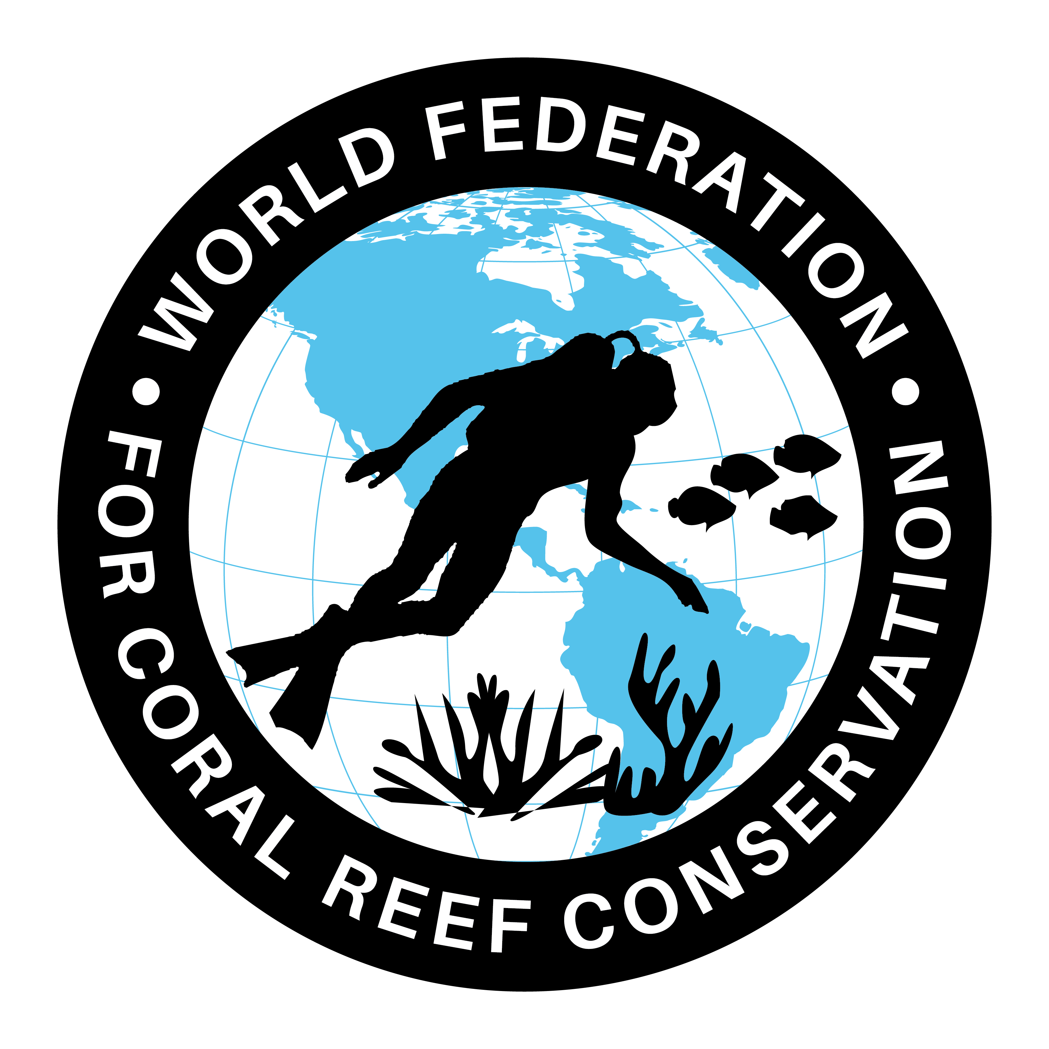
MLA-108-Coral Reefs + Ecosystems
Join WFCRC

The World Federation for Coral Reef Conservation 512.986.1902 642 S. Commerce Sebring, Florida 33870
Vic Ferguson Executive Director/Founder vic.ferguson@wfcrc.org contact@wfcrc.org
Reprinted 9/28/19


RESEARCH SUGGESTS CORAL REEF PROTECTION COULD BENEFIT ALL ECOSYSTEMS
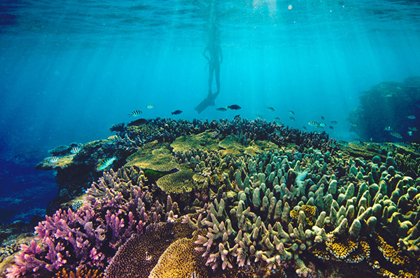
SEPTEMBER 19, 2019
EDUCATION / ENVIRONMENT
James Cook University scientists say bolder actions to protect coral reefs from the effects of global warming will benefit all ecosystems, including those on land.
In an article published today in the journal Nature, two researchers from the ARC Centre of Excellence for Coral Reef Studies at James Cook University (Coral CoE at JCU) say the world’s reefs will disappear by 2070 if climate change continues on its current path. Even well-protected World Heritage-listed coral reefs have been increasingly damaged by regional and global bleaching since 1980.
Professor Tiffany Morrison and Professor Terry Hughes suggest a new, holistic approach to safeguarding coral reefs by focussing on land as well as the ocean.
The authors advise "what we’re suggesting is not impossible. Countries such as Costa Rica, states such as California and cities such as Copenhagen have all taken up initiatives to curb greenhouse gas emissions and provide alternative economic opportunities that set powerful examples for the rest of the world.”
The article urges scientists, policymakers, non-governmental organisations and philanthropists to develop similarly bold strategies to protect reefs, other ecosystems and people in a warming world.
Lead author Professor Morrison advises “we must take a new, bolder approach to tackle the underlying causes of coral reef decline. This means fixing the causes on a global, as well as local, scale - both in the sea and on land.”
As an example, to protect the Great Barrier Reef, Prof Morrison suggests policymakers in Australia should replace coal-fired power with renewable energy sources, develop land-based aquaculture, and restore or rehabilitate terrestrial vegetation and wetlands in the 425,000 kilometre2 catchment of the Great Barrier Reef.
Prof Morrison adds “done strategically, these actions can reduce global emissions, capture carbon, curb agricultural runoff onto coastal reefs while also enhancing people’s livelihoods and food security.”
The Nature article argues that current approaches to coral reef conservation are failing as protecting local biodiversity on reefs and trying to restore damaged corals are the main focus.
Professor Hughes added "current approaches to protect coral reefs are not enough to stem the ongoing decline.
“Attempts to grow corals in aquaria or underwater nurseries are futile unless we address the major threats.
“Reefs won’t disappear if we tackle the root cause of their decline; global carbon emissions need to be slashed to 45% of 2010 levels by 2030.”
The authors suggest that a bolder, scaled-up approach to the stewardship of land and sea - focused initially on coral reefs - could itself help society meet this goal.
Coral reefs cover only 0.5% of the ocean floor, but they support almost 30% of the world’s marine fish species. 400 million people depend on reefs for work, food and protection from waves, storms and floods.
The article urges scientists, policymakers, non-governmental organisations and philanthropists to develop similarly bold strategies to protect reefs, other ecosystems and people in a warming world.

Related Articles
18th September 2019 - AUSTRALIAN MARINE CONSERVATION SOCIETY CONDEMNS INQUIRY INTO REEF SCIENCE
30th August 2019 - GREAT BARRIER REEF STATUS DOWNGRADED TO VERY POOR FOR FIRST TIME
26th June 2019 - RESEARCH SHOWS GREAT BARRIER REEF VISITORS UNDERSTAND CLIMATE THREAT
12th March 2019 - AUSTRALIAN MARINE CONSERVATION SOCIETY SAYS RESEARCH HIGHLIGHTS THE NEED FOR QUEENSLAND GOVERNMENT TO CUT FARM POLLUTION
12th December 2018 - AUSTRALIAN MARINE CONSERVATION SOCIETY DEMANDS ADANI COURT ADMISSION OF GREAT BARRIER REEF POLLUTION
23rd December 2015 - GREAT BARRIER REEF TOURISM OPERATORS CONSIDER IMPLICATIONS OF COAL PORT SPOIL DUMPING
17th March 2015 - TOURISM AUSTRALIA BACKS SIR DAVID ATTENBOROUGH GREAT BARRIER REEF DOCUMENTARY PROJECT

:
Vic Ferguson
The World Federation for Coral Reef Conservation
Executive Director/Founder
Relief without Borders
March for the Ocean
642 So. Commerce Ave
Sebring, Florida 33870
vic.ferguson@wfcrc.org (best method of contact)
512.986.1902
https://youtu.be/GJKqUNDMGsM

