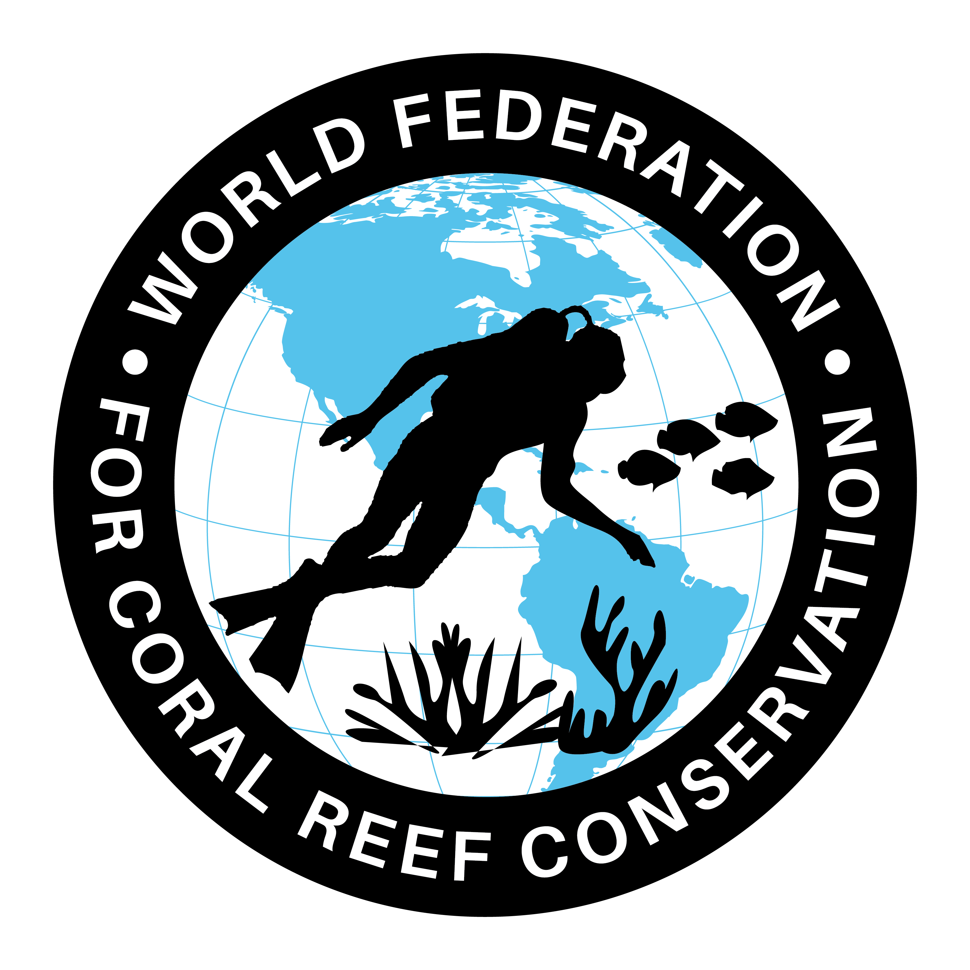
MLA-109-We now know where turtles eat
Join WFCRC

The World Federation for Coral Reef Conservation 512.986.1902 642 S. Commerce Sebring, Florida 33870
Vic Ferguson Executive Director/Founder vic.ferguson@wfcrc.org kyle.mathes@wfcrc.org
Reprinted 2/1/20


Turtle Tracking Reveals Key Feeding Grounds
University of Exeter

POSTED ON JANUARY 28, 2020

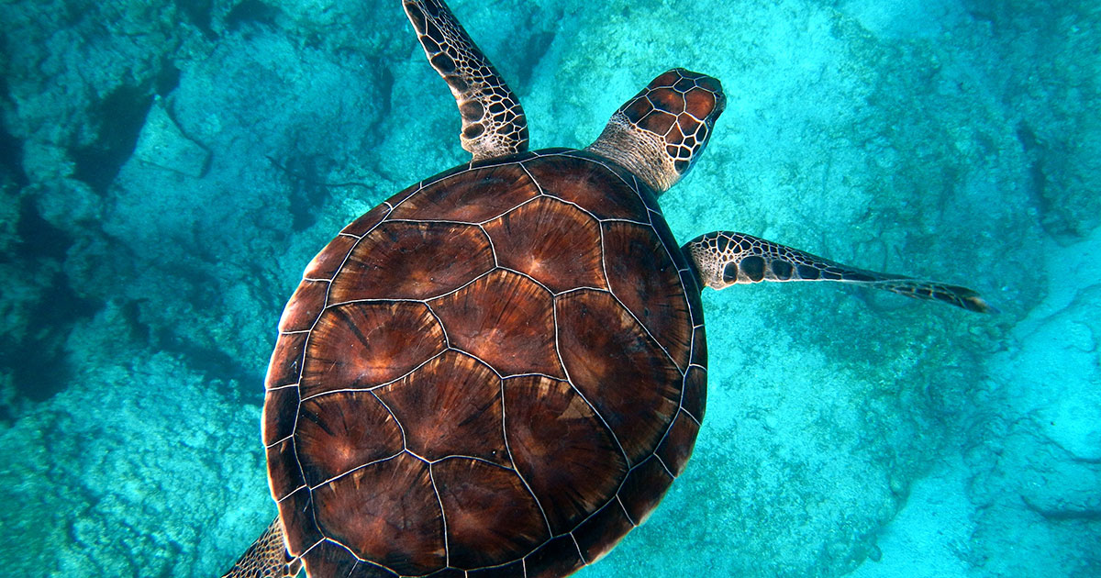
Loggerhead turtles feed in the same places year after year -- meaning key locations should be protected, researchers say. University of Exeter scientists used satellite tracking and "stable isotope ratios" -- a chemical signature also used by forensic scientists -- to track female loggerheads from two rookeries (nesting beaches) in the Mediterranean.
The study identified three main feeding areas -- the Adriatic region, the Tunisian Plateau and the eastern Mediterranean. "We show where the majority of nesting female turtles spend the most of their life, meaning that in addition to their nesting beaches we can also protect important marine habitats where they feed," said lead author Julia Haywood, of the University of Exeter.
"Nearly half of the Cyprus nesting population feeds on the Tunisian Plateau, an area known to have some of the highest turtle bycatch (accidental catch by humans fishing) in the world.
"Therefore, we support recommendations that this area should be conserved." The study tracked turtles from rookeries in Greece and Cyprus using data from 1993 to 2018.
"By studying these turtles for so long we show these females stay in the same feeding area over decades, which means if these habitats are damaged or have high fishing activities then the turtles will unfortunately not move," Haywood said.
"This work shows the importance of combining satellite tracking and stable isotopes to help understand these elusive animals." The work was carried out in collaboration with the local conservation groups: the Society for the Protection of Turtles in North Cyprus (SPOT) and ARCHELON, the Sea Turtle Protection Society of Greece.
Robin Snape, of SPOT, said: "Mediterranean loggerheads lay their nests in the European Union, just at the time of year when hundreds of thousands of European tourists arrive on holiday.
"For the rest of the year, many female loggerheads are growing and foraging in the waters off Africa, where mortality in industrialised fisheries and even direct consumption of turtles are still big concerns.
"Each year at least 10,000 turtles die as accidental bycatch off North Africa, while illegal trade in turtle meat persists.
"This research allows prioritisation of conservation resources to specific threats in specific areas."
Journal Reference: Julia C. Haywood, Wayne J. Fuller, Brendan J. Godley, Dimitris Margaritoulis, Jamie D. Shutler, Robin TE. Snape, Stephen Widdicombe, Judith A. Zbinden, Annette C. Broderick. Spatial ecology of loggerhead turtles: Insights from stable isotope markers and satellite telemetry. Diversity and Distributions, 2020; DOI: 10.1111/ddi.13023
Story by University of Exeter
Vic Ferguson
The World Federation for Coral Reef Conservation
Executive Director/Founder
Relief without Borders
March for the Ocean
642 So. Commerce Ave
Sebring, Florida 33870
vic.ferguson@wfcrc.org (best method of contact)
512.986.1902
For additional reading see The WFCRC Document Gallery for articles about:

