
MLA-110-Goliath Grouper Facts
Join WFCRC

The World Federation for Coral Reef Conservation 512.986.1902 642 S. Commerce Sebring, Florida 33870
Vic Ferguson Executive Director/Founder vic.ferguson@wfcrc.org kyle.mathes@wfcrc.org
Reprinted 3/15/20


12 Facts You Didn't Know About the Goliath Grouper
By Dr. Richard Smith April 21, 2015

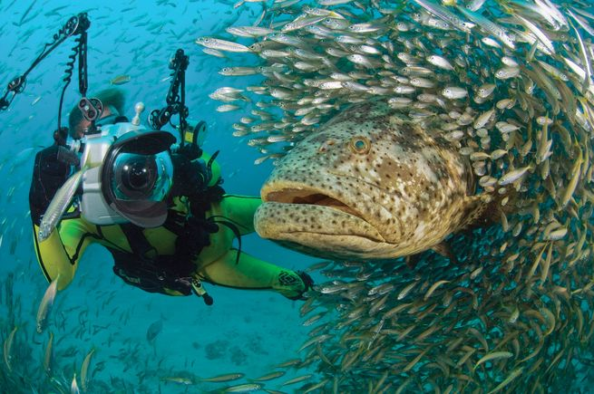
Goliath grouper facts:

Michael Patrick O'Neill
1. The goliath, Epinephelus itajara, is the largest grouper in the western hemisphere, and can reach 8 feet in length and more than 1,000 pounds.

2. A 4.6-foot-long female caught at a spawning aggregation contained 57 million eggs.
3. For a few weeks each year, spawning aggregations of up to 100 goliath grouper occur at specific times and locations.
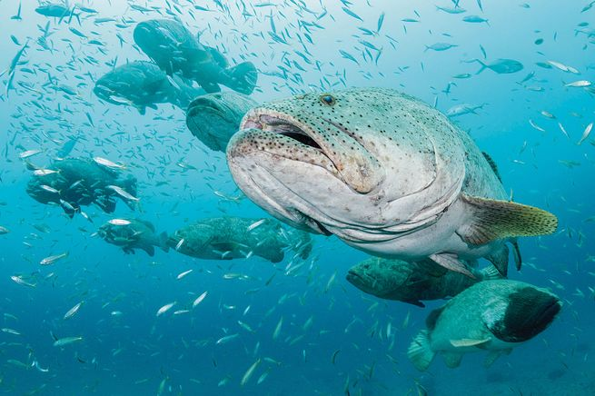
Goliath grouper facts
Michael Patrick O'Neill
1 of 4
4. Individuals can travel 100 miles to spawn.
5. Small (under 4 feet, or five to six years old) goliath grouper live around mangroves; larger adults prefer coral reefs.
6. Forty percent of goliath grouper caught in Belize had mercury levels exceeding the U. S.-recommended levels for human consumption.
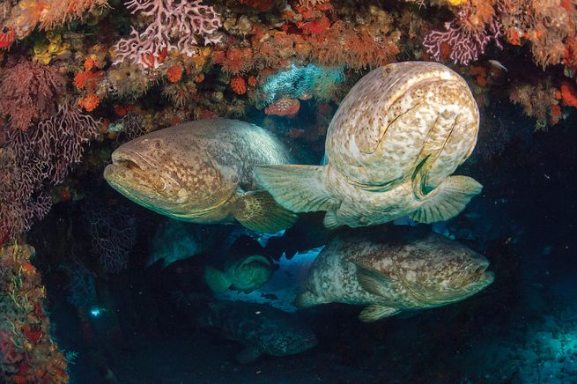
Goliath grouper facts
Michael Patrick O'Neill
2 of 4
7. These adaptable fish can live in brackish water and tolerate low oxygen levels.
8. Goliath grouper can have a lifespan of up to 37 years.
9. A goliath grouper’s age can be estimated using annual growth rings in its dorsal fin rays, much like those found within tree trunks.
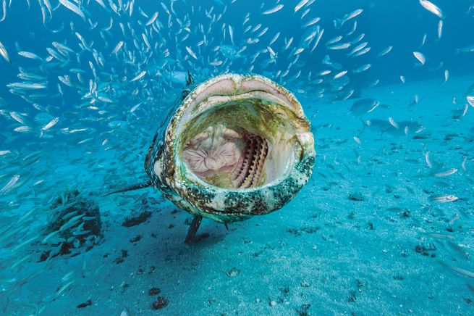
Goliath grouper facts
Michael Patrick O'Neill
3 of 4
10. Goliath grouper were removed from the NOAA Species of Concern list in 2006 but remain a “no take” species in the United States.
11. The World Conservation Union’s Red List listed the species as critically endangered in 1994. Survival is threatened by overfishing and loss of the inshore mangrove habitat required by juveniles.
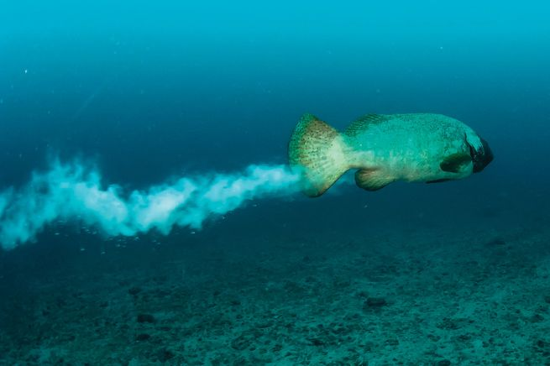
Goliath grouper facts
Michael Patrick O'Neill
4 of 4
12. Despite having teeth, goliath grouper engulf and swallow prey whole.

Vic Ferguson
The World Federation for Coral Reef Conservation
Executive Director/Founder
Relief without Borders
March for the Ocean
642 So. Commerce Ave
Sebring, Florida 33870
vic.ferguson@wfcrc.org (best method of contact)
512.986.-1902

