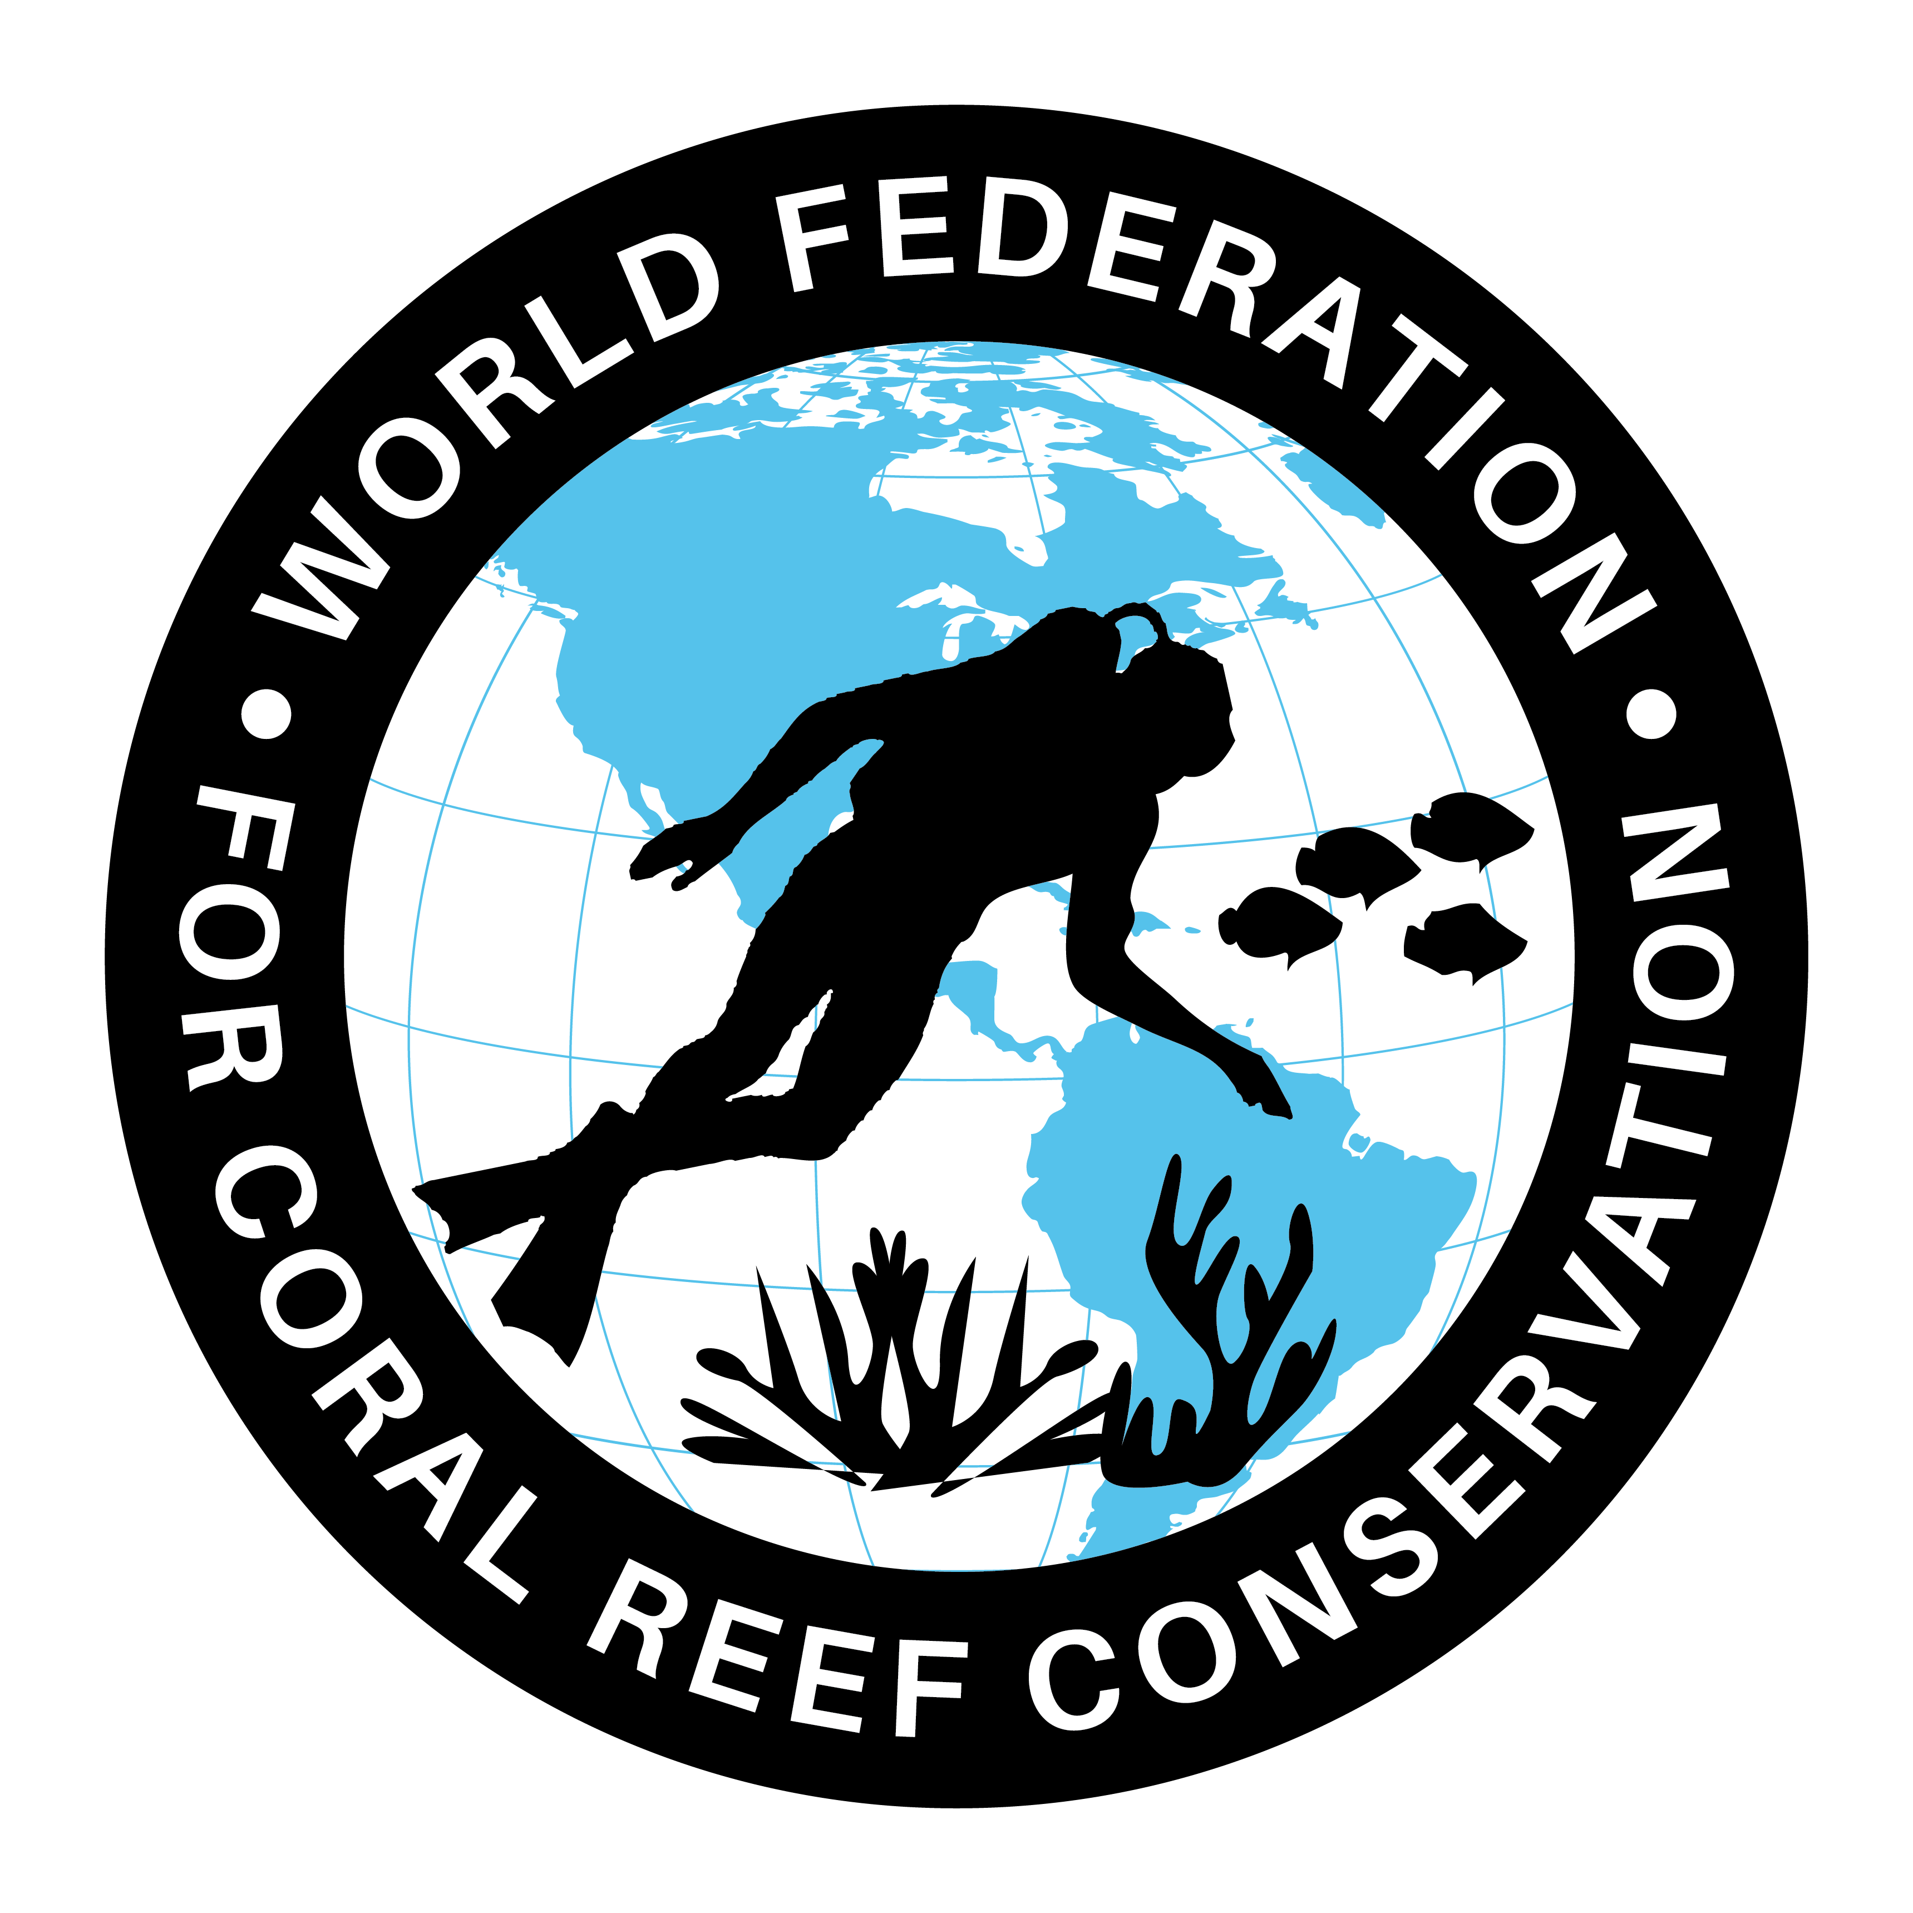
MLA-111-Spine Lobsters
Join WFCRC

The World Federation for Coral Reef Conservation 512.986.1902 4010 Skipper Rd. Sebring, Florida 33870

Vic Ferguson Executive Director/Founder vic.ferguson@wfcrc.org kyle.mathes@wfcrc.org
Reprinted 5/22/20

Virus prevalence associated with habitat
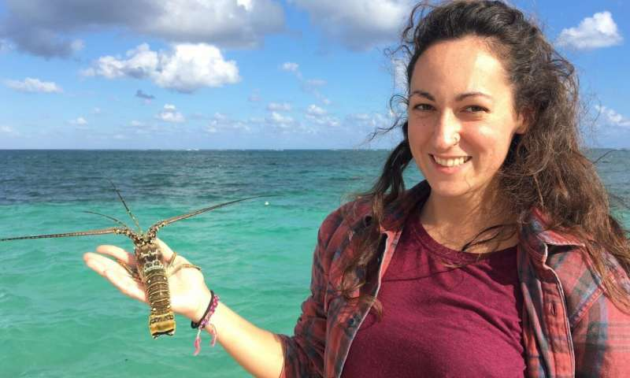
by Swansea University
Dr Charlotte Eve Davies of Swansea University releasing a Panulirus argus lobster back to the wild after sampling: studies by her research team showed that there can be a link between virus prevalance and habitat for this species Credit: Charlotte Eve Davies/Swansea University
Levels of virus infection in lobsters seem to be related to habitat and other species, new studies of Caribbean marine protected areas have shown.
The findings will support efforts to safeguard Caribbean spiny lobsters, which are a vital food source for communities across the region and world.
They also boost our understanding of how viruses spread—disease dynamics—and of the ecology of fragile environments such as tropical reef lagoons and seagrass ecosystems.
The spiny lobster, which has the scientific name Panulirus argus, is found across the Caribbean. Coastal habitats such as seagrass meadows and beds of algae act as nurseries for the juveniles before they move to the coral reefs when they are fully grown.
The research, led by Dr. Charlotte Davies, now of Swansea University, took place with colleagues at the National Autonomous University of Mexico's Reef Systems Unit.
They focused on a threat to this species called Panulirus argus virus 1 (PaV1). Discovered in 2000, PaV1 is the first known naturally occurring virus in lobsters.
The virus is a particular threat to juvenile lobsters, so tackling it is vital in protecting the species.
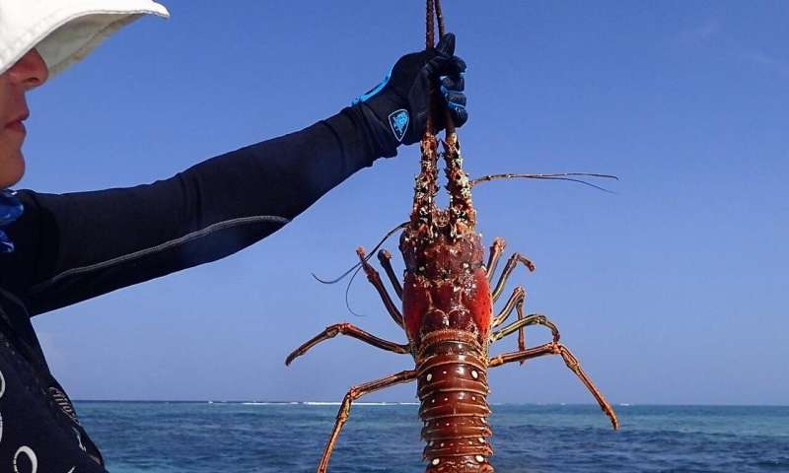
The team examined lobsters in two marine protected areas in the Mexican Caribbean: the Sian Ka'an Biosphere Reserve and the National Reef Park of Puerto Morelos, where the virus has been present since 2001.
The findings will support efforts to safeguard Caribbean spiny lobsters, which are a vital food source for communities across the region and world. They also boost our understanding of how viruses spread—disease dynamics—and of the ecology of fragile environments such as tropical reef lagoons and seagrass ecosystems. Credit: Charlotte Eve Davies/Swansea University
They carried out the systematic assessment of virus prevalence across both sites, once a year for two years in Sian Ka'an and seasonally over 4 years in Puerto Morelos. Each site was separated into zones with differing features such as water depth, sediment and extent of vegetation.
Previous research had suggested that virus prevalence may have a correlation with habitat, so investigating this in more detail was at the heart of the research, as well as looking at biodiversity of surrounding invertebrate (lobster food) communities.
The team found:
- The rate of infection overall was highest amongst smaller juvenile lobsters, confirming findings from previous studies, and true prevalence could be as high as 32% across populations.
- In Sian Ka'an, they found that significantly more lobsters with PaV1 lived in the highly vegetated seagrass meadows, compared to the coral reefs—indicating that there may be something in the seagrass which is preventing the virus spreading. Recent research elsewhere has shown that coastal seagrass meadows can trap some pathogens, greatly reducing the number that reach the open ocean and benefiting humans and marine life.
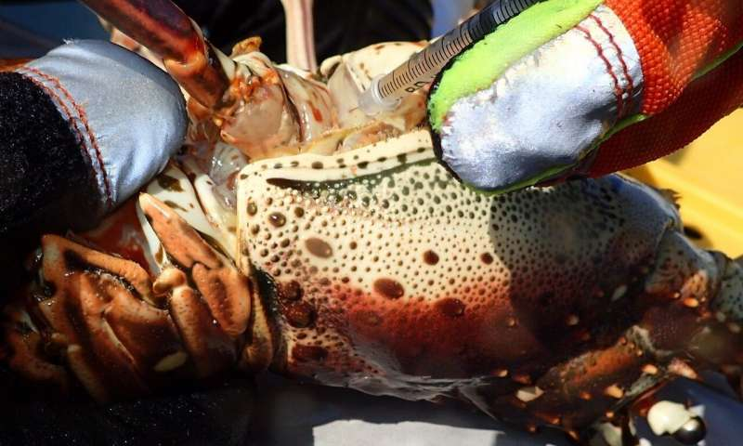
- However, in Puerto Morelos, where the lobsters are smaller and the ecosystem is very different, variations in habitat in the lagoon did not significantly influence the prevalence of the virus, showing that results may be site-specific.
The research was carried out by a team led by Swansea University's Dr Charlotte Eve Davies; they found that in this species - Panulirus argus - virus prevalence can be related to habitat, depending on the location and ecosystem. Credit: Charlotte Eve Davies/Swansea University
Dr. Charlotte Eve Davies of Swansea University, lead researcher on the project, said:
"What influences the spread of a virus? Our question was whether habitat or food species play a role, in relation to Caribbean spiny lobsters.
Our studies showed that the overall habitat—physical surroundings and other species—can significantly influence the prevalence of this virus depending on the location and ecosystem.
Our findings can help safeguard this important food resource for Caribbean communities. They also increase our understanding of this virus and give us a better picture of the wider ecosystem in this fragile environment."

Explore further
Caribbean seagrass is awash with infected lobsters – but the habitat could be saving the species

More information: Charlotte E. Davies et al, Do ecological characteristics drive the prevalence of Panulirus argus virus 1 (PaV1) in juvenile Caribbean spiny lobsters in a tropical reef lagoon?, PLOS ONE (2020). DOI: 10.1371/journal.pone.0229827
Journal information: PLoS ONE
Provided by Swansea University
17 shares

Facebook

Twitter

Email

Feedback to editors

- Featured
- Last Comments
- Popular

Laser cooling a nanomechanical oscillator close to its ground state
7 HOURS AGO
0

Environmentalists suggest COVID-19 could represent a new opportunity for a more diverse future
7 HOURS AGO
0

Researchers create global arsenic-in-groundwater maps to highlight threats
7 HOURS AGO
0

Producing ethane from methane using a photochemical looping strategy
MAY 21, 2020
0

Genetic study suggests domestic goats got pathogen-resistant gene from wild relatives
MAY 21, 2020
0

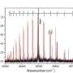

Scientists solve half-century-old magnesium dimer mystery
1 HOUR AGO


Mississippi Delta marshes in a state of irreversible collapse, study shows
1 HOUR AGO
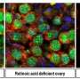

Researchers discover cell reproduction not triggered by retinoic acid as previously believed
4 HOURS AGO


Past is prologue: Genetic 'memory' of ancestral environments helps organisms readapt
4 HOURS AGO


A stitch in time: How a quantum physicist invented new code from old tricks
4 HOURS AGO
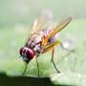

How a male fly knows when to make a move on a mate
4 HOURS AGO


Why toothpaste and cement harden over time
5 HOURS AGO


Can oilfield water safely be reused for irrigation in California?
5 HOURS AGO


Algal genome provides insights into first land plants
5 HOURS AGO


Oriented hexagonal boron nitride foster new type of information carrier
5 HOURS AGO

Relevant PhysicsForums posts

What is benign etymology?

4 HOURS AGO

Why do bacteria insert their genes into a host?

5 HOURS AGO

Is low dose radiation therapy a potential treatment for COVID-19?

7 HOURS AGO

A promising therapeutic solution to COVID-19 - using ACE2 decoy

21 HOURS AGO

Disinfecting effect of copper on SARS-CoV-2 and other viruses

MAY 21, 2020

Is Sars-Cov2 cytolytic or cytopathic?

MAY 21, 2020
More from Biology and Medical

- 1

Vic Ferguson
The World Federation for Coral Reef Conservation
Executive Director/Founder
Relief without Borders
March for the Ocean
4010 Skipper Rd.
Sebring, Florida 33875
vic.ferguson@wfcrc.org (best method of contact)
512.986.-1902
The only thing necessary for the triumph of evil is that good men do nothing”….Edmund Burke

