4.22.14
Coral Reef Conservation from an Earth Science view point.
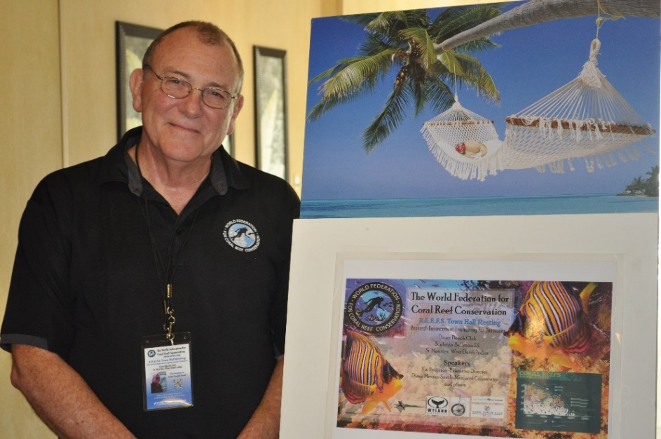
It is becoming an everyday event that somewhere in the world an oil spill is happening. We all live in the real world and know that accidents happen and spills occur. The question is are these events shared with the proper authorities to mount a response plan. The underlying problem is that in some parts of the world these events go unnoticed or the responsible party does not step forward and address the issue.
Over geologic time coral reef complexes have survived global warming, acidification, coral bleaching and other disruptive events, however it is unlikely they can survive when combined with continuous manmade disasters.
Somewhere in the world the worst case scenario already exists. As we raise awareness for data driven coastal resource planning, development and coral reef protection by providing comprehensive information that directly threatens coral reefs and actively place this information in the hands of those most affected by these threats, we empower local stakeholders with ability to have some influence on their own wellbeing.
WFCRC is the model for sharing information and best practices for addressing issues that have a direct effect of coral reefs and coastal management, we share our model in a geo portal and a digital library based on location on our web site free of charge to our end users in our project locations. As we are a 501 (c) (3) International Non-Profit Organization we feel that as believers in evidence based science we have a responsibility to share what we know about conservation with stakeholders around the world.
Our service-oriented spatial data infrastructure brings together current data and observations, data management, GIS/GPS, UAV, current technology, and cutting edge internet communication to provide the “real time” data necessary to make informed and timely decisions regarding coral reef health and other coastal aquatic related issues.

Shared information will enable the forecasting of potential trends, evaluate different policy or development sustainable options, and facilitate improved coastal management and development within a region.
Involvement by local governments will create a decision making data model for any new coastal construction projects, and will allow the search of the WFCRC geo-database to evaluate any conflict or damage to local reefs prior to coastal construction.
The coastal communities and national economies of many regions in the world and are poised to sustain substantial economic losses if current trends in coral reef degradation continue. Coral reefs provide valuable goods and services to support local and national economies, and degradation of coral reefs can lead to significant economic losses, particularly in the coastal areas of developing countries. Such losses are but not limited to, loss of fishing livelihoods, malnutrition due to lack of protein, loss of tourism revenues, and increased coastal erosion. Analyses carried out by the Reefs at Risk project indicate that Caribbean coral reefs provide goods and services with an annual net economic value in 2000 estimated at between US $3.1 billion and US $4.6 billion from fisheries, dive tourism, and shoreline protection services.
As marine disasters continue to occur, oil spills are the number one preventable events that we can plan to minimize its effects on coral reefs and coastal environments by supporting the development and sustainability of a national 1st response and action plan to address these events. We still have much to learn from the Deep Water Horizon spill in the Gulf of Mexico. When repeat offenders continually adding to the problem like the recent BP spill in Michigan and the Oil spill in Galveston Bay in the Gulf of Mexico, the ability of marine organisms to recover from a spill is greatly compromised.
Support for the development of a national 1st response and action plans for the oceans of the world is essential for the sustainability of our marine treasures.
Please help us share what we know about recovery and management of our marine treasures, it’s not rocket science it’s just the right thing to do. Go to www.wfcrc.org and join us.
The examples below are just a few incidents in the US that have been reported. It is the focus of WFCRC to raise awareness for these events in underserved developing nations around the world that are not addressed by the responsible partly and that are left to the local stakeholders who may not have the information nor the funding to mount a response.
Thank you
Vic Ferguson

Crews mopping up oil spill in Texas' Galveston Bay

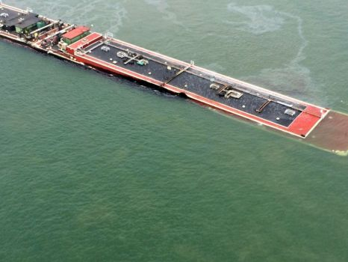
Associated Press | March 22, 2014 | Updated: March 23, 2014 10:11am
Photo by PO3PO3 Manda Emery/AP
In this image provided by the U.S. Coast Guard a barge loaded with marine fuel oil sits partially submerged in the Houston Ship Channel, Saturday March 22, 2014. The bulk carrier Summer Wind, reported a collision between the Summer Wind and a barge, containing 924,000 gallons of fuel oil, towed by the motor vessel Miss Susan. The barge collided with a ship in Galveston Bay on Saturday, leaking an unknown amount of the fuel into the popular bird habitat as the peak of the migratory shorebird season was approaching.

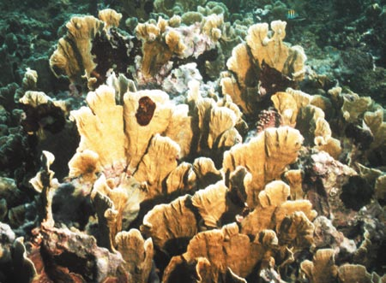

Oil covered hard coral in GOM

Research shows more than 6,000 US oil spills in 2012
JULY 10, 2013
KEYWORDS oil spill / oil industry / american petroleum institute
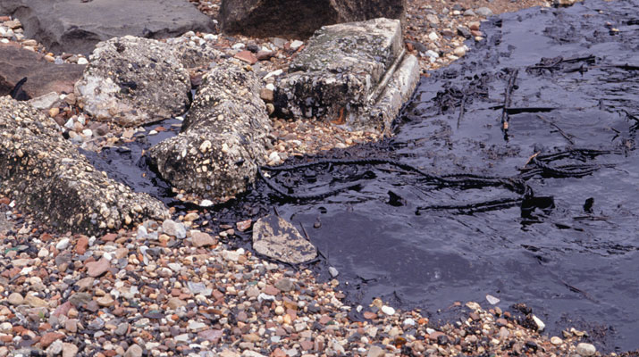
Photo credit: Paul Katz/Photodisc/Thinkstock
More than 6,000 spills and other incidents occurred at the U.S. onshore oil and gas sites last year, according to data collected by EnergyWire. This means that an average of 16 spills occurred across the United States on a daily basis, marking a 17 percent increase since 2010 in the 12 states for which data was compared.
There are thousands of oil and gas wells operating in the United States at any given moment and accidents like spills happen every day. However, data regarding these spills is scattered and fragmented, so a nationwide analysis is impossible to make. Spills on public land are reported to the Bureau of Land Management but data about the rest is kept in state agencies across the country. EnergyWire spent several months gathering data from a dozen states to put the pieces of the puzzle together and create a picture of the current state of U.S. oil and gas wells.
The report found that, although the number of spills rose by 17 percent in three years, the number of wells drilled was up by 40 percent. Overall, at least 15.6 million gallons of oil, fracking fluid, wastewater and other liquids were spilled at production sites in the states monitored in 2012. The majority of this remains contained within the wells but there are occasions when oil gushes out of the well and can harm the environment beyond the site, EnergyWire said. North Dakota reported that 80 percent of all spills remained inside the well entirely, while Utah stated that 78 percent were contained in the well. In Colorado, however, the figure barely reached 38 percent.
The total amount of spills is actually far greater than this research found, as reports in states like Pennsylvania, Oklahoma and Colorado, where drilling is a major industry, sometimes exclude spill amounts. Spills from interstate pipelines and offshore wells are also not included in the data. According to drilling companies, at least a third of the spilled amount is typically recovered.
RELATED: Nanomaterial shows promise for oil spill cleanups
People living around these areas and environmental organizations claim that the frequency with which such spills happen is a signal that oil and gas companies are not doing their best to prevent and manage them. The U.S. oil and gas industry claims that companies have a generally good record of environmental protection and take safety seriously. Jack Gerard, president of the American Petroleum Institute (API), commented that there are risks associated with producing energy but the industry has a strong safety record.
Supporting this statement, a spokesperson for the API cited a 2009 study showing that, overall, the number of oil spills in the United States has fallen by more than three-quarters since the late '60s. However, it also showed that the decreases were offshore, while inland spills have increased.
According to the EnergyWire report, there are many different types of spills. The most common are also typically less serious, such as tanks overflows or equipment malfunction. Human errors are also frequent, such as operators leaving valves open during crew changes. The biggest spills happen when something goes wrong with the construction of the well, and these are also the most expensive to repair.

BP more than doubles estimate of Lake Michigan oil spill
BP today more than doubled its maximum estimate of how much crude oil spilled into Lake Michigan earlier this week from its Whiting refinery in Northwest Indiana.
By Michael Hawthorne Tribune reporter
7:06 a.m. CDT, March 28, 2014
BP today more than doubled its maximum estimate of how much crude oil spilled into Lake Michigan earlier this week from its Whiting refinery in Northwest Indiana.
In a statement, the company said a malfunction in a new distillation unit forced up to 39 barrels or 1,638 gallons of oil into the lake just across the Illinois border. A day earlier, the company had estimated that 18 barrels at most had been spilled.
BP said it based its latest estimate on the amount of oil collected by vacuum trucks and absorbent booms, along with an inventory of the waxy balls of oil that cleanup crews scoured from a beach on BP’s property. Strong winds appear to have pushed most of the oil toward a shallow cove between the refinery and an ArcelorMittal steel mill.
- RELATED
- 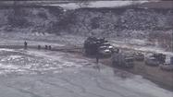Video: Crews work to clean up oil spill
- 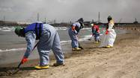Photos: Lake Michigan oil spill
- 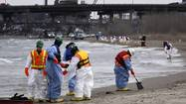BP confirms oil spill

Vic Ferguson
The World Federation for Coral Reef Conservation
Executive Director
P.O. Box 311117
Houston, Texas 77231
vic.ferguson@wfcrc.org
www.wfcrc.org
281.886.7428 (office)
281.309.1201 (cell)

