10.15.15

Japan donates vital oil slick-mopping equipment to SL
December 22, 2015, 6:57 pm
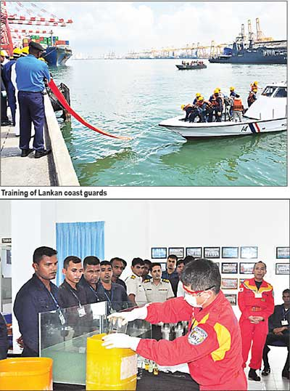
By Hiran H.Senewiratne

Sri Lanka is an island situated on main international sealanes, besides being located on the Silk Route. Accordingly, a large number of vessels/ships pass Sri Lanka. However, in the event of a major oil spill, Sri Lanka has neither the facilities nor the expertise to arrest the situation.

"In the event of a major oil spill disaster Sri Lanka has to get assistance from India to arrest such a situation because we have no sophisticated equipment. Therefore,the Japanese government through its embassy in Colombo donated seven containers of oil mopping equipment to Sri Lanka to face such challenges, security advisor to the embassy of Japan in Sri Lanka Cap. R.M.K.U.B.I Rathnayake told The Island Financial Review.

The seas around Sri Lanka are highly vulnerable to oil spills, as 25 percent of the world’s oil transportation, which amounts to 550 million tons per annum, passes via Sri Lanka’s Exclusive Economic Zone, he said.

"Though Sri Lanka has not faced huge disasters due to oil spills in Sri Lankan waters, except for a few incidents which were reported around the country during the past few decades, the risk of an oil spill is high around Sri Lanka, he said.

The Sri Lanka Coast Guard as a stakeholder in protecting the coastal belt of Sri Lanka and preventing and minimizing marine pollution, will take the opportunity to launch a training programme for its cadres with the assistance of Japanese marine environment protection and oil spill measures experts, Rathnayake said.

According to Rathnayake, the Defense Attaché to the Japanese embassy in Colombo, Cap. M Shigekawa along with the Director General Coast Guard Rear Admiral S. Wimalatunga will launch training in January 2016 in the Mirissa coastal area.

Japan has had good diplomatic relations with Sri Lanka for 62 years, which enables it to properly equip the country to manage oil spills. This is noteworthy as Sri Lanka is heavily dependent on the tourism and fishing industries, he said.

At present, Marine Pollution Prevention Bureau, Coast Conservation Department and Ports Authority are the main organizations that protect the coastal area of the country and all organizations do not have oil mopping equipment in the event of a major oil spill, he said.

The marine environment is a part of Sri Lanka’s rich eco system. In the event of such a major oil spill, it would affect international trade because ships could not enter our ports when an oil spill prevails, Cap. Rahnayake said.

A Japanese team will arrive in Sri Lanka in January to train Sri Lankan personnel with the assistance of the Sri Lankan Navy and other relevant authorities, he said.

Early this year too Japanese specialist teams arrived in the island and trained Sri Lankan coast guards and other personnel to face such an incident, he said.

Rathnayake said oil spills pose serious threats to fresh water and marine environments, affecting surface resources and a wide range of subsurface organisms that are linked in a complex food chain that includes human food resources.

"Spilled oil can harm the environment in several ways, including physical damages that directly impact wildlife and their habitats (such as coating birds or mammals with a layer of oil), and highlighting the toxicity of the oil itself, which can poison exposed organisms, he said.

Environmentalist/lawyer Jagath Gunawardene said that in the event of an oil spill, it could also harm sea birds which could get stuck and eventually perish.

"Besides, it is bound to break up the natural coral and reef and eventually deal a severe blow to marine tourism. Furthermore, cleaning up an oil slick of such magnitude will be a gigantic task and we will need millions of rupees to have it done, Gunawardene added.

Vic Ferguson
The World Federation for Coral Reef Conservation
Executive Director
P.O. Box 311117
Houston, Texas 77231
vic.ferguson@wfcrc.org
www.wfcrc.org
281.886.7428 (office)
281.309.1201 (cell)
The only thing necessary for the triumph of evil is that good men do nothing”….Edmund Burke

