
OSA-023- St. Croix Petro Spill
Join WFCRC

The World Federation for Coral Reef Conservation 512.986.1902 4010 Skipper Rd. Sebring, Florida 33870

Vic Ferguson Executive Director/Founder vferguson001@gmail.com

5/6/21

A Caribbean island bet its future on petrochemicals. Then oil rained down on homes.



By Fredreka Schouten, CNN
Updated 7:21 AM ET, Sat May 29, 2021

The EPA shut down the Limetree Bay refinery in St. Croix after it rained oil on nearby neighborhoods in mid-May.
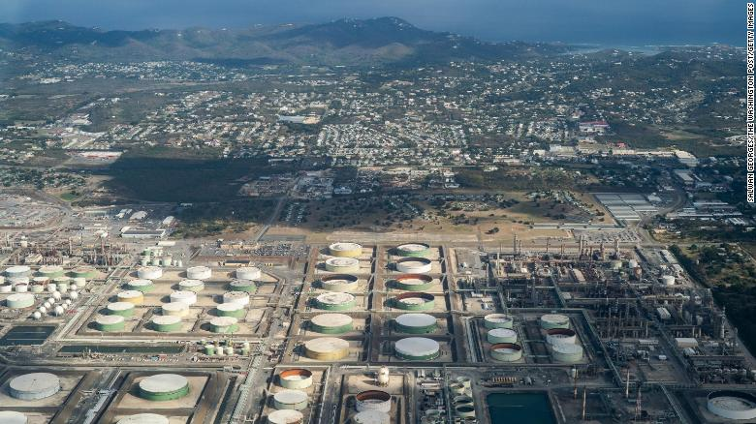
(CNN)The stench permeated Dyline Thomas' St. Croix home for weeks, she said, upsetting her stomach, making her nose run and her throat sore.
"The smell was so strong, like sulfur, like rotten eggs," the 58-year-old homemaker recalled.
Then oil was discovered in her yard in mid-May. Two days earlier, a flare incident occurred at the Limetree Bay refinery upwind of Thomas's home. As flames and smoke billowed out of the flare stack, oil droplets were launched into the sky, carried west by the wind and rained down on nearby homes.
This month the US Environmental Protection Agency took a rare and extreme step: It ordered an emergency, 60-day shutdown of the plant, citing an "imminent risk" to public health. The agency, which has jurisdiction over territories such as the U.S. Virgin Islands, reported several incidents that released oil into the environment and sent sulfur dioxide and hydrogen sulfide into the air, both of which cause respiratory illness.
In a statement sent to CNN, Limetree Bay said it intends to cooperate with the EPA and the local government in "preparing for a safe and compliant restart of the refinery."
Now St. Croix, a majority Black community in the Caribbean, is weighing its economic future against the health and environmental impacts of betting big on oil.
The refinery has been a key source of jobs and revenue for an economy battered by hurricanes and the pandemic. But some of the islands' 50,000 residents are questioning whether the price is too high, particularly for a community on the front lines of the climate change crisis in the form of sea level rise and increasingly powerful storms.
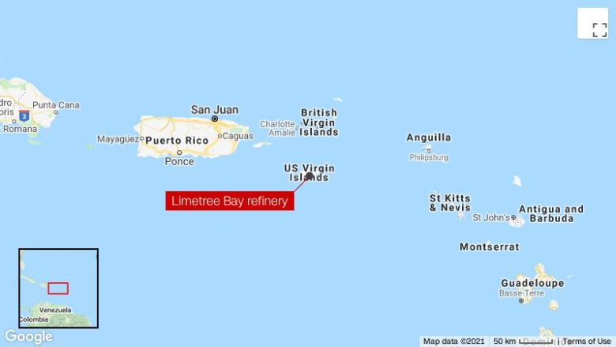
"We are at a crossroads," said Jennifer Valiulis, the executive director of the St. Croix Environmental Association, who has been critical of the plant's operation. "We have an opportunity to examine what we want our economy to look like, what we want St. Croix to be in a world that's moving away from fossil fuels as its primary energy source."

For decades, residents of this 84-square-mile island, the largest of the three major U.S. Virgin Islands, have co-existed with major industrial production. The refinery first opened in 1966, and -- under the management of Hess Corporation and then Hovensa -- boosted its Virgin Islander workforce into the middle class.
But the environmental and health tolls grew. In 2011, the Hovensa petroleum refinery -- at the time the county's second-largest -- reached a settlement with the EPA to pay more than $5.3 million for environmental violations.
The plant later closed and filed for bankruptcy. With its shutdown went more than 2,000 jobs.
Earlier this year, the facility -- backed by private equity firms -- resumed operations as Limetree Bay under a permit granted by the Trump administration with a plan to produce some 200,000 barrels of oil a day.
Virginia Clairmont, who runs a nonprofit working to revitalize the town of Frederiksted on the island's western end, told CNN she had misgivings about the refinery restarting in the first place. After multiple incidents, she wants it closed.
But, she said, "if you talk about it, you'll be attacked for trying to deprive other people of jobs."

Court orders Shell to slash CO2 emissions in landmark climate ruling
The coronavirus pandemic only added to the islands' economic woes, shutting down a cruise industry that brings in more than 1.4 million tourists per year. Hurricanes Irma and Maria devastated the Virgin Islands in 2017, and the islands still bear the scars: a sailboat tossed like a toy on the shore; a tattered blue tarp over a missing roof, disintegrating in the relentless tropical sun.
On St. Croix, the plant restart created some 400 full-time jobs. Government officials estimate the operation could generate about $7 million in annual tax revenue.
Nellie Rivera-O'Reilly, a jewelry store owner on St. Croix and former legislator, was among the local senators who voted to approve the plant's reopening. "As a business owner now, I see the benefits of the refinery, or any employer of that magnitude, remaining viable on the island of St. Croix," she said.
Lawmakers were particularly concerned about health and safety, she said, and allocated money for rigorous environmental monitoring.
"These things happen in these types of industries," Rivera-O'Reilly added. "The thing to do is to make sure we learn and put in place measures to prevent this from happening."

The Limetree Bay refinery is seen from above in St. Croix, Virgin Islands, Thursday, March 18, 2021.
EPA officials say they have received hundreds of calls and emails complaining about the plant since February. Tysha Henry, who grew up on St. Croix, was among the callers.
Henry, an HR manager in Atlanta, was visiting her mother on the island in May when she said an overpowering gasoline smell jolted her awake in the middle of the night.
"It felt like I was going to asphyxiate or something," she said. The smell abated within an hour but the next morning, she said, her eyes and face were swollen and puffy.
"I will not be going back home as long as this smell is there," said Henry.
Lawsuits representing hundreds of residents have been filed against the refinery in recent weeks.
The EPA's shutdown order, which was handed down at a moment environmental advocacy groups are pressing the Biden administration to bring environmental justice to communities of color, is just the fourth time the agency has used its emergency powers to temporarily close a plant.
It came two days after the refinery announced it was halting production on its own after the May 12 flare incident that spewed oil on homes west of the facility -- homes where residents catch rainwater on their roofs and store it in below-ground cisterns for drinking, bathing and cooking. The order calls for independent audits of the refinery's operations and its ability to comply with "environmental, health and safety limits."
"This already overburdened community has suffered through at least four recent incidents that have occurred at the facility, and each had an immediate and significant health impact on people and their property," EPA Administrator Michael Regan said in a statement announcing the emergency action.
Limetree CEO Jeffrey Rinker described the federal order as unlawful and "unnecessary" because the plant already had idled operations voluntarily. The company argues there's no proof that their plant is the source of some of the noxious odors, noting that a government-run landfill due west of the refinery had caught fire in early May and could have contributed to the foul smells.

Activist investor ousts at least two Exxon directors in historic win for pro-climate campaign
In the statement sent to CNN, Limetree Bay officials said: "We have no plans to restart the refinery before it is safe to do so."
"Notwithstanding some of our struggles during this restart period, we remain committed to being a good neighbor and responsible member of the St. Croix community," they said.
When the refinery reopened as Limetree in February, Virgin Islands Gov. Albert Bryan, Jr., a Democrat, heralded it as a "big victory for St. Croix" and the broader US territory.
"In these difficult economic times, I am very pleased that the Refinery is creating hundreds of well-paying, quality jobs," he said in a statement.
Aides to Bryan did not respond to requests for an interview, but Bryan called the flare incident "totally unacceptable."
He expressed hope, however, that the plant officials "can rectify whatever the issues are and resume operations."
Thomas, the woman who had oil in her yard and said she had a reaction to noxious fumes, said the smells that bothered her for weeks have eased, since the closing of the refinery.
Since then, she said, the refinery operators have washed her vehicles, given her three cases of bottled water and promised to get back in touch about oil that may have contaminated her cistern.
As unsettling as the incidents have been, Thomas said she doesn't want the plant to shut down permanently. It "brings a lot of jobs here," she said. "I would not want them to close."
"But I want them to take more precautions," Thomas added. "You can have all the money in the world, but you can't enjoy it if you have no health."

Vic Ferguson
The World Federation for Coral Reef Conservation
Executive Director/Founder
Relief without Borders
March for the Ocean
4010 Skipper Rd.
Sebring, Florida 33875
vferguson001@gmail.com
512.986.-1902
The only thing necessary for the triumph of evil is that good men do nothing”….Edmund Burke

