6.4.15

Santa Barbara's oil-slicked waters
May 2015 by Penny Sarchet
(Image: Brian van der Brug/Los Angeles Times via Getty Images)
This aerial photo shows part of Santa Barbara's coastline in California, after an estimated 21,000 gallons of oil spewed into the Pacific Ocean on Tuesday.
Taken on Wednesday, oil-soaked kelp darkened the water as efforts to mop up the spill continued.
The cause was a burst pipe, which leaked for 3 hours and released more than 100,000 gallons of oil in that time. Most of it remained on land, spreading across roughly 6.5 kilometres of beach, but enough leaked into the sea to form a 14-kilometre slick.
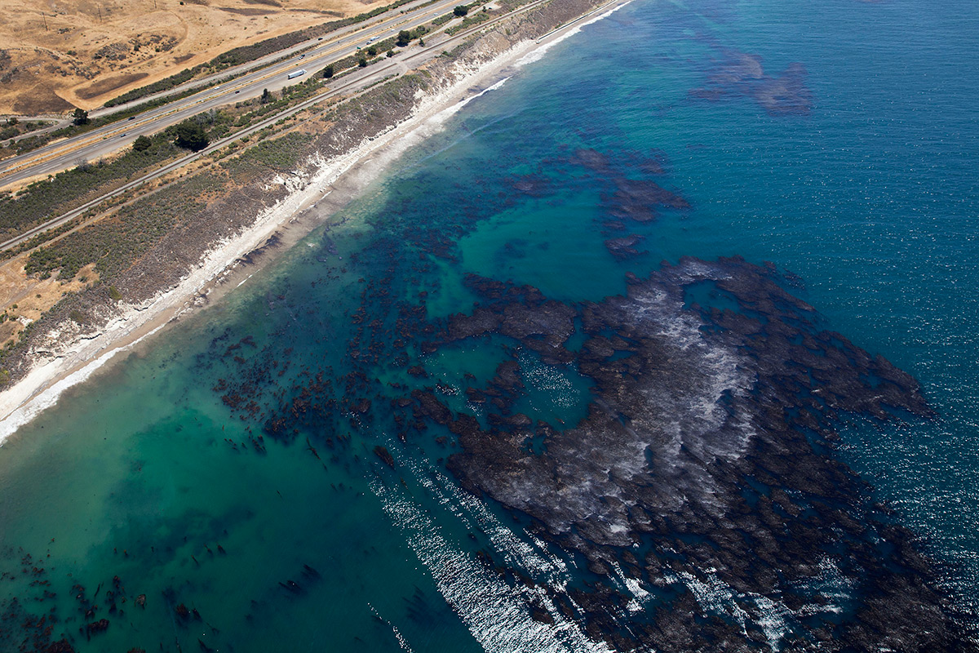
Many are concerned about the harm it will do to the area's wildlife, which includes whales and sea lions. Dead animals found so far include this oil-covered lobster.

(Image: David McNew/Getty Images)
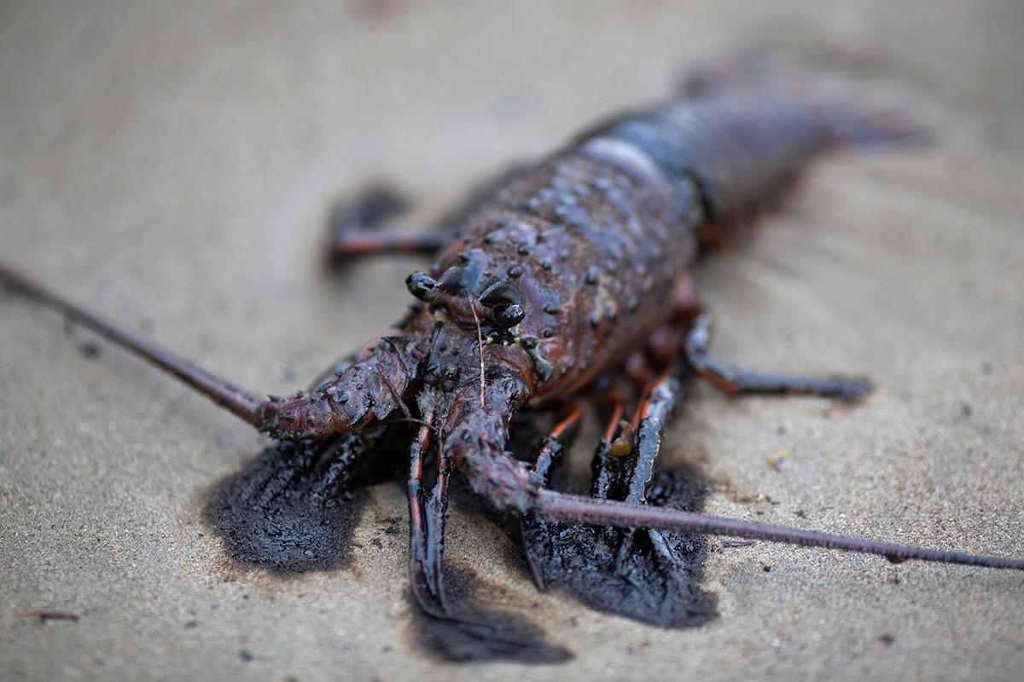
The same area suffered a devastating spill in 1969, when a platform blowout released hundreds of thousands of gallons of oil into the sea, killing thousands of marine mammals and seabirds.
In the struggle to limit the damage this time, more than 300 people have been involved in clean-up efforts so far. Volunteers have been helping a crew of workers involved in cleaning the beach by raking and vacuuming up oil, and vessels have been deployed to remove oil from the sea surface.
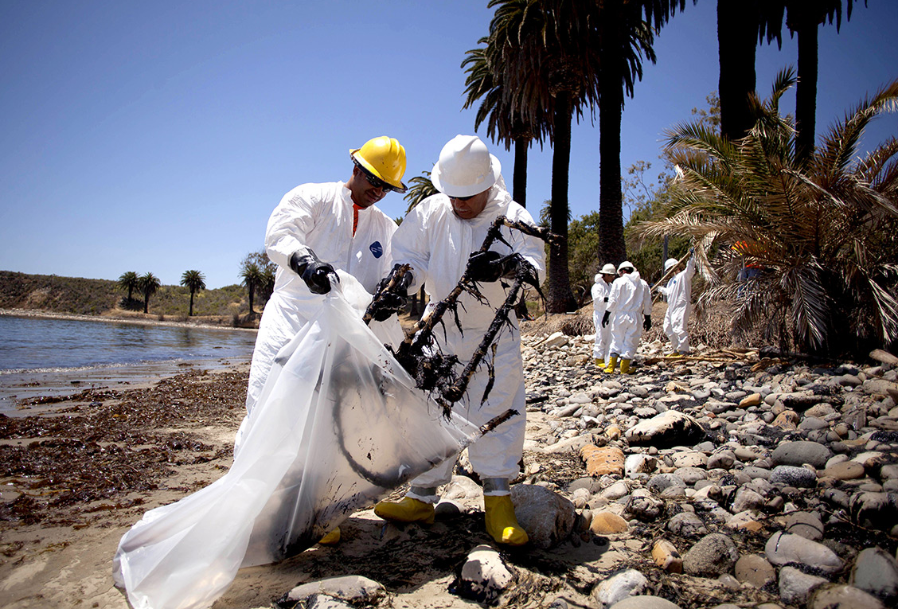
(Image: ZUMA/REX_Shutterstock)

Vic Ferguson
The World Federation for Coral Reef Conservation
Executive Director
P.O. Box 311117
Houston, Texas 77231
vic.ferguson@wfcrc.org
www.wfcrc.org
281.886.7428 (office)
281.309.1201 (cell)
The only thing necessary for the triumph of evil is that good men do nothing”….Edmund Burke

