Oil Spills in Mangroves
PLANNING & RESPONSE CONSIDERATIONS
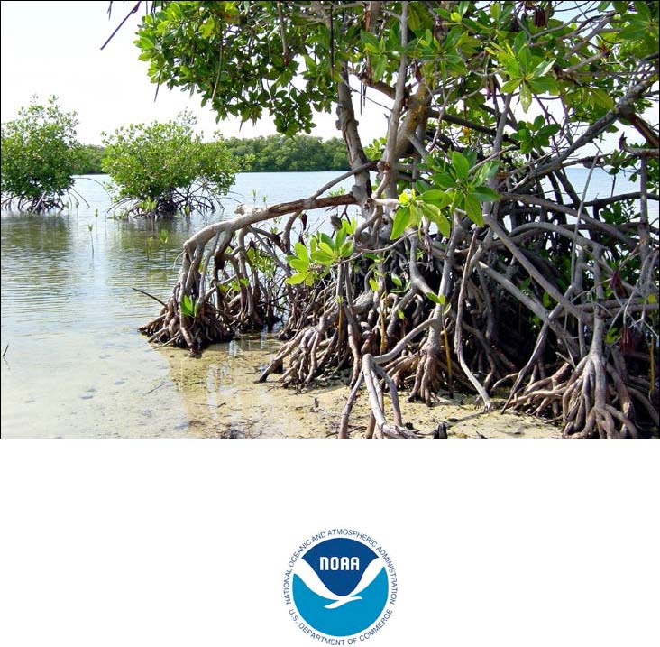
September 2014
U.S. DEPARTMENT OF COMMERCE National Oceanic and Atmospheric Administration • National Ocean Service • Office of Response and Restoration

Oil Spills in Mangroves
PLANNING & RESPONSE CONSIDERATIONS
September 2014
Rebecca Hoff1 and Jacqueline Michel2, Editors Philippe Hensel3, Edward C. Proffitt4, and Patricia Delgado5 (Ecology) Gary Shigenaka1 (Toxicity) Ruth Yender1 and Jacqueline Michel2 (Response) Rebecca Hoff1 (Recovery and Restoration) Alan J. Mearns1 and Jacqueline Michel2 (Case Studies)
1 Office of Response and Restoration, NOAA Ocean Service, National Oceanic and Atmospheric Administration, Seattle, Washington 2 Research Planning, Inc., Columbia, South Carolina 3 Johnson Controls World Services, National Wetlands Research Center, Lafayette, Louisiana 4 U.S. Geological Survey, National Wetlands Research Center, Lafayette, Louisiana 5 University of Louisiana at Lafayette, Lafayette, Louisiana

U.S. DEPARTMENT OF COMMERCE National Oceanic and Atmospheric Administration • National Ocean Service • Office of Response and Restoration
Table of Contents
INTRODUCTION i
CHAPTER 1. MANGROVE ECOLOGY 1-1 Key Points 1-1 What is a Mangrove? 1-1 Where are Mangroves and What do They Look Like? 1-1 Mangrove Ecotypes 1-5 Life History 1-6 Habitat Function 1-11 Mangrove Economic Value and Uses 1-13 Anthropogenic and Naturally Occurring Impacts 1-14 For Further Reading 1-18
CHAPTER 2. OIL TOXICITY AND EFFECTS ON MANGROVES 2-1 Key Points 2-1 Oil Groups 2-2 Mechanisms of Oil Toxicity to Mangroves 2-2 Acute Effects 2-5 Chronic Effects 2-7 Mangrove Community Impacts 2-10 Indirect Impacts 2-12 Summary and Response Implications 2-14 For Further Reading 2-15
CHAPTER 3. RESPONSE 3-1 Key Points 3-1 On-Water Response Options to Prevent or Reduce Mangrove Oiling 3-1 Booms 3-3 Stranded Oil Behavior in Mangroves 3-3 Cleanup Options for Oiled Mangroves 3-6 Inappropriate Response Techniques for Mangroves 3-13 For Further Reading 3-13
CHAPTER 4. MANGROVE RECOVERY AND RESTORATION 4-1 Key Points 4-1 Recovery 4-2 Mangrove Restoration 4-4 For Further Reading 4-8
CHAPTER 5. MANGROVE CASE STUDIES 5-1 Introduction 5-1 Zoe Colocotronis, La Parguera, Puerto Rico, 1973 5-1 Peck Slip, Eastern Puerto Rico, 1978 5-3 JP-5 Jet Fuel Spills, Roosevelt Roads, Puerto Rico (1986 and 1999) 5-5 T/V Era, Spencer Gulf, South Australia, 1992 5-8 Witwater and Texaco Storage Tank Spills, Bahía Las Minas, Panama, 1968 and 1986 5-9 Bouchard Barge B-155, Tampa Bay, August 1993 5-13 Guanabara Bay, Brazil, 2000 5-16 M/T Solar I, Guimaras Island, The Philippines, 2006 5-17
MANGROVE GLOSSARY 6-1
Figures
Figure 1.1. World map of the mangrove distribution zones and the number of mangrove
species along each region (deltares, 2014). 1-2 Figure 1.2. Distribution of mangrove forests in the continental United States 1-3 Figure 1.3. Mangroves that occur in the U.S. and Caribbean 1-4 Figure 1.4. Various types of mangrove forests 1-5 Figure 1.5. Examples of mangrove seedlings that occur in the U.S. and Caribbean 1-7 Figure 1.6. Close-up of mangrove leaf showing salt crystals 1-8 Figure 1.7. Rhizophora tree showing prop roots 1-9 Figure 2.1. Acute oil toxicity effects 2-7 Figure 2.2. Propagule and root deformities observed in january 1980 as response to the chronic
effects of oil exposure after the 1978 Howard Star oil spill in Tampa Bay, Florida 2-9 Figure 2.3. Schematic diagram depicting the effects of a large oil spill on mangrove forests 2-13 Figure 3.1. Schematic showing the different patterns of oil spill impacts to mangrove forests 3-4 Figure 3.2. Infrared aerial photograph of a band of dead mangroves where oiling was heaviest
on the prop roots and penetrated into the soils 3-4 Figure 3.3. Extensive riverine impacts to mangroves three years after the funiwa 5 spill of
400,000 barrels of crude oil in Nigeria in 1980 3-4 Figure 3.4. Vacuuming techniques in mangroves 3-10 Figure 4.1. Mangrove restoration project at West Lake Park, Ft. Lauderdale, Florida 4-7 Figure 5.1. Heavy oiling of red mangrove prop roots from the Peck Slip spill in Puerto Rico
in 1978 5-4 Figure 5.2. Heavy oil stranding on the mangrove substrate and coating of the prop roots and
pneumatophores 5-13 Figure 5.3. Heavy fuel oil from the M/T Solar I that penetrated completely through the
mangrove forest 5-17
Tables
Table 1.1. Common mangrove species with common and scientific names and general
distribution 1-3 Table 2.1. Oil groups and their characteristics 2-3 Table 2.2. Generalized responses of mangrove forests to oil spills 2-8 Table 3.1. Recommendations for response options in oiled mangroves by oil group 3-6 Table 4.1. Impacts and recovery times for mangrove trees at eight oil spills impacting five
regions 4-3
Cover Photograph Credit: Felix Lopez, U.S. Fish and Wildlife Service
INTRODUCTION
This guide is intended to assist those who work in spill response and planning in regions where mangrove ecosystems are an important part of the coastline. By understanding the basic of the ecology of these forests and learning from past oil spills in mangroves, we can better plan for, protect, and respond to spills that may threaten them. Mangroves often border coastlines where coral reefs live offshore, and these two ecosystems are closely linked. Mangroves filter and trap excess sediment that could harm coral, and coral reefs protect shorelines where mangroves grow from excessive wave energy. Both habitats can be adversely impacted by oil spills, and spill responders must often consider tradeoffs between land-based and offshore resources during a response. This guide is a companion to Oil Spills in Coral Reefs: Planning and Response Considerations.
This guide is not intended to be a definitive guidance for choosing cleanup methods, as many comprehensive versions of these exist already. Rather, it is a summary of current research on mangroves from the perspective of those who may need to make decisions about oil spill response in mangroves and presents the information in an accessible format for people with some science or response background. Experienced responders unfamiliar with mangroves may want background on mangrove ecology, while biologists may want an overview of oil toxicity and response actions applied to mangrove ecosystems. The topics are organized by chapters, which can be read as a standalone, with additional references provided at the end of each chapter. A glossary defines specialized terms.
Chapter 1 provides an overview of mangrove ecology, forest biology, associated mangrove communities, and how they respond to various natural and human stresses. Chapter 2 reviews the research on oil toxicity and impacts to mangroves. Chapter 3 discusses general guidance for responding to spills in mangroves and provides specific considerations for cleanup measures. Chapter 4 discusses long-term recovery of mangroves from oil spill impacts and restoration techniques and approaches. Chapter 5 compiles case studies to illustrate a range of issues from oil spills.
Mangrove forests are in many ways very adaptable ecosystems. They have the ability to tolerate a wide range of physical changes in their environment. However, despite their hardiness, they are highly vulnerable to oil toxicity and the impacts from cleanup activities. Thus, we must undertake any type of response or restoration activities in mangroves with caution. The information in this document will is intended to help minimize impacts to mangroves from oil spills and associated cleanup activities.
CHAPTER 1. MANGROVE ECOLOGY Mangrove – a tree or
shrub that has evolved
the adaptations for
Key Points
growing in the intertidal Mangroves worldwide cover an approximate area of 150,000 square zone (specifically, kilometers of sheltered coastlines in the tropics and subtropics. adaptations to salinity
and flooded conditions).
Five of the most common ecotypes include fringe, basin, riverine, overwash, and dwarf forests. Mangroves are restricted to the intertidal zone. Mangroves in general have a great capacity to recover from major natural disturbances. Mangroves maintain water quality by trapping sediments and taking up excess nutrients from the water. Mangroves play an important role in shoreline protection and stabilization. Mangroves provide important habitat for a wide variety of species of commercial, recreational, subsistence, and conservation interests Mangrove conservation and restoration are now also valued for carbon sequestration.
What is a Mangrove?
Ecologically, mangroves are defined as an assemblage of tropical and semi-tropical trees and shrubs that inhabit the coastal intertidal zone. A mangrove community is composed of plant species whose special adaptations allow them to survive the variable flooding and salinity stress conditions imposed by the coastal environment. Therefore, mangroves are defined by their ecology rather than their taxonomy. From a total of approximately 20 plant families containing mangrove species worldwide, only two, Pellicieraceae and Avicenniaceae, are comprised exclusively of mangroves. In the family Rhizphoraceae, for example, only four of its sixteen genera live in mangrove ecosystems (Duke 1992).
Where are Mangroves and What do They Look Like?
Mangroves worldwide cover an approximate area of 150,000 square kilometers (km2) of sheltered coastlines, which is about 50% of their historic range (Spalding et al. 2010). They are distributed within the tropics and subtropics, reaching their maximum development between 25°N and 25°S (Figure 1.1). Their latitudinal distribution is mainly restricted by temperature because perennial mangrove species generally cannot withstand freezing conditions. As a result, mangroves and grass-dominated marshes in middle and high latitudes fill a similar ecological niche.
Figure 1.1. World map of the mangrove distribution zones and the number of mangrove species along each region (Deltares, 2014).
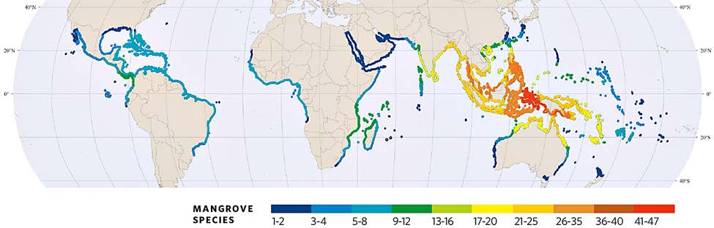
The global distribution of mangroves is divided into two hemispheres: the Atlantic East Pacific and the Indo West Pacific. As seen in Figure 1.1, the Atlantic East Pacific has fewer species than the Indo West Pacific (12 compared to 58 species, respectively). Species composition is also very different between the two hemispheres. Out of a total of approximately 70 mangrove species, only one, the mangrove fern, is common to both hemispheres.
In the continental United States, mangroves historically were distributed as distinct forests along the Atlantic and Gulf coasts of Florida. However, their range has expanded, with black mangrove forests now present in large numbers in southern Texas and Louisiana (Figure 1.2), mainly because of the decrease in the frequency and severity of hard winter freezes along the coast (Osland et al. 2013). More recently, red mangroves have started to appear in Texas. Mangroves also occur in Puerto Rico, the U.S. Virgin Islands, Hawaii, and the Pacific Trust Territories. There are 1,900 km2 of mangroves along the Florida coast, with the most developed forest occurring along the southwest coast. The Gulf of Mexico and Caribbean regions are characterized by four dominant species (Table 1.1 and Figure 1.3): Rhizophora mangle (red mangrove), Avicennia germinans (black mangrove), Laguncularia racemosa (white mangrove), and Conocarpus erectus (button-mangrove or buttonwood). Black mangroves range further north than the other species because of their greater tolerance to low temperatures and ability to recover from freeze damage (Markley et al. 1982; Sherrod et al. 1986). Osland et al. (2013) predict that an increase in winter minimum temperatures may lead to black mangroves replacing salt marsh along portions of the Texas, Louisiana, and Florida coasts.
Figure 1.2. Distribution of mangrove forests in the continental United States based on data from 2006 for Texas and Louisiana and 2004 for Florida (Osland et al. 2013).
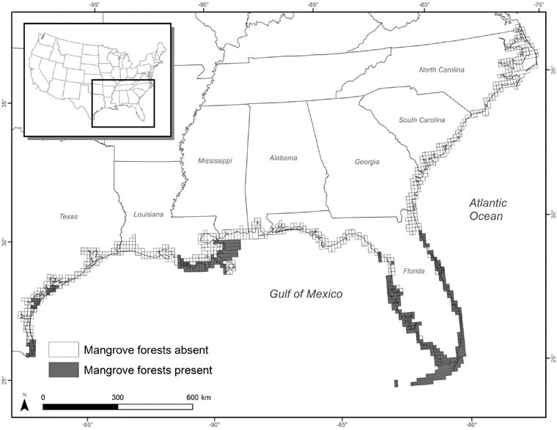
Table 1.1. Common mangrove species with common and scientific names and general distribution in the US and Caribbean regions.
Scientific name Common name Distribution
Rhizophora mangle Red mangrove Caribbean, FL, TX, HI (non-native) Avicennia germinans Black mangrove Caribbean, FL, TX, LA, MS, American Pacific Trust
Territories Laguncularia racemosa White mangrove Caribbean, FL, American Pacific Coast Conocarpus erectus Buttonwood Caribbean, FL Acrostichum aureum Mangrove fern Caribbean, FL
Figure 1.3. Mangroves that occur in the U.S. and Caribbean. A) Rhizophora mangel (red mangrove) showing the classical tangle of prop roots. B) Avicennia marina (black mangrove) showing the diagnostic presence of pneumatophores. C) Laguncularia racemosa (white mangrove). D) Conocarpus erectus (buttonwood mangrove (A, B = Research Planning, Inc. and C, D = Robin Lewis), Lewis Environmental Services, Inc.).
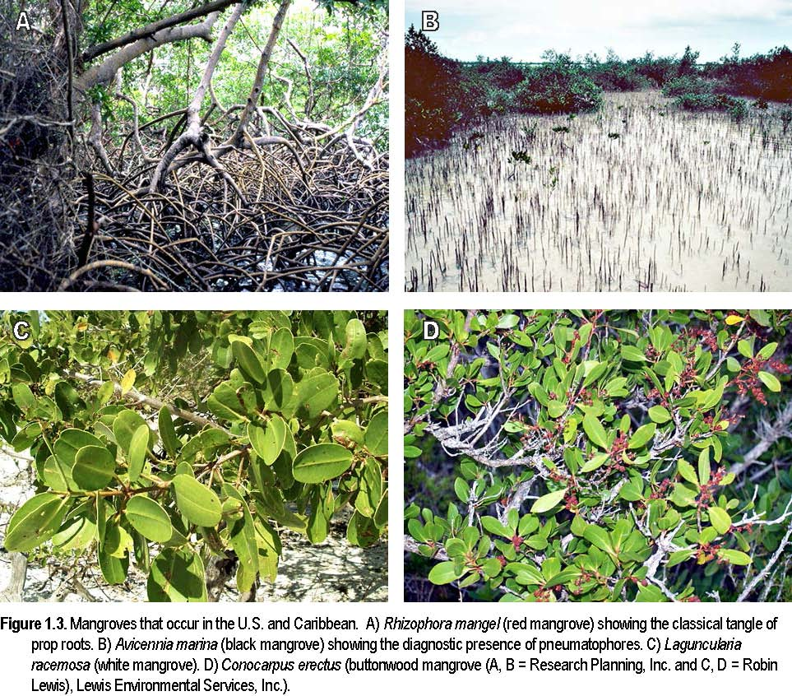
Mangrove Ecotypes
Mangroves colonize protected areas along the coast such as deltas, estuaries, lagoons, and islands. Topographic and hydrological characteristics within each of these settings define a number of different mangrove ecotypes. Five of the most common ecotypes include fringe, riverine, basin, overwash and dwarf forests as shown in Figure 1.4 (Lugo and Snedaker 1974; Twilley 1998). A fringe forest borders protected shorelines, canals, and lagoons, and is inundated by daily tides. A riverine forest flanks the estuarine reaches of a river channel and is periodically flooded by nutrient-rich fresh and brackish water. Drainage depressions in the interior of mangrove areas harbor basin forests, characterized by stagnant or slow-flowing water. Overwash forests are islands frequently inundated or washed over by tides. Dwarf or scrub forests grow in areas where hydrology is restricted, resulting in conditions of high evaporation, high salinity, or low nutrient status. Low temperatures at the northern ranges of mangrove species distribution can also result in “scrub” mangrove areas in fringe, basin, riverine, and overwash settings. Such stressful environmental conditions stunt mangrove growth.
Each of these mangrove ecotypes is characterized by different patterns of forest structure, productivity, and biogeochemistry, all of which are controlled by a combination of factors such as hydrology (tides, freshwater discharge, rainfall), soil characteristics, biological interactions, and the effects of storms and other disturbances.
Figure 1.4. Various types of mangrove forests (modified from Lugo and Snedaker 1974).
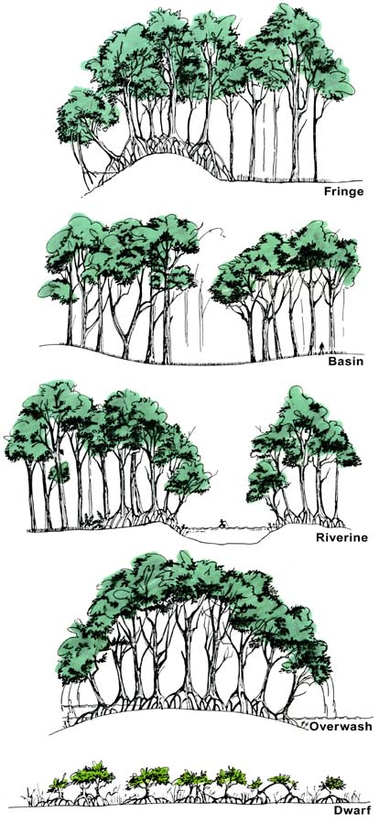
Hermaphroditic – Both Life History sexes present in an
Mangrove Reproduction and Growth
individual organism.
Vivipary – The condition Most mangroves are hermaphroditic (both sexes are present in an individual in which the embryo (the organism). Mangroves are pollinated almost exclusively by animals (bees, young plant within the small insects, moths, bats, and birds), except for Rhizophora, which is
seed) germinates while
primarily self-pollinated (Lowenfeld and Klekowski 1992). In most
still attached to the
mangroves, germination takes place while the embryo is still attached to the
parent plant.
parent tree (a condition called vivipary). The embryo has no dormant stage, Propagule – Seedling but grows out of the seed coat and the fruit before detaching from the plant. growing out of a fruit;
Because of this, mangrove propagules are actually seedlings, not seeds
this process begins while
(Figure 1.5).
the fruit is still attached to the tree.
Vivipary as a life history strategy helps mangroves cope with the varying salinities and frequent flooding of their intertidal environments, and increases the likelihood that seedlings will survive. Since most non-viviparous plants disperse their offspring in the dormant seed stage, vivipary presents a potential problem for dispersal. Most species of mangroves solve this problem by producing propagules containing substantial nutrient reserves that can float for an extended period. In this way, the propagule can survive for a relatively long time before establishing itself in a suitable location (McMillan 1971; Tomlinson 1986).
Buoyancy, currents, and tides disperse mangrove propagules and deposit them in the intertidal zone. Once established, the numerous seedlings face not only the stresses of salinity and variable flooding, but also competition for light (Smith 1992). These, in addition to other sources of mortality, cause very low survival rates for seedlings and saplings. Determining the age of mangroves is difficult, but flowering individuals have been recorded as young as 1.5 years old. Tree growth, survival, and the ensuing forest structure are determined by the mangrove forests’ ecotype.
There are few estimates of mangrove forest turnover (the time required for the forest to replace itself). Despite a precarious existence in the intertidal zone, Smith (1992) estimates mangrove turnover at 150-170 years. For comparison, an estimate for turnover in lowland tropical rainforests is about 118 years (Hartshorn 1978).
Figure 1.5. Examples of mangrove seedlings that occur in the U.S. and Caribbean. A) Rhizophora mangle (red mangrove). B) Avicennia marina (black mangrove). C) Laguncularia racemosa (white mangrove). D) Conocarpus erectus (buttonwood mangrove. (Robin Lewis, Lewis Environmental Services, Inc.).
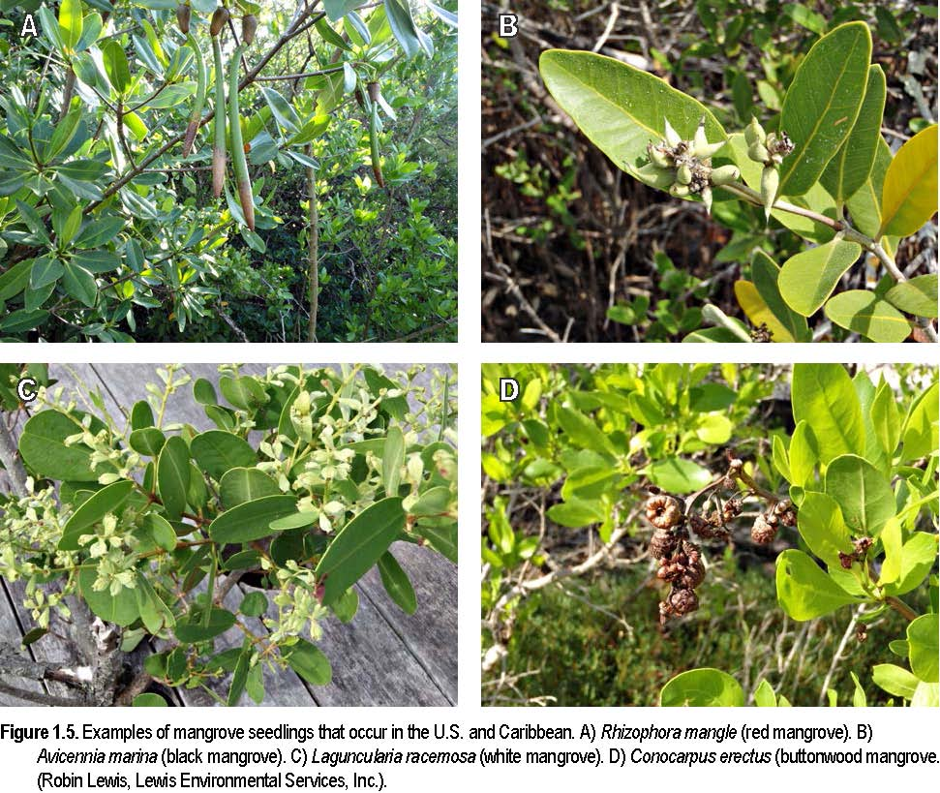
Evapotranspiration – Adaptations to Salinity
The transfer of water
Mangroves can establish and grow under a relatively wide range of flooding
from the soil, through a
plant, and to the and salinity conditions; however, they are generally restricted to the
atmosphere through the intertidal zone where there is less competition with freshwater plants.
combined processes of Mangroves have developed a series of physiological and morphological
evaporation and adaptations that have allowed them to successfully colonize these
transpiration.
environments.
Transpiration is a process of water loss
Mangroves do not require salt water to survive, but because of poor
through leaf stomatal
competition with freshwater vegetation and unique adaptations to the
openings.
intertidal zone, they are generally found under the influence of salt water. Salinity is mainly determined by local hydrology, where input of salt water comes from the periodic tides and fresh water comes from rivers, rainfall, groundwater, and runoff. High evapotranspiration (water loss through the soil and plant leaves) in the tropics and subtropics can increase salinity considerably, especially under environments with restricted water flow. Thus, salinity can fluctuate widely within mangrove forests, both over time and space.
Mangroves have evolved different mechanisms to tolerate high salinities: salt exclusion, salt secretion, and tolerance of high salt concentrations within plant tissues are the main strategies. Most mangroves have developed all three mechanisms, although to varying extents. Rhizophora, Bruguiera, and Ceriops have root ultra-filters that exclude salt while extracting water from soils (Rützler and Feller 1996). In salt secretion, special organs or glands remove salts from plant tissues. For example, Avicennia and Laguncularia have special, salt-secreting glands that cause salt crystals to form on the leaf surfaces (Figure 1.6). These crystals then can be blown away or easily washed away by the rain. Leaf fall is another mechanism for eliminating excess salt in mangroves (Kathiresan and Bingham 2001).
Figure 1.6. Close-up of mangrove leaf showing salt crystals (C.E. Proffitt; Gulf of Fonseca, Honduras).
1-8
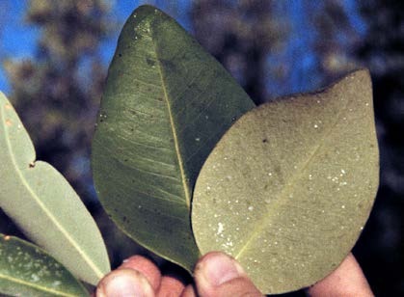
Figure 1.7. Rhizophora tree showing prop roots
(C.E. Proffitt).
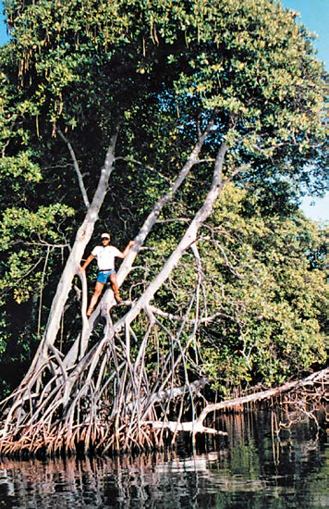
Adaptations to Flooding Aerial roots – Roots that
are formed in and Mangrove forests are periodically flooded, with the frequency and exposed to air. In magnitude of flooding determined by local topography combined with tidal mangrove species (e.g., action, river flow, rainfall, surface runoff, groundwater, and Rhizophora spp.), aerial evapotranspiration. As with salinity, hydrology in mangrove ecosystems roots develop into stilt varies greatly in time and space, and mangrove species differ in their ability roots (prop roots and to tolerate flooding. drop roots) that anchor
into the sediment, offering mechanical
At the intertidal scale, the magnitude and frequency of flooding decreases
support, nutrient
in a landward direction. Mangrove species often show a distinctive
absorption, and gas
distribution across this gradient, which is the basis for classifying mangroves
exchange.
by lower, middle, and upper intertidal zones. The lower intertidal zone represents an area inundated by Pneumatophore – A medium-high tides and is flooded vertical extension of an more than 45 times a month. The underground root, with middle intertidal is inundated by lenticels and aerenchyma normal high tides and it is generally to allow for gas
exchange.
flooded from 20 to 45 times a month.
Pneumatophores are
The upper intertidal zone represents
characteristic of trees
areas flooded less than 20 times a
adapted to flooded
month (Robertson and Alongi 1992).
conditions (such as Avicennia spp.).
Flooded conditions can decrease soil oxygen, impacting root tissues that need oxygen to metabolize, and toxic substances such as sulfides can accumulate. Mangroves have evolved special morphological adaptations to cope with this lack of oxygen. First, mangroves have shallow root systems to avoid the lack of oxygen in deeper soils. As a result, most of the root biomass is found above 70-cm soil depth (Jimenez 1992). In some species (Avicennia, Laguncularia), roots form an extensive network close to the soil surface. Other species (Rhizophora) form extensive aerial roots (prop roots and drop roots) that help stabilize the tree in unconsolidated sediments (Figure 1.7). Second, above-ground root tissue such as aerial roots (Rhizophora) and pneumatophores (Avicennia, Laguncularia) transport oxygen from the atmosphere to the root system.
Lenticel – A small, These specialized roots contain spongy tissue connected to the exterior of elliptical pore in the the root via small pores called lenticels. During low tide, when lenticels are periderm that is a means exposed to the atmosphere, oxygen is absorbed from the air and
of gaseous exchange.
transported to and even diffused out of the roots below ground. This
Defoliation – The diffusion of oxygen maintains an oxygenated microlayer around the roots
removal of the foliar that enhances nutrient uptake. The microlayer also avoids toxicity of
tissues of a plant, compounds such as hydrogen sulfide that otherwise accumulate under such
resulting from
conditions.
mechanical (e.g., hurricanes), biological
Despite the harsh conditions under which mangrove forests develop, they
(herbivore), or chemical
can form highly diverse and productive communities. Riverine mangrove
agents (e.g., plant hormones). forests are recognized among the most productive ecosystems in the world, due in large part to low salinities, high nutrient supply, and regular flooding (Day et al. 1987). Less ideal conditions, such as hypersalinity or permanent flooding, severely limit mangrove growth and productivity; extreme conditions, such as restricted hydrology due to impounding, can kill many mangroves. Growth and productivity of mangroves thus ranges widely depending on the conditions under which they grow.
Mangrove Mortality
Mangrove mortality from biological sources includes competition, disease, herbivory, predation, and natural tree senescence. All developmental stages are affected, including propagules, seedlings, saplings, and trees. However, mangroves in early stages of development experience higher mortality rates and mortality is generally density-dependent. At the tree stage, smaller trees are at higher risk due to competition with larger trees for light and/or nutrients.
Mangrove diseases include impacts from fungi that defoliate and kill black and red mangroves in Australia and Florida. Insects such as scales and caterpillars cause defoliation and, in Puerto Rico, beetles and other boring insects are known to kill mangroves. Rhizophora seedlings are especially vulnerable to mortality caused by the boring beetle. Crabs are important predators of propagules and are a major source of mortality at this stage. Differences in predation rates on seedlings of different mangrove species may eventually alter species dominance in the adult trees (Smith 1987). Overall, these various biotic disturbances have a relatively minor impact on the mangrove forest when compared with larger-scale environmental impacts.
In contrast with purely biological causes, severe environmental disturbances can inflict larger-scale mortality on mangrove forests. These disturbances include periodic frosts, hurricanes, and other storms that can cause physical damage to mangroves, and heavy sedimentation (Jiménez and Lugo 1984). In spite of the drastic consequences of massive tree mortality, mangrove forests are generally able to recover.
Habitat Function
Shoreline Stabilization and Protection
Located along the coastline, mangroves play a very important role in soil formation, shoreline protection, and stabilization. The mangrove forest’s extensive, above-ground root structures (prop roots, drop roots, and pneumatophores) act as a sieve, reducing current velocities and shear, and enhancing sedimentation and sediment retention (Carlton 1974; Augustinus 1995). The intricate matrix of fine roots within the soil also binds sediments together. Not only do mangroves trap sediments—they also produce sediment through accumulated, mangrove-derived organic matter. Mangrove leaves and roots help maintain soil elevation, which is especially important in areas of low sediment delivery, such as the southern coast of Florida. By enhancing sedimentation, sediment retention, and soil formation, mangroves stabilize soils, which reduces the risk of erosion, especially under high-energy conditions such as tropical storms.
Coastal protection is also related to the location of mangroves in the intertidal zone. Mangroves are able to absorb and reduce the impacts of the strong winds, tidal waves, and floods that accompany tropical storms, thereby protecting uplands from more severe damage (Tomlinson 1986; Mazda et al. 1997). Even though some of these forces can devastate the mangrove forest, mangroves in general have a great capacity to recover after major disturbances. Mangroves produce abundant propagules, their seedlings grow quickly, and they reach sexual maturity early—characteristics that accelerate their natural ability to regenerate. The speed of recovery, however, depends on the type of forest affected, the nature, persistence, and recurrence of the disturbance, and the availability of propagules.
Animal Habitat and Food Source
Mangroves provide both habitat and a source of food for a diverse animal community that inhabits both the forest interior and the adjacent coastal waters. Some animals depend on the mangrove environment during their entire lives while others utilize mangroves only during specific life stages, usually reproductive and juvenile stages (Yañez-Arancibia et al. 1988).
Detritus – Non-living Mangroves’ intricate aerial root system, which is most highly developed
organic matter that is so within the lower intertidal zone, provides a substrate for colonization by decomposed that it is
algae, wood borers, and fouling organisms such as barnacles, oysters,
impossible to identify the
mollusks, and sponges. From the diverse group of invertebrates found in
original parent material.
mangroves, arthropods, crustaceans, and mollusks are among the most
abundant and have a significant role in mangrove ecosystems. As mentioned earlier, some species of crabs, recognized as propagule or seedling predators, can influence mangrove forest structure (Smith 1987), as may seedling predation by beetles or other insects. Crabs and snails, important components of the detritus food chain, help break down leaf litter through grazing.
Shrimp, an important fisheries resource, find food and shelter in mangrove forests. Likewise, commercially important bivalves such as oysters, mussels, and clams are commonly found in and around mangrove roots. Mangroves are also recognized as essential nursery habitat for a diverse community of fish, such as groupers, snappers, and snook, which find protection and abundant food in these environments, especially during juvenile stages.
Many animals found within mangroves are semi-aquatic or derived from terrestrial environments. Numerous insect species are found in mangrove forests; some play critical roles as mangrove pollinators, herbivores, predators, and as a food source for other animals (Hogarth 2007). Amphibians and reptiles such as frogs, snakes, lizards, and crocodiles also inhabit mangrove forests. Birds use mangroves for refuge, nesting, and feeding. In Florida and Australia, up to 200 species of birds have been reported around mangrove communities (Ewel et al. 1998). Most of these birds do not depend completely on mangroves, and use these habitats only during part of their seasonal cycles, or during particular stages of the tide. Mammals living in or using mangrove forests include raccoons, mink, river otter, wild pigs, rodents, deer, black bear, monkeys, and bats. Finally, sea turtles, manatees, and dolphins live in mangrove-dominated estuaries.
Water Quality Improvement
Mangrove habitats maintain water quality. By trapping sediments in the mangrove root system, these and other solids are kept from offshore waters, thereby protecting other coastal ecosystems such as oyster beds, seagrasses, and coral reefs from excessive sedimentation. This process can also remove agrochemical and heavy-metal pollutants from the water, since these contaminants adhere to sediment particles.
Mangroves also improve water quality by removing organic and inorganic nutrients from the water column. Through denitrification and soil-nutrient burial, mangroves lower nitrate and phosphorus concentrations in contaminated water, preventing downstream and coastal eutrophication (Ewel et al. 1998). However, the potential of mangroves to “clean” water is limited and depends on the nature of the inputs, and the surface area and nutrient biochemistry of the mangrove forest. Mangroves have also been used to treat tertiary wastewater (Twilley 1998). Mangrove systems are often nutrient limited and thus have a large capacity to retain nutrients.
Mangrove Economic Value and Uses
Mangroves provide products and services, not all of which are easily quantified in economic terms. Mangrove products can be obtained directly from the forest (wood) or from a derivative, such as crabs, shrimp, and fish. The most common uses of mangrove wood are as a source of fuel, either charcoal or firewood, and as the primary material for the construction of boats, houses, furniture, etc. Given these uses, commercial mangrove production (especially of Rhizophora spp.) is common around the world, primarily in Asia (Bandaranayake 1998).
Besides wood, other mangrove products have been exploited commercially. Mangrove bark has traditionally been used as a source of tannins, which are used as a dye and to preserve leather. The pneumatophores of different mangrove species are used in making corks and fishing floats; some are also used in perfumes and condiments. The ash of Avicennia and Rhizophora mangle is used as a soap substitute. Other mangroves extracts are used to produce synthetic fibers and cosmetics. Mangroves are also used as a source of food (mangrove-derived honey, vinegar, salt, and cooking oil) and drink (alcohol, wine). For example, the tender leaves, fruits, seeds, and seedlings of Avicennia marina and vegetative parts of other species are traded and consumed as vegetables (Bandaranayake 1998).
Mangroves have great potential for medicinal uses. Materials from different species can treat toothache, sore throat, constipation, fungal infections, bleeding, fever, kidney stone, rheumatism, dysentery, and malaria. Mangroves also contain toxic substances that have been used for their antifungal, antibacterial, and pesticidal properties (Bandaranayake 1998).
Mangrove forests have been widely recognized for their role in maintaining commercial fisheries by providing nursery habitat, refuge from predators, and food to important species of fish and shrimp.
Demonstrating a statistical relationship between mangroves and fishery yields has proven difficult, however, because mangroves, seagrasses, and other nearshore habitats are closely linked, and all provide nursery habitat and food for fish (Pauly and Ingles 1999). Mangrove ecotourism is not yet a widely developed practice, but seems to be gaining popularity as a non-destructive alternative to other coastal economic activities. Mangroves are attractive to tourists mostly because of the fauna that inhabit these forests, especially birds and reptiles such as crocodiles.
Mangrove forests are among the most carbon-rich forests in the tropics, and there has been a growing interest in their potential value for carbon sequestration. Hutchison et al. (2013) estimated a total global mangrove above-ground biomass of 2,829,387,000 tonnes, with an average of 184.8 tonnes per hectare. McLeod et al. (2001) estimated that mangrove forests bury 31,000,000–34,000,000 tons of carbon per year. These data provide a tangible reason to conserve and restore mangroves–they can be valued directly in monetary terms for their carbon storage functions.
Anthropogenic and Naturally Occurring Impacts
Storms and Hurricanes
Mangroves are particularly sensitive to storms and hurricanes because of their exposed location within the intertidal zone, their shallow root systems, and the non-cohesive nature of the forest soils. The effect of storms and hurricanes varies, depending on factors such as wind fields and water levels. Small storms generally kill trees by lightning or wind-induced tree falling, creating forest gaps—an important mechanism for natural forest regeneration. Coastal sedimentation resulting from storms can also lead to mangrove forest expansion.
In contrast, high-energy storms (hurricanes and typhoons) can devastate mangrove forests. Entire mangrove populations can be destroyed, with significant long-term effects to the ecosystem (Figure 1.7; Jiménez and Lugo 1985). Mangrove forests that are frequently impacted by hurricanes show uniform tree height, reduced structural development and, sometimes, changes in species composition. However, mangrove forests can recover despite such impacts. How fast a forest recovers depends on the severity of mangrove damage and mortality, mangrove species composition, the degree of sediment disturbance and propagule availability.
Sea Level Rise Eustatic sea level rise – The worldwide rise in sea In response to global climate change, a gradual increase in sea level rise has level elevation due been documented since the late Holocene (7000 YBP) and continues to the mostly to the thermal expansion of seawater
present. Estimated global rates of sea level rise (eustatic) since 1992 have
and the melting of
been estimated to be 3.2 mm/yr-1 (IPCC 2013). Local subsidence, uplift, or
glaciers.
other geomorphological changes can cause relative sea level rise (RSLR) to
RSLR – relative sea level
be greater or less than eustatic rise. Along the Atlantic Coast of the United
rise -The net effect of
States, for example, an estimated RSLR of 2-4 mm/yr has been calculated for
eustatic sea level rise and a period spanning the last 50 years. In contrast, some areas along the local geomorphological Louisiana coast are experiencing a RSLR of 10 mm/yr (NOAA 2014) changes in elevation. Local subsidence can make RSLR much greater
Changes in sea level affect all coastal ecosystems. Changes in hydrology will
than eustatic rise.
result as the duration and extent of flooding increases. How well mangrove
Microtidal – A tidal range
ecosystems will adapt to this hydrological change will depend on the
of less than one meter.
magnitude of the change and the ability of mangroves to either 1) increase mangrove sediment elevation through vertical accretion, or 2) migrate in a landward direction. The mangrove sediment surface itself is in dynamic equilibrium with sea level, since a local loss of elevation will result in faster sediment accumulation. The problem with accelerated sea level rise is that the rate of rise might be faster than the ability of mangrove forests to accumulate and stabilize sediments. Mangroves can migrate back into previous uplands, but only if there is enough space to accommodate the mangroves at the new intertidal level. Local elevation gradients may make this regression impossible.
Mangroves colonizing macrotidal environments and receiving land-based and/ or marine sediments (i.e., riverine mangroves) are generally less vulnerable to changes in sea level rise than are mangroves in microtidal environments, such as in Florida and the Yucatan, or mangroves with restricted hydrology. Land-based and marine sediments increase vertical accretion through direct deposition on mangrove soils. Nutrient and freshwater supply tend to enhance mangrove productivity, which contributes to vertical accretion through the production and deposition of organic matter and root growth (Krauss et al. 2014). Mangroves under restricted hydrology depend mostly on in situ organic matter production to attain vertical accretion. Different mangrove ecotypes will therefore have differing sensitivities to increases in RSLR.
Chlorosis/chlorotic – Sedimentation abnormal condition
Even though mangroves colonize sedimentary environments, excessive
characterized by the absence of green sediment deposits can damage them. Moderate sedimentation is beneficial pigments in plants, to mangroves as a source of nutrients and to keep pace with predicted causing yellowing of increases in eustatic sea level rise. When excessive, sudden sedimentation normally green leaves. can reduce growth or even kill mangroves. Complete burial of mangrove root structures (aerial roots, pneumatophores) interrupts gas exchange, killing root tissue and trees. For example, Avicennia trees will die after 10 cm of root burial (Ellison 1998). Seedlings are especially sensitive to excessive sedimentation. Under experimental conditions, Rhizophora apiculata seedlings had reduced growth and increased mortality after 8 cm of sediment burial (Terrados et al. 1997). Excessive sedimentation can result from natural phenomena such as river floods and hurricanes, but also from human alterations to the ecosystem. Road and dam construction, mining, and dredge spoil have buried and killed mangroves.
Mangrove Pollution
Human-caused pollution in mangrove ecosystems includes thermal pollution (hot-water outflows), heavy metals, pesticides, PCBs, and other industrial pollutants, nutrient pollution (including fertilizers and sewage), and oil spills. Oil spill impacts are discussed in detail in Chapter 2. Thermal pollution from hot-water outfalls is not common in the tropics but, when present, reduces leaf area and causes chlorotic leaves, partial defoliation, and dwarfed seedlings. Seedlings are more sensitive than trees, showing 100% mortality with a water temperature rise of 7-9°C above ambient temperatures (Hogarth 2007).
Mining and industrial wastes are the main sources for heavy metal pollution (especially mercury, lead, cadmium, zinc, and copper). When heavy metals reach a mangrove environment, most are already bound onto suspended particulates (sediments) and in general do not represent an ecological threat. Although the accumulation of heavy metals in mangrove soils has not been studied in detail, they may decrease growth and respiration rates of mangroves, and will also negatively impact associated animals. Concentrations of mercury, cadmium, and zinc are toxic to invertebrate and fish larvae, and heavy metals cause physiological stress and affect crab reproduction.
Runoff from agricultural fields represents the main source of organic Anoxic – Without free chemical contamination in mangrove ecosystems, including fertilizers and oxygen. pesticides. Little is known about the effects of pesticides in mangroves and
Bioaccumulate – Uptake associated fauna, although chronic effects are likely. As with heavy metals, of dissolved chemicals many of these compounds are absorbed onto sediment particles and from water and uptake degrade very slowly under anoxic conditions. Despite the possibility of from ingested food and
sediment residues.
burial, heavy metals and pesticides may bioaccumulate in animals that use mangroves (especially those closely associated with mangrove sediments), such as fish, shrimp, and mollusks.
Nutrient pollution in mangroves can have various effects. Sewage disposal under carefully managed conditions can enhance tree growth and productivity as a result of added nutrients, especially nitrogen and phosphorus (Twilley 1998). However, if the rate of disposal is greater than the uptake rate (a function of forest size and mangrove ecotype), excessively high nutrient concentrations will result. This causes excessive algal growth, which can obstruct mangrove pneumatophores and reduce oxygen exchange. Algal mats can also hinder growth of mangrove seedlings (Hogarth 2007).
Excessive microbial activity accompanies high levels of nutrients, and depletes oxygen in the water, which is harmful for mangrove-associated aquatic fauna.
Development and Forest Clearing
Despite the ecological and economic importance of mangroves, deforestation has been widespread. Deforestation has mostly been related to firewood and timber harvesting, land reclamation for human establishment, agriculture, pasture, salt production, and mariculture. Tropical countries have sustainably harvested mangrove wood for generations, but increasing populations have led to unsustainable practices.
Despite laws established for mangrove protection in many different countries, unregulated exploitation and deforestation continues. Worldwide, 20-35% of mangrove area has been lost since about 1980, and mangrove areas are disappearing at the rate of approximately 1% per year (FAO 2007). In the Philippines, approximately 60% of the original mangrove area has disappeared. In Thailand, 55% of the mangrove cover has been lost over about 25 years. Eventually, the overexploitation of mangrove forests will degrade habitat, increase shoreline erosion, damage fisheries and, ultimately, the services derived from these ecosystems will be lost.
Anchialine ponds – A Invasive Species rare Hawaiian ecosystem,
Mangroves have been introduced in several tropical islands where they did
consisting of pools with no surface connection to not occur naturally, and may thus be considered an invasive species. Hawaii is
the ocean, but affected an example of such a case, where the proliferation of Rhizophora mangle has
by tides. These pools deteriorated habitat for some endemic waterbirds and has damaged
support an assemblage
sensitive archaeological sites.
of animals and plants, many of which are
The proliferation of mangroves has also been linked to the premature
endangered.
infilling of a unique Hawaiian aquatic ecosystem called anchialine ponds.
Despite providing useful environmental services (e.g., shoreline protection, organic matter production, and water quality), the mangroves may proliferate in these foreign environments and seriously impact the native flora and fauna. The cost of mechanical removal has been reported to vary from $108,000 to $377,000 per hectare (Allen 1998).
For Further Reading
Allen, J.A. 1998. Mangrove as alien species: the case of Hawaii. Global Ecology and Biogeography
Letters 7: 61-71.
Augustinus, P. G. E. F. 1995. Geomorphology and sedimentology of mangroves. In: Perillo, G.M.E. (ed.), Geomorphology and Sedimentology of Estuaries. Developments in Sedimentology 53. Amsterdam: Elsevier Science. pp. 333-357.
Bandaranayake, W.M. 1998. Traditional and medicinal uses of mangroves. Mangroves and Salt Marshes
2:133-148.
Carlton, J. M. 1974. Land-building and stabilization by mangroves. Environmental Conservation
1(4):285-294.
Day, J., W. Conner, F. Ley-Lou, R. Day, and A. Machado. 1987. The productivity and composition of
mangrove forests, Laguna de Terminos, Mexico, Aquatic Botany 27:267-284.
Deltares. 2014. Habitat requirements for mangroves. Available at: https://publicwiki.deltares.nl/display/BWN/Building+Block+-+Habitat+requirements+for +mangroves
Duke, N.C. 1992. Mangrove floristics and biogeography. In: Robertson, A.I. and D.M. Alongi (eds.), Coastal and Estuarine Studies. Tropical Mangrove Ecosystems. Washington, D.C.: American Geophysical Union. pp. 63-100.
Ewel, K.C., R.R Twilley, and J. E. Ong. 1998. Different kinds of mangrove forests provide different goods and services. Global Ecology and Biogeography Letters 7:83-94.
Ellison, A. M. 2000. Mangrove restoration: Do we know enough? Restoration Ecology 8:219-229.
Ellison, J.C. 1998. Impacts of sediment burial on mangroves. Marine Pollution Bulletin 37:420-426.
FAO. 2007. The World’s Mangroves 1980-2005. FAO Forestry Paper 153. Rome, Italy: Food and Agricultural Organization. pp. 77.
Hartshorn, G.S. 1978. Tree fall and tropical forest dynamics. In: Tomlinson, P.B. and M.H. Zimmerman (eds.), Tropical Trees as Living Systems. London: Cambridge University Press. pp. 617-38.
Hutchison. J., A. Manica,. R. Swetnam, A. Balmford, and M. Spalding. 2013. Predicting global patterns in mangrove forest biomass. Conservation Letters 7(3):233-240.
Hogarth, P.J. 2007. The Biology of Mangroves and Seagrasses. 2nd Edition. New York: Oxford University Press. 273 pp.
IPCC. 2013. Working Group I Contribution to the IPCC Fifth Assessment Report (AR5), Climate Change 2013: The Physical Science Basis .Chapter 13 – Sea Level Change -Final Draft Underlying Scientific-Technical Assessment. International Panel on Climate Change.
Jiménez, J.A. and A.E. Lugo. 1985. Tree mortality in mangrove forests. Biotropica 17(3):177-185.
Jiménez, J.A. 1992. Mangrove forest of the Pacific Coast of Central America. In: U. Seelinger (ed.), Coastal Plant Communities of Latin America. San Diego: Academic Press. pp. 259-267.
Kathiresan, K. and B.L. Bingham. 2001. Biology of mangroves and mangrove ecosystems. Advances in Marine Biology 40:81-251.
Krauss, K.W, K.L. McKee, C.E. Lovelock, D.R. Cahoon, N. Saintilan, R. Reef, and L. Chen. 2014. How mangrove forests adjust to rising sea level. New Phytologist 202:19-34
Lacerda, L.D. 2002. Mangroves Ecosystems: Function and Management. Berlin: Springer Verlag. 342 pp.
Lowenfeld, R. and E.J. Klekowski. 1992. Mangrove genetics. I. Mating system and mutation rates of Rhizophora mangle in Florida and San Salvador Island, Bahamas. International Journal of Plant Science153:394-399.
Lugo, A.E., S. Brown, and M.M. Brinson. 1990. Concepts in wetland ecology. In: Lugo, A.E., M. Brinson, and S. Brown (eds.), Ecosystems of the World. 15. Forested Wetlands. Amsterdam: Elsevier Science. pp. 53-85.
Lugo, A.E. and S.C. Snedaker. 1974. The ecology of mangroves. Annual Review of Ecology and Systematics 5:39-64.
Markley, J.L., C. McMillan, and G.A. Thompson, Jr. 1982. Latitudinal differentiation in response to chilling temperatures among populations of three mangroves, Avicennia germinans, Laguncularia racemosa, and Rhizophora mangle from the western tropical Atlantic and Pacific Panama. Canadian Journal of Botany 60:2704-2715.
Mazda, Y., M. Magi, M. Kogo, and P.N. Hong. 1997. Mangroves as a coastal protection from waves in the Tong King delta, Vietnam. Mangroves and Salt Marshes 1:127-135.
McKee, K.L. and P. Faulkner. 2000. Restoration of biogeochemical function in mangrove forests. Restoration Ecology 8:247-259.
Mcleod, E, G.L. Chmura, S. Bouillon, R. Salm, M. Björk, C.M. Duarte, C.E. Lovelock, W.H. Schlesinger, and
B.R. Silliman. 2001. A blueprint for blue carbon: toward an improved understanding of the role of vegetated coastal habitats in sequestering CO2. Frontiers in Ecology and Environment 9:552–560.
McMillan, C. 1971. Environmental factors affecting seedling establishment of the black mangrove on the central Texas Coast. Ecology 52(5):927-930.
Mook, D. 1986. Absorption efficiencies of the intertidal mangrove dwelling mollusk Melampus coffeus Linne and the rocky intertidal mollusk Acanthopleura granulata Gemlin. Marine Ecology 7:105-113.
NOAA. 2014. How sea level rise affects coastal planning. Available at: http://www.noaa.gov/features/climate/sealevelchanges.html
Osland, M.J. N. Enwright, R.H. Day, and T.W. Doyle. 2013. Winter climate change and coastal wetland foundation species: salt marshes vs. mangrove forests in the southeastern United States. Global Change Biology 19:1482-1494.
Pauly, D. and J. Ingles. 1999. The relationship between shrimp yields and intertidal vegetation (mangrove) areas: a reassessment. In: Yañez-Arancibia, A. and A.L. Lara-Dominguez (eds.), Mangrove Ecosystems in Tropical America. Instituto de Ecologia, A.C. Xalapa, Mexico; UICN/ORMA Costa Rica; NOAA/NMFS Silver Spring, Maryland. pp. 311-316.
Proffitt, C.E., K.M. Johns, C.B. Cochrane, D.J. Devlin, T.A. Reynolds, D.L. Payne, S. Jeppesen, D.W. Peel, and
D.D. Linden. 1993. Field and laboratory experiments on the consumption of mangrove leaf litter by the macrodetritivore Melampus coffeus L. (Gastropoda: Pulmoneta). Florida Scientist 56:211-222.
Robertson, A.I. and D.M. Alongi (eds.). 1992. Tropical Mangrove Ecosystems, Washington, D.C.: Coastal and Estuarine Studies Series, American Geophysical Union. 329 pp.
Rützler, K. and I.C. Feller. 1996. Caribbean mangrove swamps. Scientific American, March 1996:94-99.
Saenger, P. 2002. Mangrove Ecology, Silviculture and Conservation. Dordrecht, The Netherlands: Kluwer Academic. 360 pp.
Sherrod, C.L., D.L. Hockaday, and C. McMillan. 1986. Survival of red mangrove Rhizophora mangle, on the Gulf of Mexico coast of Texas. Contributions in Marine Science 29:27-36.
Smith, T.J. 1992. Forest structure. In: Robertson, A.I. and Alongi, D.M. (eds.), Coastal and Estuarine Studies. Tropical Mangrove Ecosystems. Washington, D.C.: American Geophysical Union. pp. 101-136.
Smith, T.J. III. 1987. Seed predation in relation to tree dominance and distribution in mangrove forests. Ecology 68:266-273.
Spalding, M., M. Kainuma, and L. Collins. 2010. World Atlas of Mangroves. Washington, D.C.: Earthscan. 319 pp.
Terrados, J., U. Thampanya, N. Srichai, P. Kheowvongsri, O. Geertz-Hansen, S. Boromthanarath, N. Panapitukkul, and C.M. Duarte. 1997. The effect of increased sediment accretion on the survival and growth of Rhizophora apiculata seedlings. Estuarine, Coastal and Shelf Science 45:697-701.
Tomlinson, P.B. 1986. The Botany of Mangroves. New York: Cambridge University Press. 433 pp.
Twilley, R.R. 1989. Impacts of shrimp mariculture practices on the ecology of coastal ecosystems in Ecuador. A sustainable shrimp mariculture industry for Ecuador. In: Olsen, S. and L. Arriaga (eds.), International Coastal Resources Management Project. Technical Report Series TR-E-6. Providence: University of Rhode Island. pp. 91-120.
Twilley, R.R. 1998. Mangrove wetlands. In: Messina, M.G. and W.H. Conner (eds.), Southern Forested Wetlands. Ecology and Management. Boca Raton, Florida: Lewis Publishers. pp. 445-473.
Yañez-Arancibia, A., A.L. Lara-Domínguez, J.L. Rojas-Galaviz, P. Sánchez-Gil, J.W. Day, and C.J. Madden. 1988. Seasonal biomass and diversity of estuarine fishes coupled with tropical habitat heterogeneity (southern Gulf of Mexico). Journal of Fisheries Biology 33 (Suppl. A):191-200.
Weathering – Changes in
CHAPTER 2. OIL TOXICITY AND EFFECTS ON
the physical and
MANGROVES
chemical properties of oil
due to natural processes,
including evaporation, Key Points
emulsification,
• Mangroves are highly susceptible to oil exposure; oiling may kill
dissolution, photo-
them within a few weeks to several months.
oxidation, and
biodegradation. • Lighter oils are more acutely toxic to mangroves than are heavier oils. Increased weathering generally lowers oil toxicity. However,
Canopy – topmost layer
heavier oils can result in substantial physical smothering and
of leaves, twigs, and
branches of forest trees coating impacts.
or other woody plants. • Oil-impacted mangroves may suffer yellowed leaves, defoliation, and tree death.
- More subtle responses include branching of pneumatophores, germination failure, decreased canopy cover, increased rate of mutation, and increased sensitivity to other stresses.
- Response techniques that reduce oil contact with mangroves, such as offshore use of chemical dispersants, reduce the resultant effects as well. Tradeoffs include potential increased toxicity to adjacent communities, and increased penetration of dispersed oil to mangrove sediments.
- The amount of oil reaching the mangroves and the length of time spilled oil remains near the mangroves are key variables in determining the severity of effect.
- Mangrove-associated invertebrates and plants recover more quickly from oiling than do the mangroves themselves, because of the longer time for mangroves to reach maturity.
- Under severe oiling conditions, mangrove impacts may continue for years to decades, resulting in permanent habitat loss.

In this chapter we discuss the toxicity of oil to the broad class of trees called mangroves. In contrast to other habitats, tropical or otherwise, there is a fairly robust literature on the effects of oil to mangroves. This work includes monitoring of mangrove areas oiled during actual spills, field studies of oil impacts on mangroves, and laboratory studies that attempt to control some of the variables that may otherwise complicate the interpretation of research results. Predictably, the body of results is not unanimous in type of impact or the severity of those documented, but there are some consistencies that can serve as the starting point for spill response guidance.
Oil Groups Sublethal effect – An effect that does not
One of the universal challenges faced by resource managers and spill
directly cause death but
responders when dealing with oil impacts is the fact that “oil” is a complex
does adversely affect mixture of many kinds of chemicals. The oil spilled in one incident is almost behavior, biochemical, certainly different from that spilled in another. In addition, oils within broad physiological, or categories like “crude oil” or “diesel” can be vastly different, depending on reproductive functions, the geological source of the original material, refining processes, and or tissue integrity. additives incorporated for transportation in barges, tankers, or pipelines. Even if we could somehow stipulate that all spilled oil was to be of a single fixed chemical formulation, petroleum products released into the environment are subjected to differential processes of weathering that immediately begin altering its original physical and chemical characteristics. As a result, samples of oil from exactly the same source can be very different in composition after being subjected to a differing mix of environmental influences.
Oils can be divided into five groups as shown in Table 2.1 based on their general behavior, persistence, and properties. Each group is defined by a range in specific gravity, defined as the ratio of the mass of the oil to the mass of freshwater, for the same volume and at the same temperature. If the specific gravity of the oil is less than the specific gravity for the receiving water (freshwater = 1.00 at 4°C; seawater = 1.03 at 4°C), it will float on the water surface. API gravity1 is another property that is often reported and can be used to characterize an oil’s behavior.
Mechanisms of Oil Toxicity to Mangroves
Observations from many spill events around the world have shown that mangroves suffer both lethal and sublethal effects from oil exposure. Past experience has also taught us that such forests are particularly difficult to protect and clean up once a spill has occurred because they are physically intricate, relatively hard to access, and inhospitable to humans. In the rankings of coastal areas in NOAA’s Environmental Sensitivity Indices, commonly used as a tool for spill contingency planning around the world, mangrove forests are ranked as the most sensitive of tropical habitats.
1 API = (141.5/specific gravity) -131.5. An API of 10 is equal to a specific gravity of 1.00; an API of 45 is equal to a specific gravity of 0.80. Note that API gravity has an inverse relationship with specific gravity.
Table 2.1. Oil groups and their characteristics.
Group 1: Gasoline products • • Specific gravity is less than 0.80; API gravity >45 • • • • • Very volatile and highly flammable Evaporate and dissolve rapidly (in a matter of hours) Narrow cut fraction that will evaporate with no residues Low viscosity; spread rapidly into thin sheens Will penetrate substrates but are not sticky High acute toxicity to animals and plants
Group 2: Diesel-like Products and Light Crude Oils • • • • • • Specific gravity is 0.80-0.85; API gravity 35-45 Moderately volatile and soluble Refined products can evaporate to no residue Crude oils can have residue after evaporation is complete Low to moderate viscosity; spreads rapidly into thin slicks; not likely to form stable emulsions Are more bioavailable than lighter oils (in part because they persist longer), so are more likely to affect animals in water and sediments
Group 3: Medium Crude Oils and Intermediate Products • • • • • • Specific gravity of 0.85-0.95; API gravity 17.5-35 Moderately volatile For crude oils, up to one-third will evaporate in the first 24 hours Moderate to high viscosity; will spread into thick slicks Are more bioavailable than lighter oils (because they persist longer), so are more likely to affect animals and plants in water and sediments Can form stable emulsions and cause long-term effects via smothering or coating
Group 4: Heavy Crude Oils and Residual Products • • • • • • • • Specific gravity of 0.95-1.00; API gravity of 10-17.5 Very little product loss by evaporation or dissolution Very viscous to semi-solid; may be heated during transport Can form stable emulsions and become even more viscous Tend to break into tarballs quicklyLow acute toxicity to biota Penetration into substrates will be limited at first, but can increase over time Can cause long-term effects via smothering or coating, or as residues on or in sediments
Group 5: Sinking Oils • • • • • • Specific gravity of >1.00; API gravity <10 Very little product loss by evaporation or dissolution Very viscous to semi-solid; may be heated during transport or blended with a diluent that can evaporate once spilled Low acute toxicity to biota (though may have some toxicity if blended with a lighter, more -toxic diluent) Penetration into substrates will be limited at first, but can increase over time Can cause long-term effects via smothering or coating, and as residues on or in sediments

It is clear from spills, and field and laboratory studies, that oil can harm or kill mangroves. What is less obvious is how that harm occurs and the mechanism of toxicity. Although there is some consensus that oil causes physical suffocation and toxicological/physiological impacts, researchers disagree as to the relative contributions of each mechanism, which may vary with type of oil and time since the spill (Proffitt et al. 1997).
Similar to the oil toxicity situation for many other intertidal environments, the mangrove-related biological resources at risk in a spill situation can be affected in at least two principal ways: first, from physical effects; second, the true toxicological effects of the petroleum.
Many oil products are highly viscous. In particular, crude oils and heavy fuel oils can be deposited on shorelines and shoreline resources in thick, sticky layers that may either disrupt or completely prevent normal biological processes of exchange with the environment. Even if a petroleum product is not especially toxic in its own right, when oil physically covers plants and animals, they may die from suffocation, starvation, or other physical interference with normal physiological function.
Mangroves have developed a complex series of physiological mechanisms to enable them to survive in a low-oxygen, high-salinity world. A major point to remember in terms of physical effects of oil spills on mangroves is that many, if not most, of these adaptations depend on unimpeded exchange with either water or air. Pneumatophores and their lenticels tend to be located in the same portions of the intertidal most heavily impacted by stranded oil. While coatings of oil can also interfere with salt exchange, the leaves and submerged roots of the mangrove responsible for mediation of salts are often located away from the tidally influenced (and most likely to be oiled) portions of the plant. Thus, salt mediation is less susceptible to impacts from oil than are respiratory functions occurring at the air-water interface.
These physical impacts of oil are linked to adaptive physiology of the mangrove plants, but are independent of any inherent chemical toxicity in the oil itself. The additional impact from acute or chronic toxicity of the oil would exacerbate the influence of physical smothering. Although many studies and reviews of mangroves and oil indicate that physical mechanisms are the primary means by which oil adversely affects mangroves, other reviewers and mangrove experts discount this weighting. See, for example, Snedaker et al. (1997). They suggest that at least some species can tolerate or accommodate exposure to moderate amounts of oil on breathing roots.
The lighter, or lower molecular weight, aromatic hydrocarbons that often are major components of oil mixtures are also known to damage the cellular membranes in subsurface roots; this, in turn, could PAH – polynuclear impair salt exclusion in those mangroves that have the root filters described
aromatic hydrocarbon; in Chapter 1-adaptations to salinity. Disruption of ion transport mechanisms also called polycyclic
in mangrove roots, as indicated by sodium to potassium ion ratios in leaves,
aromatic hydrocarbon, a
was identified as the cause of oil-induced stress to mangroves in the 1973
component of oil. PAHs
Zoe Colocotronis spill in Puerto Rico (Page et al. 1985). Mangroves oiled by
are associated with
the 1991 Gulf War spill in Saudi Arabia showed tissue death on
demonstrated toxic effects. pneumatophores and a response by the plants in which new, branched
pneumatophores grew from lenticels—an apparently compensatory
Genotype – Genetic
mechanism to provide gaseous exchange (Böer 1993).
makeup of an individual organism.
Genetic damage is a more subtle effect of oil exposure, but can cause significant impact at the population level. For example, researchers have linked the presence of polynuclear aromatic hydrocarbons (PAH) in soil to an increased incidence of a mangrove mutation in which chlorophyll is deficient or absent (mangroves such as Rhizophora mangle are viviparous and can self-fertilize, so they are well-suited for genetic screening studies such as those examining the frequency of mutations under different conditions; Klekowski et al. 1994a, 1994b). The presence or absence of pigmentation allows for easy visual recognition of genotype in the trees. The correlation between sediment PAH concentration and frequency of mutation was a strong one, raising the possibility that a spill can impact the genetic mix of exposed mangroves.
Acute Effects
The acute toxicity of oil to mangroves has been clearly shown in laboratory and field experiments, as well as observed after actual spills. Seedlings and saplings, in particular, are susceptible to oil exposure: in field studies with Avicennia marina, greater than 96% of seedlings exposed to a weathered crude oil died, compared to no deaths among the unoiled controls (Grant et al. 1993). Other studies found that mangrove seedlings could survive in oiled sediments up to the point where food reserves stored in propagules were exhausted, whereupon the plants died.
The Avicennia study cited above also found that fresh crude oil was more toxic than weathered crude. Based on laboratory and field oiling experiments in Australia, the authors cautioned against readily extrapolating results from the laboratory to what could be expected during an actual spill. Container size and adherence of oil to container walls were thought to be important factors that may have skewed laboratory toxicity results by lowering actual exposure concentrations (Grant et al. 1993).
Another set of Australian studies investigated the toxicity of two oil types, a Infrared photography –
light crude and a Bunker C, to mature mangroves (Rhizophora stylosa) over a Photography using films sensitive to both visible
period of two years (Duke et al. 2000). A number of interesting results were
light and infrared
obtained from this study, including:
radiation. Live
vegetation is particularly
• Unoiled control mortality was low over the two-year study period;
highlighted with infrared
• Plots oiled with Bunker C showed no difference in mangrove
films and so is a useful mortality relative to unoiled controls; tool for aerial surveys of
- Mangroves treated with the light crude oil showed a significantly live and dead plants. higher mortality than controls and the Bunker C treatment;
- Addition of chemical dispersant to the crude significantly reduced the toxicity but not to control levels;
- Most tree deaths occurred in the first six months after treatment.

The last observation is consistent with conditions observed at several oil spills in mangrove areas. In fact, obvious signs of mangrove stress often begin occurring within the first two weeks of a spill event, and these can range from chlorosis (Figure 2.1A) to defoliation to tree death. In the 1999 Roosevelt Roads Naval Air Station (Puerto Rico) spill of JP-5 jet fuel, an initial damage assessment survey conducted in the first month post-spill determined that 46% of mangrove trees, saplings, and seedlings along a transect in the most impacted basin area were stressed (defined as showing yellowed, or chlorotic, leaf color). This compared to 0% along the unoiled reference transect (Geo-Marine, Inc. 2000). Figure 2.2B shows the most heavily impacted area about nine months after the initial release with many of the initially stressed trees dead. Color infrared, aerial photography taken at regular intervals through 19 months post-spill confirmed the visual observations. Analysis of the infrared photographs of the affected mangrove area shown in Figure 2.2B indicated that two weeks after the release, 82% of the total mangrove area was classified as “impacted” relative to pre-spill conditions. Under more controlled conditions, studies using fresh crude oils have suggested that defoliation, when it occurs, should reach a maximum between 4-12 weeks post-spill.
Figure 2.1. Acute oil toxicity effects. A) Chlorosis of red mangroves three weeks after a spill of an intermediate fuel oil spill from the M/T
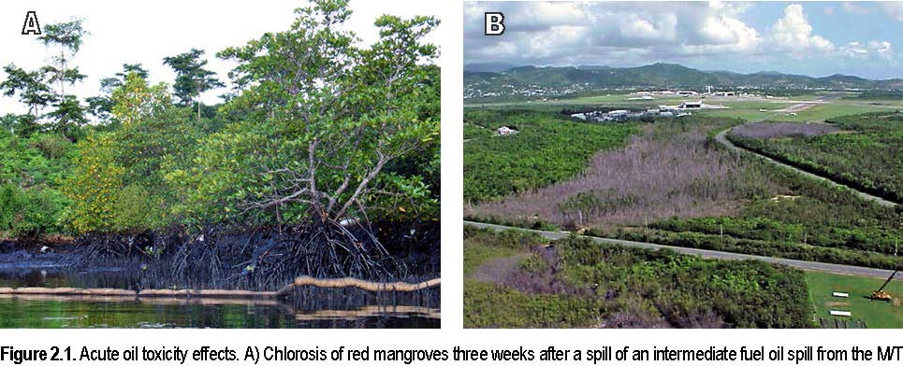Solar I in the Philippines (Ruth Yender, NOAA). B) Aerial view of Roosevelt Roads, Puerto Rico jet fuel spill in 1999 showing dead
mangroves (Dan L. Wilkinson, Geo-Marine, Inc).
A monitoring study conducted in Australia after the Era spill in 1992 found a consistent set of mangrove responses including leaf staining, chlorosis, leaf death, and complete defoliation. Within three months after the oil washed ashore, extensive defoliation of mangrove trees had begun and many appeared to be dead. The degree to which mangroves were damaged and the extent to which they recovered from spill damage were correlated to oiling levels (Wardrop et al. 1996).
In the 1986 Bahía las Minas (Panama) spill, scientists monitoring the effects of the oil on mangroves recorded a band of dead and dying trees where oil had washed ashore five months previously. A year and a half after the spill, dead mangroves were found along 27 km of the coast. Photographs taken just before the spill showed no evidence of tree mortality (Jackson et al. 1989).
Chronic Effects
The line between acute and chronic impacts can be a little blurry at times. In the case of mangroves, visible response to oiling may be almost immediate, with leaves curling or yellowing, as at the Era and Bahía las Minas spills. The tree, however, may survive for a time only to succumb weeks or months later. Alternatively, depending on the nature of exposure, it may recover to produce new leaf growth.
At least one researcher has summarized acute and chronic effects of oil to mangroves in tabular form (Table 2.1) (Lewis 1983). In this case, the line between acute and chronic effect was defined at 30 days; others may shift the border one way or the other.
Table 2.2. Generalized responses of mangrove forests to oil spills. From Lewis (1983). STAGE OBSERVED IMPACT
Acute
0 -15 days 15 -30 days Chronic | Deaths of birds, fish, invertebrates Defoliation and death of small (<1 m) mangroves Loss of aerial root community
30 days -1 year 1 year – 5 years | Defoliation and death of medium (<3 m) mangroves Tissue damage to aerial roots Death of larger (>3 m) mangrovesLoss of aerial roots
1 year – 10 years? 10 – 50 years? | Regrowth of roots (sometimes deformed) Recolonization of oiled areas by new seedlingsReduction in litter fall Reduced reproduction ReducedseedlingsurvivalDeath or reduced growth of recolonizing trees? Increased insect damage? Complete recovery

Mangroves can be chronically impacted by oil in several ways. Stressed mangroves could show differences in growth rates or altered reproductive timing or strategy. They may also develop morphological adaptations to help them survive either the physical or chemical consequences of residual oil contamination. Such modifications may require expending additional energy, which in turn, could reduce the mangroves’ ability to withstand other non-spill-related stresses they may encounter. One consequence of the complex physical structure and habitat created by mangrove trees is that oil spilled into the environment is very difficult to clean up. The challenge and cost of doing so, and the remote locations of many mangrove forests, often results in unrecovered oil in mangrove areas affected by spills. This, in turn, may expose the trees and other components of the mangrove community to chronic releases of petroleum as the oil slowly leaches from the substrate, particularly where organic-rich soils are heavily oiled.
Researchers who have compared oil spill impacts at several different spill sites have found similar types of impacts that differ primarily in the magnitude of effect. The degree of impact appears to be related to the physical factors that control oil persistence on the shoreline and exposure to waves and currents. Interestingly, the presence and density of burrowing animals like crabs also affects the persistence of oil in mangrove areas and can determine whether an exposure is short-or long-term, because of oil penetration via burrows into an otherwise impermeable sediment.
In many parts of the world, mangrove stands co-occur with industrial facilities and thus may be subjected to chronic contamination from petroleum compounds, other organic chemicals, and heavy metals. As a result, it can be difficult to determine the additional stress imposed by a spill event vs. existing stress. Newer assessment tools, such as molecular biomarkers, can isolate sources of stress more readily than non-specific but commonly used methodologies, and show promise for distinguishing spill impacts from other pollution sources.
Root abnormalities have been reported as a response to chronic oil exposures. Adventitious roots and deformed red mangrove propagules were observed on Avicennia trees after the 1978 Howard Star spill in Tampa Bay (Figure 2.2) and at many spills since then. Avicennia mangroves oiled during the 1991 Gulf War spill had surviving pneumatophores that tended to develop branched secondary pneumatophores. These were observed two years after the spill in areas that were known to have been oiled, and were interpreted to be a response to impairment of normal respiration (Böer 1993).
Figure 2.2. Propagule and root deformities observed in January 1980 as response to the chronic effects of oil exposure after the 1978 Howard Star oil spill in Tampa Bay, Florida. A) Deformed red mangrove propagules collected from oil sediments (upper) contrasted with normally developed propagules from adjacent unoiled sediments (lower). B) Abnormal adventitious roots at the base of a black mangrove tree (Research Planning, Inc.).
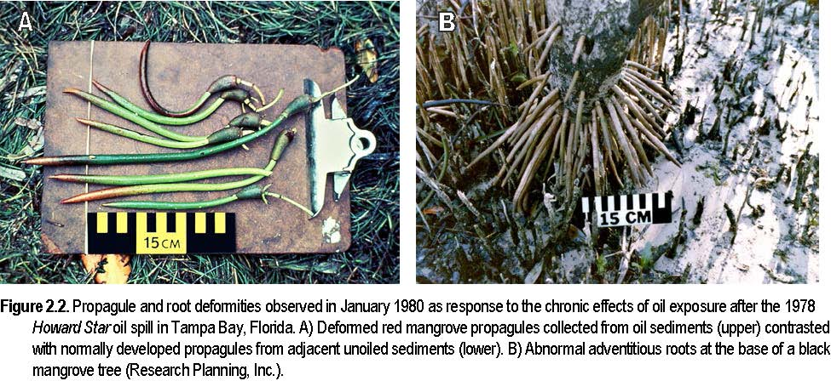
Studies of the 1986 Bahía las Minas (Galeta) oil spill in Panama concluded that its impact was “catastrophic.” Five years after the incident, researchers suggested that oil remaining in mangrove sediments adversely affected root survival, canopy condition, and growth rates of mangrove seedlings in oil-deforested gaps. Six years after the spill, surviving forests fringing deforested areas showed continued deterioration of canopy leaf biomass (Burns et al. 1993).
The follow-up study of the 1992 Era spill in Australia also noted a lack of recovery four years after the initial release–although effects themselves had appeared to have peaked, no strong signs of recovery were recorded in the affected mangrove areas (Wardrop et al. 1996).
The experimental (i.e., intentional and controlled) 1984 TROPICS spill in Panama confirmed long-term impacts to oiled mangroves, termed “devastating” by the original researchers who returned to the study sites ten years later. They found a total mortality of nearly half of the affected trees and a significant subsidence of the underlying sediment. This was compared to a 17-percent mortality at seven months post-oiling, a level that appeared to be stable after 20 months (Dodge et al. 1995). Over the decades, the dead trees at the oiled site were slowly replaced by “waves” of seedlings because early ones did not survive to produce trees (Baca et al. 2014). In 2009, 25 years after oiling, the oiled site exhibited a decline of the mangroves (there were 1,085 small trees), whereas the dispersed and reference sites remained at baseline levels (with 124 and 392 small trees, respectively) (DiMicco et al. 2011). In 2013, 29 years later, the counts of adult trees had recovered though there were still an abundance of small trees at the oiled site, and curling and distortions of prop roots in small trees and seedlings were noted at the oiled site, but not at the other sites (Baca et al. 2014).
The results from the more intensively studied spills that have occurred in the last fifteen years suggest that chronic effects can be measured over long time periods, potentially a decade or decades. They also indicate the difficulties in measuring longer-term impacts due to the time frames involved–and, hence, the value of longer-term monitoring of mangrove status following an oil spill.
Mangrove Community Impacts
With the realization that mangrove stands provide key habitat and nursery areas for many plants and animals in the tropical coastal environment, many researchers have included the associated biological communities in their assessments of oil impacts. Of course, this considerably broadens the scope of spill-related studies, but realistically, it would be arbitrary and artificial to consider only the impacts of oil on the mangroves themselves.
Endpoint – A measured Studies of the Bahía las Minas spill in Panama concluded that significant long-response of a natural term impacts occurred to mangrove communities. Both the habitat itself resource to exposure to a
and the epibiotic community changed in oiled areas. After five years, the
contaminant, such as oil,
length of shoreline fringed by mangroves had decreased in oiled areas
in the field or laboratory.
relative to unoiled areas, and this translated to a decrease in available
surface area ranging from 33 to 74 percent, depending on habitat type. In addition, defoliation increased the amount of light reaching the lower portions of the mangrove forest (Burns et al. 1993).
In the Bahía las Minas spill, a massive die-off of plants and animals attached to the mangrove roots followed the initial release. Five years after the spill, the cover of epibiotic bivalves was reduced in oiled areas relative to unoiled reference areas. Open-coast study sites recovered more quickly, although differences in cover of sessile invertebrates remained significant through four years.
More controlled experimental oiling experiments have been less conclusive. One such study in New South Wales, Australia found that invertebrate populations were highly variable with differences attributable to oiling treatment difficult to discern. Though snails were less dense shortly after oiling treatments, they recovered by the end of the study period several months later (McGuinness 1990).
Another experiment in Australia focused on the effect of one toxic component of oil, naphthalene, on a gastropod snail common in the mangroves of eastern Australia. The sublethal endpoint used for impact assessment was the crawling rate of the snails. Two responses were elicited in short-and long-term exposures to naphthalene. An increased level of activity in the short-term exposure was interpreted as an avoidance response, while the decreased crawling rate induced by the longer-term exposure suggested a physiological consequence of the toxicant. The measurable differences in response attributed to the hydrocarbon implied that normal behavior patterns of the snails would be significantly disrupted by oil exposure (Mackey and Hodgkinson 1996).
The TROPICS experimental spill found no short- or long-term effects to three species of mangrove oysters studied in the experiment. In fact, populations at oiled sites showed the most substantial increases over time that was speculatively attributed to breakdown and mobilization of petroleum hydrocarbons as additional food sources (Dodge et al. 1995). However, by 2013, 29 years later, oysters and snails in the oiled site declined, whereas the dispersed oil and reference sites maintained gradual increases (Baca 2014) Some studies have looked at the toxicity of undispersed and dispersed oil to both mangroves and the associated invertebrate community. The limited findings are somewhat equivocal: one study found that dispersing oil appears to reduce the inherent toxicity of the oil to mangroves, but increases the impacts to exposed invertebrates (Lai 1986). Another assessment concluded no difference in toxicity to crustaceans from dispersed and undispersed crude oil (Duke et al. 2000). However, the same study also evaluated toxicity of Bunker C fuel oil and found that crude oil was more acutely toxic than the Bunker. The authors attributed this to the physical and chemical differences between the oil types.
Australian researchers studying the effects of the 1992 Era spill on fish populations around oiled mangroves found no measurable assemblage differences between groups inside and outside oiled zones, although juveniles of several species were significantly smaller in oiled creeks than in unoiled creeks (Connolly and Jones 1996).
Indirect Impacts
As is the case with most, if not all, spill-affected resources, some indirect impacts on mangroves have been identified. For example, residual oil remaining on the surface of mangrove sediments oiled during the Gulf War spill in Saudi Arabia increased the ambient soil temperatures to the point where germination and growth of intertidal plants was adversely affected (Böer 1993).
In Panama, the breakdown of protective structure provided by roots of dead mangroves caused a secondary impact from the oil spill at Bahía las Minas. For five years post-spill, the tree remnants had protected young seedlings, but when the roots finally gave way, drift logs crushed the recovering mangrove stand and essentially destroyed that part of the mangrove fringe (Duke et al. 1993).
Decomposition of the mangrove root mass following large-scale mortality causes significant erosion and even subsidence of the land where the forest was located. In the TROPICS experiment, approximately 8 cm of surface elevation loss was noted by researchers who returned to the study site 10 years after the oiling (Dodge et al. 1995).
Prolonged flooding of diked mangrove areas due to cleanup operations is a possible indirect spill impact that would be limited to those areas where hydrologic conditions are easily controlled. This was suggested as a factor in the 1999 jet fuel spill at Naval Station Roosevelt Roads in Puerto Rico. In that spill, culverts providing water exchange with coastal waters were closed both to facilitate oil recovery and to prevent the spread of oil to other areas. However, in doing so, the water levels in some basin mangrove forests were held at much higher levels (>1 m) for periods of more than a week. It has been suggested that this action either contributed to or was a major source of mortality to mangroves in the weeks that followed (Wilkinson et al. 2001).
Even if oiling does not result in tree death, the surviving trees can become weakened and vulnerable to other natural stressors, which can eventually lead to death (Figure 2.3). Examples of these stresses include cold weather and hypersalinity (Snedaker et al. 1997), drought, flooding, storms, disease, and
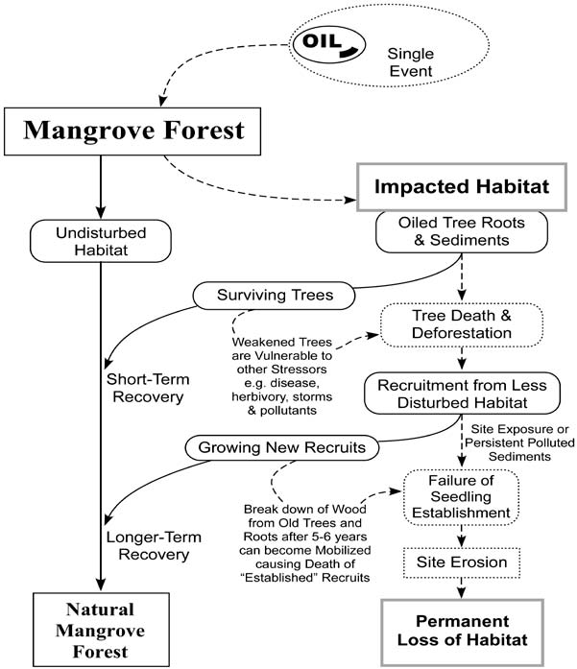
2-13
Summary and Response Implications
The body of literature available for the toxicity of oil to mangroves presents a range of results from which we can extract some points for spill response guidance.
- Mangroves are highly susceptible to oil exposure. Acute effects of oil (mortality) occur within six months of exposure and usually within a much shorter time frame (a few weeks). Commonly observed mangrove responses to oil include yellowing of leaves, defoliation, and tree death. More subtle responses include branching of pneumatophores, germination failure, decreased canopy cover, increased rate of mutation, and increased sensitivity to other stresses.
- Different oil types confer different toxicity effects. While this is a universal truth in spill response, for mangroves the lighter oils are more acutely toxic than heavier oils (for example, light crude oil is more toxic than a Bunker-type fuel oil). Similarly, less-weathered oil is more toxic to mangroves than the same oil that has been subjected to more intense weathering.
- The physical effects of oiling (e.g., covering or blocking of specialized tissues for respiration or salt management) can be as damaging to mangroves as the inherent toxicity of the oil. Although some studies indicate that mangroves can tolerate some coating without apparent damage, many others identify physical effects of oiling as the most serious.
- Response techniques that reduce oil contact with mangroves reduce the resultant toxicity as well. For example, chemical dispersants seem to reduce oil toxicity to mangroves. In this case, the tradeoff is the possibility of increased toxicity to adjacent and associated communities, such as offshore coral reefs, and increased penetration of dispersed oil that may reach mangrove sediments.
- Comparing spill impacts at several mangrove sites indicates that variable effects are related to geomorphology and hydrologic kinetics of the mangrove ecosystem that, in turn, control whether oil persists in the mangrove habitat. Oiled mangrove forests that are sheltered from wave and current exposure are likely to be more severely affected than well-exposed, “outer fringe” mangrove areas. Another consideration that also can be significant is the density of burrows from associated organisms such as crabs, which can increase the penetration and persistence of oil with depth into sediments. Berms can protect inner areas or concentrate oil in front of them.
- Mangrove communities are complex and, as might be expected, the impacts of oil to the associated plants and animals vary. The available information suggests that while oil spills undoubtedly affect such communities, they appear to recover more quickly than the mangroves themselves. Because of this, longer-term effects are likely to be related to death of the mangroves and loss of the habitat that supports and protects the community.

As we have noted, the toxicity implications from an oil spill in a mangrove area depend on a wide variety of different factors. Generally, the amount of oil reaching the mangroves and the length of time spilled oil remains near the mangroves are key variables in determining the severity of effect. Although it is stating the obvious to a spill responder that prevention is the best tool for minimizing the environmental impacts of an incident, for mangroves this is especially true. Reducing the amount of oil reaching the mangroves not only reduces the short-and long-term toxicological effects but also reduces cleanup impacts and the potential for chronic contamination. In a response, these considerations may translate into increased protection for mangroves and possible use of response measures that reduce mangrove exposure to oil (e.g., offshore countermeasures such as burning or dispersants, shoreline countermeasures such as chemical cleaners or flushing). The long-term character of many of the mangrove impacts that have been observed argues for serious consideration of such strategies.
For Further Reading
Baca, B., E. Rosch, E. DiMicco, and P.A. Schuler. 2014. TROPICS: 30-year follow-up and analysis of mangroves, invertebrates, and hydrocarbons. In: Proceedings of the 2014 International Oil Spill Conference. pp. 1734-1748.
Böer, B. 1993. Anomalous pneumatophores and adventitious roots of Avicennia marina (Forssk.) Vierh. Mangroves two years after the 1991 Gulf War oil spill in Saudi Arabia. Marine Pollution Bulletin 27:207-211.
Burns, K.A., S.D. Garrity, and S.C. Levings. 1993. How many years until mangrove ecosystems recover from catastrophic spills? Marine Pollution Bulletin 26(5):239-248.
Connolly, R.M. and G.K. Jones. 1996. Determining effects of an oil spill on fish communities in a mangrove-seagrass ecosystem in southern Australia. Australasian Journal of Ecotoxicology 2:3-15.
DiMicco, E., P.A. Schuler, T. Omer, and B. Baca. 2011. Net environmental benefit analysis (NEBA) of dispersed oil on nearshore tropical ecosystems: TROPCS – the 25th year research visit. In: Proceedings of the 2011 International Oil Spill Conference. pp. 1-14.
Dodge, R.E., B.J. Baca, A.H. Knap, S.C. Snedaker, and T.D. Sleeter. 1995. The effects of oil and chemically dispersed oil in tropical ecosystems: 10 years of monitoring experimental sites. MSRC Technical Report Series 95-104. Washington, D.C.: Marine Spill Response Corporation. 82 pp. + appendices.
Duke, N.C., Z.S. Pinzón, and M.C. Prada. 1993. Mangrove forests recovering from two large oil spills in Bahía Las Minas, Panama, in 1992. In: Long-Term Assessment of the 1986 Oil Spill at Bahía Las Minas, Panama. MSRC Technical Report Series 93-019. Washington, D.C.: Marine Spill Response Corporation. pp. 39-87.
Duke, N.C., K.A. Burns, S. Codi, O. Dalhaus, J.C. Ellison, C. Pratt, and R.J. Rupp. 1999. Fate and effects of oil and dispersed oil on mangrove ecosystems in Australia. Final Report to the Australian Petroleum Production Exploration Association. June 12, 1999. Queensland: Australian Institute of Marine Science and CRC Reef Research Centre.
Duke, N.C., K.A. Burns, R.P.J. Swannell, O. Dalhaus, and R.J. Rupp. 2000. Dispersant use and a bioremediation strategy as alternate means of reducing impacts of large oil spills on mangroves: The Gladstone field trials. Marine Pollution Bulletin 41(7-12):403-412.
Geo-Marine, Inc. 2000. Natural resource damage assessment for a JP-5 fuel spill at Naval Station Roosevelt Roads, Puerto Rico. Draft final report. Norfolk: Commander, Atlantic Division, Naval Facilities Engineering Command. 58 pp.
Getter, C.D., G.I. Scott, and J. Michel. 1981. The effects of oil spills on mangrove forests: A comparison of five oil spill sites in the Gulf of Mexico and the Caribbean Sea. In: Proceedings of the 1981 Oil Spill Conference. pp. 535-540.
Grant, D.L., P.J. Clarke, and W.G. Allaway. 1993. The response of grey mangrove (Avicennia marina (Forsk.) Vierh.) seedlings to spills of crude oil. Journal of Experimental Marine Biology and Ecology 171:273-295.
Jackson, J., J. Cubit, B. Keller, V. Batista, K. Burns, H. Caffey, R. Caldwell, S. Garrity, C. Getter, C. Gonzalez, H. Guzmán, K. Kaufmann, A. Knap, S. Levings, M. Marshall, R. Steger, R. Thompson, and E. Weil. 1989. Ecological effects of a major oil spill on Panamanian coastal marine communities. Science 243:37-44.
Klekowski, E.J. Jr., J.E. Corredor, J.M. Morell, and C.A. del Castillo. 1994a. Petroleum pollution and mutation in mangroves. Marine Pollution Bulletin 28(3):166-169.
Klekowski, E.J. Jr., J.E. Corredor, R. Lowenfeld, E.H. Klekowski, and J.M. Morell. 1994b. Using mangroves to screen for mutagens in tropical marine environments. Marine Pollution Bulletin 28(6):346-350.
Lai, H.C. 1986. Effects of oil on mangrove organisms. In: Maclean, J.L., L.B. Dizon, and L.V. Hosillos (eds.), Proceedings of the First Asian Fisheries Forum. pp. 285-288.
Lai, H.C., H.J. Teas, F. Pannier, and J.M. Baker. 1993. Biological impacts of oil pollution: Mangroves. IPIECA Report Series, Volume Four. London: International Petroleum Industry Environmental Conservation Association. 20 pp.
Lewis, R.R. III. 1983. Impact of oil spills on mangrove forests. In: Teas, H.J. (ed.), Tasks for Vegetation Science, Vol. 8 (Biology and Ecology of Mangroves), The Hague: Dr W. Junk Publishers. pp. 171-183.
Mackey, A.P. and M. Hodgkinson. 1996. Assessment of the impact of naphthalene contamination on mangrove fauna using behavioral bioassays. Bulletin of Environmental Contamination and Toxicology 56:279-286.
McGuinness, K.A. 1990. Effects of oil spills on macro-invertebrates of saltmarshes and mangrove forests in Botany Bay, New South Wales, Australia. Journal of Experimental Marine Biology and Ecology 142:121-135.
Page, D.S., E.S. Gilfillan, J.C. Foster, J.R. Hotham, and L. Gonzalez. 1985. Mangrove leaf tissue sodium and potassium ion concentrations as sublethal indicators of oil stress in mangrove trees. In: Proceedings of the 1985 Oil Spill Conference. pp. 391-393.
Proffitt, C.E. (ed.). 1997. Managing Oil Spills in Mangrove Ecosystems: Effects, Remediation, Restoration, and Modeling. OCS Study MMS 97-0003. New Orleans: U.S. Department of the Interior, Minerals Management Service, Gulf of Mexico OCS Region. 76 pp.
Snedaker, S. C., P.D. Biber, and R.J. Aravjo. 1997. Oil spills and mangroves: an overview. In: Proffitt, C.E. (ed.), Managing Oil Spills in Mangrove Ecosystems: Effects, Remediation, Restoration, and Modeling. OCS Study MMS 97-0003. New Orleans: U.S. Department of the Interior, Minerals Management Service, Gulf of Mexico OCS Region. pp. 1-18.
Wardrop, J.A., B. Wagstaff, P. Pfennig, J. Leeder, and R. Connolly. 1996. The distribution, persistence and effects of petroleum hydrocarbons in mangroves impacted by the “Era” oil spill (September, 1992): Final Phase One report. Adelaide: Office of the Environment Protection Authority, South Australian Department of Environment and Natural Resources.
Wilkinson, D.L., C. Moore, M. Lopez, and M. Figueroa. 2001. Natural resource damage assessment for a JP-5 fuel spill at Naval Station Roosevelt Roads, Puerto Rico. Pre-final report. Norfolk: Atlantic Division, Naval Facilities Engineering Command.
CHAPTER 3. RESPONSE Biogenic – In mangroves,
the trees themselves Key Points create the habitat.
Biogenic also means
- Mangroves are highly sensitive to oil and are priority areas for “resulting from the protection. actions of living
- Winds and tides carry spilled oil into mangrove forests, where oil organisms.” coats the soil surface, aerial roots, and propagules.
- Dispersing or burning oil offshore can prevent or lessen impacts to mangroves.
- Spill containment and cleanup techniques should minimize any additional impacts to mangroves and other natural resources at risk.

As detailed in the previous chapter, mangroves are particularly sensitive to oil and, where they are native, often are priority areas for protection. The objective of spill response in mangroves, as in any habitat, is to minimize the damage caused by the accident and released oil. Spill containment and cleanup techniques should minimize any additional impacts to mangroves. Mangrove forests are a biogenically structured habitat–the trees themselves create the habitat. Death of the trees, the structuring organism, causes loss of habitat, with corresponding impact on the suite of associated species dependent upon them, including offshore and nearshore resources such as coral reefs and seagrass beds. Potential response strategies should be evaluated to determine whether the ultimate benefits from the response action outweigh any environmental costs to the mangrove forests and associated sensitive habitats at risk.
Variables such as oil type, weather, location, and availability of response equipment will determine initial spill response options. In the best-case scenario, oil is prevented from moving into and contaminating mangrove areas. Promising, on-water response techniques that can help prevent or reduce the amount of oil reaching mangrove forests in some cases include offshore chemical dispersion and in situ burning.
On-Water Response Options to Prevent or Reduce Mangrove Oiling
Mechanical Recovery Offshore
Mechanical containment and collection of spilled oil on water using equipment such as booms and skimmers are primary initial cleanup methods used at many spills. Experience has shown, though, that mechanical recovery alone usually cannot adequately deal with very large spills offshore. Weather and sea conditions, the nature of the oil, and other factors may limit the effectiveness of mechanical recovery. In such cases, alternative open-water response techniques, such as dispersant application or in situ burning of oil on water, may significantly reduce the risk that oil will reach shore and impact mangroves and other sensitive intertidal and shoreline habitats.
Offshore Dispersant Application
Chemical dispersants are products applied to oil on the water surface to enhance formation of smaller oil droplets that are more readily mixed into the water column and dispersed by turbulence and currents. During and since the Deepwater Horizon oil spill, dispersants have also been considered as a response action to reduce the amount of oil reaching the surface during a subsea release. Most oils physically disperse to some degree due to agitation created by wave action and ocean turbulence. Chemical dispersants enhance and speed up this natural dispersion process. Dispersing oil soon after release minimizes impacts to wildlife at the water surface (e.g., birds and marine mammals) and reduces the amount of floating oil that may reach sensitive nearshore and shoreline habitats. If applied appropriately offshore, chemical dispersants can be an effective tool for protecting mangroves and the habitat they provide. Tradeoffs among other resources at risk, such as potential effects of temporarily higher concentrations of oil in the water column on pelagic organisms and sedimentation of oil in sensitive benthic habitats such as coral reefs and seagrass beds, should be considered before dispersant use. When applied appropriately in sufficiently deep water, impacts to coral reefs and seagrass beds are expected to be minimal.
Offshore in situ Burning
In situ burning is a response technique in which spilled oil is burned in-place. When used appropriately, in situ burning can remove large quantities of oil quickly and efficiently with minimal logistical support. Like dispersants, in situ burning can help minimize impacts to wildlife at the water surface and reduce the amount of oil that reaches sensitive nearshore and shoreline habitats, including mangroves. A potential disadvantage of open-water in situ burning is that a small percentage of the original oil volume may remain as a taffy-like residue after the burn. Floating residue can be collected but residues that sink or escape collection and move inshore could potentially contaminate mangroves or other habitats. It is important to note that, in contrast to open-water burning, in situ burning should not be conducted within mangrove forests, as explained below under “Response Techniques Inappropriate for Mangroves.”
Booms Wrack – Organic material, usually from
Booms are floating barriers that deflect or contain oil, and they can be used
dead seagrass or algae
along mangrove shorelines and inlets to prevent oil entry. Booms are usually
that wash up on used in two modes: 1) to deflect oil to containment and recovery areas, and shorelines. 2) to exclude oil from coming ashore. To be effective, booms must be deployed immediately after a spill before oil moves into mangrove areas. This means that appropriate types and sufficient amounts of booming materials must be stockpiled and available at the time of the spill, and that strategies for boom placement and deployment have already been established and tested. Booms generally cannot be deployed successfully along mangrove shorelines with strong currents, breaking or choppy wave action, or along sections of mangrove shorelines behind shallow flats where the boom fouls on the flat at low tide. Booms must be deployed and anchored carefully, and maintained vigilantly to prevent physical damage during installation and removal.
Stranded Oil Behavior in Mangroves
Mangroves grow in low-energy depositional areas, which also tend to be the sites where oil accumulates. Spilled oil is carried into mangrove forests by winds and tidal currents. Oil slicks generally move into mangrove forests when the tide is high, depositing on the soil surface and on aerial roots and propagules when the tide recedes. The resulting distribution of deposited oil is typically patchy due to the variability in tidal heights within the forest. If there is a berm or shoreline present, oil tends to concentrate and penetrate into the berm or accumulated detrital wrack–organic material, usually from dead seagrass or algae, that washes up on shorelines. The oil can penetrate into the soil, particularly through burrows and other voids like those formed by dead mangrove roots. Lighter oils tend to penetrate more deeply into mangrove forests than heavier and more weathered oils, but will not persist unless they mix into the soil. However, crude oils and heavier refined products can pool onto sediment surfaces and can be highly persistent. These heavy oils and emulsified oil can be trapped in thickets of red mangrove prop roots and black mangrove pneumatophores and are likely to adhere to and coat these surfaces, as well as other organic materials, such as seagrass wrack. Re-oiling from resuspended oil, particularly as tides rise and fall, may further injure plants over time. Where oil persists, sheens may be generated for months or years.
Getter et al. (1981) identified four patterns of oil stranding that result in extensive tree mortality in mangroves (Figure 3.1). The main factor causing the highest tree mortality is where there is a rise in elevation, called a berm, where the oil tends to accumulate in highest concentrations. If the berm is located in the interior of the forest, usually created by the accumulation of sediments and wrack built
Figure 3.1. Schematic showing the different patterns of oil spill impacts to mangrove forests (modified from Getter et al. 1981).
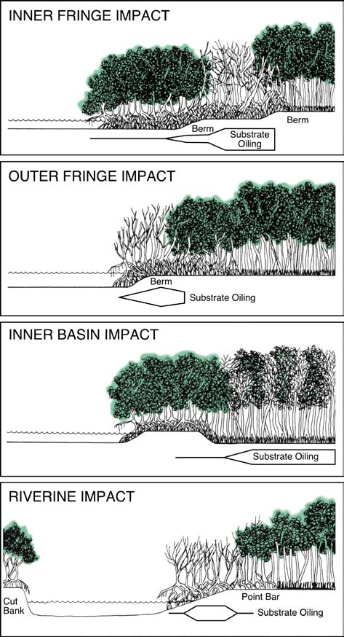
Figure 3.2. Infrared aerial photograph of a band of dead mangroves where oiling was heaviest on the prop roots and penetrated into the soils. Note the lighter color of the outer fringe mangroves indicating stress. This is a classic example of inner fringe impact (Research Planning, Inc.).
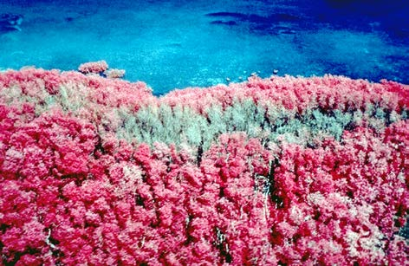
Figure 3.3. Extensive riverine impacts to mangroves three years after the Funiwa 5 spill of 400,000 barrels of crude oil in Nigeria in 1980 (Research Planning, Inc.).
3-4
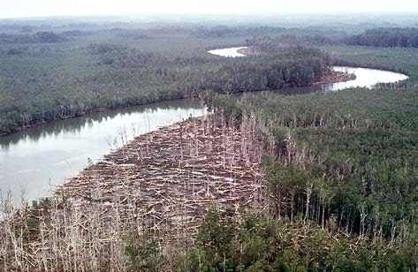
by storm waves, oil accumulation there causes “inner fringe” impact, as Anaerobic – Occurring shown in Figure 3.2 at the Peck Slip spill in Puerto Rico. If the berm is at the with little or no oxygen. seaward edge of the forest, the result is “outer fringe” impact. If oil is washed through a fringing mangrove into a shallow interior basin, the result is ‘inner basin” impact. Along rivers, the oil tends to strand most heavily on the point bar, causing “riverine” type impacts, as shown in Figure 3.3 at the Funiwa-5 oil spill in Nigeria. Note that the trees on each point bar up the river are dead.
Assessing the extent and distribution of stranded oil can be difficult, particularly in dense forests, because the forest interior sometimes can be oiled even if the mangrove fringe is not, due to its lower tidal height. Access to interior areas of forests usually must be limited in order to minimize damage. Also, the tree canopy may hide oil on the ground during oil-observation overflights. Affected areas may become more apparent from the air as trees die or defoliate. Oiled trees may start to show evidence of effects, such as leaf yellowing, within weeks after oiling. Trees may take months (or longer) to die, especially with heavy oils.
Cleanup of oiled interior mangroves can be particularly difficult because some mangrove forests are nearly impenetrable. Intrusive cleanup operations may significantly damage roots and seedlings, and also trample oil deeper into sediments, where it is slower to break down.
Consequently, access to interior areas of mangrove forests should be limited and highly supervised. During later, less-supervised stages of mangrove cleanup on Eleanor Island at the 1993 Bouchard B-155 Bunker oil spill in Tampa, Florida, cleanup workers reportedly spread oil from the mangrove fringe to the roots of previously unoiled mangrove plants in the mangrove interior as they moved back and forth removing surface sediment contamination. In spills of relatively fresh, lighter oil, such as diesel or crude, sediment penetration and toxic damage can occur very rapidly and the oil can break down relatively quickly. In such cases, cleanup operations are not expected to save many mangrove trees or effectively remove much oil, and any benefits are probably outweighed by the potential additional damage from access for cleanup.
Natural processes will eventually remove remaining oil. Tidal action and precipitation can help physically flush stranded oil out of contaminated mangrove areas. Weathering processes degrade the oil, gradually reducing quantity and toxicity. Oiled substrate may not be able to support mangrove growth while toxicity levels remain high. Oil can degrade quickly in warm tropical environments, but more slowly if degradation is inhibited by anaerobic soil conditions. Oil may persist for very long periods in the peaty or muddy sediment where mangroves are most often found. Heavier oils can persist in mangrove sediment for decades after a spill.
Cleanup Options for Oiled Mangroves
If mangrove shorelines are oiled, extreme caution must be exercised in selecting cleanup activities. Potential benefits of oil removal must be weighed against the risks of potential additional harmful impacts from the cleanup technique. Table 3.1 lists possible cleanup methods and their potential impacts.
Natural Recovery
There are several circumstances under which it is appropriate to do nothing. The foremost of these situations is when cleanup would cause more harm than benefit to mangroves or other associated habitats, or when shorelines are inaccessible. When no cleanup is conducted, oil will slowly degrade and be removed naturally, assisted by natural and storm-generated flushing. (See Era spill case study, Chapter 5).
Table 3.1. Recommendations for response options in oiled mangroves by oil group (modified from NOAA 2010).
Oil Group Descriptions I – Gasoline products II – Diesellike products and light crudes III – Medium grade crudes and intermediate products IV – Heavy crudes and residual products The following categories are used to compare the relative environmental impact of each response method in the specific environment and habitat for each oil type. The codes in each table mean: A = The least adverse habitat impact. B = Some adverse habitat impact. C = Significant adverse habitat impact. D = The most adverse habitat impact. I = Insufficient information – impact or effectiveness of the method could not be evaluated. – = Not applicable. | Response Method | I | Oil Group II III | IV/V
 | Natural Recovery | A | A A | A
 | Barriers/Berms | C | B B | B
 | Manual Oil Removal/Cleaning | – | D C | C
 | Mechanical Oil Removal | – | – – | –
 | Sorbents | – | A A | A
 | Vacuum | – | B B | B
 | Debris Removal | – | A A | A
 | Sediment Reworking/Tilling | – | – – | –
 | Vegetation Cutting/Removal | – | – – | –
 | Flooding (deluge) | – | B B | B
 | Low-pressure, Ambient-water Flushing | – | B C | C
 | Shoreline Cleaning Agents | – | – I | I
 | Nutrient Enrichment | – | C C | C
 | Natural Microbe Seeding | – | I I | I
 | in situ Burning | – | – – | –

Spills of light oils, which will naturally evaporate and break down very rapidly, do not require cleanup. Such light oils are usually gone within days. Furthermore, light fuel oils such as gasoline and jet fuels typically impart their toxic impacts immediately, and cleanup can do little to reduce the damage. The only light refined products that might warrant some cleanup are diesel and No. 2 fuel oil where the sediments are heavily contaminated. It is important to recognize, though, that even where natural recovery is advisable, light oils can cause significant injury and contaminated mangrove habitats may require many years to recover.
Cleanup also is not recommended for small accumulations of oil, regardless of product type. Impacts caused by light accumulations generally do not warrant the tradeoffs associated with cleanup activity. Even for major spills, there may be cases for which it is best to rely on natural recovery, depending on the nature of the oiling and the characteristics of the mangrove forest affected. Generally, cleanup should not be conducted in interior areas of mangrove forests because of the risk of damaging mangrove roots and seedlings, trampling oil into the sediment where it will degrade much more slowly, and spreading oil into previously unoiled areas. Exceptions may be made if access is possible from upland areas or if vegetation is sparse enough to permit access without injury to pneumatophores and prop roots. If cleanup is attempted in interior mangroves, experienced personnel must constantly oversee cleanup crews to prevent further injury.
In any case, attempts should be made to control the movement and spread of any mobile oil within the mangroves to prevent contamination of adjacent areas. Several response techniques described below, including barriers, passive collection, and flushing, can be used to help control and contain mobile oil.
Barriers/Berms
Sediment berms and dams can be used to temporarily close off the mouths of small inlets where currents and waves are low enough not to wash the sediments away. This method would be most appropriate to protect a small pond that was of high sensitivity. If water quality is of concern, an underflow dam can be installed to allow water flow in/out of the area. A nearby source of sediment to build the berm is needed. Because of the risk of altering the hydrology of the site, special care will be needed to make sure that all sediments are removed and the site restored to its original configuration.
Filter fences can be installed along the mangrove fringe; however, numerous stakes are necessary to keep them in place, and they often fail under wave action. Furthermore, they are very difficult to remove because the stakes get buried in mud, the cloth can get weighted down with mud, and debris tends to accumulate around them. Complete removal is important because the stakes and other materials can pose hazards to people, boats, and wildlife. Recording accurate GPS coordinates when such barriers are installed will aid in their location during removal. Most of the time, filter fences will have low effectiveness and a high risk of additional impacts.
Manual Oil Removal
Manual removal, using hand tools and manual labor, is often conducted to remove bulk oiling by heavier oils, such as crude oil or intermediate fuel oils, stranded in mangroves. Manual removal can help prevent other areas from becoming contaminated as the oil moves around, and helps limit long-term sediment contamination. Consideration should be given, however, to the trade-off between these benefits of manual removal and the damage to the mangroves that often accompanies manual cleanup. It is nearly impossible to reach the tangle of prop roots and pneumatophores of most mangroves without causing physical damage. Trampling of oil deeper into the sediment from foot traffic can be another harmful consequence of manual cleanup. Garrity and Levings (1996) observed that black mangrove pneumatophores along paths used by cleanup workers were significantly more likely to be killed than those in areas accessed by one or a few workers. Where pneumatophores had been dense at the time of the spill, paths often were bare substrate by 15 months post-spill as broken pneumatophores died and rotted away. (See Bahía las Minas case study.)
If manual removal is conducted in mangroves, and particularly in interior areas, consideration should be given to ways to minimize foot traffic and other impacts. Conducting activities from boats, when possible, is advisable. Close supervision of cleanup crews is essential.
Passive Collection with Sorbents
Even when natural recovery is the selected option, sorbents are often deployed to recover any oil released from the area. Sorbents are composed of materials that either adsorb oil on the surface or absorb oil into the pores of the material. There are many types: natural organic substance (e.g., peat, wood, cotton, straw, shredded sugarcane process residue called “bagasse”), synthetic organic substance (e.g., polypropylene, polyurethane), inorganic mineral substance (e.g., clay, vermiculite, diatomite), or a mixture of the three. The material may also be treated with oleophilic (oil-loving) or hydrophobic (water-hating) compounds to improve performance. They come in various forms: round sausage “boom,” snare, sweeps, pads, rolls, loose particulates, pillows, and socks.
Sorbents vary in their effectiveness depending upon oil type, degree of oil weathering, and sorbent absorption or adsorption capacity. Sorbent materials must be placed and removed carefully to minimize disturbance of sediments and injury to the mangroves. Likewise, sorbent materials must be closely monitored and maintained to ensure they do not move, become stranded on the shoreline, tangled in the vegetation, or buried in sediments, causing damage to the mangroves or associated resources. Sorbents must be removed when they become saturated or are no longer effective or needed.
Sorbents have been used to wipe heavy oil coating from mangrove surfaces. Before using sorbents in this way, consideration should be given to associated physical damage. This activity is best conducted under close supervision and only in areas where substrate is firm enough to support foot traffic and prevent mixing of oil into the sediments.
Vacuuming
Vacuuming can be used to remove pooled oil or thick oil accumulations from the sediment surface, depressions, and channels. Vacuum equipment ranges from small units to large suction devices mounted on barges, usually used outside vegetated areas. Generally, vacuuming should be conducted only at the outer fringe of mangrove forests; it is most feasible and least damaging where vegetation is not very dense, enabling easy access. Vacuuming can be used effectively on heavier and medium oils, providing they are still reasonably fluid. Lighter, more flammable petroleum products such as jet fuel and diesel generally should not be vacuumed.
As shown in Figure 3.4A, vacuuming was used effectively to remove pooled Bunker C oil that stranded in mangroves during the 1993 Tampa Bay oil spill response (see Case Studies for more details). Vacuuming worked particularly well where oil stranded on sand substrate at the mangrove fringe. The technique was less effective over fine sediment and oyster beds. To minimize cleanup damage, care was taken to place the vacuum barge over firm sand substrate, where there were no seagrass beds. Removing or disturbing fine sediments during vacuuming in mangrove areas should be minimized.
Vacuuming free-floating oil on the water surface is much more difficult. Vacuuming of a heavy fuel oil floating in the mangroves on the south coast of Puerto Rico generated mostly water, requiring extensive oil:water separation systems (Figure 3.4B). Overall, it was not very effective.
Figure 3.4. Vacuuming techniques in mangroves. A) Successful removal of thick oil from mangroves working on a firm sand flat during
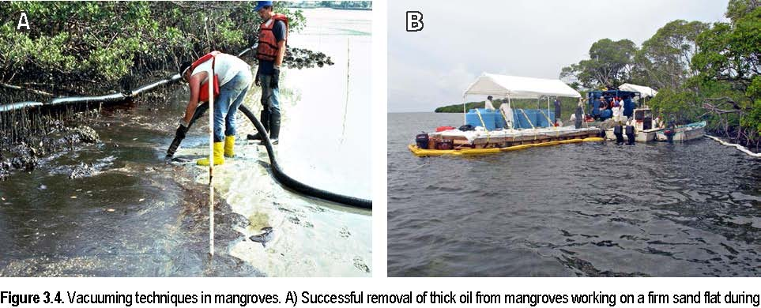the 1993 Tampa Bay, Florida spill (Jacqueline Michel, Research Planning, Inc.) B) Unsuccessful attempt to remove floating oil
trapped in the mangrove fringe during the 2007 Guánica, Puerto Rico spill of heavy fuel oil. Note the multiple tanks to separate the
large volume of water recovered (Brad Benggio, NOAA).
Ambient Water Flooding (Deluge) and Low-Pressure Ambient Water Flushing
Low-pressure flushing with ambient seawater can wash fluid, loosely adhered oil from the sediment surface and mangrove vegetation into areas where it can be collected, as long as it can be done without resulting in significant physical disturbance of the sediment. Generally, flushing is most feasible at the outer fringe, but can sometimes be used to remove oil trapped within the mangrove forest. Ibáñez (1995) successfully used low-pressure flushing of the soils and mangrove roots in a 2.5-3 hectare mangrove affected by 28,000 gallons of slop oil in Cartagena, Colombia over a 54-day period; three years later, the forest had grown to cover 7 hectares. Flushing at water levels high enough to submerge sediments may help minimize impact to the substrate. If substrate mixing is likely or unavoidable, responders should allow the oil to weather naturally. Flushing is not effective with heavy oils or highly weathered oils. One of the biggest challenges is to get “behind” the oil that is trapped in the vegetation so it can be flushed to open water where the oil can be contained with boom and recovered using vacuums, skimmers, or sorbents. Flushing operations have to consider tidal currents (flush on a falling tide) and wind (an onshore wind will push any released oil back onto the shoreline).
Chemical Shoreline Cleaners
Chemical shoreline cleaners are products sprayed on oil-coated surfaces to “loosen” the oil so that it can be flushed off with ambient water. Tidal flushing or water sprays alone cannot effectively wash away heavy oil. Shoreline cleaning products vary in their toxicity and recoverability of the treated, mobilized oil. Chemical shoreline cleaners loosen or dissolve heavy oil deposited over the lenticels on coated prop roots or pneumatophores so the residue can be washed away and lenticel functioning restored. Functioning of the lenticels, which enable delivery of oxygen to the subsurface roots, is critical to survival of the trees. Further testing and more experience with the effectiveness and effects of using shoreline cleaners on mangroves are needed to determine whether their use is advisable, and under what conditions.
Some experimental studies (Teas et al. 1987, 1993) have reported promising results using chemical shoreline cleaners on mangrove trees coated with oil. A shoreline cleaner (Corexit 9580) applied to oiled red mangroves coated with Bunker C oil and then washed with seawater (within 7 days of oiling) reportedly effectively reduced oil adhesion and exposed the lenticels, restoring their air permeability. The study concluded that mangrove trees can be saved with shoreline cleaners if the interval between oiling and cleaning is no longer than about a week. Another study (Quilici et al. 1995) reported harmful effects on mangrove trees treated with shoreline cleaner without flushing. Results likely depend on the particular product used and application technique, as well as the unique spill and habitat conditions encountered. Again, there is currently insufficient information on the efficacy and effects of shoreline cleaning agent use in mangrove areas. In addition, RRT approval would be required prior to the use of shoreline cleaning agents in mangroves.
Enhancing Bioremediation: Nutrient Enrichment, Microbe Seeding, and Soil Oxidants
Nutrient addition (generally nitrogen and phosphorus) can enhance biodegradation of oil under nutrient-limited conditions. Because so many other cleanup techniques are either ineffective or can cause physical damage to mangroves, there have been several field studies to determine if adding nutrients, microbes, and/or oxygen to speed degradation of the oil in mangrove habitats (there are many studies showing oil degradation in laboratory and greenhouse studies under optimum conditions). Teas et al. (1991) found that adding fertilizer to the soil when planting Rhizophora propagules in oiled sediments 28 months after the Panama spill enhanced their growth in the dense peaty soils in only one of three sites, so further use of fertilizers was not recommended. Quilici et al. (1995) found that photosynthetic capacity, litter disappearance rate, and soil respiration were no different in oiled Rhizophora plots with or without added nutrients. Scherrer and Mille (1989) reported that oleophilic fertilizer enhanced the oil biodegradation process in peaty mangrove sediment, though the fertilizer in this experiment was added to the oil before the mangrove vegetation was contaminated.
Field studies in Australia using a light, waxy crude oil and a heavy fuel oil with nutrient addition and forced air injection compared to oil-only plots showed that, after 13 months, although there had been an increase by up to five orders of magnitude in the number of oil-degrading microbes, there were no differences in oil removal or weathering rates and no difference in tree mortality (Burns et al. 2000, Duke et al. 2000, Ramsey et al. 2000). However, leaf densities of surviving trees and Sipunculan worm densities in the soils were higher in bioremediation plots. Field studies in Brazil showed that natural microbe seeding did not stimulate oil degradation after 3 months (Brito et al. 2009). It appears that most mangrove soils have large amounts of readily degradable carbon, thus nutrient addition can stimulate the microbial population without increasing the oil degradation rates.
Some researchers are looking to phytoremediation as a treatment method for oiled mangroves, though the results are mixed. Tam and Wong (2008) showed that, in greenhouse microcosms, natural attenuation was more effective than microbe seeding and phytoremediation. A group in Brazil found that Avicennia seedlings planted in oiled mangrove soils did speed degradation of the oil compared to nutrients and controls (Moreira et al. 2013). They also reported that the seedlings in the oiled plots grew taller and had a larger root, compared to seedlings in unoiled soils. Nutrient addition could provide some value to the surviving plants, but keeping the nutrients in place during tidal flushing is difficult. Therefore, in the matrix in Table 3.1, nutrient enrichment methods are ranked as “C” because of the lack of proven effectiveness in speeding oil removal or weathering rates under realistic, field conditions.
Removal of Oiled Wrack and Debris
Heavily oiled wrack and debris should be removed if it can be done without significantly damaging prop roots, pneumatophores, and seedlings or trampling oil into the sediment. However, oiled wrack should not be removed until the threat of oiling has passed, since wrack and leaf litter can act as a sort of natural barrier sorbent and actually protect the trees from direct oil contact. Unoiled and lightly oiled wrack and leaf litter should not be removed because they provide habitat and contribute to the ecosystem.
Inappropriate Response Techniques for Mangroves
Under no circumstances should live mangrove vegetation be cut or burned. Both techniques will destroy trees and mangrove habitat. Mangrove trees are slow-growing and take decades to reach a mature stage. The loss of a large number of trees may compromise the forest structure, making it unlikely to recover naturally. Other cleanup techniques used at some oil spills but inappropriate in mangroves include mechanical oil removal, high-pressure or hot-water flushing, steam-cleaning, slurry sand blasting, trenching, and sediment reworking, tilling, or removal. All these methods would severely damage or destroy mangrove forests and associated organisms and habitats. All of these techniques may also cause or contribute to severe erosion.
For Further Reading
Allen, A.A. and R.J. Ferek. 1993. Advantages and disadvantages of burning spilled oil. In: Proceedings of the 1993 Oil Spill Conference. pp. 765-772.
Ballou, T.G., S.C. Hess, R.E. Dodge, A.H. Knap, and T.D. Sleeter. 1989. Effects of untreated and chemically dispersed oil on tropical marine communities: A long-term field experiment. 1989. In: Proceedings of the 1989 Oil Spill Conference. pp. 447-454.
Brito, E.M., R. Duran, R. Guyoneaud, M. Goñ-Urriza, and T. Garcia de Oteyza. 2009. A case study of in situ oil contamination in a mangrove swamp (Rio De Janeiro, Brazil). Marine Pollution Bulletin 58:418-423.
Burns, K.A., S.D. Garrity, and S.C. Levings. 1993. How many years until mangrove ecosystems recover from catastrophic oil spills? Marine Pollution Bulletin 26(5):239-248.
Burns, K.A, S.D. Garrity, D. Jorrisen, J. MacPherson, M. Stoelting, J. Tierney, and L. Yelle-Simmons. 1994. The Galeta oil spill. II. Unexpected persistence of oil trapped in mangrove sediments. Estuarine, Coastal and Shelf Science 38:349-364.
Burns, K.A., S.C. Codi, and N.C. Duke. 2000. Gladstone, Australia field studies: weathering and degradation of hydrocarbons in oiled mangrove and salt marsh sediments with and without the application of an experimental bioremediation protocol. Marine Pollution Bulletin 41:392-402.
Burns, K.A., S. Codi, C. Pratt, and N.C. Duke. 1999. Weathering of hydrocarbons in mangrove sediments: testing the effects of using dispersants to treat oil spills. Organic Geochemistry 30:1273-1286.
Chaw, LH, H.J. Teas, F. Pannier, and J.M. Baker. 1993. Biological impacts of oil pollution: mangroves. International Petroleum Industry Environmental Conservation Association (IPIECA) Report Series Volume 4. 20 pp.
Duke, N.C., K.A. Burns, R.J.P. Swannell, O. Dallahus, and R.J. Rupp. 2000. Dispersant use and a bioremediation strategy as alternate means of reducing impacts of large oil spills on mangroves: the Gladstone field trials. Marine Pollution Bulletin 41:403-412.
Duke, N.C., Burns, K.A, S. Codi, O. Dalhaus, J.C. Ellison, C. Pratt, and R.J. Rupp. 1999. Fate and effects of oil and dispersed oil on mangrove ecosystems in Australia. Final Report to the Australian Petroleum Production Exploration Association. June 12, 1999. Queensland: Australian Institute of Marine Science and CRC Reef Research Centre.
Cintrón-Molero, G. 1992. Restoring mangrove ecosystems. In: Thayer, G.W. (ed.), Restoring The Nation’s Marine Environment, College Park, Maryland: Maryland Sea Grant College. pp. 223-277.
Corredor, J.E., J.M. Morell, and C.E. Del Castillo. 1990. Persistence of spilled crude oil in a tropical intertidal environment. Marine Pollution Bulletin 2(8):385-388.
Daykin, M., G. Sergy, D. Aurand, G. Shigenaka, Z. Wang, and A. Tang. Aquatic toxicity resulting from in situ burning of oil-on-water. In: Proceedings of the Seventeenth Arctic and Marine Oil Spill Program (AMOP) Technical Seminar 2:1165-1193.
Fingas, M.F., G. Halley, F. Ackerman, N. Vanderkooy, R. Nelson, M.C. Bissonnette, N. Laroche, P. Lambert, P. Jokuty, Li, G. Halley, G. Warbanski, P.R. Campagna, R.D. Turpin, M.J. Trespalacios, D. Dickens, E.J. Tennyson,
D. Aurand, and R. Hiltabrand. 1994. The Newfoundland Offshore Burn Experiment -NOBE: Experimental design and overview. In: Proceedings of the Seventeenth Arctic and Marine Oil Spill Program (AMOP) Technical Seminar 2:1053-1163.
Garrity, S.D. and S.C. Levings. 1993. Chronic oiling and long-term effects of the 1986 Galeta spill on fringing mangroves. In: Proceedings of the 1993 Oil Spill Conference. pp. 319-324.
Garrity, S.D. and S.C. Levings. 1993. Effects of an oil spill on some organisms living on mangrove (Rhizophora mangle L.) roots in low wave-energy habitats in Caribbean Panama. Marine Environmental Research 35:251-271.
Garrity, S.D. and S.C. Levings. 1994. The 10 August 1993 Tampa Bay oil spill: Injury assessment for the mangrove keys inside John’s Pass. Final Report, Findings through June 1994. Silver Spring, Maryland: Damage Assessment Center, National Oceanic and Atmospheric Administration. 140 pp.
Garrity, S.D., S.C. Levings, and K.A. Burns. 1994. The Galeta oil spill. I. Long-term effects on the physical structure of the mangrove fringe. Estuarine, Coastal and Shelf Science 38:327-348.
Getter, C.D., G.I. Scott, and J. Michel. 1981. The effects of oil spills on mangrove forests: a comparison of five oil spill sites in the Gulf of Mexico and the Caribbean Sea. In: Proceedings of the 1981 Oil Spill Conference Proceedings. pp. 535-540.
Getter, C.D., T.G. Ballou, and C.B. Koons. 1985. Effects of dispersed oil on mangroves: synthesis of a seven-year study. Marine Pollution Bulletin 16:318-324.
Getter, C.D., T.G. Ballou, and J.A. Dahlin. 1983. Preliminary results of laboratory testing of oil and dispersants on mangroves. In: Proceedings of the 1983 Oil Spill Conference. pp. 533-538.
Ibáñez, M. 1995. Mangrove restoration: Cartagena, Colombia, coastal oil spill case study. In: Proceedings of the 1995 Oil Spill Conference. pp. 990-991.
Jackson, J.B., J.D. Cubit, B.D. Keller, V. Batista, K. Burns, M. Caffey, R.L. Caldwell, S.D. Garrity, D.C. Getter,
C. Gonzalez, H.M Guzman, K.W. Kaufmann, A.H. Knap, S.C. Levings, M.J. Marshall, R. Steger, R.C. Thompson, and E. Weil. 1989. Ecological effects of a major oil spill on Panamanian coastal marine communities. Science 243:37-44.
Levings, S.C., S.D. Garrity, and K.A. Burns. 1994. The Galeta Oil Spill. III. Chronic reoiling, long-term toxicity of hydrocarbon residues and effects on epibiota in the mangrove fringe. Estuarine, Coastal and Shelf Science 38:365-395.
Levings, S.C. and S.D. Garrity. 1994. Effects of oil spills on fringing red mangroves (Rhizophora mangle): losses of mobile species associated with submerged prop roots. Bulletin of Marine Science 54:782-794.
Levings, S.C. and S.D. Garrity. 1995. Oiling of mangrove keys in the 1993 Tampa Bay oil spill. In: Proceedings of the 1995 Oil Spill Conference. pp. 421-428.
Levings, S.C. and S.D. Garrity. 1996. The 10 August 1993 Tampa Bay oil spill: Injury assessment for the mangrove keys inside John’s Pass: Final Report, Findings through January 1996. Silver Spring, Maryland: Damage Assessment Center, National Oceanic and Atmospheric Administration. 193 pp.
Moreira, I.T.A., O.M.C. Oliveira, J.A. Triguis, A.F.S. Queiroz, S.L.C. Ferreira, C.M.S. Martins, A.C.M Silva, and
B.A. Falcao. 2013. Phytoremediation in mangrove sediments impacted by persistent total petroleum hydrocarbons (TPH’s) using Avicennia schaueriana. Marine Pollution Bulletin 76:130-136.
NOAA. 2010. Characteristic coastal habitats: choosing spill response alternatives. Seattle: Office of Response and Restoration, National Oceanic and Atmospheric Administration. 85 pp.
Proffitt, C.E., D.J. Devlin, and M. Lindsey. 1995. Effects of oil on mangrove seedlings grown under different environmental conditions. Marine Pollution Bulletin 30(12):788-793.
Proffitt, E. and P.F. Roscigno (eds.). 1996. Symposium Proceedings: Gulf of Mexico and Caribbean Oil Spills in Coastal Ecosystems: Assessing Effects, Natural Recovery, and Progress in remediation Research. OCS Study/MMS 95-0063. New Orleans: U.S. Department of Interior, Minerals Management Service, Gulf of Mexico OCS Region. 245 pp.
Proffitt, E. (ed.). 1997. Managing Oil Spills in Mangrove Ecosystems: Effects, Remediation, Restoration, and Modeling. OCS Study/MMS 97-0003. New Orleans: U.S. Department of Interior, Minerals Management Service, Gulf of Mexico OCS Region. 76 pp.
Quilici, A., C. Infante, J. Rodriguez-Grau, J.A. La Schiazza, H. Briceno, and N. Pereira. 1995. Mitigation strategies at an estuarine mangrove area affected by an oil spill. In: Proceedings of the 1995 Oil Spill Conference. pp. 429-433.
Ramsay, M.A., R.P.J. Swannell, W.A. Shipton, N.C. Duke, and R.T. Hill. 2000. Effect of bioremediation on the microbial community in oiled mangrove sediments. Marine Pollution Bulletin 41:413–419.
Scherrer, P. and G. Mille. 1989. Biodegradation of crude oil in an experimentally polluted peaty mangrove soil. Marine Pollution Bulletin 20:430-432.
Scientific and Environmental Associates, Inc. 1995. Workshop Proceedings: The Use of Chemical Countermeasures Product Data for Oil Spill Planning and Response, Volume I, April 4-6, 1995. Leesburg, Virginia: SEA. 83 pp.
Teas, H.J., E.O. Duerr, and J.R. Wilcox. 1987. Effects of South Louisiana crude oil and dispersants on Rhizophora mangroves. Marine Pollution Bulletin 18:122-124.
Teas, H.J., M.E. De Diego, E. Luque, and A.H. Lasday. 1991. Upland soil and fertilizer in Rhizophora mangrove growth on oiled soil. In: Proceedings of the 1991 International Oil Spill Conference. pp. 477-481.
Tam, N.F and Y.S. Wong. 2008. Effectiveness of bacterial inoculums and mangrove plants on remediation of sediment contaminated with polycyclic aromatic hydrocarbons. Marine Pollution Bulletin 57:716-726.
Teas, H.K, R.R. Lessard, G.P. Canevari, C.D. Brown, and R. Glenn. 1993. Saving oiled mangroves using a new nondispersing shoreline cleaner. In: Proceedings of the 1993 Oil Spill Conference. pp.147-151.
CHAPTER 4. MANGROVE RECOVERY AND RESTORATION
Key Points
Mangroves can take more than 30 years to recover from severe oil spill impacts. Adequate tidal exchange is critical to restoration success. Mangrove seedling and tree density and health are the only widely measured recovery indicators at many spills. Restoration that works with natural recovery processes to reestablish mangrove habitat is the best course of action over the long term.
Mangrove ecosystems around the world suffer degradation from logging, coastal development, spraying of herbicides, conversion to fish ponds, and from oil spills and other pollutants. The continued loss of mangrove forests worldwide underscores the importance of projects focusing on restoration of forest structure and functions.
Because mangroves take 20–30+ years to recover from severe oil spill impacts, restoration projects attempt to speed up this recovery process. Adequate tidal exchange is most critical to restoration success. Mangrove restoration projects in Florida and the Caribbean often involve re-establishing natural hydrologic and tidal regimes, planting mangrove propagules, and/or planting marsh plants to provide a habitat that can be colonized more easily by mangrove trees.
An oil spill alone rarely changes the basic geophysical appearance and shape of the mangrove ecosystem. For this reason, restoration after an oil spill may be easier than after an event that substantially changes tidal elevation or hydrology or results in the complete removal of mangrove trees. However, an oil spill may come as an additional impact on a mangrove ecosystem already degraded by human and industrial development, such as near refineries (Bahía las Minas), ports, or airfields (Roosevelt Roads) or stressed by other natural or man-made causes such as hurricanes, cold weather, sea level rise, changes in hydrology or salinity regime. Cumulative or chronic impacts may decrease the resiliency of the mangrove ecosystem and increase the time it takes the system to recover, or make it more difficult for the system to recover at all.
As with other wetland ecosystems adversely impacted by oil spills, we have learned valuable lessons from past mangrove restoration projects, including those that failed. Restoration projects need a clear goal from the outset that is based on understanding the mangrove ecosystem’s natural ability to recover. The most effective role for restoration projects is to correct hydrology and elevation, or assist when natural recruitment mechanisms are impeded or no longer functioning.
Recovery
Recovery of any impacted ecosystem following a perturbation such as an oil spill is interpreted by many to mean a return to the system in place at the time of the spill. Mangroves’ specialized niche is in a unique, changeable zone, subject to sediment flow that accretes and erodes, varying amounts of fresh water, impacts from storms and hurricanes, invasion by foreign species, and predation. Thus, even if we had a precise description of ecosystem conditions just before the spill, we still might not be able to return it to its pre-spill state.
A more practical way to measure recovery is to compare the impacted system with an unimpacted one (hopefully, nearby), using metrics such as tree height, density, canopy cover, above-ground biomass, and abundance and diversity of associated invertebrates, fish, and plants. Since compromised ecosystems can be more vulnerable to stresses such as disease or predation, the recovering habitat must also show the resilience of a functioning ecosystem.
It is rare to find long-term, follow-up studies on mangroves beyond 1-2 years post-spill. It is even rarer to find studies that measure associated communities of invertebrates or other components of the mangal (mangrove forest habitat) besides the mangrove trees themselves. Even when mangrove trees appear to have recovered, restored mangrove ecosystem may differ from unimpacted mangal in its functioning and ecosystem complexity. Even with its limitations, mangrove tree density and health are the only widely measured recovery indicators at many spills, so we are using mangrove tree recovery to compare between spills shown in Table 4.1. Keep in mind that the recovery times indicated would probably be even longer if more comprehensive and ecological recovery measures were used.
Table 4.1 summarizes impacts and recovery times for mangrove trees at eight oil spills impacting five regions. Mangroves in the Bahía las Minas region of Panama were oiled by the Witwater spill in 1968 and again in 1986 by a refinery spill. Mangroves at Roosevelt Roads Naval Air Station in southeastern Puerto Rico were impacted by spills in 1986 and again in 1999, though different sections of mangroves were oiled at each spill. Because of the short duration of the follow-up studies, no cases were able to document recovery, except for fringe mangroves at the Witwater spill. In most of these studies, mangroves were regrowing in the oil-impacted areas but tree height, percent area of open canopy, and other parameters remained different from controls.
Table 4.1. Impacts and recovery times for mangrove trees at eight oil spills impacting five regions. Location Oil Type Mangrove Impacts Mangrove Recovery Published Reports
Era, Australia, | Bunker fuel | Avicennia marina | >4 yr. | Wardrop et al. 1997
August 1992 |  | 75-100 ha impacted
Santa Augusta, | Crude | Rhizophora mangle | >7 yr. (little to no | Lewis 1979
U.S. Virgin Islands |  |  | recolonization)
1971
Zoe Colocotronis, | Venezuela | Rhizophora mangle | >6 yr. (mangrove fringe) | Nadeau and Bergquist
Puerto Rico | crude | Avicennia nitita |  | 1977, Gilfillan et al.
March 1973 |  |  |  | 1981
Witwater, |  | 49 ha deforested | 23 yr. (fringe) | Duke et al. 1997
Panama, 1968 |  |  | >23 yr. (sheltered)
Bahía las Minas, | Crude | Rhizophora mangle | >5 yr. (fringing mangroves) | Garrity et al. 1994,
Panama, |  | Laguncularia racemosa | >6 yr. (recovery underway) | Duke et al. 1997
April 1986 |  | Avicennia germinans
 |  | Pelliciera rhizophorae
Roosevelt Roads | Jet fuel (JP-5) | Laguncularia racemosa
NAS, Puerto Rico,
Nov 1986 |  | 6 ha killed (1986) | >1 yr. | Ballou and Lewis 1989
October 1999 |  | 31 acres impacted (1999) | >1.5 yr. | Wilkinson et al. 2001

Tampa Bay, | No. 6 & No. 2 | Avicennia germinans | >2 yr. | Levings et al. 1995,
August 1993 | fuel | Rhizophora mangle |  | 1997
 |  | Laguncularia racemosa
 |  | 5.5 acres oiled

Da Silva et al. (1997) diagrammed generalized mangrove impact and recovery from an oil spill in four stages. These timeframes are approximate and will likely vary in different systems. See also Table 2.1 in Chapter 2 for additional details on timeframes for oil impacts to mangroves.
Initial impact ~ 1 year: propagules and young plants are most likely to die during this time Structural damage ~ 2 1/2 years: trees begin to die Stabilization ~ 5+years: deterioration of mangroves ceases, but no improvement noticeable Recovery ~ timeframe unknown: system improves via colonization, increased density, etc.
4-3
Additional impacts such as from hurricanes or other natural or human-caused disturbances could significantly delay these recovery processes.
Mangrove Restoration
Restoration success has rarely been studied quantitatively, but we know restored mangrove ecosystems often do not equate with natural ones. Shirley (1992) found that plant diversity was similar in restored and natural forests one year after restoration, but that environmental conditions were different and a number of fish and invertebrate species were absent from the restored site. McKee and Faulkner (2000) found that development of structure and biogeochemical functions differed in two restored mangrove stands because of different hydrological and soil conditions. Tree production and stand development were less where tidal exchange was restricted, and some waterlogging occurred due to uneven topography. Other assessments of restoration success, in terms of initial survival and percent cover after one or several years, have been mixed.
These experiences emphasize the need for developing clear restoration goals that incorporate the mangrove ecosystem and its functions, as well as the growth and health of the trees themselves. Once the goal is defined, the project is designed and implemented, followed by monitoring to ensure that restoration is proceeding as anticipated. Projects should be monitored for 10 or more years to adequately assess long-term survival, resiliency, and complexity of the restored system (Field 1998). Depending on the type of impact and the state of the impacted mangal, restoration may take several approaches:
Replant mangroves Remediate soils Encourage natural regeneration through improved site conditions Restore an alternate site to provide similar habitat (in-kind restoration)
Replant Mangroves
There is an extensive body of technical information on replanting mangroves. Specific details on elevation, use of fertilizer, planting density, species selection, etc. can be found in Snedaker and Biber (1996) and Field (1996, 1998). Today, restoration projects have moved away from broad use of planting except in those cases where natural processes are inadequate to naturally repopulate the area with recruits from surviving trees or more distant sources. Examples include mangrove forests where hydrology has been substantially altered, or where physical barriers such as dead trees, debris, or berms restrict circulation such that propagules have no access to denuded areas. Getter and Lewis (2003) stated: “It is a waste of time and money just to attempt to replant mangroves without understanding why they died or why they have not recolonized on their own.”
If planting is chosen as the best course, seedlings will survive best when they are planted in a sheltered location and at appropriate tidal elevation levels for each species. Planted seedlings are lost primarily because of erosion, predation, death from natural causes, planting at incorrect elevations, and residual oil toxicity (Getter et al. 1984). Planting one-to three-year old trees (usually supplied from nurseries) costs more but results in much better survival rates, especially in locations exposed to higher wave energy. Seedlings and propagules can survive even when planted in soils with residual oil contamination, though generally only after oil has weathered for 9-12 months.
Red mangrove seedlings (R. mangle) survived when planted in areas with one-year old residual oil at Bahía las Minas. A restoration planting project at St. Croix in the U.S. Virgin Islands planted seedlings 8 years after heavy oiling from the Santa Augusta spill, with 40% survival after two years (Lewis 1989).
Planting is still used to establish new mangrove forests in areas where they have not previously existed (such as in newly accreted shorelines or along human-built structures), or to replant in forests that have been logged. Survival of planted mangroves ranges from 0% to as high as 80% after one year. Lowest rates are often in areas with high wave energy where propagules are simply washed away. A planting technique that successfully increases survival rates of planted mangroves in exposed areas is called the Riley encasement method. Seedlings are planted inside PVC tubes (bamboo can also be used) to anchor and protect the seedlings until they become established (Rothenberger 1999).
Survival rates drop as the time after planting increases (e.g., one to two years or more). Even when plantings survive and grow, densities of planted trees may be lower than those naturally recruited, as found at the Bahía las Minas spill. Five years post-spill, replanted R. mangle survived well (especially in sheltered areas), but trees were less dense than in areas that recolonized naturally (Duke 1996). Restoration that enhances natural recovery processes to reestablish mangrove habitat has proven to be the best course of action over the long term.
Remediate Soils
Residual oil that has contaminated soils in mangrove forests degrades very slowly, since these soils are anaerobic below the top 1-2 mm (Burns et al. 2000). Experiments and field studies examining the possibility of accelerating oil degradation through addition of nutrients or increased aeration have shown little advantage to these methods. During the first year after a spill, biodegradation occurs at very low levels, and the main routes of oil removal are dissolution and evaporation. Thus, it is critical during spill response to attempt to keep oil from penetrating into sediments. Some restoration-planting projects surround seedlings with clean, fertilizer-augmented soil so the new trees can establish themselves and develop root structures in uncontaminated soils, before having to contend with possible toxic effects from residual oil.
Erosion of soils in mangrove forests following a disturbance can impede future re-establishment of new trees, since mangroves thrive only at specific tidal elevations. Since mangrove root mass comprises 40-60% of the total forest biomass, any substantial die-off of adult trees could cause subsidence of soils and erosion as a secondary impact. In such cases, augmenting soils, or assisting processes of sediment accretion may be a necessary part of restoration activities.
Encourage Natural Regeneration
Restore hydrology
Adequate hydrology has been identified as the most important parameter for mangrove recruitment (Lewis and Streever 2000). When tidal connections have been cut off or altered, as is common along developed coasts, re-establishing these connections can promote natural recruitment and improve the overall health and functioning of the mangrove ecosystem. Roosevelt Roads NAS is an example where impounded mangroves were impacted by a jet fuel spill in 1999. These mangroves suffered both from toxic fuel impacts and from extended submersion of roots when tidal conduits were closed to contain the spill during response. Facilitating or increasing tidal exchange to these impounded mangrove forests could be a promising restoration activity. A component of in-kind restoration conducted after the Tampa Bay spill involved restoring tidal circulation at a previous dredge disposal site where mangroves had been impounded by dikes. Figure 4.1 shows an example of a restoration project where dredged materials were excavated to the appropriate elevations and natural recruitment was very successful.
Figure 4.1. Mangrove restoration project at West Lake Park, Ft. Lauderdale, Florida. Dredged materials were excavated to the appropriate tidal elevation. No planting was conducted, mangroves re-established solely by natural recruitment once hydrology was restored (Robin Lewis, Lewis Environmental Services, Inc.).
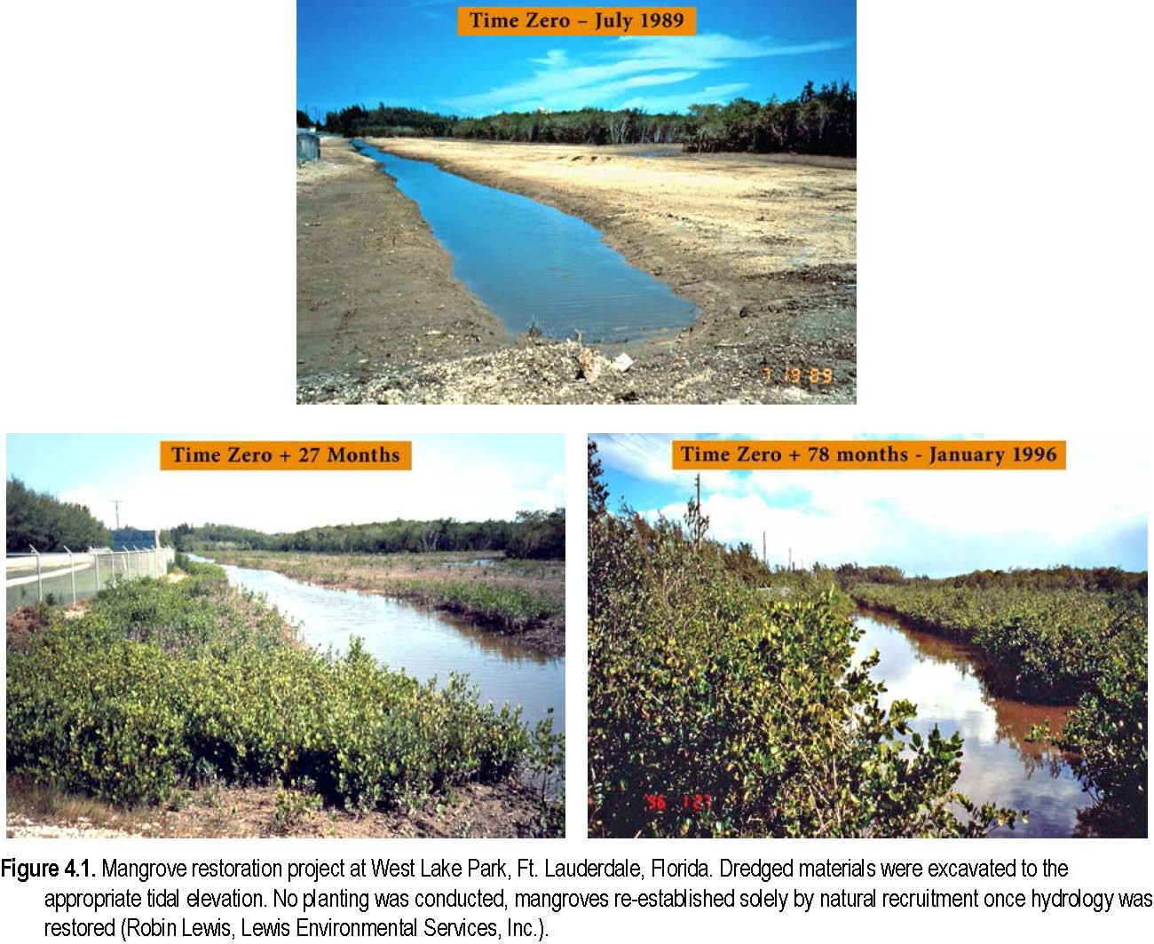
Plant “nurse” habitat
Since mangrove propagules and seedlings grow best in sheltered conditions, one strategy for more exposed areas is to plant salt marsh plants such as Spartina alterniflora to create nurse habitat. These plants grow quickly (one to two years), trap and hold sediments (which decreases erosion), and create a more sheltered habitat where young mangroves can establish. This staged approach is modeled after natural successional patterns and boosts natural recruitment of mangroves (Mauseth et al. 2001).
Propagules may be available only during certain times of the year or may not distribute far from the parent tree due to poor circulation or blocking by debris. Removing floating debris that may block channels enables propagules to reach and recolonize denuded areas naturally.
Restore in-kind resources
Increasingly, in-kind restoration is used for projects in the United States, especially for resource damage settlements after oil spills. In-kind restoration restores habitat in a different location in the same ecosystem and is meant to contribute to the overall habitat function of the region. A recent example of in-kind restoration is Tampa Bay, Florida, where several mangrove islets were heavily oiled during a spill in 1993. Restoration efforts purchased a former dredge disposal site within Tampa Bay that included degraded mangrove forest. Tidal connections were restored, marsh grasses were planted along the shoreline, and the land was deeded to the County to function as wildlife habitat and provide water-filtering functions (see Case Studies for more detail).
For Further Reading
Ballou, T.G. and R.R. Lewis III. 1989. Environmental assessment and restoration recommendations for a mangrove forest affected by jet fuel. In: Proceedings of the 1989 Oil Spill Conference. pp. 407-412.
Burns, K.A., S. Codi, and N.C. Duke. 2000. Gladstone, Australia field studies: weathering and degradation of hydrocarbons in oiled mangrove and salt marsh sediments with and without the application of an experimental bioremediation protocol. Marine Pollution Bulletin 41:392-402.
Burns, K.A., S.D. Garrity, and S.C. Levings. 1993. How many years until mangrove ecosystems recover from catastrophic oil spills? Marine Pollution Bulletin 26:239-248.
Cintrón-Molero, G. 1992. Restoring mangrove systems. In: Thayer, G.W. (ed.), Restoring the Nation’s Marine Environment. College Park, Maryland: Maryland Sea Grant College. pp. 223-277.
Da Silva, E.M., M.C. Peso-Aguiar, M.F.T. Navarro, C. De Barros, and A. Chastinet. 1997. Impact of petroleum pollution on aquatic coastal ecosystems in Brazil. Environmental Toxicology and Chemistry 16: 112-118.
Duke, N.C. 1996. Mangrove reforestation in Panama, an evaluation of planting in areas deforested by a large oil spill. In: Field, C. (ed.), Restoration of Mangrove Ecosystems. Okinawa: The International Society for Mangrove Ecosystems. pp. 209-232.
Duke, N.C., Z.S. Pinzon, and M.C. Prada T. 1997. Large-scale damage to mangrove forests following two large oil spills in Panama. Biotropica 29:2-14.
Ellison, A.M. 2000. Mangrove restoration: do we know enough? Restoration Ecology 8:219-229.
Field, C. 1996. General guide for the restoration of mangrove ecosystems. In: Field, C. (ed.), Restoration of Mangrove Ecosystems. Okinawa: The International Society for Mangrove Ecosystems. pp. 233-250.
Field, C. 1998. Rehabilitation of mangrove ecosystems: an overview. Marine Pollution Bulletin 37:383
392.
Garrity, S.D., S.C. Levings, and K.A. Burns. 1994. The Galeta oil spill: I. Long-term effects on the physical structure of the mangrove fringe. Estuarine, Coastal and Shelf Science 38:327-348.
Getter, C.D. and R.R. Lewis. 2003. Spill response that benefits the long-term recovery of oiled mangroves. In: Proceedings of the 2003 International Oil Spill Conference. pp. 1-12.
Getter, C.D., G. Cintrón, B. Dicks, R.R. Lewis III, and E.D. Seneca. 1984. The recovery and restoration of salt marshes and mangroves following an oil spill. In: Cairns, J.J. Jr. and A.L. Buikema, Jr. (eds.), Restoration of Habitats Impacted by Oil Spills. Boston: Butterworth Publishers. pp. 65-113.
Levings, S.C., S.D. Garrity, E.S. VanVleet, and D.L. Wetzel. 1997. Sublethal injury to red mangroves two years after oiling. In: Proceedings of the 1997 Oil Spill Conference. pp. 1040-41.
Levings, S.C. and S.D. Garrity. 1995. Oiling of mangrove keys in the 1993 Tampa Bay oil spill. In: Proceedings of the 1995 Oil Spill Conference. pp. 421-428.
Lewis, R.R. III. 2009. Chapter 28: Methods and Criteria for Successful Mangrove Forest Restoration. In: Gerardo, M., E. Perillo, R. Wolanski, D.R. Cahoon, and M.M. Brinson (eds.), Coastal Wetlands: An Integrated Ecosystem Approach. Elsevier. pp 787-800.
Lewis, R.R. 1979. Large scale mangrove restoration on St. Croix, U.S. Virgin Islands. In: Proceedings of the Sixth Annual Conference on the Restoration and Creation of Wetlands. pp. 231-241.
Lewis, R.R. and B. Brown. 2014. Ecological mangrove rehabilitation – a field manual for practitioners. Revised Version 2. Mangrove Action Project, Canadian International Development Agency, and OXFAM. 275 p.
Lewis, R.R. and B. Streever. 2000. Restoration of mangrove habitat. WRP Technical Notes Collection (ERDC TN-WRP-VN-RSW-3.2). Vicksburg, Mississippi: U.S. Army Engineer Research and Development Center. 7 pp. Available at: www.wes.army.mil/el/wrp.
Mauseth, G.S., J.S. Urquhart-Donnelly, and R.R. Lewis. 2001. Compensatory restoration of mangrove habitat following the Tampa Bay oil spill. In: Proceedings of the 2001 International Oil Spill Conference. pp. 761-767.
McKee, K.L. and P. Faulkner. 2000. Restoration of biogeochemical function in mangrove forests. Restoration Ecology 8:247-259.
Milano, G.R. 1999. Restoration of coastal wetlands in southeastern Florida. Wetland Journal 11(2):15
24.
Rothenberger, P. 1999. Utilization of encasement technology in restoration of mangrove forest on St. Croix, U.S. Virgin Islands. Reef Research 9 (3).
Shirley, M.A. 1992. Recolonization of a restored red mangrove habitat by fish and macroinvertebrates. In: Webb, J. (ed.), Proceedings of the 19th Annual Conference on Wetlands Restoration and Creation. pp. 159-173.
Wilkinson, D.L., C. Moore, M. Lopez, and M. Figueroa. 2001. Natural resource damage assessment for a JP-5 fuel spill at Naval Station Roosevelt Roads, Puerto Rico. Pre-Final Report. Norfolk: Atlantic Division, Naval Facilities Engineering Command. 96 pp.
CHAPTER 5. MANGROVE CASE STUDIES
Introduction
Mangroves around the world have been exposed to oil both from individual spills and from chronic pollution from refinery and storage tank discharges. Well-documented oil spills in mangrove areas provide a good idea of some of the complexities and variability of the impacts and response options. This chapter highlights techniques (learned from field trials, toxicology, and laboratory studies) to measure the health of mangroves. With help from NOAA’s IncidentNews.gov database and from colleagues around the world, case studies of oil spills impacting–or potentially impacting–mangroves are presented in this chapter. The focus is on individual incidents and does not include cases involving long-term pollution. However, some spills occurred at sites that had been impacted by previous spills (Bahía las Minas, Panama and Roosevelt Roads, Puerto Rico). The selected case studies also focus more on the direct and indirect effects of oiling and cleanup on the mangroves themselves, less on associated fauna and flora. The response data from the case studies investigated included a wide range of documentation such as: incident description, response actions, cleanup methods, oil type, environmental impacts, and recovery and restoration efforts. These are briefly reviewed below in chronological order.
One lesson that is quite clear from even a few of the cases is that the full extent of damage to mangroves is not apparent for many months or years after an incident, regardless of the fuel type and extent of response (other than full protection). Many questions remain about most studies. The most important is, how long does recovery actually take? Although a number of post-spill studies were conducted for as long as 10 to 20 years, only a few reports discussed monitoring that continued long enough to confirm full recovery.
Zoe Colocotronis, La Parguera, Puerto Rico, 1973
On March 18, 1973, the Zoe Colocotronis ran aground on a reef 3.5 miles off the La Parguera tourist area on the southwest coast of Puerto Rico. The master intentionally released 37,579 barrels (1.58 million gallons) of Venezuelan (Tijuana) crude oil. An estimated 24,000 barrels (1.01 million gallons) stranded on the beaches of Cabo Rojo. Three separate pools of black oil 6-8 inches thick oiled the shore of Cabo Rojo on the Bahía Sucia side. On March 21, a large number of sea cucumbers, conchs, prawns, sea urchins, and polychaete annelids washed ashore. Organisms died in the Thalassia seagrass beds and oil moved into mangrove forests composed of white, red, and black mangroves.
Response
Cleanup efforts were conducted outside the mangrove areas and involved booming, digging sumps, and pumping the collected oil into tank trucks. On March 23, before the oil in the mangroves could be recovered, an unexpected wind shift drove patches of oil out of the mangroves and into other areas and onto the beaches. By March 24, 604,000 gallons of nearly pure oil had been removed from other areas using sumps, skimmers, and vacuum trucks. Steam cleaning was not used because there was no accessible source of fresh water. No cleanup was conducted in the mangroves.
Impacts
U.S. Environmental Protection Agency (EPA) scientists surveyed the mangrove areas for a week beginning 24 hours after the spill. Detailed surveys were conducted of all oiled areas during the second week after the spill and again during the thirteenth week. Additional EPA site visits were made in January 1974 (10 months later) and January 1976 (34 months later) providing some idea of long-term effects. In one well-studied area, one hectare of red and black mangrove trees was defoliated and died during the three years following the spill. However, the EPA scientists also noted that much of the associated invertebrate life had recovered (Nadeau and Bergquist 1977).
In November 1973, eight months following the spill, oil chemists from Bowdoin College in Maine visited several oiled sites and noted a re-emergence of young trees. Although sediment oil concentrations remained high, the oil was heavily weathered and degraded. These observations suggested that the toxic components were gone in about half a year. This team had also visited oiled black mangrove sites four times between April 1979 and April 1981, 6 to 8 years after the spill. The scientists measured ratios of sodium and potassium in some plants, supporting the idea that oil injured the trees by disrupting salt and water balance and that such disruption might have been alleviated by directed cleanup. However, they made no comment on the visible health of the mangroves at that time (Page et al. 1979; Gilfillan et al. 1981).
Eleven years after the spill other chemists took sediment cores from several previously oiled mangrove sites and found concentrations ranging from 10,000 to 100,000 ppm (dry weight, total unresolved hydrocarbons) in a layer 6 cm below the relatively clean surface sediments. In addition, they found oil, possibly from the 1962 Argea Prima spill, 14-16 cm below the surface. These researchers did not report the status of the mangrove trees themselves (Corredor et al. 1990).
In 2002, 29 years after the spill, Getter and Lewis (2003) re-occupied the twelve original EPA transects and compared tree measurements and photographs with those from the 1970s. They reported that the outer fringe forests had fully recovered in terms of vegetation structure (?), with mature red mangroves that were 10-15 cm in diameter. Vegetation structure in the inner basin forest of black mangroves was also fully recovered.
Restoration
No restoration activities were undertaken at this spill.
For Further Reading
Nadeau, R.J. and E.T. Bergquist. 1977. Effects of the March 18, 1973 oil spill near Cabo Rojo, Puerto Rico on tropical marine communities. In: Proceedings of the 1977 Oil Spill Conference. pp. 535-538.
Getter, C.D. and R.R. Lewis. 2003. Spill response that benefits the long-term recovery of oiled mangroves. In: Proceedings of the 2003 International Oil Spill Conference. pp. 1-12.
Page, D.S., D.W. Mayo, J.F. Cooley, E. Sorenson, E.S. Gilfillan, and S.A. Hanson. 1979. Hydrocarbon distribution and weathering characteristics at a tropical oil spill site. In: Proceedings of the 1979 Oil Spill Conference. pp. 709-712.
Gilfillan, E.S., D.S. Page, R.P. Gerber, S. Hansen, J. Cooley, and J. Hothman. 1981. Fate of the Zoe Colocotronis oil spill and its effects on infaunal communities associated with mangroves. In: Proceedings of the 1981 Oil Spill Conference, p. 360.
Page, D.S., E.S, Gilfilan, C.C. Foster, J.R. Hotham, and L. Gonzales. 1985. Mangrove leaf tissue sodium and potassium ion concentrations as sublethal indicators of oil stress in mangroves. In: Proceedings of the 1985 Oil Spill Conference. pp. 391-393.
Corredor, J.E., J.M. Morell, and C.E. Del Castillo. 1990. Persistence of spilled crude oil in a tropical intertidal environment. Marine Pollution Bulletin 21:385-388.
Peck Slip, Eastern Puerto Rico, 1978
On December 19, 1978 the barge Peck Slip released between 440,000 and 450,000 gallons of Bunker C oil into open waters offshore of eastern Puerto Rico. Within two days oil had stranded in segments along 26 km of eastern Puerto Rico shorelines, mostly sand beach. However, some oil entered outer and inner fringing mangroves in three areas, and inner basin mangroves in one of these areas.
Response
No cleanup actions were undertaken although observers noted floating absorbent pads at one site. Surveys of mangroves were conducted shortly after the spill (December-early January 1979; Robinson 1979), 3 months later (Gundlach et al. 1979), 10 months later, and 18 months later (Getter et al. 1981).
Impacts
Mangroves on a small island (Isla de Ramos) were lightly impacted (prop roots had a 15-cm band of oil 50 to 60 cm above the substrate) and apparently did not suffer long-term injury. Near Punta Medio Mundo, about 1.05 hectares of inner fringe and inner basin mangrove roots were heavily oiled (prop roots with up to a 1-m band of oil) and 1 hectare was moderately oiled (0.3 to 0.45-m band of oil; Robinson, 1979). An estimated 3.5 tons of oil coated the mangrove roots. Algae growing on the prop roots absorbed the oil. Another two acres of mangroves at Pasaje Medio Mundo were moderately oiled with an estimated 1.3 tons of oil (prop roots oiled by a 0.2-m band on oil).
Figure 5.1. Heavy oiling of red mangrove prop roots from the Peck Slip spill in
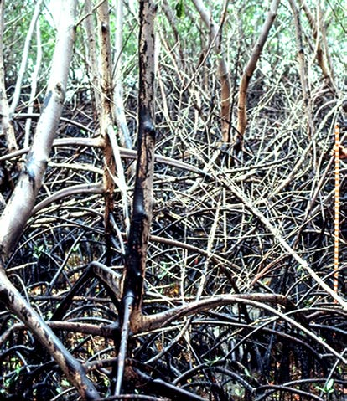Within two to three months the heavily oiled inner fringing and basin mangroves at the Punta Medio Mundo forest were defoliated. Prop-root oiling had widened to a band of over 2 m high, possibly from climbing crabs that were oiled (Figure 5.1). Later site visits confirmed that mangroves with the most heavily oiled prop roots remained defoliated 10 and 18 months later (Getter et al. 1981). This was one of five sites studied by Getter et al. (1981). From these studies the authors urged that inner fringing and inner basin mangroves receive highest priority for protection from oil spills. Puerto Rico in 1978. Note that the oil has spread 2 m above high tide by climbing crabs. The rod to the right is 1.5 m high (Research Planning, Inc.).
Getter and Lewis (2003) visited the site in 2002 but noted that the entire forest had been destroyed (by Hurricane Hugo in 1989), and a new forest had been reestablished.
Restoration
No restoration activities were undertaken at this spill.
For Further Reading
Getter, C.D. and R.R. Lewis. 2003. Spill response that benefits the long-term recovery of oiled mangroves. In: Proceedings of the 2003 International Oil Spill Conference. pp. 1-12.
Robinson, J.H. (ed.). 1979. The Peck Slip oil spill: a preliminary scientific report. Boulder: Office of Marine Pollution Assessment, National Oceanic and Atmospheric Administration. Unpublished report.
Gundlach, E.R., J. Michel, G.I. Scott, M.O. Hayes, C.D. Getter, and W.P. Davis. 1979. Ecological assessment of the Peck Slip (19 December 1978) oil spill in eastern Puerto Rico. In: Proceedings, Ecological Damage Assessment Conference, Society of Petroleum Industry Biologists. pp. 303-317.
Getter, C.D., G.I. Scott, and J. Michel. 1981. The effects of oil spills on mangrove forests: A comparison of five oil spill sites in the Gulf of Mexico and the Caribbean Sea. In: Proceedings of the 1981 Oil Spill Conference. pp. 535-540.
JP-5 Jet Fuel Spills, Roosevelt Roads, Puerto Rico (1986 and 1999)
In 1986 and again in 1999, Roosevelt Roads Naval Air Station storage tanks released JP5 jet fuel into a cove in eastern Puerto Rico. Before the 1986 and 1999 JP-5 spills, the area had been contaminated by oils from several past spills: a Bunker C spill in 1958 and a diesel spill in 1978, both from onshore storage tanks, and a 210,000-gallon diesel spill in 1981 from a tanker. All of these spills contaminated mangrove areas but effects of the earlier spills are unknown. In both cases, mangrove forests were contaminated, though response strategies differed markedly. Effects on mangroves were monitored at both spills.
On November 27, 1986, 59,000 gallons of JP-5 fuel washed down a catchment stream (tidal creek) and into Ensenada Honda. Two mangrove forest areas were contaminated, one in the tidal creek and the other at the head of the saltwater bay.
On October 20, 1999, 112,000 gallons of JP-5 fuel spilled from a day-tank at the Navy Base. The oil flowed into an underground drainage pipe, which runs under a runway and several roads for several hundred yards. The pipe empties into an open drainage ditch, which drains to a 12-hectare mangrove forest. This forest drains through a culvert into Ensenada Honda Bay.
Response
No cleanup actions were mentioned in reports dealing with the 1986 incident, presumably because of the high evaporation rate of JP-5 jet fuel in open conditions.
In the 1999 incident the Navy’s primary environmental concern was the bay. In the face of an approaching hurricane, USN Construction Battalion (Sea Bees) personnel constructed a dam to plug the culvert between the first impacted mangrove (later named “mangrove A”) and the mangrove adjacent to the bay (later named “mangrove C”). This dam trapped the water in mangrove area A, raising the levels by nearly 1 m above normal for 1.5 months. The final reports should be consulted for specifics as there were many details to the flow diversion response. Fuel was recovered, where practical, using underflow dams, skimmers, vacuum trucks, and sorbent materials. Attempts to manually remove oil with sorbents proved both ineffective and a human health risk for responders from inhalation of jet fuel fumes. It was estimated that 15-20% of the product was recovered, over 70 percent evaporated, and some 10-15% (approximately 11,200-16,800 gallons) remains unaccounted for; presumably stranded in the mangroves or in the sediments near the spill site.
The fuel flowed through the mangroves and some portion of the oil changed color from almost clear with a slight yellow tint to brown/black, similar to a light crude oil. It is unknown as to whether this was as a result of tannins from the mangroves dissolving into the oil or the JP-5, liberating heavier product remaining from previous spills.
Impacts
1986 Spill.
In the 1986 incident two mangrove areas were contaminated by JP-5 fuel: (1) the northernmost red mangroves drained by the tidal creek, and (2) the mixed species mangroves adjacent to the Coast Guard pier in Ensenada Honda. Local responders noted visible effects on adult trees within 10 days of oiling. Follow-on surveys were conducted in the second area 17 months later and again 23 months later. During these surveys 10 x 10-m grids along transects documented tree height, canopy, tree death, percent open canopy, seedling counts, and invertebrate biota. There were three transects in oiled areas plus two in unoiled areas. In June 1987, false-color aerial photos were taken of the impacted forest.
Detailed surveys five months later found most adult trees in the oiled areas dead and/or defoliated. However, there were live seedlings with highest densities along the forest front. Furthermore, sediment oil concentrations were extremely low (less than 1 ppm) and similar to concentrations in unoiled areas. Because of the low impact on seedlings and the near-absence of fuel oil six months later, researchers concluded that there was no smothering effect from the jet fuel. Adult tree defoliation and mortality was likely caused by initial direct toxicity of the fuel to root structures.
Apparently these mangroves recovered sufficiently from the 1986 JP-5 spill to merit no comment from personnel responding to the 1999 spill, other than that they were protected by the response itself.
1999 Spill.
Tidal creek mangroves were clearly damaged from the 1999 incident, due either to fuel toxicity or extended flooding, or both. Follow-up studies through October 2001 indicated that there was some recovery in the flooded area A two years after the incident, with new propagules and new shoots on injured trees. However, there were no signs of recovery in area B. Of a total of 50 acres of injured mangrove forest, about 30 acres showed no signs of recovery two years later (Lehman et al. 2001, Wilkinson et al. 2001). However, the series of water diversion activities resulted in preventing oiling of the mangrove (C) area bordering the shoreline of Ensendada Honda.
Restoration
The restoration plan consisted of hydraulic improvements to the Los Machos mangrove area. The Navy had a poorly designed culvert bridge across the mangrove channel, and the restoration consisted of removing the culverts, widening the channel, and replacing the bridge with an open span bridge. This increased tidal flushing throughout the section of mangroves.
For Further Reading
Ballou, T.G. and R.R. Lewis III. 1989. Environmental assessment and restoration recommendations for a mangrove forest affected by jet fuel. 2 In: Proceedings of the 1989 Oil Spill Conference. pp. 407-412.
Lehman, S., F. Lopez, and F. Csulak. 2001. Case study: spill of JP-5 fuel at Roosevelt Roads Naval Air Station, Puerto Rico, into a basin mangrove. In: Proceedings of the 2001 International Oil Spill Conference. pp. 197-201.
Wilkinson, D.L., C. Moore, M. Lopez, and M. Figueroa. 2001. Natural Resource Damage Assessment for a JP-5 fuel spill at Naval Air Station Roosevelt Roads, Puerto Rico. Pre-final Report prepared for Commander, Atlantic Division, Naval Facilities Engineering Command, Norfolk, VA.
T/V Era, Spencer Gulf, South Australia, 1992
On August 30, 1992, the tanker Era released an estimated 296 tonnes (974,000 gallons) of heavy Bunker oil (a blend of diesel and heavy residual) at a jetty near the head of Spencer Gulf, South Australia. On the night of September 1-2, an estimated 20 tonnes (5,500 gallons) stranded along 10-15 km of mangrove (Avicennia) forest south of Port Pirie, S.A. However, subsequent surveys estimated that the actual quantity stranded in the mangroves was 57 tonnes (15,600 gallons).
Response
Within two to three hours of the release, the oil slick was treated from vessels spraying dispersants Corexit 9527 and 7667; the following day, aircraft also sprayed slicks with Ardrox dispersant. Responders were advised that cleanup within the mangrove forest was not feasible and would likely increase damage to adjacent, unimpacted areas. Thus, all subsequent activity in the mangrove forest was restricted to detailed and long-term monitoring.
Impacts
Oiled mangroves were monitored for four years after the spill. This is perhaps one of the most well documented accounts available of the fate and effects of oil in a mangrove forest. Only a brief, highly simplified account can be given here, and the reader is advised to consult the report for important details and qualifications (Wardrop et al. 1997).
Due to an extremely high tide, oil penetrated far into the mangrove forest (50 m) coating leaves as well as stems, trunks, and sediment. Oil concentrations and visible damage to mangrove trees were recorded over four years. About 75-100 hectares were oiled: of these, 4.2 hectares were heavily oiled,
7.3 hectares were moderately oiled, and 38.0 hectares were lightly oiled. In 1992 heavy oiling of canopy and extensive mats of oiled seagrass debris characterized heavily oiled areas. By November 1992 mangroves over a total area of 2.3 hectares suffered extensive defoliation; the defoliated area expanded slightly to 3.2 hectares by 1995 and then stopped increasing. Trees that were totally defoliated did not recover during the four-year period. Defoliation and degree of sediment oiling were correlated: heavily oiled areas were completely defoliated and moderately oiled areas were “severely” defoliated. In lightly oiled areas, trees had less leaf damage and recovered rapidly. “Overall the extent of damage in each of the studied locations, and the speed with which it occurred, has correlated to the oiling classification assigned in the first survey” (Wardrop et al. 1997). Finally, the veracity of the original recommendation of “no cleanup” was supported: injury to mangrove trees was restricted to those initially impacted by moderate to heavy oiling.
For Further Reading
Wardrop, J.A., B. Wagstaff, P. Pfennig, J. Leeder, and R. Connolly. 1997. The distribution, persistence and effects of petroleum hydrocarbons in mangroves impacted by the “Era” oil spill (September, 1992). Final Phase One report (1996). Report ERAREP/96. Adelaide, South Australia: Office of the Environmental Protection Authority, S.A. Department of Environment and Natural Resources.
Witwater and Texaco Storage Tank Spills, Bahía Las Minas, Panama, 1968 and 1986
Two large oil spills, 18 years apart, resulted in long-term injury to a portion of the 1,200 hectares of mangroves of the Bahía Las Minas area of Panama.
Witwater. On December 13, 1968, the oil tanker Witwater broke up in heavy seas off the Atlantic coast of Panama, spilling 14,000 barrels (588,000 gallons) of Bunker C and diesel oil into the water 5 miles from Galeta Island. Strong seasonal winds pushed the slick towards the island, oiling sand beaches, rocky coasts, and mangroves.
Texaco Storage Tank. On April 27, 1986, a Texaco storage tank at a refinery on Isla Payardi, Panama, ruptured, releasing approximately 240,000 barrels (10.1 million gallons) of medium-weight crude oil. Approximately 140,000 barrels (5.9 million gallons) of oil flooded through a dike and overflowed separators and a retaining lagoon and flowed into Bahía Cativá, an arm of Bahía las Minas.
Response
Witwater. Several thousand barrels of an oil and water mix were pumped from the waters surrounding Galeta Island, and approximately 5,000 barrels (210,000 gallons) of oil were ignited and burned along shorelines in the bay. By December 17, pumping and shoreline burning cleaned up approximately half of the spilled oil.
Texaco Storage Tank. Refinery personnel reported that 60,000 barrels (2.52 million gallons) of oil were recovered. It is not known how much of this recovered oil was from the sea. Dispersants were applied in Bahía Cativá, Islas Naranjos, offshore of Bahía Las Minas, near Portobelo, and along the northern breakwater at the mouth of the Panama Canal, although the dispersants appeared to be ineffective due to the weathered state of the oil and the calm seas. Skimmers were also used and recovered some floating oil. Vacuum trucks were used as part of the shore-based cleanup effort, recovering oil floating on the nearshore water. Several channels were dug through the mangroves to drain the oil. These channels appeared, instead, to have helped move the oil inshore. Increased disturbance due to the construction of the channels may have also contributed to subsequent erosion. Oiled sediment and debris were manually removed along the more accessible shorelines. Seawater was sprayed on some sandy areas to aid oil removal. Pumping to recover floating oil appeared to be the most effective oil recovery method. The shallow waters and mangroves rendered many oil spill cleanup techniques impractical.
Impacts
Archived aerial photographs (1966, 1973, 1979, and 1990) and ground surveys were keys to understanding the effects of these two spills on mangrove forests.
Witwater. Despite the cleanup, both red and black mangrove trees were severely oiled, and the majority of the red mangrove seedlings were killed. Oil also damaged much of the mangrove forest biota. Initial reports did not indicate that adult trees had suffered. Aerial survey photos from 1966 and 1973 were used to assess deforestation and open canopy. About 49 hectares of mangrove forest (representing 4 percent of the total mangrove area) had been completely deforested in 1973 (five years after the spill). Most deforested areas had new recruits by 1979 (eleven years after the spill) but 3 hectares were lost to sea-margin encroachment. Observable differences (crescent-shaped bands of open canopy that were 5-100 m wide, and canopy height and structure) and oiled sediment persisted into 1992, 23 years after the Witwater spill.
Texaco Storage Tank Spill. The distribution of oil was surveyed from aircraft for two months following the release. A total of 51 miles of shoreline was heavily oiled, including some mangroves recovering from the Witwater spill. In a central embayment (Bahía Cativá), approximately half the surrounding forested area (and halfway up the intertidal zone) was killed. Oiled habitats within this distance included extensive mangroves, intertidal reef flats, seagrass beds, and subtidal coral reefs. Re-oiling of the shoreline and mangroves was a continuing problem. Oil slicks were regularly observed within Bahía las Minas for at least four years following the spill with oil coming predominantly from areas of fringing mangroves. As the oiled red mangrove trees decayed, it was believed that eroding, underlying sediments released trapped oil.
An affected reef flat habitat was the site of an ongoing study at the Smithsonian Tropical Research Institute’s field station at Punta Galeta. A detailed study of mangrove trees revealed that one-to twoyear-old seedlings appeared to survive whereas the surrounding adults died. It was believed that, somehow, young seedling structure (perhaps lack of prop roots) enabled the young trees to tolerate periods of oil immersion. It was suggested that the disruption of the substrate before replanting may remove such survivors, hampering forest recovery. Oil persisted in the mangroves through May 1989. Initial oiling of the trees produced measurable amounts of oil on 100% of all the roots that were sampled. Through May 1989, the mangrove roots in the open coast and channel areas showed 70% oiling, while the oiled proportion in the stream mangroves remained 100% oiled. The decrease in oil coverage resulted from weathering, microbial degradation, and loss of oiled bark or encrusting organisms. Root mortality was greater in oiled areas.
Subsequent aerial and ground surveys indicated “recovery of the 1986 spill was well-advanced by 1992” (Duke et al. 1997) due, in part, to extensive restoration. However, about 5 hectares of fringing forest were lost to sea-margin encroachment and important differences remained between sheltered and exposed areas.
Although ten times more oil was spilled in 1986 than in 1968, this did not result in ten times more damage to mangroves. Calm winds, lower tides, different oil type, and longer weathering time before impact may have resulted in less toxicity.
Restoration
Because of extensive mangrove mortality, several replanting projects were conducted at Bahía las Minas, in hopes of speeding mangrove forest recovery, which was at the time estimated to take 20 years or longer (Teas et al. 1989).
Experiments to determine whether propagules could survive if planted directly in oiled sediment found 100% mortality up until six months post spill. By nine months post-spill, propagules survived at rates similar to those at unoiled sites. Beginning 12 months after oiling, red mangrove seedlings that had been raised in a separate nursery area were planted (with added fertilizer) in areas of the damaged mangrove forest. A total of 42,000 nursery plants and 44,000 propagules were planted.
Studies conducted in 1989 (33 months post-spill) looked at the effectiveness of the plantings conducted in 1987, by comparing mangrove densities in areas that had recruited naturally with those that were replanted. Though planted seedlings had survived in all areas studied, naturally recruited plants were most dense. Thus, natural recruitment was more effective at recolonizing oil-damaged areas and, over time, natural recruits out-competed planted seedlings. Researchers also noted detrimental collateral impacts from planting, including cutting and removing dead timber for boat access (which removed shelter for seedlings), trampling sediments, digging holes (which accelerated erosion), and damaging existing seedlings (Duke 1996). Overall, planting did not result in a net benefit to the mangrove forest. However, since recolonization of mangroves was lowest in exposed areas, Duke (1996) suggested that an effective restoration activity could be to protect very exposed areas until mangrove trees are well established.
For Further Reading
Duke, N.C. 1996. Mangrove reforestation in Panama, an evaluation of planting in areas deforested by a large oil spill. In: Field, C. (ed.), Restoration of Mangrove Ecosystems. Okinawa: The International Society for Mangrove Ecosystems. pp. 209-232.
Duke, N.C., Z.S. Pinzon, and M.C. Prada. 1997. Large-scale damage to mangrove forests following two large oil spills in Panama. Biotropica 29:2-14.
Garrity, S.D., S.C. Levings, and K.A. Burns. 1994. The Galeta oil spill: I. Long-term effects on the physical structure of the mangrove fringe. Estuarine, Coastal and Shelf Science 38:327-348.
Jackson, J.B.C., J.D. Cubit, B.D. Keller, V. Batista, K. Burns, H.M. Caffey, R.L. Caldwell, S.D. Garrity, C.D. Getter,
C. Gonzalez, H.M. Guzman, K.W. Kaufmann, A.H. Knap, S.C. Levings, M.J. Marshall, R. Steger, R.C. Thompson, and E. Weil. 1989. Ecological effects of a major oil spill on Panamanian coastal marine communities. Science 243:37-44.
Teas, H.J., A.H. Lasday, E. Luque L., R.A. Morales, M.E. De Diego, and J.M. Baker. 1989. Mangrove restoration after the 1986 Refineria Panama oil spill. In: Proceedings of the 1989 Oil Spill Conference. pp. 433-437.
Bouchard Barge B-155, Tampa Bay, August 1993
On August 10, 1993, the freighter Balsa 37, the barge Ocean 255, and the barge Bouchard 155 collided in the shipping channel west of the Sunshine Skyway Bridge and south of Mullet Key in Tampa Bay, Florida. The collision caused three separate emergencies: (1) the Balsa 37 was listing, threatening to spill phosphate rock; (2) jet fuel, gasoline, and diesel caught fire on the Ocean 255; and (3) the Bouchard 155 was holed at the port bow, spilling approximately 8,000 barrels (338,000 gallons) of No. 6 fuel oil into Tampa Bay. By August 15 most of the floating fuel oil had come ashore and heavily coated sand beaches, several mangrove islands, and seawalls within Boca Ciega Bay.
By August 16 very little floating oil was seen offshore. In the shallow, low-energy areas along the mangrove islands inside Johns Pass and at a few locations in the surf zone, oil had mixed with beach sand and shallow sediments to form underwater tarmats, some of which came ashore on the mangrove keys (Figure 5.2)
Response
The No. 6 fuel from the barge is the only material known to have been released from this incident. Countermeasures used during this spill were mechanical or manual removal. Skimming operations were used to collect free-floating oil. Efficiency and effectiveness of skimming operations were extremely high. Oil in and around mangrove islands was removed by vacuuming. Areas were left oiled when it was felt that cleanup methods would cause greater impact than leaving the oil in place. Some of the submerged oil in very shallow areas was removed using buckets and shovels. Oiled seagrass beds were cleaned by gently lifting oil out of them by hand.
Figure 5.2. Heavy oil stranding on the mangrove substrate and coating of the prop roots and pneumatophores (Research Planning, Inc.).
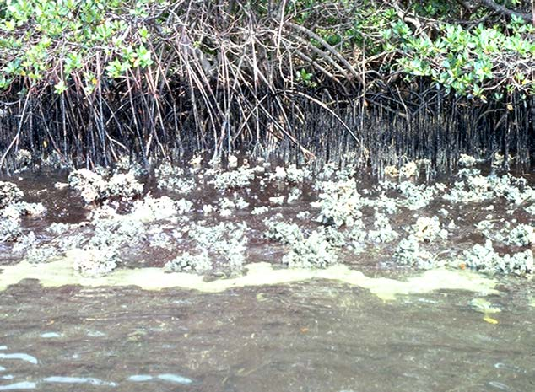
Impacts
Tarmats had formed when the viscous oil mixed with sand in the surf zone along the Gulf beaches and when slicks passed over shoals at the entrance to Johns Pass. The mats that entered Johns Pass were almost neutrally buoyant and stranded on the tidal flat and in the mangrove fringe on one of the small islands just inside the pass (Eleanor Island). There, mats up to 10 cm thick accumulated around the mangrove roots and oyster clusters. Much of this oil was vacuumed out using a vacuum transfer unit on a grounded barge staged on the firm, sandy tidal flat. On all, 2.2 hectares of mangroves were moderately to heavily oiled.
Scientists visited oiled and unoiled mangrove keys quarterly between November 1994 and April 1996. Individual trees, pneumatophores, and prop roots were tagged to enumerate trends in defoliation, leaf health, shoot number and length, and mortality of juvenile and adult plants or their structures. Visual oiling trends were documented through late 1995 and sediment samples for wet chemistry were collected in 1996. Adult red mangrove trees at the most heavily oiled site (outer Eleanor Island) deteriorated over this time period, with moderate to heavy defoliation and soft, rotting prop roots. “Of marked trees, 20% were totally defoliated and appeared dead by June 1994” (Levings and Garrity 1995). Nine-month mortality of juvenile red and black mangrove plants was 5% at unoiled reference sites, 35% in heavily oiled areas on the protected side of the island, and 50% in heavily oiled areas on the exposed side of Eleanor Island. It was predicted additional mortality would continue to occur.
The researchers also measured for signs of sublethal stress in adult trees: one to two years after the spill and cleanup, surviving red mangroves experienced graded negative responses in four measures of shoot growth and production, suggesting that sublethal long-term effects may be common in oiled mangroves. Sediments around trees experiencing these responses contained greater than 500 ppm total hydrocarbons (dry weight).
More follow-up observations are needed at these sites, but we are not aware of any extending beyond three years after the spill and cleanup.
Restoration
Trustees from state and Federal agencies and the responsible party developed a restoration plan for mangroves and associated habitats damaged in the spill. A compensatory plan provided mangrove and associated wetland habitat for fish, birds, and epibenthic communities at a site in the same watershed but not necessarily impacted by the spill.
The responsible party purchased a former dredge disposal site in Boca Ciega Bay and deeded it into public ownership. This site contained degraded mangrove forest that was restored through excavation of the upland fill to appropriate tidal elevations to increase tidal exchange and removal of exotic plants and debris. On the bayward edge of the mangrove forest, smooth cordgrass (Spartina alterniflora) was planted to create a fringing salt marsh buffer that could eventually provide habitat for mangrove seedlings. A monitoring program was established with specific success criteria, including vegetative cover and height of mangroves, absence of exotic species, and functional tidal exchanges. At 60 months post-restoration, the site met five of the six performance criteria. The rapid recolonization of the site by mangroves precluded smooth cordgrass, which was planted initially after the site was re-constructed, from expanding to form a significant cover. The restoration project was considered a success because the ultimate objective was re-establishment of mangrove habitat (Lewis 2004).
For Further Reading
Levings, S.C. and S.D. Garrity. 1995. Oiling of mangrove keys in the 1993 Tampa Bay oil spill. In: Proceedings of the 1995 International Oil Spill Conference. pp. 421-428.
Levings, S.C., S.D. Garrity, E.S. VanVleet, and D.L. Wetzel. 1997. Sublethal injury to red mangroves two years after oiling. In: Proceedings of the 1997 International Oil Spill Conference. pp. 1040-41.
Lewis, III, R.R. 2004. Time Zero plus 60 months report for the Cross Bayou mangrove restoration site, Pinellas County, Florida. Prepared for The Cross Bayou Project Review Group, Tampa, Fl. Lewis Environmental Services, Salt Springs, Fl. 25 pages.
Mauseth, G. S., J.S. Urquhart-Donnelly, and R.R. Lewis. 2001. Compensatory restoration of mangrove habitat following the Tampa Bay oil spill. In: Proceedings of the 2001 International Oil Spill Conference. pp. 761-767.
Guanabara Bay, Brazil, 2000
On January 18, 2000, 340,000 gallons of marine fuel oil (a blend of diesel and a residual fuel oil) were released from a pipeline at the Petrobras refinery inside Guanabara Bay, north of Rio de Janeiro, Brazil. Two areas of mangroves were heavily impacted: 1) near the pipeline break which resulted in extensive contamination of interior mangrove habitats; and 2) near the Suruí River where the heaviest oiling was along the outer fringe.
Response
Initial efforts included mechanical oil recovery from the water surface, mangrove areas protection with booms, beach cleanup, and rocky shore cold water flushing. No cleanup efforts were attempted in mangroves.
Impacts
In the heavily oiled areas one year after the spill, impacts were as follows: 24-96% tree mortality versus 11-22% in unoiled areas; adventitious roots in juveniles and seedlings of Avicennia at 20-50% whereas unoiled sites had ~0%; increased litter production; adult crab density reductions of 70% and juvenile crab density reductions of 40%; and no differences or a large increase in ovid female crabs. Total PAHs in soils were patchy, ranging from 11-355 ppm.
By 5-7 years post-spill, vegetative recovery was similar to mangrove growth following a natural disturbance, with no persisting chronic effects of oiling. The abundance of adult and juveniles crabs at three oiled sites showed no difference compared to an unoiled site, whereas one oiled site had a 65% reduction in juvenile crabs. The total PAHs in soils decreased, ranging from 3-18 ppm and soil bioassays showed no toxicity; however, large numbers of oligochaetes indicated continued stress in the oiled sediments.
In lightly oiled mangrove areas, impacts were as follows: 34-49% tree mortality versus 11-22% in unoiled areas; increased litter production; adult crab density reductions of 30-50% and juvenile crab density reductions of 20-50%; and ovid females crab abundances that were 1.5-3x greater than in unoiled areas. Total PAHs in soils at were at background levels (0.1-0.2 ppm) in one oiled area, and were 0.9-3.4 ppm in other oiled areas. By 5-7 years post-spill, there were no differences in any of these measures in the lightly oiled areas compared to unoiled reference sites.
M/T Solar I, Guimaras Island, The Philippines, 2006
On August 11, 2006, the tanker M/T Solar I sank in 700 m of water offshore of Guimaras Island, near Iliolo, in the central Philippines. The vessel was carrying an estimated 2 million liters (528,000 gallons) of bunker fuel for a local power plant. Over 200 km of shoreline were oiled, including sand beaches, cobble beaches, rocky shores, and mangroves.
Response
Cleanup was conducted on sand and cobble beaches, using mostly manual methods and local workers. Oiled seawalls around villages were scrubbed. The mangroves were heavily oiled, in many areas oiling extended throughout the mangrove stands, from the seaward edge to the landward extent of mangroves (Figure 5.3). There were some initial attempts to cut the oiled mangroves, which were
stopped. Cleanup activities were completed in about one month, although some areas were not accessible and were left uncleaned.
Impacts
A long-term monitoring plan was implemented to assess the impacts of the spill. Studies of mangrove forests found that 0.93 hectares died in patches throughout the impacted area within three months. The largest patch was 0.49 ha. Though the oil swept through and oiled the entire mangrove forest in many areas, the dead patches occurred only at the inner part of the forest, adjacent to the terrestrial uplands. This pattern is likely a result of higher oil concentration at the landward extent of tides (up to the uplands) reduced tidal flushing, and no wave action.
Figure 5.3. Heavy fuel oil from the M/T Solar I that penetrated completely through the mangrove forest to the landward zone, coating the prop roots and trunks of the trees (Ruth Yender, NOAA).
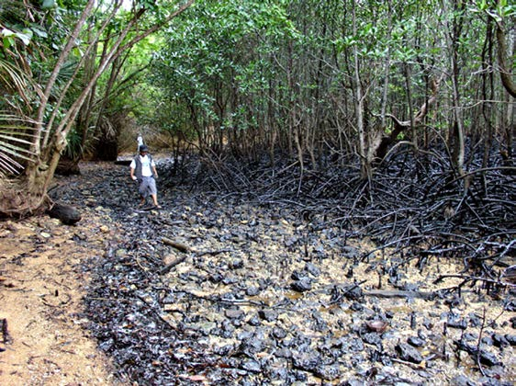
The oil apparently did not penetrate into the mangrove soils, and one year later, total PAHs (16 parent PAHs) in soils were <0.16 -0.8 ppm. PAHs in shellfish (bivalves, crabs, and gastropods) were 0.04-3.1 ppm one month after the spill, 9.7 to 18.7 ppm one year after the oil spill, and 1 ppm to 2.4 ppm two years after. It was noted that several storms hit the area in 2007 and 2008.
One year later, the mangrove forest community structure showed a drastic reduction in density and stand basal area. Rhizophora trees adjacent to the deforested area showed reductions in leaf size and canopy cover that reached up to a maximum of 48-58%. Propagules adjacent to the deforested area showed deformities and necrosis. In the deforested areas, saplings and seedlings were highly grazed and necrotic. No information was provided on the degree of sediment oiling in the deforested areas; however, the researchers attributed the continued stress responses to residual oil exposure. Three years after the spill, the deforested areas showed two patterns of response: 1) in areas where the dead trees were not being harvested for firewood, the logs trapped propagules and facilitated mangrove colonization; and 2) where the dead trees were harvested, an open gap was formed that exposed the area to surging waves, preventing recolonization. PAHs in the mangrove soils were reported to be below sediment toxicity levels.
For Further Reading
Barnuevo, A.B. and R.B. Sadaba. 2014. Recovery of mangrove deforested areas from M/T Solar oil spill in Guimaras, Philippines. In: Proceedings of the 2014 International Oil Spill Conference. pp. 2260-2272.
Pahila, I.G., H. Taberna, Jr., R. Sadaba, Jr. L. Gamarcha, J. Koyama, and S. Uno. 2009. Assessment of residual petroleum hydrocarbon two years after the M/T Solar I oil spill in southern Guimaras, Central Philippines. Mem. Fac. Fish. Kagoshima University Special Issue 59-62.
Sadaba, R.B., A.P. Barnuevo, C.S. Madas, J. Biñas, and E. Hortillosa. 2009. Assessment of the short-term damage in the Guimaras mangrove forests by the M/T Solar I oil spill. University of Philippines Visayas,
J. Natural Science, Oil Spill Issue: 71-82.
Sadaba, R.B. and A.P. Barnuevo. 2010. Status of mangroves within Taklong Island National Marine Reserve, Nueva Valencia, Guimaras, Philippines: A one-year post spill monitoring study. Mem. Fac. Fish. Kagoshima University Special Issue: 9-17.
Uno S., J. Koyama, E. Kokushi, H. Monteclaro, S. Santander, J.O. Cheikyula, S. Miki, N. Anasco, I.G. Pahila,
H.S. Taberna, and T. Matsuika. 2010. Monitoring of PAHs and alkylated PAHs in aquatic organisms after 1 month from the Solar I oil spill off the coast of Guimaras Island, Philippines. Environmental Monitoring and Assessment 165:501-515.
MANGROVE GLOSSARY
Aerial roots – Roots that are formed in and exposed to air. In mangrove species (e.g., Rhizophora spp.), aerial roots develop into stilt roots (prop roots and drop roots) that anchor into the sediment, offering mechanical support, nutrient absorption, and gas exchange.
Anaerobic – Occurring with little or no oxygen.
Anchialine ponds – A rare Hawaiian ecosystem, consisting of pools with no surface connection to the ocean, but affected by tides. These pools have a characteristic water quality and assemblage of animals and plants, many of which are endangered.
Anoxic – Without free oxygen. Aerobic metabolism (e.g., bacterial respiration) can consume dissolved free oxygen in water and soils, resulting in anoxic conditions that are detrimental to oxygen-breathing organisms.
Bioaccumulate – Uptake of dissolved chemicals from water and uptake from ingested food and sediment residues.
Biogenic – In mangroves, the trees themselves create the habitat. Biogenic also means “resulting from the actions of living organisms.”
Canopy – topmost layer of leaves, twigs, and branches of forest trees or other woody plants.
Chlorosis – abnormal condition characterized by the absence of green pigments in plants, causing yellowing of normally green leaves.
Defoliation – The removal of the foliar tissues of a plant, resulting from mechanical (e.g., hurricanes), biological (herbivore), or chemical agents (e.g., plant hormones).
Deposition – The accumulation of material on a substrate. In mangrove systems this term is typically used in relation to accumulation of surface sediment.
Detritus – Non-living organic matter that is so decomposed that it is impossible to identify the original parent material.
Drop roots – Roots that develop on a branch and begin as aerial roots but eventually grow into a substrate; these roots can provide mechanical support (e.g., Rhizophora spp.).
Endpoint – A measured response of a natural resource to exposure to a contaminant, such as oil, in the field or laboratory.
Eustatic sea level rise – The worldwide rise in sea level elevation due mostly to the thermal expansion of seawater and the melting of glaciers.
Evapotranspiration – The transfer of water from the soil, through a plant, and to the atmosphere through the combined processes of evaporation and transpiration. Evaporation is a function of surface area, temperature, and wind. Transpiration is a process of water loss through leaf stomatal openings, and is related to gas exchange and water transport within a plant. When the stomates open, a large pressure differential in water vapor across the leaf surfaces causes the loss of water from the leaves.
Genotype – Genetic makeup of an individual organism.
Hermaphroditic – Both sexes present in an individual organism.
Infrared photography – Photography using films sensitive to both visible light and infrared radiation. Live vegetation is particularly highlighted with infrared films and so is a useful tool for aerial surveys of live and dead plants.
Lenticel – A small elliptical pore in the surface tissues of mangrove pneumatophores and prop roots, where gas exchange occurs.
Mangal – a mangrove forest and its associated microbes, fungi, plants, and animals.
Mangrove – a tree or woody shrub that has adaptations for growing in the intertidal zone (specifically, adaptations to salinity and flooded conditions).
Microtidal – A tidal range of less than one meter.
PAH – polynuclear aromatic hydrocarbon; also called polycyclic aromatic hydrocarbon, a component of oil. PAHs are associated with demonstrated toxic effects.
Pneumatophore – A vertical above ground extension of an underground root, with lenticels and aerenchyma to allow for gas exchange. Pneumatophores are characteristic of trees adapted to flooded conditions (such as Avicennia spp.)
Prop roots – Roots that develop on a trunk and begin as aerial roots but eventually grow into a substrate; these roots can provide mechanical support (e.g. Rhizophora spp.), sometimes called “stilt roots.”
Propagule – Seedling growing out of a fruit; this process begins while the fruit is still attached to the tree. For some species of mangroves, propagules represent the normal, tidally dispersed means of reproduction.
RSLR – relative sea level rise -The net effect of eustatic sea level rise and local geomorphoplogical changes in elevation. Local subsidence can make RSLR much greater than eustatic rise.
Sublethal effect – An effect that does not directly cause death but does affect behavior, biochemical, physiological, or reproductive functions, or tissue integrity.
Vivipary – The condition in which the embryo (the young plant within the seed) germinates while still attached to the parent plant (synonymous with viviparity)
Weathering – Changes in the physical and chemical properties of oil due to natural processes, including evaporation, emulsification, dissolution, photo-oxidation, and biodegradation.
Wrack – Organic material, usually from dead seagrass or algae that wash up on shorelines.

Kathryn D. Sullivan, Ph.D.Under Secretary of Commerce for Oceans and Atmosphere, andAdministrator, National Oceanic and Atmospheric Administration

September 2014 U.S. DEPARTMENT OF COMMERCE Penny PritzkerSecretary, U.S. Department of Commerce
Holly A. Bamford, Ph.D.Assistant Administrator for Ocean Services and Coastal Zone Management,NOAA Ocean Service
U.S. DEPARTMENT OF COMMERCE • National Oceanic and Atmospheric Administration • National Ocean Service
䘀椀最甀爀攀㄀⸀㄀⸀圀漀爀氀搀洀愀瀀漀昀琀栀攀洀愀渀最爀漀瘀攀搀椀猀琀爀椀戀甀琀椀漀渀稀漀渀攀猀愀渀搀琀栀攀渀甀洀戀攀爀漀昀洀愀渀最爀漀瘀攀猀瀀攀挀椀攀猀愀氀漀渀最攀愀挀栀爀攀最椀漀渀⠀䐀攀氀琀愀爀攀猀Ⰰ㈀ ㄀㐀⤀⸀
䘀椀最甀爀攀㄀⸀㈀⸀䐀椀猀琀爀椀戀甀琀椀漀渀漀昀洀愀渀最爀漀瘀攀昀漀爀攀猀琀猀椀渀琀栀攀挀漀渀琀椀渀攀渀琀愀氀唀渀椀琀攀搀匀琀愀琀攀猀戀愀猀攀搀漀渀搀愀琀愀昀爀漀洀㈀ 㘀昀漀爀吀攀砀愀猀愀渀搀䰀漀甀椀猀椀愀渀愀愀渀搀㈀ 㐀昀漀爀䘀氀漀爀椀搀愀⠀伀猀氀愀渀搀攀琀愀氀⸀㈀ ㄀㌀⤀⸀
䘀椀最甀爀攀㄀⸀㌀⸀䴀愀渀最爀漀瘀攀猀琀栀愀琀漀挀挀甀爀椀渀琀栀攀唀⸀匀⸀愀渀搀䌀愀爀椀戀戀攀愀渀⸀䄀⤀刀栀椀稀漀瀀栀漀爀愀洀愀渀最攀氀⠀爀攀搀洀愀渀最爀漀瘀攀⤀猀栀漀眀椀渀最琀栀攀挀氀愀猀猀椀挀愀氀琀愀渀最氀攀漀昀瀀爀漀瀀爀漀漀琀猀⸀䈀⤀䄀瘀椀挀攀渀渀椀愀洀愀爀椀渀愀⠀戀氀愀挀欀洀愀渀最爀漀瘀攀⤀猀栀漀眀椀渀最琀栀攀搀椀愀最渀漀猀琀椀挀瀀爀攀猀攀渀挀攀漀昀瀀渀攀甀洀愀琀漀瀀栀漀爀攀猀⸀䌀⤀䰀愀最甀渀挀甀氀愀爀椀愀爀愀挀攀洀漀猀愀⠀眀栀椀琀攀洀愀渀最爀漀瘀攀⤀⸀䐀⤀䌀漀渀漀挀愀爀瀀甀猀攀爀攀挀琀甀猀⠀戀甀琀琀漀渀眀漀漀搀洀愀渀最爀漀瘀攀⠀䄀Ⰰ䈀㴀刀攀猀攀愀爀挀栀倀氀愀渀渀椀渀最Ⰰ䤀渀挀⸀愀渀搀䌀Ⰰ䐀㴀刀漀戀椀渀䰀攀眀椀猀⤀Ⰰ䰀攀眀椀猀䔀渀瘀椀爀漀渀洀攀渀琀愀氀匀攀爀瘀椀挀攀猀Ⰰ䤀渀挀⸀⤀⸀
䘀椀最甀爀攀㄀⸀㐀⸀嘀愀爀椀漀甀猀琀礀瀀攀猀漀昀洀愀渀最爀漀瘀攀昀漀爀攀猀琀猀⠀洀漀搀椀昀椀攀搀昀爀漀洀䰀甀最漀愀渀搀匀渀攀搀愀欀攀爀㄀㤀㜀㐀⤀⸀
䘀椀最甀爀攀㄀⸀㔀⸀䔀砀愀洀瀀氀攀猀漀昀洀愀渀最爀漀瘀攀猀攀攀搀氀椀渀最猀琀栀愀琀漀挀挀甀爀椀渀琀栀攀唀⸀匀⸀愀渀搀䌀愀爀椀戀戀攀愀渀⸀䄀⤀刀栀椀稀漀瀀栀漀爀愀洀愀渀最氀攀⠀爀攀搀洀愀渀最爀漀瘀攀⤀⸀䈀⤀䄀瘀椀挀攀渀渀椀愀洀愀爀椀渀愀⠀戀氀愀挀欀洀愀渀最爀漀瘀攀⤀⸀䌀⤀䰀愀最甀渀挀甀氀愀爀椀愀爀愀挀攀洀漀猀愀⠀眀栀椀琀攀洀愀渀最爀漀瘀攀⤀⸀䐀⤀䌀漀渀漀挀愀爀瀀甀猀攀爀攀挀琀甀猀⠀戀甀琀琀漀渀眀漀漀搀洀愀渀最爀漀瘀攀⸀⠀刀漀戀椀渀䰀攀眀椀猀Ⰰ䰀攀眀椀猀䔀渀瘀椀爀漀渀洀攀渀琀愀氀匀攀爀瘀椀挀攀猀Ⰰ䤀渀挀⸀⤀⸀
䘀椀最甀爀攀㄀⸀㘀⸀䌀氀漀猀攀ⴀ甀瀀漀昀洀愀渀最爀漀瘀攀氀攀愀昀猀栀漀眀椀渀最猀愀氀琀挀爀礀猀琀愀氀猀⠀䌀⸀䔀⸀倀爀漀昀昀椀琀琀㬀䜀甀氀昀漀昀䘀漀渀猀攀挀愀Ⰰ䠀漀渀搀甀爀愀猀⤀⸀
㄀ⴀ㠀
䘀椀最甀爀攀㄀⸀㜀⸀刀栀椀稀漀瀀栀漀爀愀琀爀攀攀猀栀漀眀椀渀最瀀爀漀瀀爀漀漀琀猀
⠀䌀⸀䔀⸀倀爀漀昀昀椀琀琀⤀⸀
䘀椀最甀爀攀㈀⸀㄀⸀䄀挀甀琀攀漀椀氀琀漀砀椀挀椀琀礀攀昀昀攀挀琀猀⸀䄀⤀䌀栀氀漀爀漀猀椀猀漀昀爀攀搀洀愀渀最爀漀瘀攀猀琀栀爀攀攀眀攀攀欀猀愀昀琀攀爀愀猀瀀椀氀氀漀昀愀渀椀渀琀攀爀洀攀搀椀愀琀攀昀甀攀氀漀椀氀猀瀀椀氀氀昀爀漀洀琀栀攀䴀⼀吀
䘀椀最甀爀攀㈀⸀㈀⸀倀爀漀瀀愀最甀氀攀愀渀搀爀漀漀琀搀攀昀漀爀洀椀琀椀攀猀漀戀猀攀爀瘀攀搀椀渀䨀愀渀甀愀爀礀㄀㤀㠀 愀猀爀攀猀瀀漀渀猀攀琀漀琀栀攀挀栀爀漀渀椀挀攀昀昀攀挀琀猀漀昀漀椀氀攀砀瀀漀猀甀爀攀愀昀琀攀爀琀栀攀㄀㤀㜀㠀䠀漀眀愀爀搀匀琀愀爀漀椀氀猀瀀椀氀氀椀渀吀愀洀瀀愀䈀愀礀Ⰰ䘀氀漀爀椀搀愀⸀䄀⤀䐀攀昀漀爀洀攀搀爀攀搀洀愀渀最爀漀瘀攀瀀爀漀瀀愀最甀氀攀猀挀漀氀氀攀挀琀攀搀昀爀漀洀漀椀氀猀攀搀椀洀攀渀琀猀⠀甀瀀瀀攀爀⤀挀漀渀琀爀愀猀琀攀搀眀椀琀栀渀漀爀洀愀氀氀礀搀攀瘀攀氀漀瀀攀搀瀀爀漀瀀愀最甀氀攀猀昀爀漀洀愀搀樀愀挀攀渀琀甀渀漀椀氀攀搀猀攀搀椀洀攀渀琀猀⠀氀漀眀攀爀⤀⸀䈀⤀䄀戀渀漀爀洀愀氀愀搀瘀攀渀琀椀琀椀漀甀猀爀漀漀琀猀愀琀琀栀攀戀愀猀攀漀昀愀戀氀愀挀欀洀愀渀最爀漀瘀攀琀爀攀攀⠀刀攀猀攀愀爀挀栀倀氀愀渀渀椀渀最Ⰰ䤀渀挀⸀⤀⸀
䘀椀最甀爀攀㌀⸀㄀⸀匀挀栀攀洀愀琀椀挀猀栀漀眀椀渀最琀栀攀搀椀昀昀攀爀攀渀琀瀀愀琀琀攀爀渀猀漀昀漀椀氀猀瀀椀氀氀椀洀瀀愀挀琀猀琀漀洀愀渀最爀漀瘀攀昀漀爀攀猀琀猀⠀洀漀搀椀昀椀攀搀昀爀漀洀䜀攀琀琀攀爀攀琀愀氀⸀㄀㤀㠀㄀⤀⸀
䘀椀最甀爀攀㌀⸀㈀⸀䤀渀昀爀愀爀攀搀愀攀爀椀愀氀瀀栀漀琀漀最爀愀瀀栀漀昀愀戀愀渀搀漀昀搀攀愀搀洀愀渀最爀漀瘀攀猀眀栀攀爀攀漀椀氀椀渀最眀愀猀栀攀愀瘀椀攀猀琀漀渀琀栀攀瀀爀漀瀀爀漀漀琀猀愀渀搀瀀攀渀攀琀爀愀琀攀搀椀渀琀漀琀栀攀猀漀椀氀猀⸀一漀琀攀琀栀攀氀椀最栀琀攀爀挀漀氀漀爀漀昀琀栀攀漀甀琀攀爀昀爀椀渀最攀洀愀渀最爀漀瘀攀猀椀渀搀椀挀愀琀椀渀最猀琀爀攀猀猀⸀吀栀椀猀椀猀愀挀氀愀猀猀椀挀攀砀愀洀瀀氀攀漀昀椀渀渀攀爀昀爀椀渀最攀椀洀瀀愀挀琀⠀刀攀猀攀愀爀挀栀倀氀愀渀渀椀渀最Ⰰ䤀渀挀⸀⤀⸀
䘀椀最甀爀攀㌀⸀㌀⸀䔀砀琀攀渀猀椀瘀攀爀椀瘀攀爀椀渀攀椀洀瀀愀挀琀猀琀漀洀愀渀最爀漀瘀攀猀琀栀爀攀攀礀攀愀爀猀愀昀琀攀爀琀栀攀䘀甀渀椀眀愀㔀猀瀀椀氀氀漀昀㐀 Ⰰ 戀愀爀爀攀氀猀漀昀挀爀甀搀攀漀椀氀椀渀一椀最攀爀椀愀椀渀㄀㤀㠀 ⠀刀攀猀攀愀爀挀栀倀氀愀渀渀椀渀最Ⰰ䤀渀挀⸀⤀⸀
㌀ⴀ㐀
䘀椀最甀爀攀㌀⸀㐀⸀嘀愀挀甀甀洀椀渀最琀攀挀栀渀椀焀甀攀猀椀渀洀愀渀最爀漀瘀攀猀⸀䄀⤀匀甀挀挀攀猀猀昀甀氀爀攀洀漀瘀愀氀漀昀琀栀椀挀欀漀椀氀昀爀漀洀洀愀渀最爀漀瘀攀猀眀漀爀欀椀渀最漀渀愀昀椀爀洀猀愀渀搀昀氀愀琀搀甀爀椀渀最
䘀椀最甀爀攀㐀⸀㄀⸀䴀愀渀最爀漀瘀攀爀攀猀琀漀爀愀琀椀漀渀瀀爀漀樀攀挀琀愀琀圀攀猀琀䰀愀欀攀倀愀爀欀Ⰰ䘀琀⸀䰀愀甀搀攀爀搀愀氀攀Ⰰ䘀氀漀爀椀搀愀⸀䐀爀攀搀最攀搀洀愀琀攀爀椀愀氀猀眀攀爀攀攀砀挀愀瘀愀琀攀搀琀漀琀栀攀愀瀀瀀爀漀瀀爀椀愀琀攀琀椀搀愀氀攀氀攀瘀愀琀椀漀渀⸀一漀瀀氀愀渀琀椀渀最眀愀猀挀漀渀搀甀挀琀攀搀Ⰰ洀愀渀最爀漀瘀攀猀爀攀ⴀ攀猀琀愀戀氀椀猀栀攀搀猀漀氀攀氀礀戀礀渀愀琀甀爀愀氀爀攀挀爀甀椀琀洀攀渀琀漀渀挀攀栀礀搀爀漀氀漀最礀眀愀猀爀攀猀琀漀爀攀搀⠀刀漀戀椀渀䰀攀眀椀猀Ⰰ䰀攀眀椀猀䔀渀瘀椀爀漀渀洀攀渀琀愀氀匀攀爀瘀椀挀攀猀Ⰰ䤀渀挀⸀⤀⸀
䘀椀最甀爀攀㔀⸀㄀⸀䠀攀愀瘀礀漀椀氀椀渀最漀昀爀攀搀洀愀渀最爀漀瘀攀瀀爀漀瀀爀漀漀琀猀昀爀漀洀琀栀攀倀攀挀欀匀氀椀瀀猀瀀椀氀氀椀渀
䘀椀最甀爀攀㔀⸀㈀⸀䠀攀愀瘀礀漀椀氀猀琀爀愀渀搀椀渀最漀渀琀栀攀洀愀渀最爀漀瘀攀猀甀戀猀琀爀愀琀攀愀渀搀挀漀愀琀椀渀最漀昀琀栀攀瀀爀漀瀀爀漀漀琀猀愀渀搀瀀渀攀甀洀愀琀漀瀀栀漀爀攀猀⠀刀攀猀攀愀爀挀栀倀氀愀渀渀椀渀最Ⰰ䤀渀挀⸀⤀⸀
䘀椀最甀爀攀㔀⸀㌀⸀䠀攀愀瘀礀昀甀攀氀漀椀氀昀爀漀洀琀栀攀䴀⼀吀匀漀氀愀爀䤀琀栀愀琀瀀攀渀攀琀爀愀琀攀搀挀漀洀瀀氀攀琀攀氀礀琀栀爀漀甀最栀琀栀攀洀愀渀最爀漀瘀攀昀漀爀攀猀琀琀漀琀栀攀氀愀渀搀眀愀爀搀稀漀渀攀Ⰰ挀漀愀琀椀渀最琀栀攀瀀爀漀瀀爀漀漀琀猀愀渀搀琀爀甀渀欀猀漀昀琀栀攀琀爀攀攀猀⠀刀甀琀栀夀攀渀搀攀爀Ⰰ一伀䄀䄀⤀⸀
䬀愀琀栀爀礀渀䐀⸀匀甀氀氀椀瘀愀渀Ⰰ倀栀⸀䐀⸀਀唀渀搀攀爀匀攀挀爀攀琀愀爀礀漀昀䌀漀洀洀攀爀挀攀昀漀爀伀挀攀愀渀猀愀渀搀䄀琀洀漀猀瀀栀攀爀攀Ⰰ愀渀搀਀䄀搀洀椀渀椀猀琀爀愀琀漀爀Ⰰ一愀琀椀漀渀愀氀伀挀攀愀渀椀挀愀渀搀䄀琀洀漀猀瀀栀攀爀椀挀䄀搀洀椀渀椀猀琀爀愀琀椀漀渀਀

