Below is an illustration of the impact areas covered by The World Federation for Coral Reef Conservation (WFCRC) conservation programs. The area identified as ”UAV Capture Area” is the area that will be captured by Uav’s utilizing aerial imagery at a 1.5 cm resolution making coastal auditing and change management a much more informed decision.

We approach this conservation effort from an informational-sharing business aspect. Our main focus is to share ideas and data with underserved and developing nations around the world that are developing much faster than their infrastructure, public departments, and other government/public departments and counterparts. See what's possible when diverse institutions, organizations and conservationist work collaboratively toward a common goal.
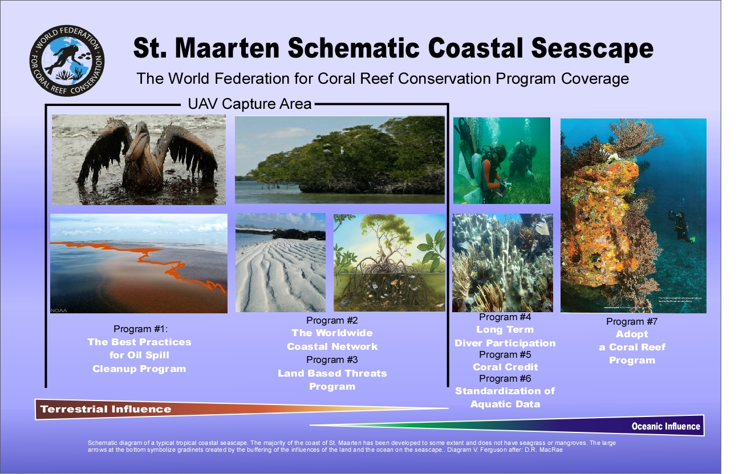

WFCRC Program Descriptions

The World Federation for Coral Reef Conservation (WFCRC) is the model for sharing information and best practices for addressing issues that have a direct effect of coral reefs and coastal management. We share our website’s user friendly one-stop-shop clearinghouse house free of charge to our end users in the underserved nations of the world.

Program #1 “The Best Practice for Oil Spill Cleanup Program”
WFCRC is the model for collaboration for these issues - - petroleum spills and leaks - - and develop the necessary tool for sharing first response information and creating a collection of “Best Practices for Oil Spill Cleanup.” We are collecting pertinent information on oil spill best practices from around the world and creating a “clearing-house” of data and information that will be housed on our web site. This cloud-based, user friendly, searchable database will serve as a “one stop shop” for all stakeholders involved with oil spills and other petroleum-related incidents. It will employ the latest technologies and valuable information including geo-referenced data, UAV imagery, and the best practices developed through practice and experience, the latest research, as well as the appropriate contacts invaluable to all in this industry or associated with such issues.
WFCRC provides 1st response and action plans, case histories, Public Service Announcements and critical information for responders and assist all in mounting a defensive posture to minimize one of man’s most devastating impacts on coastal environments and sensitive eco-systems.
In light of several recent high profile oil platform incidents that have occurred in environmentally-sensitive areas, more attention has been given to these types of incidents because of the severity and far-reaching impacts they can have. Of particular note was the April 20, 2010 BP Deepwater Horizon Platform leak that spilled more than 200 million gallons of crude oil into the Gulf of Mexico; the Sept. 2, 2010 Mariner Energy Platform 380 explosion also in the Gulf of Mexico; and various recent oil pipeline leaks throughout the U.S. that have garnered considerable world-wide attention. Inevitably over time, accidents do happen: tankers spill, pipelines leak, platforms have incidents, and storage facilities have releases. However, the severity from these accidents depend upon the type and timeliness of the response, particularly when considering sensitive areas such as coral and oyster reefs and tropical foliage that are extremely susceptible to pollutants.
In many parts of the world, the source of a leak or spill and the responsible parties are not so easily identified often due to available data, lack of adequate monitoring procedures, and oversight. In all instances, even if managers of MPAs and local constituents are able to identify a problem or spill, they may still not know how to respond or who to contact to mount an expeditious response. This information is so invaluable and creates a smoother and most efficient 1st response to any incident that could become a disaster nightmare. This highlights the urgent need for a “tool” or collection of accessible information that can be shared between all stakeholders, regardless of where they are located in the world or what their interest might be (i.e. oil production, MPA protection and management, or regulation), to expeditiously attack a spill or leak and reduce its impact.
As spills, leaks, and other breaches occur, it is necessary to identify the source of the spill or leak as well as the facility operator, so they can assist in the spill cleanup and provide necessary background information. With the BP Deepwater Horizon Platform disaster, it was a known operator who took responsibility for the cleanup. However, in many areas throughout the world, determining responsibility is not so easy to do and cooperation may not be as forthcoming. Having an easily-accessible single location or “clearing-house” of information to reference for best practices and other pertinent information could mean the difference in being able to respond immediately and saving precious coral reefs, or harmful delays that most likely will cause the problem to worsen to the point that people are endangered and natural resources are irrevocably harmed. The purpose of this effort is not to point blame or punish anyone, but rather to promote responsible and appropriate 1st responses to serious and potentially harmful problems and incidents. By identifying the source of the spill or leak, it could be immediately stopped before it gets worse. In many cases, responsible parties have the necessary knowledge, expertise, and resources to prevent and respond to these breaches. In so many cases the responsibility for FIRST RESPONSE falls on the hands of the local stakeholders that do not have the knowledge or expertise to deal with such a devastating event.

Program #2 “The Worldwide Coastal Network”

Our user friendly, real-time database of threats/events to coastal environments and coral reefs globally, is driven by data from local WFCRC affiliated reporting stations, local governments/stakeholders, and individuals. In as such this will facilitate the sharing of information between coastal constituents in our areas of mutual interest.
Our site provides advance warning of imminent threats to coastal environments and coral reefs.
Over time an invaluable collection of data can be used to analyze the biggest polluters, major threats and problem coral reef areas, etc.
WFCRC provides all reporting stations with Emergency Reporting Documents (ERDs) that request information about the severity of the incident (scale of incident), location, responsible party, etc. The reporting station then emails the ERD to WFCRC. Reporting stations around the world report any local incidents which could have an impact on the coral reefs in their area or in the surrounding region. As a result of these invaluable reports, WFCRC is then able to provide this reporting station with the WFCRC Best Practices so that they may respond in an effective and timely manner to the incident by initiating 1st response teams world-wide.
Examples of Data Descriptions/Data Gathered to be shared will include but not limited to:
- Input and observations from local stakeholders on location
- Environmental events, oil spill trajectory forecast
- Man made threats like oil spills, erosion events and sediment flows in mountainous areas
- Weather and seismic events (tsunami)
- Tidal events-Red Tide movement
- Wetland monitoring and health
- Coral bleaching with a known location component
- Change management in accelerated coastal morphology
- Governmental legislations effecting costal environments
- Local fire and flooding events
- Movement of fish/mammals tracking (Whale Sharks etc.)
- Overfishing-Fishing and Harvesting Aquatic Resources Closures and limited access zones
- Scientific Studies and Results
- Stocking and Fish studies with Results
- Restocking of lobster to control anemone devastation of kelp.
- Lion Fish
- Crown of Thorns
- And other invasive species and destruction of near shore shellfish beds
- Marine Protected Areas (MPA) programs Ecosystem-based management-results and planned programs (http://conprostage.tnc.org/1802/ )
- As well as a forum to express concerns, comments and pictures by coastal constituents

The coastal communities and national economies of the Caribbean region are poised to sustain substantial economic losses if current trends in coral reef degradation continue. Coral reefs provide valuable goods and services to support local and national economies, and degradation of coral reefs can lead to significant economic losses, particularly in the coastal areas of developing countries. Such losses are but not limited to, loss of fishing livelihoods, malnutrition due to lack of protein, loss of tourism revenues, and increased coastal erosion. Analyses carried out by the Reefs at Risk project indicate that Caribbean coral reefs provide goods and services with an annual net economic value in 2000 estimated at between US $3.1 billion and US $4.6 billion from fisheries, dive tourism, and shoreline protection services.
Shoreline Protection
To analyze the economic contribution of shoreline protection services provided by Caribbean coral reefs, the study estimated the extent of the region's shoreline protected by coral reefs, the value of the shoreline protection services provided by these reefs (based on costs required to replace them by artificial means), and potential losses in the annual benefits of shoreline protection services due to reef degradation.
Source of the above report may be found at: http://www.wri.org/publication/reefs-risk-caribbean

Program #3 “Land Based Threats Program”
Somewhere in the world the worst case scenario already exists. As we raise awareness for data driven coastal resource planning/development and coral reef protection by providing comprehensive information that directly threatens coral reefs and actively places this information in the hands of those most affected by these threats.
Alteration of the natural landscape for development, road construction, or agriculture can have adverse impacts on coral reefs. These human-induced changes cause sediment, nutrients and other pollutants to drain through rivers and streams and enter coastal waters. The threat associated with land clearing is higher in areas of steep relief, intense precipitation, and where soils are erosive in nature. Appropriate land-use practices in erosion-prone areas are essential in order to minimize these threats. The use of drone captured aerial imagery will make detection of these threats more evident. Once introduced into the marine environment, toxins that are not taken up by organisms can accumulate in sediments and remain there for long periods of time. Many metals, like mercury and copper, are extremely toxic and can concentrate in the tissues of organisms. In some cases, toxins can
move through food chains and potentially be easily consumed by humans.
Oil and other petroleum products, human waste and sewage are also very harmful to coral reef ecosystems. Some fuel oils can quickly degrade or evaporate, while other heavier oils can remain in the marine environment for long periods. If spills occur during low tides or sink to the seafloor, oil may cover and kill corals and other organisms. Mangroves and sea grass beds are similarly vulnerable to oil pollution.
We assemble this (report) data with current GIS data, remotely sensed data and worldwide RSS and dashboards and deliver the report in a cloud based environment using web applications. Industrial facilities are often located near coasts in order to have access to water to (1) cool their machines; (2) enable them to discharge their waste into the ocean; (3) to ship and transport their products/goods worldwide.
Toxins also find their way into the marine environment from the anti-fouling paints used on ships and in sewage discharge. Petroleum contamination in coastal environments often results from accidental spills, intentional discharges from ships and refineries, urban and river runoff, and airborne pollution (DENR 2001).
Mine tailings can also contain high concentrations of heavy metals like copper and zinc. These toxins can be transported many km away from their source and incorporated into the tissues of and other reef organisms (Cabanban et al. 2002).

Program #4 “Long Term Diver Participation Program”
We involve divers and citizen scientists from across the world in our projects for the long term. Unchecked coastal development will have a negative impact on coastal constituents for many years to come. Our programs involve divers and consumers of ocean resources personally for the long term rather than their participation ending with the dive. We will employ our database development to not only be compatible with other sources and databases but will contain diver profiles and personal expertise for future use of a currently untapped resource of citizen scientists and recreational divers.

Our service-oriented spatial data infrastructure brings together current data and observations, data management, GIS/GPS current technology, and cutting edge internet communication to provide the “real time” data necessary to make informed timely decisions regarding coral reef health and other coastal aquatic related issues.
Shared information will enable the forecasting of potential trends, evaluate different policy or development options, and facilitate improved land management and development within a region.
Involvement by local governments will create a data model for any new construction projects, and will allow the search of the WFCRC geo-database to evaluate any conflict or damage to local reefs prior to construction.

Currently, this type of information is available only on a contract basis paid for by interested parties, universities, developers, or local governments. All of our programs rely on the sharing of data. With this information being available to all, it encourages (making) better data driven decisions about protecting reefs and reef environments will help preclude further reef decline.
The World Federation for Coral Reef Conservation organization promotes collaboration and participation on a very personal and professional level. Historically and currently, most reef health data has only been provided by academia and scientists. By involving recreational divers - over 5 million participants worldwide – these volunteers are changed into citizen scientists with the goal of keeping them involved for the long term. As a WFCRC participant, a diver’s involvement carries into infinity, making their dives not only remembered for years to come, but, most importantly, their data remains easily accessible by any global entity. Recreational divers are an invaluable source of information due to their awareness of their playground they are diving in.
WFCRC works closely with local stakeholders, magistrates, dive shops, and independent vendors to facilitate a method by which data driven decisions can be made and brought to a logical conclusion. WFCRC is prepared to be the model for sharing information and best practices for addressing issues that have a direct effect of coral reefs; we will share our model in a clearing house on our web site. WFCRC will produce watershed based analysis of threats to coral reefs where ever the necessary data is available.

Program #5 “Coral Credit Program”
WFCRC has established a “Coral Credit Program” similar to a “Carbon Credit Program” by which purchasers of harvested coral and marine life can make a contribution to fund the continuation of coral conservation efforts. Live corals and marine life are being harvested from their environment in an unregulated manner. These organisms are not easily replaced and are in danger of extinction if this harvesting continues. Aquarium hobbyists and curio businesses, in their quest to replicate marine ecosystems, are posing an ecological threat to coral reefs worldwide. These man made threats to coral and oyster reefs and other environmentally sensitive areas (Marine Protected Areas) are developing from man made threats and actions. Invertebrates for Curio Trade, Invertebrates for Food, and the Marine Ornamental Trade are sold on the open markets without regard to sustainability concerns. In many parts of the world, these actions are not regulated and are not kept in check. In many of the countries that export reef animals for the curio trade -including the Philippines, Mozambique, Fiji, Taiwan, and New Caledonia- there is a general lack of regulatory resources to manage the trade. Reefs in general are not able to withstand a prolonged curio trade, and are undergoing a broad array of stresses that are undermining their health and ability to withstand this type of assault.

Program #6 “Standardization of Aquatic Data Program”
Standardization of Aquatic Data will need the support of divers, research institutes, universities and other marine organizations around the world. Some effort has already been made to reach this goal, however the results are only published in obscure web sites. More work is still needed for this program.

Program #7 “Adopt a Reef Program”
Adopt a Reef Program is somewhat like “Adopt a Highway” or a park or other feature. Concerned citizens are given the chance to donate to the preservation of a particular reef complex or to reefs in a particular island or country. These funds are used to identify their location and health. The use of drone technology with enhance this inventory of reef complexes.

Program #8 “Outreach for future generations Program”
Our effort here is to “feed the pipeline” of sustaining the world’s coral reefs well into the future, we must pass along our conservation principles and ideals to the next generation – the youngest ocean consumers - so they will understand the importance of these natural reef systems and carry on our efforts. As part of our outreach, we will develop educational programs targeting young people and lifelong learners. Assuming we are able to prevent the loss of our marine treasures we will need to pass these conservation efforts on to future generations. With the popularity of the “Finding Nemo” film and Sponge Bob Square Pants with its cast of characters creates a message of saving the home that they live in, a message that will resonate with young people now and for a long time.
Our link and feed will also be shared with public library, public schools and other institutes of learning.
Over geologic time coral reef complexes have survived global warming, acidification, coral bleaching and other disruptive events, however it is unlikely they can survive when combined with oil spills. Let’s share this strategic knowledge we already have with the rest of the world. To join this unique opportunity to make a difference from your living room visit by clicking on: WFCRC Welcome

Please visit our web site www.wfcrc.org
now and make a generous contribution
which will be use for a direct effort
to share what we know
about coral reef conservation.

Vic Ferguson
The World Federation for Coral Reef Conservation
Executive Director
P.O. Box 311117
Houston, Texas 77231
vic.ferguson@wfcrc.org
www.wfcrc.org
281.886.7428 (office)
281.309.1201 (cell)

