
The inevitable has happened-
Plastic in Humans
Join WFCRC

The World Federation for Coral Reef Conservation 281.971.7703 642 S. Commerce Sebring, Florida 33870
Vic Ferguson Executive Director 512.986.1902 vic.ferguson@wfcrc.org info@wfcrc.org

Reprinted 9/8/18

PLASTICS 101
Once a completely natural product, much of today's plastic is man-made and largely dependent upon fossil fuels. From polymers to nurdles, learn how plastic is created and what we can do to slow the lasting repercussions this material will have on both our planet and our lives.

BY LAURA PARKER

PUBLISHED OCTOBER 22, 2018
THE INEVITABLE HAS happened. Microplastics have already been found in birds and fish and whales, so it should have come as no surprise that they have now been discovered in humans. To be specific but indelicate, tiny plastic particles and fibers have been found in the stool of eight people who provided samples as part of a pilot study.
This news confirms the predictions of researchers who have tracked microplastics to remote locations, and identified these tiny particles in drinking water, beer, table salt, and seafood. But the implications in this particular case remain unclear.

The fact that this is the first documentation of such materials in humans is significant. Yet such a small survey can’t begin to answer the unknowns that hang over the science of microplastics: Where precisely did these plastic fragments originate? And what are the potential risks to human health?

Pieces of microplastic, which were found on the banks of the Warnow in Rostock, Germany, on 17 March 2015, attached to a piece of sticky tape on a finger, at the Leibniz Institute for Baltic Sea Research(IOW) in Warnemuende, Germany, 9 February 2016.PHOTOGRAPH BY BERND WÜSTNECK/ PICTURE-ALLIANCE/ DPA/

Food packaging can shed small fibers. So can household carpeting, clothing, and other plastic-based items that populate our everyday lives. Could the fibers in the stool have come from airborne dust that fell onto the study participants’ food before they consumed it? Or did the microplastics come from the food or packaging itself?
The questions don’t stop there. Once inside the human body, can plastic nanofibers—some five times smaller than the width of a human hair—work their way into the bloodstream, lymphatic system, or perhaps even reach a person’s liver? To date, all of that remains a mystery.

“I’d say microplastics in poop are not surprising,” says Chelsea Rochman, an ecologist at the University of Toronto, who studies the effects of microplastics on fish. “For me, it shows we are eating our waste—mismanagement has come back to us on our dinner plates. And yes, we need to study how it may affect humans.”
Plastics on the inside
Every year, an average of eight million tons of plastic waste, most of it single-use varieties, flows into the world’s oceans from coastal regions. There, sunlight and wave action break these waterborne plastics down into bits the size of grains of rice. Fibers from synthetic clothes such as polyester and acrylic make their way into freshwater systems via washing machines. You can see this in action with a fleece jacket; just scratching the arm of the jacket can shed invisible fibers. As a result, tiny plastic fragments and fibers have now spread all over the planet. They're in deep sea trenches and in the air we breathe.

Marine life—from the smallest plankton to the largest whales—eat these plastics, including those tiny enough to be considered microplastics. And encounters with plastics often prove fatal. So far, much of the research into the consequences of this spread has focused on birds and other animals. Microplastics have been found in more than 114 aquatic species, and studies have shown the potential damage to reproductive systems and the liver.
Philipp Schwabl, the physician-scientist who conducted the human stool experiment, says he hopes his findings will hasten research into the effects of microplastics on human health.

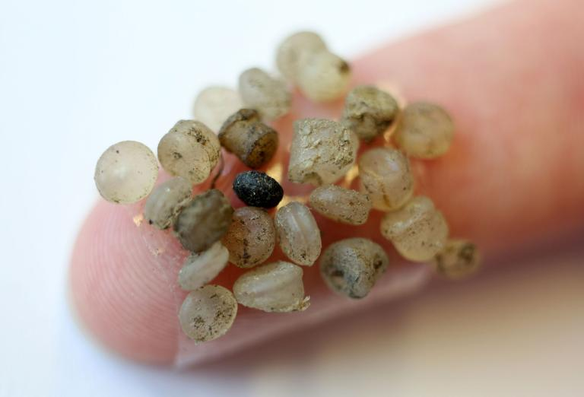

“Based on the research, it was highly likely that microplastics would be present in humans,” he says. “But nobody ever investigated if microplastics also reach the human gut. Now this discussion can be taken up in humans.”

Schwabl, a gastroenterologist at the Medical University of Vienna, will present his findings Tuesday at a United European Gastroenterology conference in Vienna. The findings have not yet been peer-reviewed or published; Schwabl says he hopes to have both those steps completed in November. He added that he wants to expand the study to a larger group.

The study involved three men and five women, aged 33 to 65, from seven different European countries and Japan. Participants kept a food diary for a week and then provided a stool sample for testing. All stool samples tested positive for plastic.

The diaries also provided information about potential sources of the plastics. Two of the eight participants chewed gum daily. Six ate seafood. Over the course of the week, they all consumed food that had been wrapped in plastic. On average, participants drank about 25 ounces of water daily from bottles made of PET (polyethylene terephthalate, the material widely used to make plastic bottle.)

Schwabl cautioned that the study is too small to draw conclusions about individual factors, such as the chewing gum or fish or the participants' household routines or where they lived.

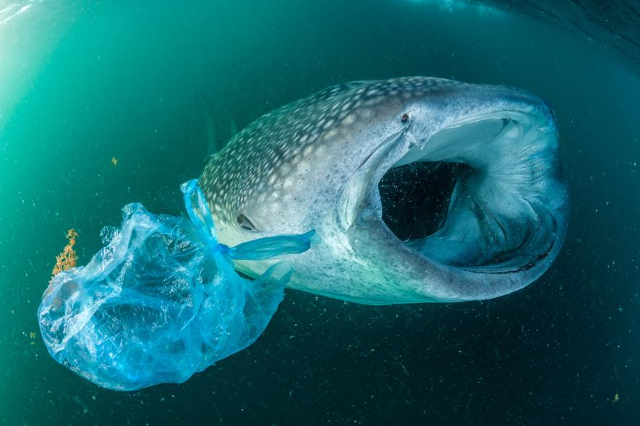
A whale shark swims beside a plastic bag in the Gulf of Aden near Yemen. Although whale sharks are the biggest fish in the sea, they're still threatened by ingesting small bits of plastic.
PHOTOGRAPH BY THOMAS P. PESCHAK, NAT GEO IMAGE COLLECTION

A great bowerbird in Queensland, Australia, decorates its home with broken glass, plastic toys, and other pieces of human trash.

In terms of quantity, the stool samples contained, on average, 20 particles of plastic, ranging in size from 50 to 500 micrometers. (For comparison, a human hair is about 100 micrometers thick.)

Plastic pathways
Richard Thompson, a marine scientist at the University of Plymouth in the U.K., says he was surprised by the amount of plastic in the stool. The figure is higher than he would have expected based on the amounts of plastics that are reported in seafood.
Thompson and four other scientists published a study earlier this year that compared potential exposure from airborne plastic fibers that fall onto food during meal preparation to the amounts of microplastics ingested by edible mussels in Scotland. The group found that the risk of plastic consumption to humans was greater from exposure to airborne fibers than from eating the mussels.

HOW TO CLEANSE YOUR BEAUTY REGIME OF MICROPLASTIC
Microplastics are polluting oceans and harming wildlife—and your beauty products could be part of the problem.
That raises questions, Thompson says, about the sources of plastic found in the stool study.

He says the PET could be coming from plastic bottles and food packaging, but it is also possible that it is coming from carpets or curtains or clothing and just falling onto the plate. “If we can understand what the pathway is, it helps understand a little bit about the solution.”

But even knowing the pathway, Thompson adds, “That doesn’t tell me anything about harm.”
Schwabl himself cautions against drawing too many conclusions from an eight-person sample.
“We didn’t study harm,” he says. “We showed there are microplastics in human stool. Up to now, people believed it, but now we know it. That’s important.”

This story was updated on October 23, 2018 to reflect that a study subject also came from Japan.

For additional reading see The WFCRC Document Gallery for articles about:

- Public Service Announcements (PSA)
- Coral Alert Network (CAN)
- Emergency Reporting Reports (ERR)
- Call to Action (CTA)
- Marine Protected Areas (MPA)
- Marine Life Alert (MLA)
- Seismic and Oil Production Threats
- Natural Science Reports (NSR)
- Oil Spill Alerts (OSA)
- And other miscellaneous documents

