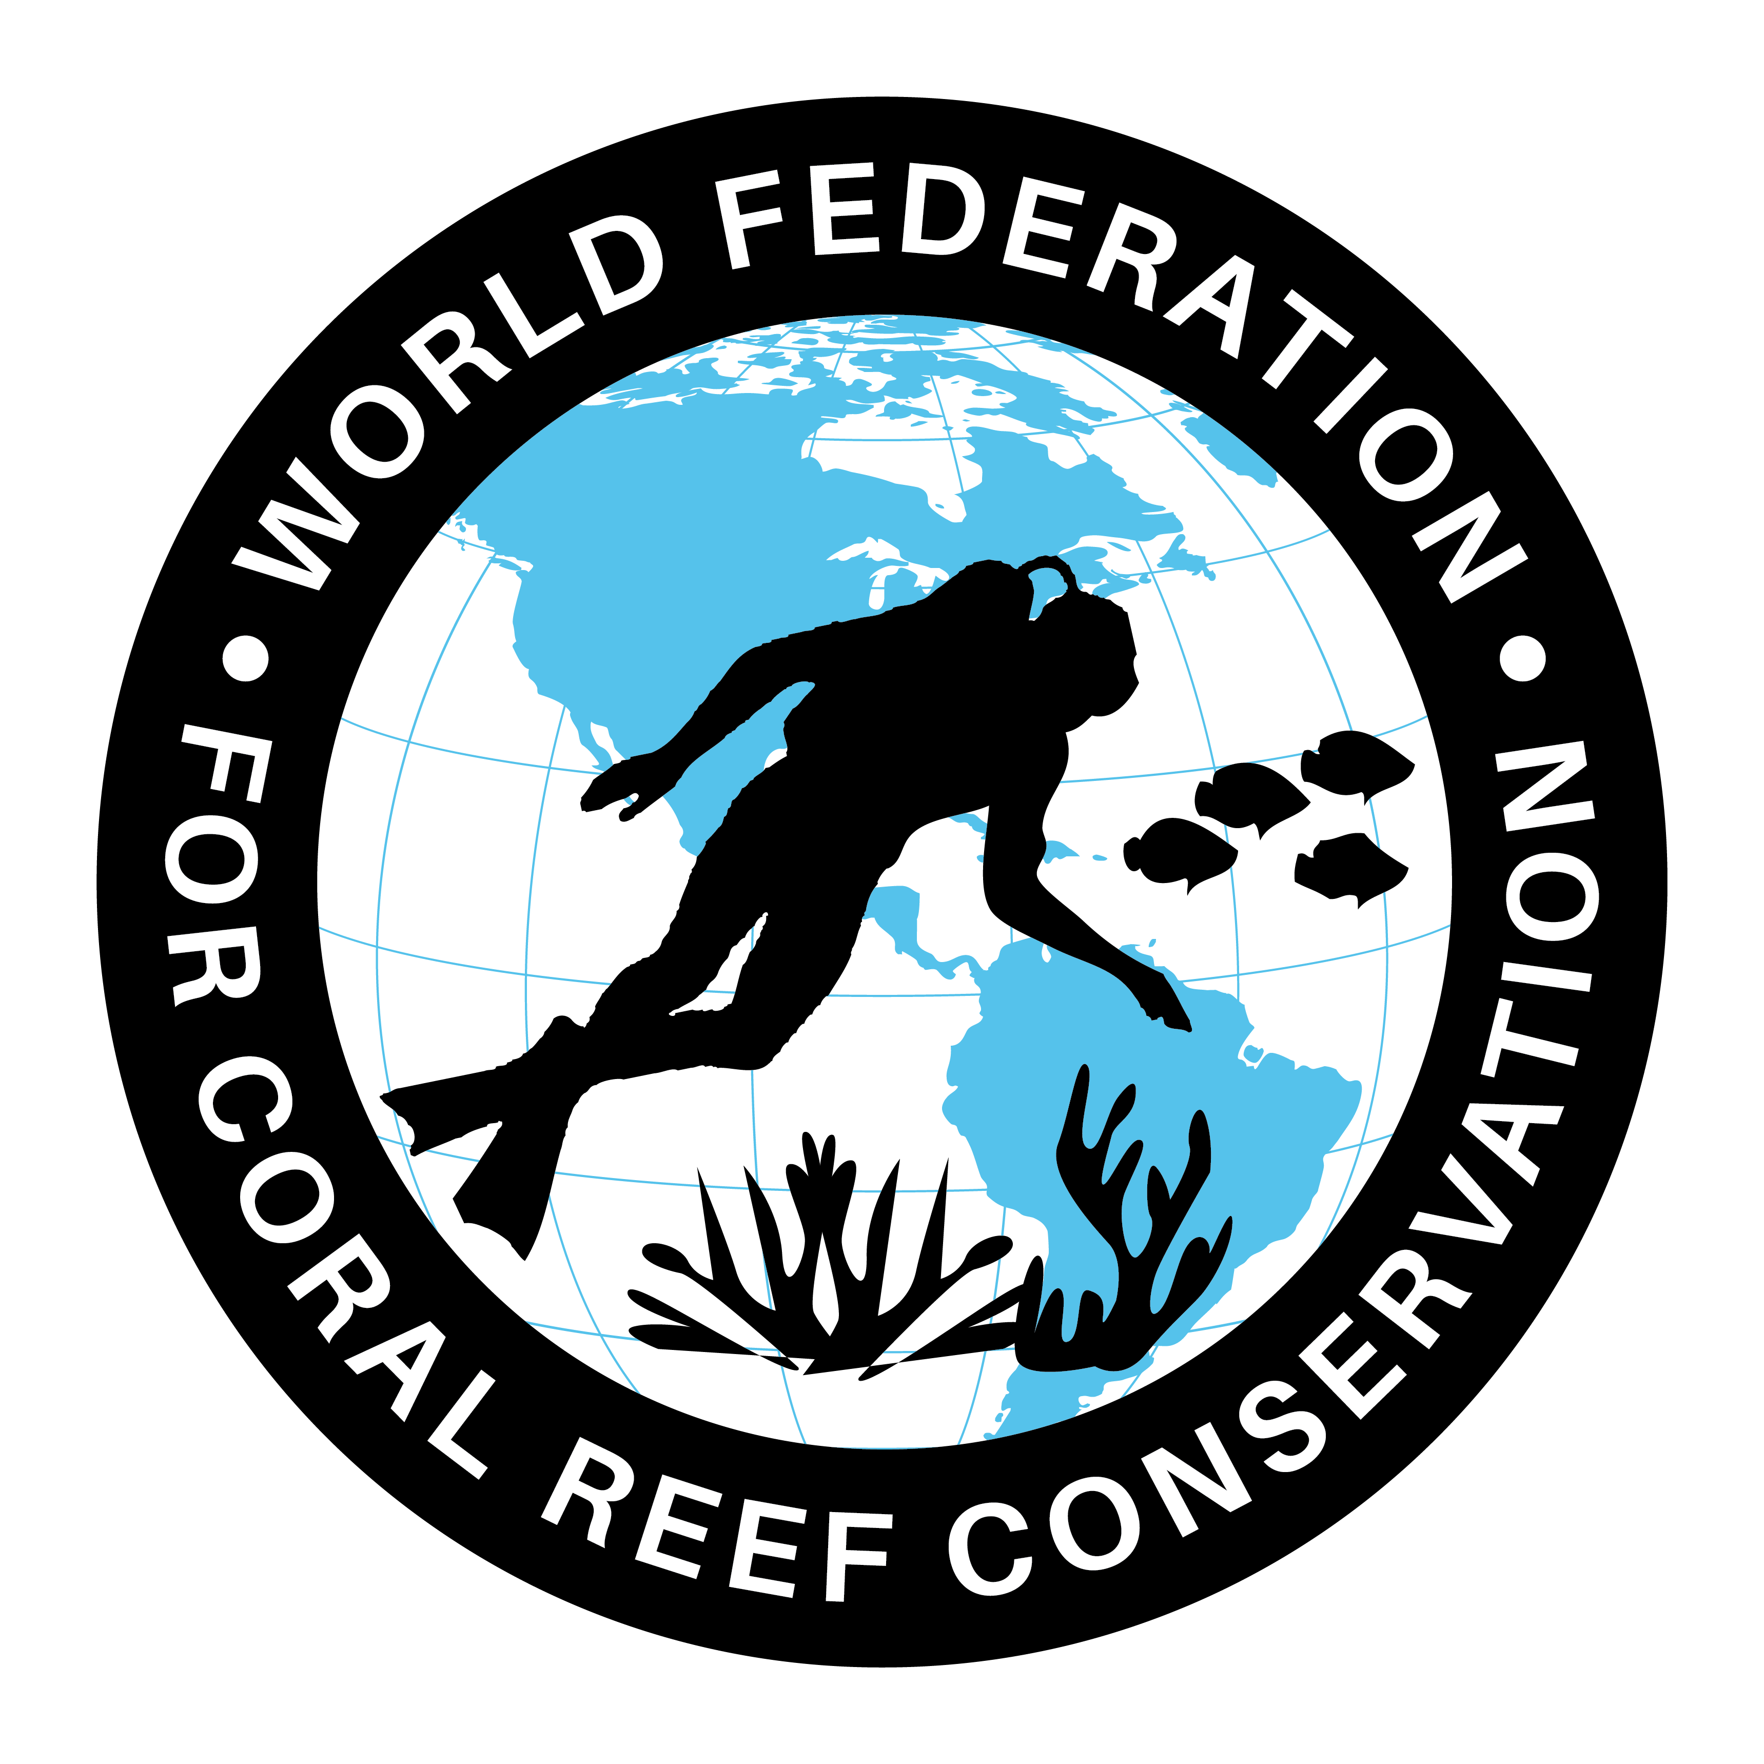
Threats to the Keys
Join WFCRC

The World Federation for Coral Reef Conservation 512.986.1902 642 S. Commerce Sebring, Florida 33870
Vic Ferguson Executive Director/Founder vic.ferguson@wfcrc.org kyle.mathes@wfcrc.org



SOUTH FLORIDA AQUATIC ENVIRONMENTS

Threats to the Keys
Florida Keys
The native habitats and communities of the Florida Keys are being severely impacted directly and indirectly by human activity.
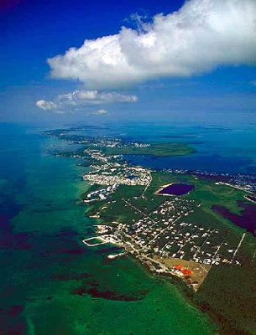
Upper Matecumbe Key. Photo courtesy South Florida Water Management District
The Keys and south Florida are the only locations in the U.S. to support tropical flora with over 120 species of trees in the hardwood hammock alone!
Along with this rich diversity of native plant life, the Keys are also home to many species of terrestrial and marine wildlife.
The habitats of the Keys include mangroves, coral reefs, seagrasses, pinelands, and hardwood hammocks, making this area quite diverse in flora and fauna. However, due to the small land area of the Keys, these sensitive habitats are easily impacted.

Water Pollution
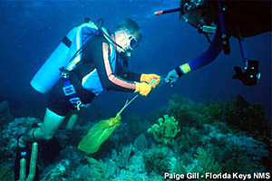
Water quality is deteriorating in nearshore and confined waters of the Florida Keys.
Divers clean the reef of monofilament and debris. Photo courtesy Florida Keys National Marine Sanctuary
Nutrient-rich wastewater is released from cesspits, septic tanks and sewage treatment plants. Other sources of water pollution are storm water runoff containing fertilizers, pesticides, herbicides, petroleum products, and heavy metals all of which may be affecting marine communities including coral reefs, seagrasses, and mangroves.

Urban Development
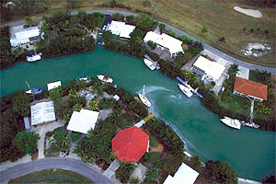
Ever-increasing human population growth as well as heavy tourism in the Florida Keys has resulted in the development of large tracts of land, destroying natural habitats and deteriorating the surrounding natural environments.
Man-made canal in Marathon Key. Photo courtesy South Florida Water Management District

Introduced Species
The Florida Keys is home to a variety of introduced species.
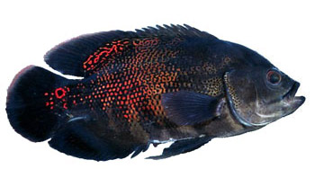
Introduced species are those organisms that are native to somewhere else that have been introduced through human activities. Many of these species have detrimental effects on native flora and fauna due to lack of population controls such as predators and disease. As population numbers grow out of control, introduced species are often referred to as invasive species.

Oscar. Photo courtesy U.S. Geological Survey/Howard Jelks

Overfishing
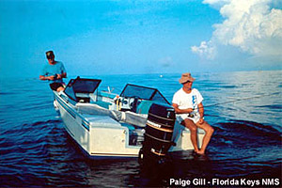
Along with human population growth, the harvest of resources from the sea is ever-increasing.
Fishing boat. Photo courtesy Florida Keys National Marine Sanctuary
This holds true for south Florida where commercial fishing is the fourth largest industry and recreational fishing is the primary tourist-related activity. Areas in the Upper Keys that are heavily fished contain smaller fish and fewer species than outlying areas where fishing activity is much less.
Overfishing has changed the ecological dynamics of marine communities, allowing some organisms to dominate reefs that once were kept in check by large reef fish populations. Recently, the largest No-Fishing Zone in U.S. waters was established in the Dry Tortugas, 70 miles west of Key West. This protected area will help restore depleted fish stocks in the keys and beyond as well as protect the coral reefs.

Boating
In south Florida, over 30,000 acres (121 square km) of seagrass have been scarred by boat propellers.
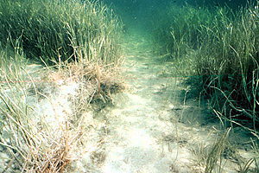
Seagrasses stabilize sediments. Photo courtesy Florida Keys National Marine Sanctuary
Scarring is caused primarily by large numbers of small boats, although larger boats cause a much greater impact when they run aground. Damage occurs when boats enter shallow waters, causing the propeller to come into contact with seagrasses
Boats also cause damage by running aground on coral reefs, crushing and killing corals on impact. Most noted are the groundings of large ships, however small recreational boat groundings can be just as destructive with over 500 groundings reported in a single year in the Keys. Anchor damage also adds to the destruction
.

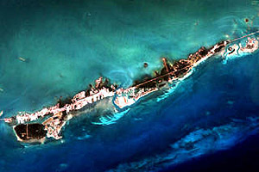
Global Climate Change
Global climate change may cause increases in sea temperature and sea level as well as ocean current patterns, all of which can cause damage to the Florida Keys and associated reefs.
Key Colony Beach photographed by NASA’s Landsat 7 Spacecraft. Photo courtesy NASA/Goddard Space Flight Center Scientific Visualization Studio

Vic Ferguson
The World Federation for Coral Reef Conservation
Executive Director/Founder
Relief without Borders
March for the Ocean
642 So. Commerce Ave
Sebring, Florida 33870
vic.ferguson@wfcrc.org (best method of contact)
512.986.1902
For additional reading see The WFCRC Document Gallery for articles about:

