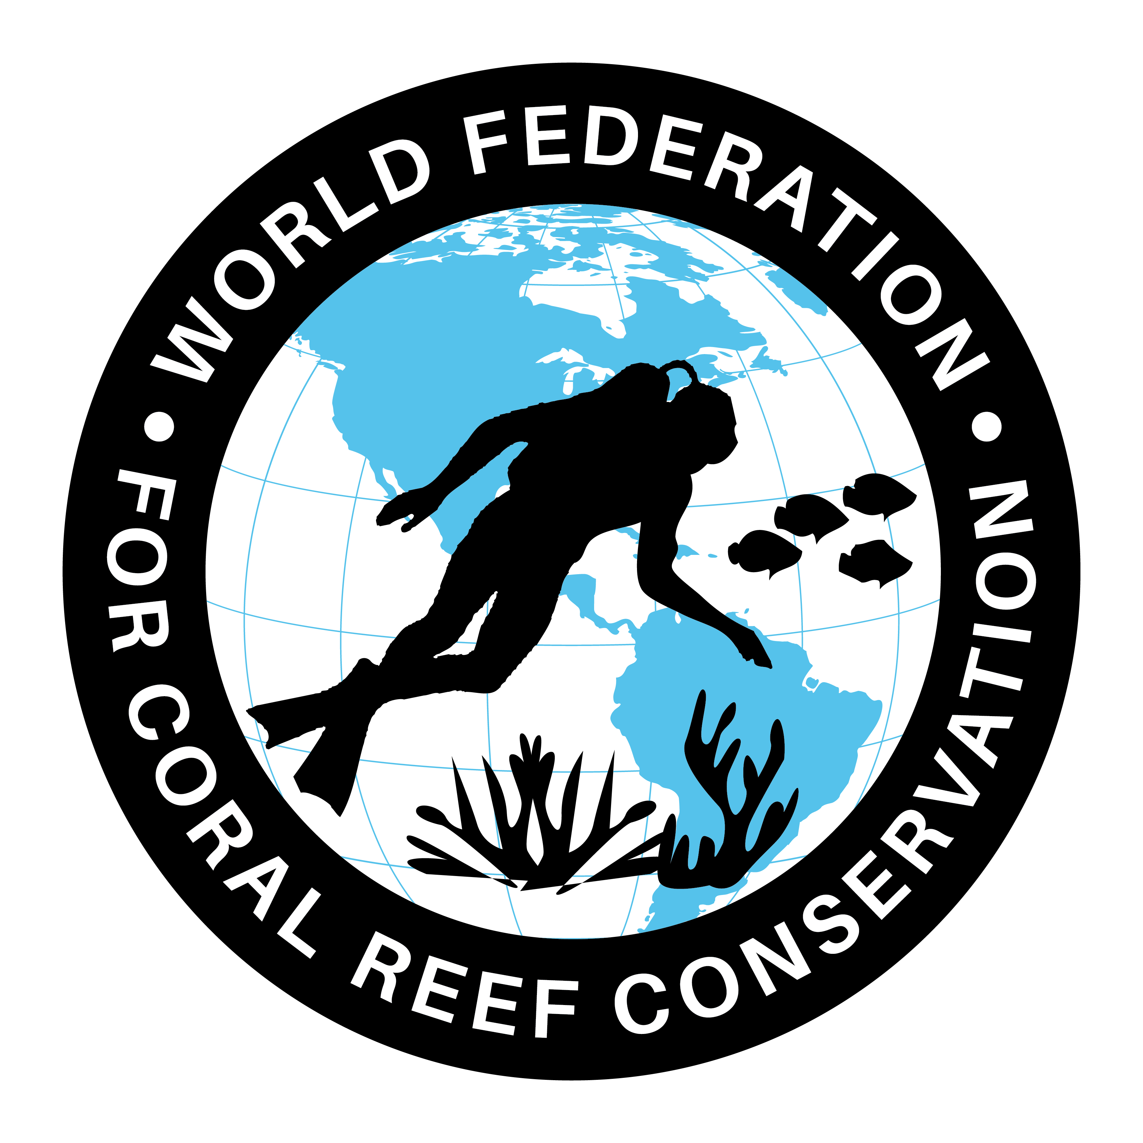
WFCRC Geo-Platform
Collaborative Coral Reef Registry
The Keys Collector

The World Federation for Coral Reef Conservation 512.986.1902 4010 Skipper Rd. Sebring, Florida 33870
Vic Ferguson Executive Director/Founder vferguson001@gmail.com
10/11/21
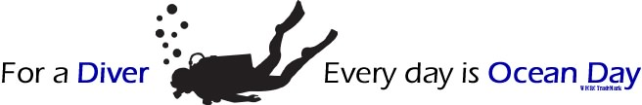

Development of the World Federation for Coral Reef Conservation (WFCRC) Geo-Platform Using ArcGIS Online for Organizations

Introduction
The World Federation for Coral Reef Conservation (WFCRC) is developing a web platform for publishing and sharing information on the ocean's corals and coastal conservation efforts, and promoting knowledge management and exchange among local stakeholders of the coral reef conservation community.

The platform will provide education, and enabling citizens and researchers to publish up-to-date data and information on the coastal and marine environment; this will support conservation, repopulation, and disaster relief efforts. The platform will provide a dashboard summarizing marine events and threats as well as serving a knowledge resource for project development like “The Collaborative Coral Reef Registry.”

Components of the WFCRC Geoportal
The five components in the WFCRC Geoportal are: 1) Web mapping application(s), 2) Search and discovery mechanism, 3) Citizen reporting / crowdsourcing, 4) Real-time alerts, 5) Content gallery:

Web Mapping Application
The system will contain dynamic and interactive webmaps, based on the following pertinent coastal and marine themes, and subject to the availability of up-to-date data:
- Coral reef locations
- Turtle nesting areas
- Water quality
- Identify points of pollution
- Real-time weather and ocean data
- Wind and ocean currents
- Coast lines and Island outlines
- Oil producing areas of the world co located with coral reefs and other sensitive environmental areas
- Ocean floor topography and ESRI EMU
- Natural and man-made marine disasters including red tide, seismic/tsunami, floods, hurricanes, oil spills, ship wrecks, sediment transport, and land-based threats etc.
- Satellite imagery and Unmanned Aerial Vehicles (UAV’s)
- Georeferenced research, reports and documents related to coral reefs and coastal conservation
These maps will be available, both as individual thematic maps, and combined together in a web mapping application. The latter will be a visually pleasing and intuitive mapping interface that uses RIA (Rich Internet Application) technologies such as Javascript, Adobe Flex or MS Silverlight, and that supports basic mapping functions including but not limited to:
1) Map navigation (zoom and pan)
2) Turning map layers on/off

Search and Discovery Mechanism
The search and discovery mechanism will provide easy and seamless access to all documents, images, and videos and other content from WFCRC and partners. It will support a search by:
- Keyword
- Geography
- Content type
- Date
- Citizen Scientist

Citizen Reporting / Crowdsourcing
The WFCRC Geoportal will provide an interface for uploading data/observations provided by citizens on selected marine-related events, situations or hot spots. This is by incorporating technology solutions to solicit information from the general public – namely “crowd sourcing” - to identify and report on environmental hot spots, with the aim of facilitating the participation of citizens in coastal and marine governance and management. These have been envisioned as follows:
- Allow citizens to upload data/observations on certain pre-selected phenomena (air/water pollution events or impacts on biodiversity “hot spots”), thereby offering true ‘real-time’ alerts;
- Display contributing citizens’ locations on a map with cascading details accessible by user by moving and clicking the cursor;

Real-Time Alerts
The Geoportal will provide a Geo RSS-type application that inventories and reports on various coastal and marine alert systems by:
- Showing on the map the various alerts from RSS feeds or other means from sources such as USGS, FEMA, and ARGO etc.
- Allowing the user to subscribe to the alerts through RSS

Content Gallery
The Geoportal will contain a gallery on the dashboard landing page providing quick access to featured maps, documents, and videos and thereby giving users a quick snapshot of all available content.

Approach

The ArcGIS Online for Organizations (AGOO) was identified as a suitable technology, owing to its versatility in handling maps, as a geospatial content management system that supports collaboration. Some of the major benefits of using AGOO are:
- It enables publishing of maps to the web without an expensive web mapping solution such as ArcGIS Server
- Flexibility for accessing the maps, with options for opening them in a web browser, map viewer, or desktop; data published is in the cloud
- Ease of building mobile and web apps that complement each other using “solution templates” that are easily customizable and provide targeted maps and data

Sources of Data
Some of the suggested sources of data are as indicated in the table below:
Map | Source | Format and delivery
Coral reef locations | Reefbase | Webmap from offline and online data sources  http://www.reefbase.org/gis_maps/datasets.aspx
Real-time weather and ocean data | Pacific Disaster Center (PDC), NOAA | GeoRSS feed
Wind and ocean currents | NOAA
Island outlines
Oil producing areas of the world | US Energy Information Administration | Webmap from offline data  http://www.eia.gov/cfapps/ipdbproject/IEDIndex3.cfm?tid=5&pid=53&aid=1
Ocean floor topography | Google ocean | http://129.194.231.208:8080/geonetwork/srv/en/csw?service=CSW&request=GetCapabilities&version=2.0.2
Natural marine disasters | PDC | Webmap from PDC webservices
Oil spills
Ship wrecks | SHOM | http://www.wrecksite.eu/wrecksite.aspx  http://www.shom.fr/les-services-en-ligne/portail-datashomfr/
Submarine cables | SIG Cables | http://www.sigcables.com/
Coastal orthophotos | US Energy Information Administration | Webmap from offline data  http://www.eia.gov/cfapps/ipdbproject/IEDIndex3.cfm?tid=5&pid=53&aid=1
Marine raster chart | NOAA | http://nauticalcharts.noaa.gov/mcd/Raster/download.htm
World maritime boundaries | VLIZ | http://www.vliz.be/vmdcdata/marbound/index.php
Bathymetry | National Geophysical Data Center (NGDC) | http://www.ngdc.noaa.gov/mgg/image/2minrelief.html
Ecological Marine Units | EMU | ESRI
Other related material | Outside sources

Deliverables

WFCRC GeoPortal Dashboard
A WFCRC GeoPortal Dashboard based on the ArcGIS Online for Organizations with the following components:
- Web Mapping Application(s) with functionality for searching and discovery of content, as well as crowd sourcing.
- Real Time Alerts application that allows users to view various coastal and marine alerts on a map, as GeoRSS feeds, as well as to subscribe to alerts on these feeds.
- Content Gallery that provides a snapshot of various content types available in the GeoPortal

Vic Ferguson
The World Federation for Coral Reef Conservation
Executive Director/Founder
Relief without Borders
March for the Ocean
4010 Skipper Rd
Sebring, Florida 33870
vferguson001@gmail.com (best method of contact)
512.986.-1902

