
WFCRC Keys Collector
Join WFCRC

The World Federation for Coral Reef Conservation 512.986.1902 4010 Skipper Rd. Sebring, Florida 33870

Vic Ferguson Founder vferguson001@gmail.com
5/17/21

WFCRC ArcGIS Dashboards enables users to convey information by presenting local location-based analytics using intuitive and interactive data visualizations on a single screen. Users will be able to take advantage of ArcGIS Dashboards to help make data driven decisions, visualize trends, monitor status in real time, and inform their communities. Our tailor-made Keys dashboard, gives our users the ability to dive into the data to get the answers they need. Dashboards are essential information products, like maps and apps, providing a critical component for your Situational Awareness.

WFCRC’s Keys Collector Enhances Situational Awareness
for Response with Operational Dashboards
From, hurricanes, red-tides to ecotourism, the entire Florida Keys has been impacted by natural and manmade disasters that cause power outages, property damage, disruption to food and water supplies, injuries and fatalities to both human and marine environments.
The “Keys Collector”. Is committed to protecting both our coral reefs and residents by sharing disaster planning efforts; assisting with the sharing of emergency plans; and ensuring information flow to the public before, during, and after major emergencies or disasters. Coral nursery’s, out plant projects, bleaching events and updates are well suited for monitoring with this dashboard. Very large data sets are also a good fit in its ability to process large amounts of information.
We recently renewed our focus on situational awareness in addition to data collection and management. The Keys Collector is the model for a command center to coordinate emergency response and is responsible for increasing visibility and providing situational awareness throughout an emergency event for the Keys
Providing situational awareness includes sharing information on marine events, on-the-ground observations, sensor readings, predictions, and resource deployment. In addition, the Keys Collector aims to provide crucial details regarding events of interest to keep the public informed and marine environments safe.
Our GIS team implemented a new solution that leveraged the investment in our 10 plus year existing ArcGIS platform. This allowed us to develop operational dashboards, giving the command team real-time data and easily viewable information in one place.

Challenge
The WFCRC team is coordinating response efforts among different groups in an emergency event. As such, real-time data is crucial to help first responders answer requests, dispatch necessary resources, and deploy emergency personnel.
Users
End users are residents and organizations in the Florida Keys or project locations, that are members of our organization.
Challenge
Getting real-time data in one place in order to coordinate response efforts. As GIS becomes a part of everyday life, a flood of new information is now available for end users to use.
Solutions
ArcGIS Dashboards, Keys Collector and Survey 123
(https://storymaps.arcgis.com/stories/f38c42351be84ca2886a5bb9253502b2 )
Results
Customized dashboards for the Keys, improving overall management, knowledge sharing and response will provide near real time awareness for the multiple sources for information that we track.

Solution
Over 10 years ago WFCRC connected with ESRI to explore emergency management solutions for situational awareness and incident management. They selected ArcGIS Dashboards, a configurable web app that allows for the dynamic display of data and analytics.
The GIS team chose ArcGIS Dashboards for its ability to incorporate visual elements like charts and maps for an operational view of people, assets, and events in real time. Also, the GIS team was already proficient with the Esri suite and believed ArcGIS Dashboards would be easy to learn.

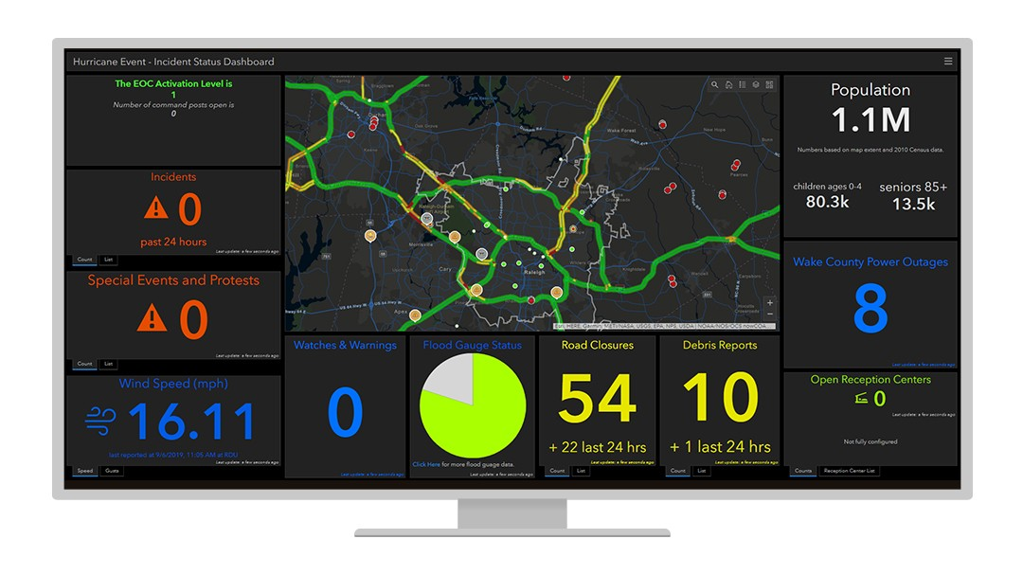
Several customized dashboards were implemented as an ongoing component solution relevant to real-time information such as where debris was located for cleanup, how many unresolved issues are in need of attention.

Results
The use of operational dashboards has transformed how information is viewed and communicated as well as improved overall management and response. The major benefit of ArcGIS Dashboards is the ability to display many layers of information at one time and in one place,….. data mining.
With our Keys Collector Dashboard, we're able to display everything we need to, then do some minor analysis on the fly, like counting the number of incidents that are active and resolved or the number and location of diseased coral.
For example, we can see that if there is a new wave of coral bleaching or other events critical to coral management we can produce a map and a visual representation with ArcGIS Dashboards—and even add camera footage to allow citizen scientists to bring together all the information needed, at the same time in the same place.
We have the opportunity to put real-time data feeds (RSS, IoE or so many others) in and have it update and show that real-time information. And I think that that's one area where ArcGIS Dashboards are definitely beneficial.. When you combine that real-time power with the power of on-the-spot analysis and being able to visualize multiple things at once in different ways, it becomes this awesome, all-encompassing solution.
Real-time data on the status of stream gauges is helping to determine where flooding has occurred and transported more sediment into the ocean.
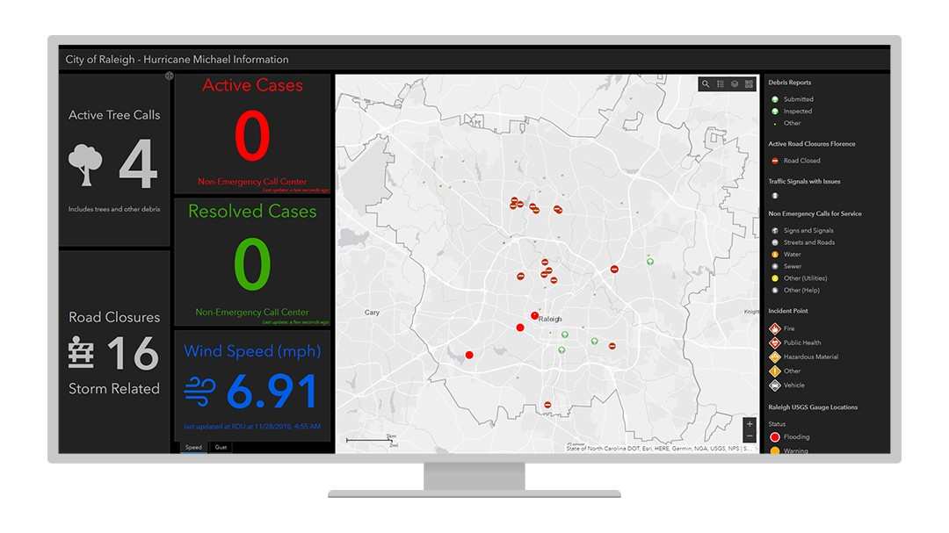
This dashboard, created during Hurricane Michael, is another example of how information is tracked within a dashboard.
With this type of flexibility we are only limited by our imagination.
The roll of our Keys Collector will dove tail with our effort to bring the next Mission Blue Hope Spot to the Keys by allowing a new and larger audience to view conditions, projects, conservation efforts and ecotourism efforts in the Keys.
NOAA Coral Information

We would like to identify and stop this,
it is unacceptable!
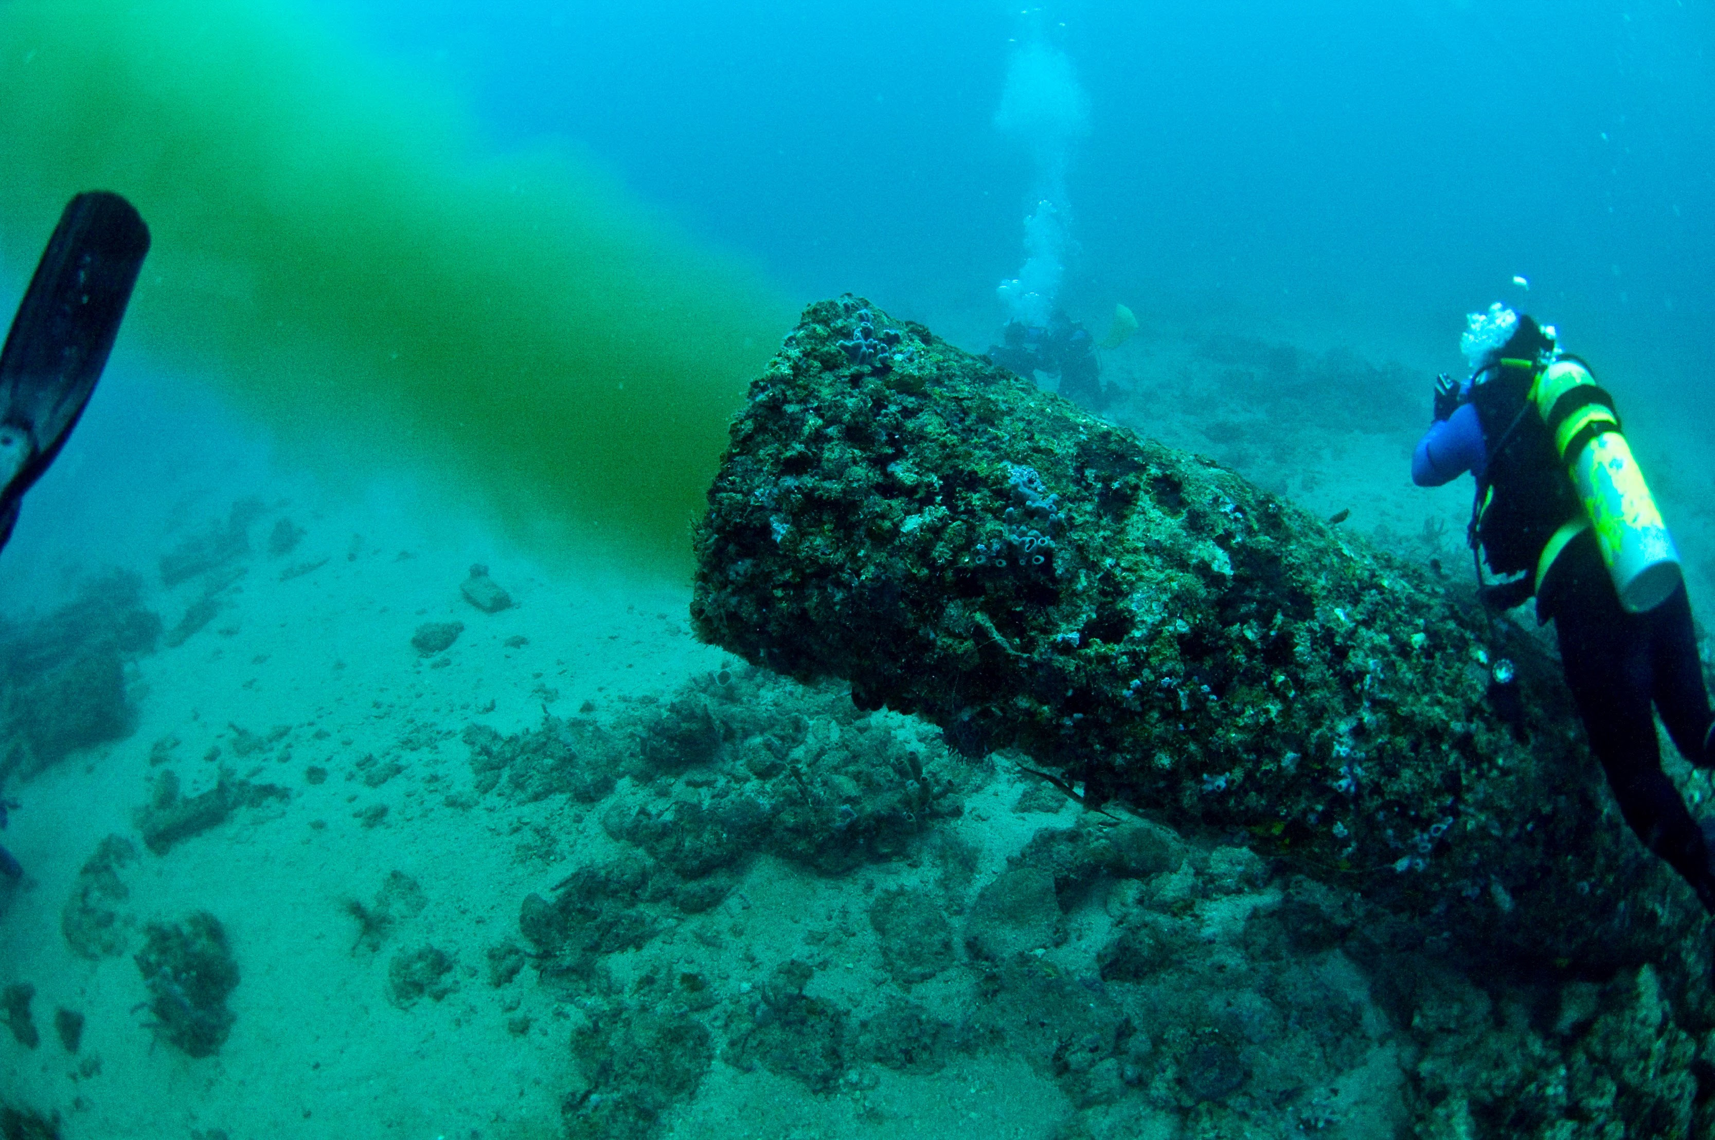

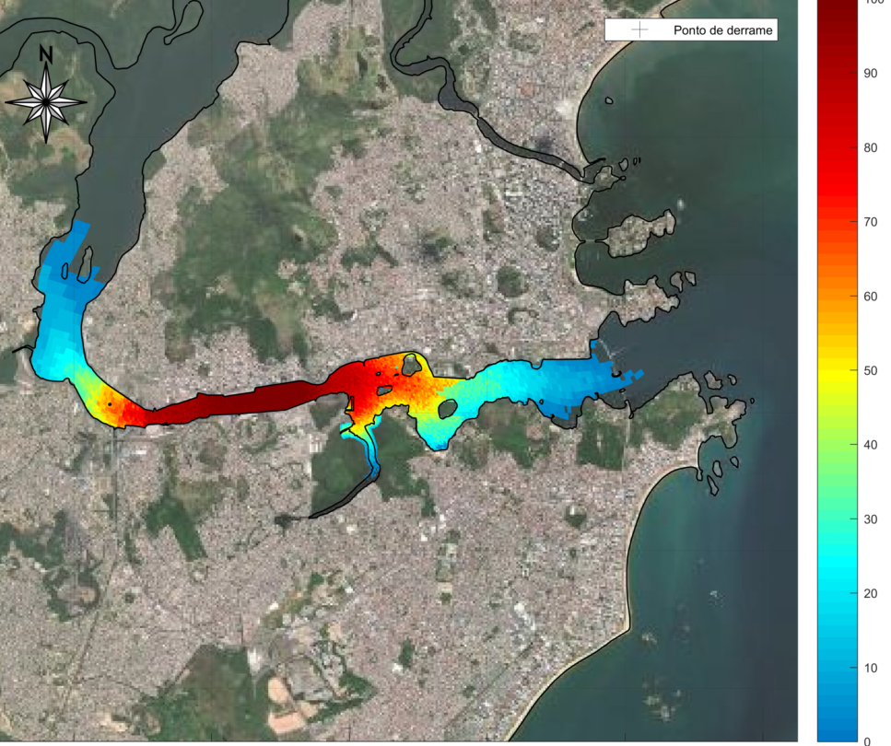

“Within the last two years, we've gone from GIS being a topic of discussion to proactively sharing information and situational awareness with ArcGIS Dashboards and Story Maps.”
Vic Ferguson
The World Federation for Coral Reef Conservation
vferguson001@gmail.com
Founder
Relief without Borders
March for the Ocean
4010 Skipper Rd.
Sebring, Florida 33875
512.986.-1902
The only thing necessary for the triumph of evil is that good men do nothing”….Edmund Burke

