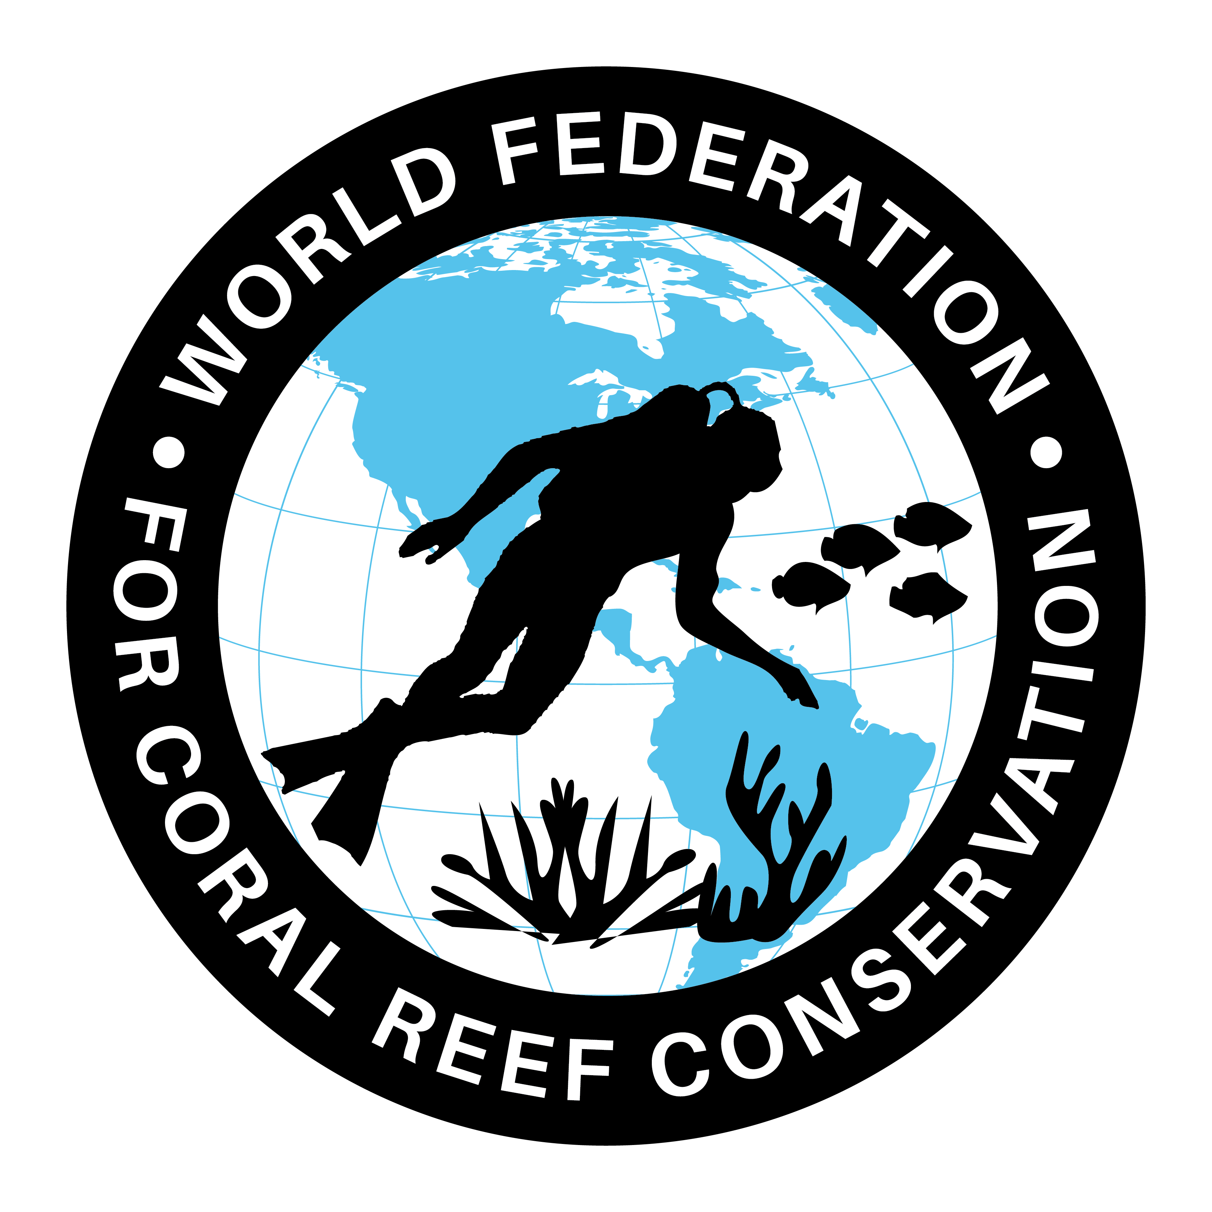
Mutual Areas of Interest
Join WFCRC

The World Federation for Coral Reef Conservation 512.986.1902 4010 Skipper Rd. Sebring, Florida 33875
Vic Ferguson Executive Director/Founder vferguson001@gmail.com

5/6/21

Vic Ferguson
The World Federation for Coral Reef Conservation
www.wfcrc.org
Executive Director/Founder
Relief without Borders
March for the Ocean
4010 Skipper Rd.
Sebring, Florida 33875
vferguson001@gmail.com
512.986.-1902
The only thing necessary for the triumph of evil is that good men do nothing”….Edmund Burke

