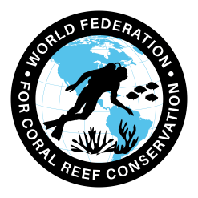 **Research Enhancement Engineering**

Join WFCRC

**The World Federation for Coral Reef Conservation 512.986.1902 4010 Skipper Rd. Sebring, Florida 33875**

Vic Ferguson Executive Director/Founder vferguson001@gmail.com

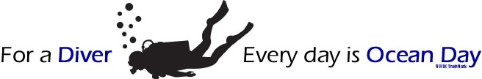

*11/10/21*

**Research Enhancement Engineering for Seascapes (R.E.E.F.S.)**

**Executive Summary and Case History**

The World Federation for Coral Reef Conservation (**WFCRC**) has, over the past thirteen years researched, held town hall meetings, and has consulted with stake holders and experts in coral reef conservation to create programs that focus on procedures for coral reefs that will minimize mans impact on sensitive ocean environments, done in real time. We focus on current issues and monitor tomorrows issues; we want to see change in years not lifetimes. It is imperative that we protect our marine treasures now, [before they are gone.](https://img1.wsimg.com/blobby/go/86aa78a2-f797-4f21-b4f2-49af2981c9f0/downloads/CTA-045-Coral%20Decline-Worlds%20Oceans.pdf?ver=1636560409612)

The **R.E.E.F.S** (Research Enhancement Engineering for Seascapes) Program is a global partnership supported by Mission Blue, The Living Ocean Foundation, the UN Goal 14, local stakeholders, marine biologists, coral experts and MPA mangers in project locations to address key monitoring knowledge gaps in our understanding and sharing the science behind a need for immediate action and 1st response plans. These issues require site specific attention in order to maintain current levels of a reef presence and to prevent future decline and need to be executed in the necessary time frame. The need to provide this information for decision-makers to promote needed actions for sustainable reef conservation is **now** and is necessary to advance the understanding, use and conservation of coral reefs through an integrated program of excellence in data gathering/sharing, monitoring, education, and outreach built upon active and long term partnerships with divers, conservationist, the science community and local island governments. To share this information on a broad spectrum will give decision makers the knowledge necessary to make better data driven decisions.

**R.E.E.F.S**. is a multi-phase initiative that:

1) lays the scientific framework for improved on-site management interventions;

2) builds a framework and capacity to carry out adaptive management and monitoring in sensitive eco systems

3) works to integrate findings into management and policy at local, regional levels for better data driven decisions.

4) produce application-oriented results that are clearly useful in management, science and coastal conservation.

5) and are *in line* with and supports The United Nations Goal 14 for ocean conservation.

The **R.E.E.F.S**. Program is nearing the end of the first 10 years of developmental operation. The achievements to date include: GIS Coral Reef Mapping Tool, a network of over 1000 participants, build an organization that is of high ethical and awareness values, web sites, mobile applications, document gallery based on location. Research documents and articles involving international scientists, marine biologists, and experts in the field of coral conservation are also included.

Project locations and discussions are underway with local stakeholders to establish future locations using the same procedures as a template to establish other project locations to share our knowledge about conservation via smart phones and social networking. Which in turn reduces developmental cost and increase area of shared 1st response and action plans. We also encourage other NGO’s or agencies to adopt this holistic approach to coral and coastal environments.

New and previously unseen tools are being developed for managers and decision makers to assess threats to reefs and to design, identify and to volumetrically account for coral volume, including remote sensing tools like [NASA’s CORAL Satellite](https://img1.wsimg.com/blobby/go/86aa78a2-f797-4f21-b4f2-49af2981c9f0/downloads/Remote%20Image%20Gathering.pdf?ver=1636561543450), Landsat 8 and UAV infrared and near infrared imagery to monitor and view the entire coastal picture like those used in the BP Deepwater oil spill in the Gulf Of Mexico.

The **R.E.E.F.’s** Program has promoted the use of information to convince decision-makers of ‘win-win’ actions with measures to involve stakeholders in their own wellbeing which in turn, directly effects coral reefs.

**Development of an assessment methodology and tool for assessing the status of the**

**protection for coral reefs and coastal environments – A Case History Study**

**WFCRC Priority area:** Research Engineering Enhancement for Sea Scapes (**R.E.E.F.S.)** Project

**Geographical coverage and background:**St. Martin is the smallest Island in the world to be shared by two sovereign governments - the Dutch and French. Since 1648 the island has been divided in two, with the smaller Southern side making up part of the Netherlands Antilles (34km2), and the larger Northern side being a French Overseas Territory (52 km²)

The island is situated on a submarine plateau called the Anguilla bank with a maximum depth of 36m, which it shares with the islands of Anguilla and St. Barthélemy. St. Martin has an irregular shape, having many bays and lagoons along its coast. Several uninhabited small islands surround St. Martin. Tintamarre, also called Flat Island, Ilet Pinel, Little Key and Green Key at the eastern side of the main island as well as Great Key in Simpson Bay Lagoon belong to French St. Martin (Figure 2). Pelican Key, also called Guana Key, Molly Beday, Cow and Calf and Hen and Chickens at the eastern side of the main island as well as Little Key in Simpson Bay Lagoon belong to the Netherlands Antilles (Dutch) side of St. Martin.

**Geographical history and coverage:**

[**Saint-Martin**](https://en.wikipedia.org/wiki/Saint-Martin) – The Collectivity of Saint-Martin (French Side) is the northern part of Saint Martin, a tropical island in the northeast Caribbean, approximately 240 km (150 miles) east of Puerto Rico. The 98 km² (38 square-mile) island is divided roughly in half between France and the Netherlands; it is one of the smallest inhabited landmasses in the world that is divided between two nations. The northern French half is a French overseas collectivity (the southern Dutch half is called [► Sint Maarten](https://commons.wikimedia.org/wiki/Atlas_of_Sint_Maarten) and is part of the former [► Netherlands Antilles](https://commons.wikimedia.org/wiki/Atlas_of_Netherlands_Antilles)). Collectively, the two territories are known as, "St.-Martin/St. Maarten", "St. Martins", or simply, "SXM" (SXM is the IATA identifier for Princess Juliana International Airport, the island's main airport). The island lies near [► Anguilla](https://commons.wikimedia.org/wiki/Atlas_of_Anguilla), [► Saint-Barthélemy](https://commons.wikimedia.org/wiki/Atlas_of_Saint-Barth%C3%A9lemy) and the [► British Virgin Islands](https://commons.wikimedia.org/wiki/Atlas_of_British_Virgin_Islands).

Kenya: Vision 2030 and First Medium Term Plan, 2008‐2012 (www.planning.go.ke)

**Expected starting date:** January 2017

**Expected duration:** 1 year with continued monitoring by NAFSXM

**Implementing partners: NAFSXM**

**External:** The Nature Foundation St. Maarten (NAFSXM) was established in January 1997 with the objective of enhancing the environment through effective management, education, awareness and protection of natural resources. The Nature Foundation is a non-governmental/non-profit organization with a staff currently consisting of an office manager, marine park manager, and chief marine park ranger, supported by a 7 member board. In the past, concerns for nature were over looked; however NAFSXM has worked very hard for the last years and has seen a greater awareness developing on the part of the population, demonstrating that the community cares about conservation efforts. The mainstay of St. Maarten’s economy is tourism which depends on clean beaches and healthy waters, reinforcing the need to protect the environment.

**Background:**

The 34km2 of St. Maarten is one of the five islands that previously made up the Netherlands Antilles, with a Separate Status achieved on the 10th of October 2010, making it a separate entity within the Dutch Kingdom. The Windward Islands are part of the Lesser Antillean Island Arc, which stretches from Puerto Rico in the North to the coastline of Venezuela in the South (see below).



The Windward Islands lie within eye sight of one another, St. Maarten is 63 km from St. Eustatius (the location of a 13 MBBL oil storage facility) and 48km from Saba. St. Maarten is the largest of the three Windward Islands and has a combined area of about 86 km².

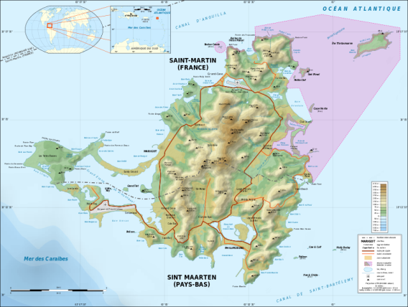  
St. Martin is the smallest Island in the world to be shared by two sovereign governments - the Dutch and French. Since 1648 the island has been divided in two, with the smaller Southern side making up part of the Netherlands Antilles (34km2), and the larger Northern side being a **French Overseas Territory** (52 km²) right.

The island is situated on a submarine plateau called the Anguilla bank with a maximum depth of 36m, which it shares with the islands of Anguilla and St. Barthélemy. St. Martin has an irregular shape, having many bays and lagoons along its coast and claims a 12 m territorial and resource boundary. Several uninhabited small islands surround St. Martin. Tintamarre, also called Flat Island, Ilet Pinel, Little Key and Green Key at the eastern side of the main island as well as Great Key in Simpson Bay Lagoon belong to French St. Martin (on right).

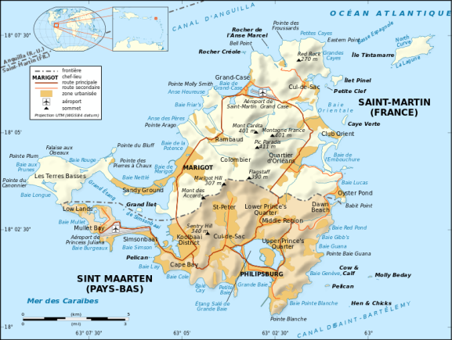

Pelican Key, also called Guana Key, Molly Beday, Cow and Calf and Hen and Chickens at the eastern side of the main island as well as Little Key in Simpson Bay Lagoon belong to the Netherlands Antilles (Dutch) side of St. Martin. Coral reefs, seagrass beds, mangrove and salt pond habitats are apparent around the coastline of St Maarten. The [coral reefs](https://coral.jpl.nasa.gov/about-coral) have spur and groove formations (coral ridges divided by sand channels) and boulders at the dive sites ‘The Maze’ and ‘Hen and Chicks’ are encrusted with numerous species of corals, sponges and anemones. Seagrasses are found mainly along the southern and south western shores, although they are experiencing considerable pressure due to damage caused by unsustainable fisheries and coastal development. Mangroves can be found around Simpson Bay Lagoon, and around the salt ponds, which provide a perfect habitat for roosting, nesting and migrating birds as well as a wealth of other species. The salt ponds provide important foraging areas for many birds and the brackish and sometimes hypersaline conditions give rise to a unique wildlife community that includes several fish species, snails and insects. The highest points and the geologically oldest parts of the island are in the center, including Fort Hill (220m), Cole Bay Hill (215m), Sentry Hill (344m), Saint Peter’s Hill (317m), Flagstaff (386m), Pic Paradis (400m) and Naked Boy Hill (300m). Flagstaff is the highest hill on the Dutch side. Founded in 1763, Philipsburg, the capital of Dutch St. Maarten, fills a narrow stretch of land between Great Bay and the Great Salt Pond. With its numerous shops, restaurants, cafes and casinos the waterfront forms the focal point of tourist activities and has become a popular stop for cruise ships.

With a 58.9 km coast line, a 12 nm territorial waters, a 12 nm exclusive fishing zone, 12 major bays, The Simpson Bay Lagoon, Salt Pond and Oyster Pond St. Maarten is dominated by marine features. With its proximity to a 13 MBBL oil storage facility on St. Eustaus and oil tanker traffic coming within 2-3 nm of its southern coast line there is an ever increasing chance of oil spills. Several spills in Simpson Bay Lagoon have already been identified. There are locations of raw sewage affluent dumping into the ocean creating unidentified zones of toxic contamination. Drinking water quality problems exist on the island as well as other island nations. With the new developing technology soon to be available from WFCRC partners, clean drinkable water will be available soon at a very reasonable price well below RO technologies. WFCRC will act as an intermediary for the delivery of said technologies.

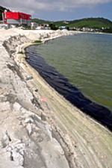Current seismic activity is under way in the Caribbean by a Russian Consortium with intentions of gathering 30,000 km of 2D seismic data using multi spectral acoustic air guns. Proposed seismic program lines are within 2 nm of the island. Increased exploration of the world’s oceans will result in more boat traffic, anchorage damage, fuel spills and the inevitable drilling/production programs.

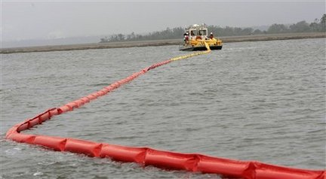

The varied and unique coral reef complexes and beach environments supports several economic services that are vital to the economy of St. Maarten. They are fishing with the largest by far (85%) being tourism. The dependence on tourism has been in place for so long that it has become the major industry in St. Maarten. The number of cruise visitors is expected to increase considerably from just fewer than 1.4 million to nearly 2 million visiting the whole of the island in 2015. Marine based tourists such as Yacht visitors are also likely to increase in number. These increases in the temporary and permanent populations on St. Maarten will place increasing pressure on the islands environment and infrastructure. St. Maarten produces very few consumable goods. The government is looking into Ways of diversifying the economy, particularly with industry that would support the main economic activity and not damage the tourism product. Government is currently involved in preparing zoning plans, which will reserve an area for light Industry/manufacturing and an area for heavy industry. Once this is in place efforts would be made to attract industries. One of which could be used in coastal conservation and oil spill management by growing industrial hemp that absorbs many times ifs weight in contaminants. This would create a new cottage industry for the 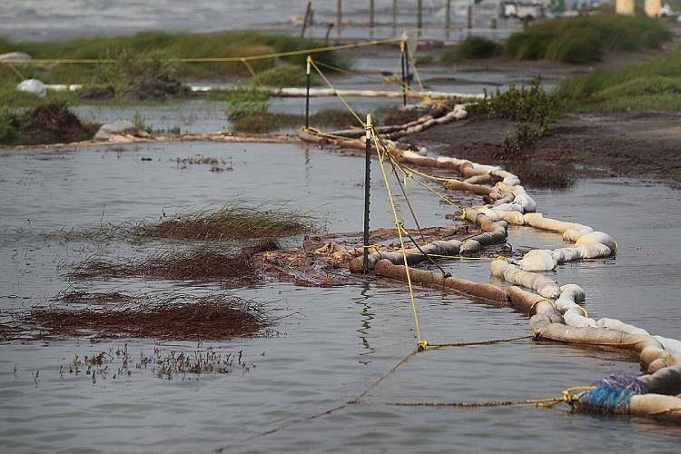making of sediment and contaminant capture and containment booms.

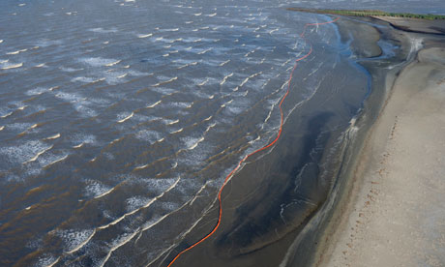

There are other global and local concerns resulting from loss of biodiversity, and increased carbon dioxide emissions as a result of the increased tourism and traffic. Investigations has revealed that changes in land cover due to human activities have caused the surface runoff to increase drastically. Groundwater recharge and soil moisture storage have decreased as well.

Other consequences of degradation have been the, loss of employment, reduced agricultural production, food security, loss of livelihoods and loss of revenue to the Treasury due to lower taxation base and poor economic performance. In addition, the Government is expending more resources in law enforcement activities.

**Justification-Current management practice and activities**

The role of The Nature Foundation St. Maarten (NFSXM) is currently confused between a management agency for the marine park and a nature foundation for the island resources and is the only agency on the island that is fully engaged in marine conservation efforts.

**Current issues are:**

**Coastal Development** and unchecked terrestrial influences. User conflicts between fisher folk vs divers, and a hidden community of immigrants and users from neighboring islands.

**Pollution** from Oil spills, sediment runoff, raw sewage and toxic water disposal and who should administer to these concerns.

**Fishing industry**, poor fish stocks, poaching of sea-turtles, gill netting, spearfishing, diving, and shark feeding.

**Management Issues** like population accepting laws, government support, mooring placement, lack of human resources and physical resources, and unsustainable finance.

**Monitoring** and the Lack of and professional research. Large scale assessment studies of the reefs of St. Maarten are highly recommended

**Future issues**

Politics of making changes – issues over how to manage developments ‘sensitively’

Natural disasters such as hurricanes and beach decline

Man made threats such as increased chance of oil spills from current and future drilling in proximity

Conflicts of interest

Lack of enforcement

Cutting away of dive moorings

More cruise ships are expected to visit the port, an extra arm is expected to be built to accommodate up to 8 cruise ships – so the port can accommodate 12 at any one time.

Major concerns over maneuvering and not hitting the reefs.

Loss of traditional fishing practices

**MANAGEMENT ACTIVITIES**

**Patrols**

Increased patrolling, especially at night when fishermen approach

Concerns over where the responsibility for patrolling and enforcement

**Training**

Training for rangers especially in enforcement procedures and IT

A program of staff development and training is required

Train coral gardener

**Resources**

Boats and 2 dinghy’s requested

Uniforms requested

Computers

ArcGIS 10.2 donated by **WFCRC**

New GPS required to update old GPS system

Office space for visiting researchers and scientists/accommodation and work space

An extra vehicle is required

Power supply for VHS radio

Maps, rules and guidelines are required for surveillance

**Outreach**

Outreach needed on dive boats, along with books and brochures

University contacts required to increase research being carried out.

Visitor center requested

Dive orientation required for operators to appreciate the value of the reef.

A video of the MPA would be useful to show on local channels (Currently being created by **WFCRC** Underwater Film Director)

2 day workshops that involve local stakeholders and tourist alike. (Held during the **WFCRC** R.E.E.F.S. Fund Raising Event)

Work with local dive shops to develop unique dives for divers who have mastered the art of diving by challenging them with aquatic data gathering. (WFCRC Long Term Diver Participation Program)

**Monitoring**

Monitoring and research required for the reefs and fish stocks.   
 Fish stock population estimates can also be used for bird research. Monitoring also required for spawning aggregations and water quality testing.

Approach divers to carry out monitoring

Possibility of involving fishermen in monitoring fish stocks

Fishermen may take part in fish monitoring

Monitoring of illegal and coastal constructions requested (**WFCRC** Coastal Protection Master Plan and The Coral Reef Registry)

Launch and maintain a tethered drone for continuous monitoring of the most critical eco systems, (The **WFCRC** Simpson Bay Lagoon Mapping Project)

**Maintenance**

Possibility of involving fishermen in maintenance activities

Fishermen volunteers to place temporary marker buoys

**Partners**

DCNA, FWC, NOAA and local support is seen as essential partners

Share program with other local NGO’s.

Partner with **WFCRC** and Execute **WFCRC’s** conservation plans in its entirety along with its other programs

Share activities with other NGO’s like The Ocean Conservation, Oceania and others.

**FURTHER DISCUSSION AND COMMENTS**

The tourism bureau would like to market diving as a major attraction of St Maarten ([Develop **WFCRC’s** Long Term Diver Participation Plan](http://wfcrc.org/index.php/programs-2/long-term-diver-participation/) and Coral Reef Registry)

Lack of good mapping resources, including GIS. A terrestrial PA is essential for the wellbeing of the marine environment.

Adequate patrols are essential

Unsuccessful or unsustainable planning, management and execution of best practices for the island of St. Marten have identified how a lack of understanding and local stakeholder buy in, can cause environmental disasters as well as socioeconomic problems affecting human wellbeing now and well into the future. An assessment of past and present practices and a prediction of the likely scenarios based on credible scientific data and current technology would be of great value for the pursuit of conservation efforts in St. Maartin.

**St. Maartin Government Effort**

The Government of St. Maarten is committed to reversing the continued environmental destruction and decline of its marine treasures immediately and the long term, as outlined in the NFSXM’s web site. Continuing Governmental lobbying efforts contain other important goals in helping NFSXM to achieve its objectives. Examples of our attempts to influence legislators and officials, single-handedly or with fellow environmental NGOs include:

* Request for zoning and legal protection of Mangrove Ponds
* Planning /building permit and environmental inspection reforms
* Environmental Impact Assessment as mandatory for large-scale developments
* Request for government financial support to help cover the Foundation’s operational costs
* Light Assessment Policy proposal for coastal developments on sea turtle nesting beaches

**Government lobbying with fellow environmental NGOs include:**

* Request for plastic bag ban
* Protection of Mullet Pond from being turned into a Marina
* Emilio Wilson Estate designated as a terrestrial protected area
* Recommendations for the improvement of St. Maarten’s Environmental legislation
* Protected Area status for the island of Little Key in the Simpson Bay Lago

**Suitability of Martine assets in St. Maarten**

The island of St. Maarten and the services provided are ideally suited for controlled development and for the use of an assessment and management tool focused on promoting new standards and models for a sustainable management program. The proposed tool will incorporate coral protection action plans, coastal protection master plans and modeling plans to visually present the impact of past and current activities and predict future impacts of human interventions. The analysis of data and information using the tool will determine which actions and management policies to adopt, which in turn will contribute to improved marine and maritime resource development for the island.

**The Assessment**

The visualization assessment will graphical visualize and analyze available data and information making it available to all local residents in each project location by the use of a smart phone. This will help to better understand how human activities impact marine activities, and in turn how the variable nature of oceans and how they can affect human well-being. The assessment will be carried out at the local level with the NFSXM being the repository of the tool and data. The assessment will focus on current human activities; analyze existing data and information for planning, management and for future development.

It will also, provide recommendations for further monitoring of pertinent scientific data and information, which will provide a holistic understanding of the major physical, socioeconomic, and political aspects essential for an integrated watershed management, planning, and decision making.

It will in the process draw one UNEP’s expertise and lessons learnt from previous assessment programs globally as well as other professional organizations with expertise in conservation programs. The assessment methodology developed during this process will be applied to other problem areas as they pose a threat to marine and land based assets.

**Project Approach**

This project will develop an assessment methodology that will provide the required information for management, and to enhance management of these fragile ecosystems. It will be applied throughout the entire island. The method will be designed in such a way that its basic step will also have effects on many areas of interest. During the implementation stage, NFSXM, stakeholders (local communities, scientific and universities) and experts in assessment methodology development will consulted on the best approach to use to meet the overall objectives of the project. Relevant data and information at different levels of the ecosystem i.e. the physiographic, anthropological and the socio-economic will be collected to be utilized for visual presentation through application of GIS, smart phones and social networking. It is hoped that the assessment will meet the needs for the island for many years to come as well as strengthening the role of NFSXM and outside organizations, like **WFCRC**.

Specifically, the developed assessment methodology will utilize existing relevant local or community and scientific data and information and will have an opportunity to be revisited in future workshop and events.

The second step – when funding is available, will focus on promoting the application of other **WFCRC** programs like:

**The Collaborative Coral Reef Registry  
R.E.E.F.S./Coastal Protection Plan (CPMP)**

**The Best Practices for Coral Reef Conservation**

**Worldwide Coastal Network Program**

**Coral Credit Program**

**Standardization of Aquatic Data Program**

**Long Term Diver Participation Program**

**Out Reach Program**

**Adopt a Reef Program**

The assessment methodology will incorporate interoperable models ([Interactive Ocean Maps](http://wfcrc.org/index.php/geo-portal/interactive-ocean-maps/)) with a range of scenarios enhanced by diverse visualization capabilities (graphs, text, 3D, images, analytical data and maps, with georeferenced data).

The selected tool will enable stakeholders to visualize their ecosystem and research based on location, simply by moving a mouse over a map of their location.

The selected tool will be hosted by NFSXM/WFCRC and made available to stakeholders free of charge. Funding will consist of local, and outside foundations, corporations, and concerned citizens around the world. Content will be gathered from various sources both locally and from around the world. It will consist of input from local stakeholder observations and photographs, input via a website connection and direct communication.

**The Objective:**

The overall objective of the project is to develop an assessment methodology and tool for assessing the status of shallow water and coastal ecosystems and the impact of socio-economic drivers that lead to their degradation and to promote management options of the ecosystems in St. Marten.

**R.E.E.F.S. Project Framework**

|  |  |  |
| --- | --- | --- |
| Outcomes | Enhanced in-country understanding and skills in the application and utilization of ecosystem based water assessment methodology and tool for managing and addressing priority issues of freshwater ecosystems.  Enhanced in-country capacities to integrate ecosystem assessment approach in development and planning processes at the national and local levels. | Conservations programs that will keep up with ever increasing infrastructure development |
| Outputs |  | Estimated budget for output |
|  | An assessment methodology and tool for assessing marine and beach ecosystems such as: hydrological scenarios for surface and groundwater developed; guidelines for water assessments established; water quality monitored and data and information collected; training courses for conducting assessments undertaken and assessment results disseminated to raise awareness. | An estimated $125,000 USD has already funded the WFCRC Project for the past 10 years.  Another estimated $125,000 will be needed to execute the balance of the programs. Subsequent programs at other locations will be on a cost sliding scale |

**This component includes the following main activities**:

* Facilitating the collation and analysis of primary information and data – which includes baseline data and information on various marine related ecosystem services and issues (Currently gathering related data)
* Stake holder and local resident town hall meetings. (**WFCRC** R.E.E.F.S. Town Hall Meeting in St. Maartin on November 14, 2013 delivered an introduction to St. Maartin and gathered contacts and what concerns stake holders have about conservation issues)
* Developed relations with NFSXM and recruited Tadzio Bervoets ([tadzio.bervoets@wfcrc.org](mailto:tadzio.bervoets@wfcrc.org)) manager of NFSXM as **WFCRC** Charge s’affaires-St. Maartin. (November, 2012)
* Continual developed relations with local stake holders, businesses, restaurant owners, dive shops, etc. (**WFCRC** R.E.E.F.S. Town Hall Meeting in St. Maartin November 2013)
* Comprehensive literature review and library and drafting of reports from literature review is contained in **WFCRC** Interactive Ocean Maps
* Carrying out of an assessment of the anthropogenic and socio-economic issues of St. Maartin (**WFCRC** R.E.E.F.S. Town Hall Meetings)
* Stakeholder workshop to raise awareness, participation on the issues and, to execute **WFCRC** assessment tool to develop, and to determine the level of existing data and information and future requirements to manage the ecosystem.
* Organize 2 day event during **WFCRC** R.E.E.F.’s Fund Raising Event November 14th, 2017 to plant baby coral and mangroves around the island which will require permits. Day 2, will start with an event much like [“The Amazing Race”](https://en.wikipedia.org/wiki/The_Amazing_Race_(U.S._TV_series))

Which will task participants with visiting a number of local establishments to get the answer to a question that pertains to that establishment, something like owners name or best known for what drink. Then continue on to the next establishment and so on. Then return to the beginning point for a lapsed time. The team with the shortest time will win the honorary seating at the evening’s entertainment as well as other collateral prizes. This event will engage local establishments and get participation as well as acquainting visitors with the island.

Organized a technical workshop to test usability of the assessment methodology and tool in St. Maarten

Analyzing available data using the assessment tool (scenarios, ecological niche modelling, spatial planning) and identifying a strategy to address data gaps.

Workshop to validate and finalize the development of the assessment methodology and tool with stakeholders and technical experts. It will test the usability of the tool in the Mau.

Fine-tuning the assessment tool based on inputs from the second workshop

Ten year development of **WFRC** network of professionals (over 1500) in the field and 26 core team members from around the world with experience in Marine Biology, Geology, GIS, Data Management, Non Profit, Diving and Spill Control/1st Response and concern for the Ocean.

Further awareness campaigns to demonstrate the use and application of the tool starting with the **WFCRC** R.E.E.F.S. Fund Raising Event in November 14th, 2017

Write the final report and develop an online geo-portal showing spatial and socio-economic data of maritime activities and research with final results available and viewable by **WFCRC** mobile application**.**

**Expected accomplishment**

Under construction.

**Indicators of achievement**

Assessments carried out using the assessment methodology and tool in the follow up phase and programs.

Assessments initiated by trained officials using the developed assessment methodology and tool in the next phase

Assessments executed as template for use in other locations like the Island of Saba and other islands in proximity.

“We all should realize that there is a problem with our oceans and should be addressed globally, it’s our ocean to save……

**This global issue is the emotional equivalent to a war and should have an equivalent response. Break the mold, no more business as usual. Change how we administer to our oceans, it’s the only one we have…….*The Executive Director of The World Federation for Coral Reef Conservation.***

One Ocean………One Planet

Vic Ferguson  
The World Federation for Coral Reef Conservation  
Executive Director  
4010 Skipper Rd

Sebring, Florida 33875   
www.wfcrc.org   
512.986.1902 (cell)

*The only thing necessary for the triumph of evil is that good men do nothing”….Edmund Burke*