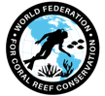
WFCRC and The Tortuga Tour
Join WFCRC

The World Federation for Coral Reef Conservation 281.971.7703 642 S. Commerce Sebring, Florida 33870
Vic Ferguson Executive Director 512.986.1902 vic.ferguson@wfcrc.org info@wfcrc.org

8/27/18
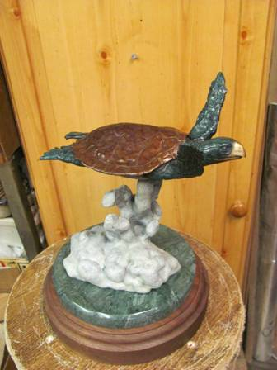
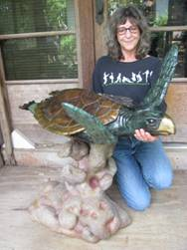
Tortuga Tour 2018
Michael W. Hall, a world renowned bronze sculptor has been one of WFCRC’s featured artist for some time and has created “The WFCRC Bronze Sea Turtle” in a small version in a signed and numbered limited addition of 75 which is available now (see picture) to be used as a desk top version. The detail and life like patina makes these turtles almost indiscernible from the real life turtle.

The life sized version (above) is in a signed and numbered limited addition of 25 and is also available now. One of its intended purposes is to be a diving and snorkeling attraction and as a monument to preserving one of our ocean treasures…..sea turtles. It is to be placed in shallow waters of nations who participate in our Caribbean Ring of Hope Sites that have a large marine presence to encourage divers and snorkelers to do what they can to protect this gentle giant of the ocean and to have their picture taken with the world’s first underwater Bronze Tortuga Monument.

