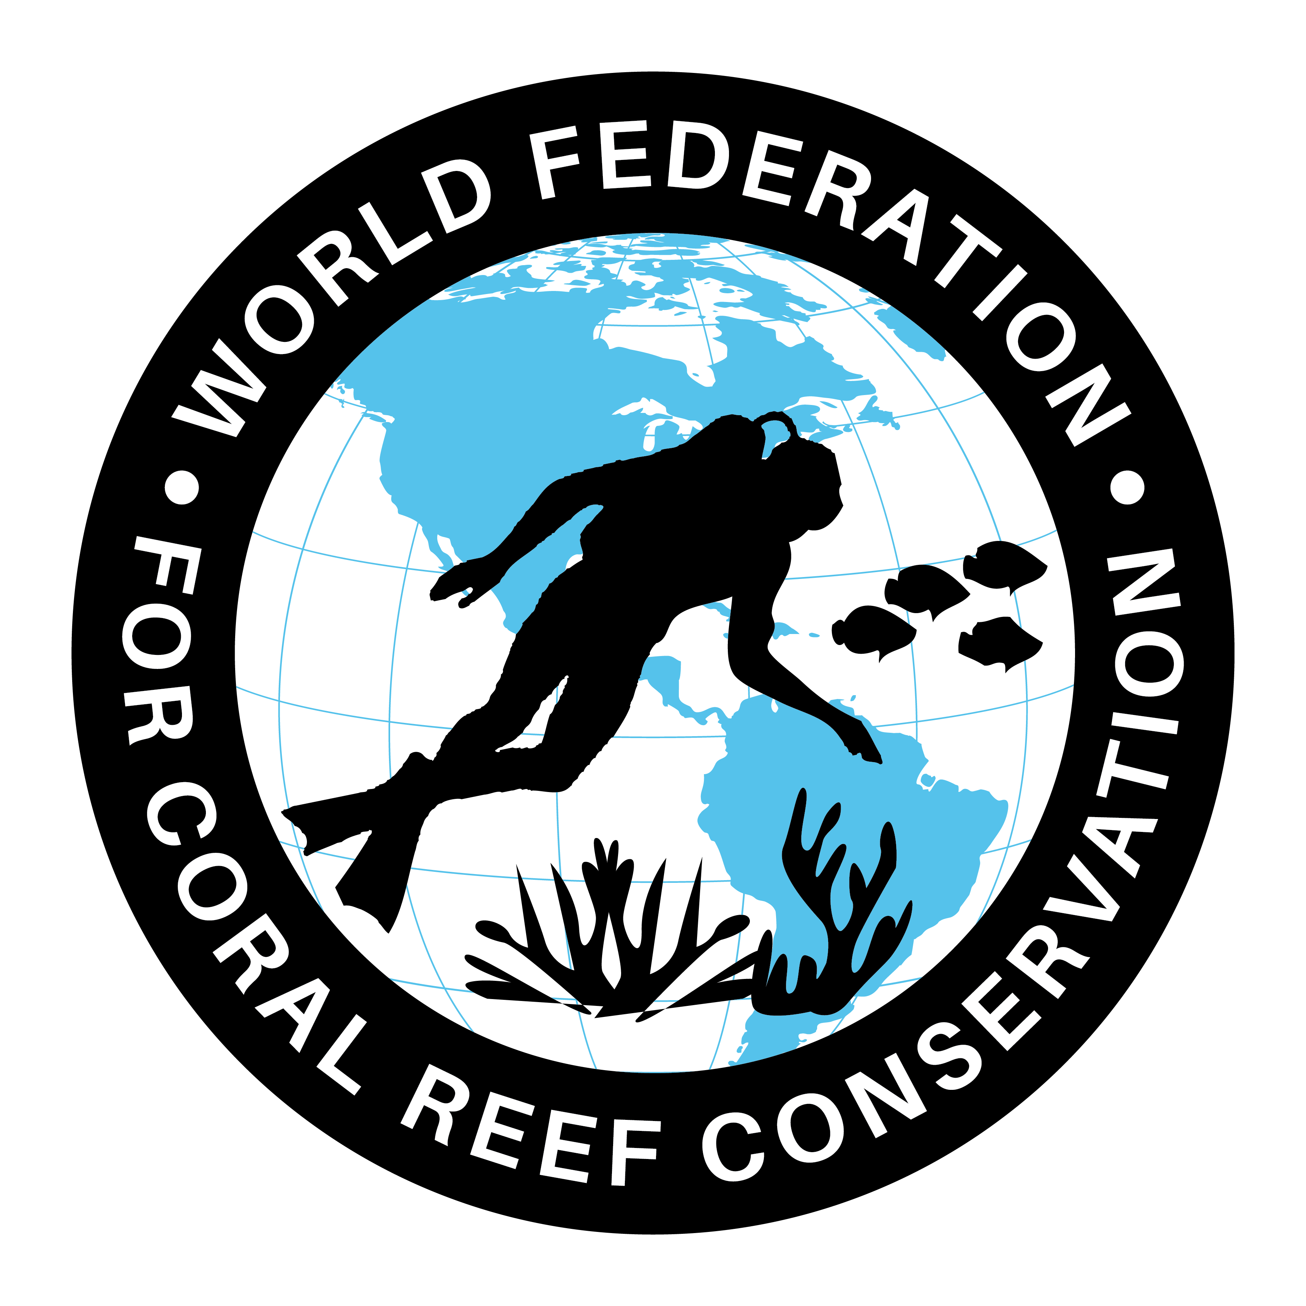
WFCRC and The Turtle Tour
Join WFCRC

The World Federation for Coral Reef Conservation 281.971.7703 642 S. Commerce Sebring, Florida 33870
Vic Ferguson Executive Director 512.986.1902 vic.ferguson@wfcrc.org info@wfcrc.org

8/27/18
Tortuga Tour 2018
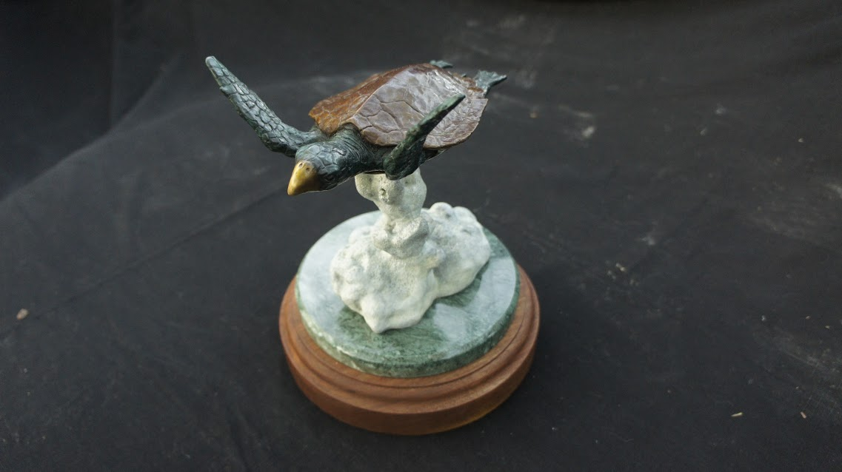
Michael W. Hall, a world renowned bronze sculptor has been one of WFCRC’s featured artist for some time and has created “The WFCRC Bronze Sea Turtle” in a small version in a signed and numbered limited addition of 75 which is available now (see picture) to be used as a desk top version. The detail and life like patina makes these turtles almost indiscernible for the real life turtle.
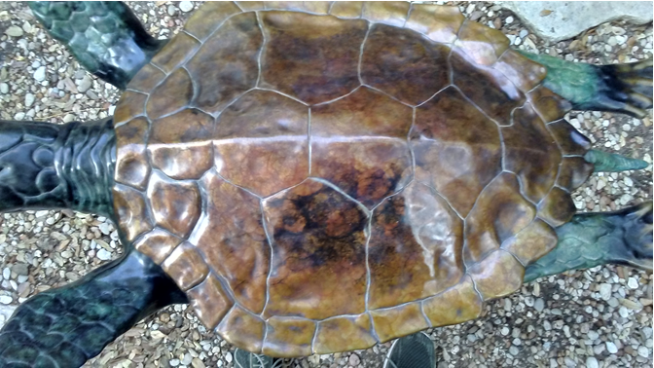

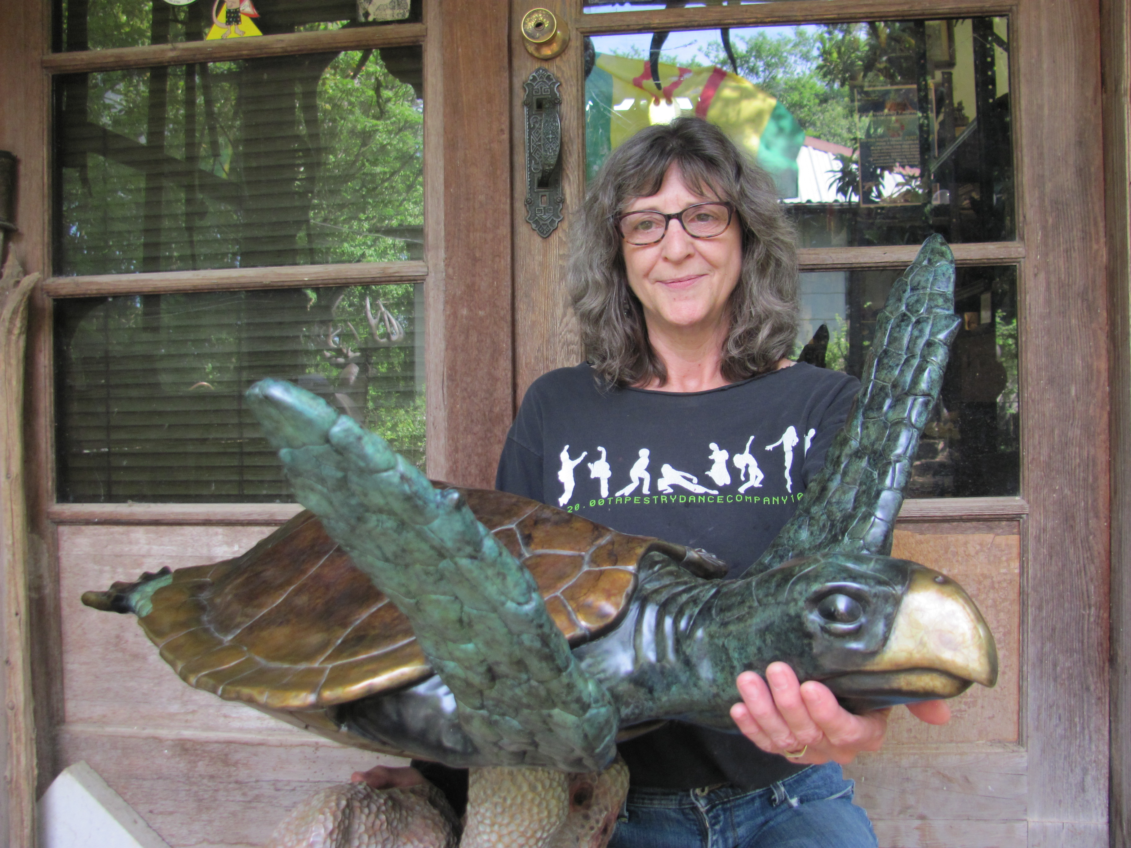
The life sized version (below) is in a signed and numbered limited addition of 25 and is also available now. One of its intended purposes is to be a diving and snorkeling attraction and as a monument to preserving one of our ocean treasures…..sea turtles. It is to be placed in shallow waters of nations who participate in our Caribbean Ring of Hope Sites that have a large marine presence to encourage divers and snorkelers to do what they can to protect this gentle giant of the ocean and to have their picture taken with the world’s first underwater Tortuga Monument.

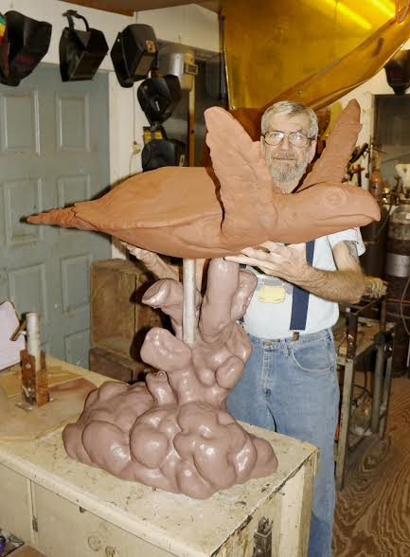
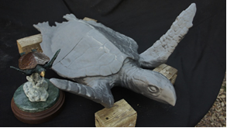

The cast bronze sculpture w/base is 38” high, 27” wide, 36’ long and weigh approximately 200 lbs.
The Turtle Tour 2018

Our current proposal is to tour the Coastal Waters of Florida with both bronzes starting with Reef Fest in Key Largo and to have the artists present during the event in Key Largo which will start the premier unavailing and the actual tour and promotion of the WFCRC Turtle to raise the awareness for the need to keep these gentle giants healthy and protected for the long term.

The next stop will be the Aquarium in Key West and will remain on display for two weeks before moving on to Miami for a couple of weeks and other locations as they become available.

The next proposed site is the Tampa Aquarium Research Center and turtle hospital for a two week promotional appearance.

Mote Marine Labs will be approached to join us in the turtle tour.

It is also proposed to place the bronze sculpture in an underwater area where coral growth potential is greatest to allow for coral growth on the specially designed base to enhance coral growth and to increase the life like surroundings. ReefLive Restoration technology will aid in this new coral growth phase. In addition to the bronze turtle coral growth it should also be placed in an area that divers will use the site to have their picture taken with the “Caribbean Sea Turtle” as an attraction for divers as well as creating a tourism attraction.

This is also the place to put a plaque on the sculpture showing support of coral and turtle conservation into perpetuity. The support you show here will be here for hundreds of years.

It is also proposed to be one of 25 turtle monuments for each Caribbean country participating in the Caribbean Ring of Hope Sites.

We also thought that to have the large turtle on display in airports to raise funds to pay for the sculpture and placement would be an appropriate avenue to introduce local stakeholders as well as visitors to see, “The Caribbean Sea Turtle” and what it is raising the awareness for.

The sculptor Michael Hall, born in Austin, Texas on February 4th, 1945, holds a degree in Aeronautical and Aerospace Engineering and has 45 years’ experience as a professional artist, 41 of which spent as a sculptor and founder, operating his own full service fine art sculpture studio and lost wax bronze casting foundry in Driftwood, Texas
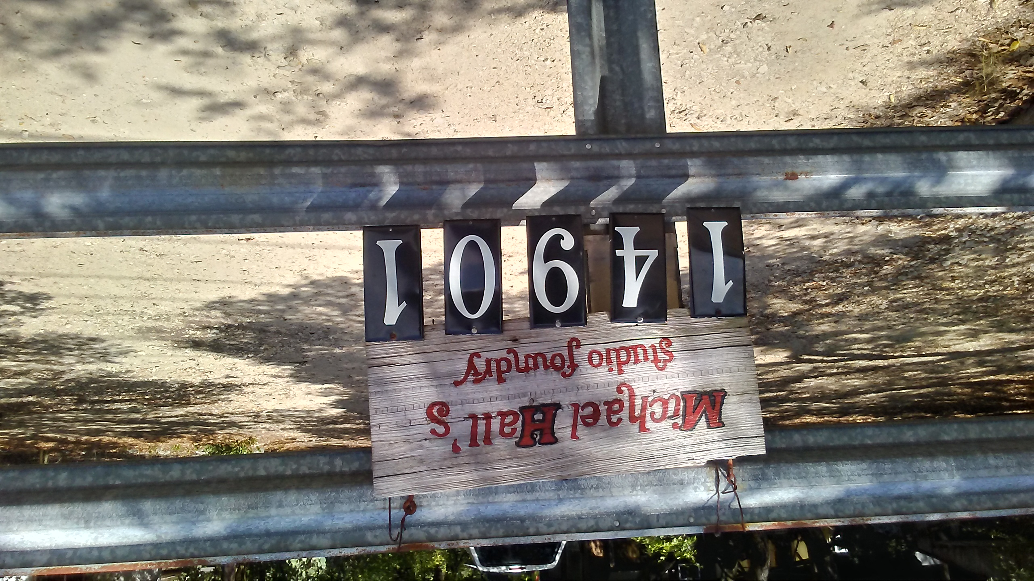

Hall has enjoyed diving the Caribbean for over 40 years and has a deep and abiding appreciation for the area and our ocean.

Michael has been honored as President Emeritus of The Texas Society of Sculptors since 1989 and sits on the Board of Director of that organization.
Bronze sculptures created by Michael can be found in private and corporate collections from The Royal Palace in Kathmandu, Nepal to The Smithsonian Institute’s National Museum of Medicine.

All of Michael’s work illustrates the fine detail and beautiful composition of a truly imaginative artist. His experience has surpassed his education, which was well focused in the fields of art and engineering, and his commissions are vast, as are his awards.

For information and/or to purchase contact Vic Ferguson at vic.ferguson@wfcrc.org or 512.986.1902.

Dates and details will follow.

People, museums, and organizations that own
sculpture by Michael Hall
His Royal Majesty, Bihendra Bhikram Sha Dev - King of Nepal
Gov. John Conlley - Former Governor of Texas
Andy Edgerton - President Texas Long Horn Assoc.
Museum Of the Southwest - Corpus Christy, Tx
Smithsonian Institute, Museum of Medical Art
H.E.B. Foundation Camp, Leaky, Tx
Gulfside Hospice, Zepherhills, Fla.
Camp Swift, Smithville, Tx
CAA President Dr. Denis Bowyer
Neil A. Armstrong - U S Astronaut, Apollo 11, first man to walk on the moon
Dr. Robert Zubrin - Mars Society President
James A. Lovell - U S Astronaut
B. Gen. Charles (Chuck) Yeager - U S Astronaut, first man to orbit the Earth
Burt Rutan
Peter Diamandis, International Space University, X-Prize founder
International Space University,
Dr. Stephen Hawking
Stevens Squyers
Elon Musk- co-founder SpaceX, chairman Tesla Motors
John H. Marburger III
Freeman Dyson - Scientist, author
Russell Schneickart - Apollo IX astronaut
David R Scott - Apollo IX astronaut
James A McDivitt - Apollo IX astronaut
Senator Harrison Schmitt - U S Astronaut
Dr. A.P.J. Abdul Kalam - former President of India
Ray Bradbury
Arthur C Clark
Dr. Robert Farquhar, Mission Director, Near Earth Asteroid Rendezvous (NEAR) Mission Team
Robert Goddard, author
McDonnell Douglas Space Systems Delta Clipper Team
Sen. Barbara Milukski
NASA-Ames LCROSS Mission Team
Gerard K O'Neill
Orbital Sciences Corporation
Rep. Ron Packard
Carl Sagan
Virginia’s Center for Innovative Technology
Dr. Wernher von Braun
Richard Branson Virgin
Vic Ferguson WFCRC

