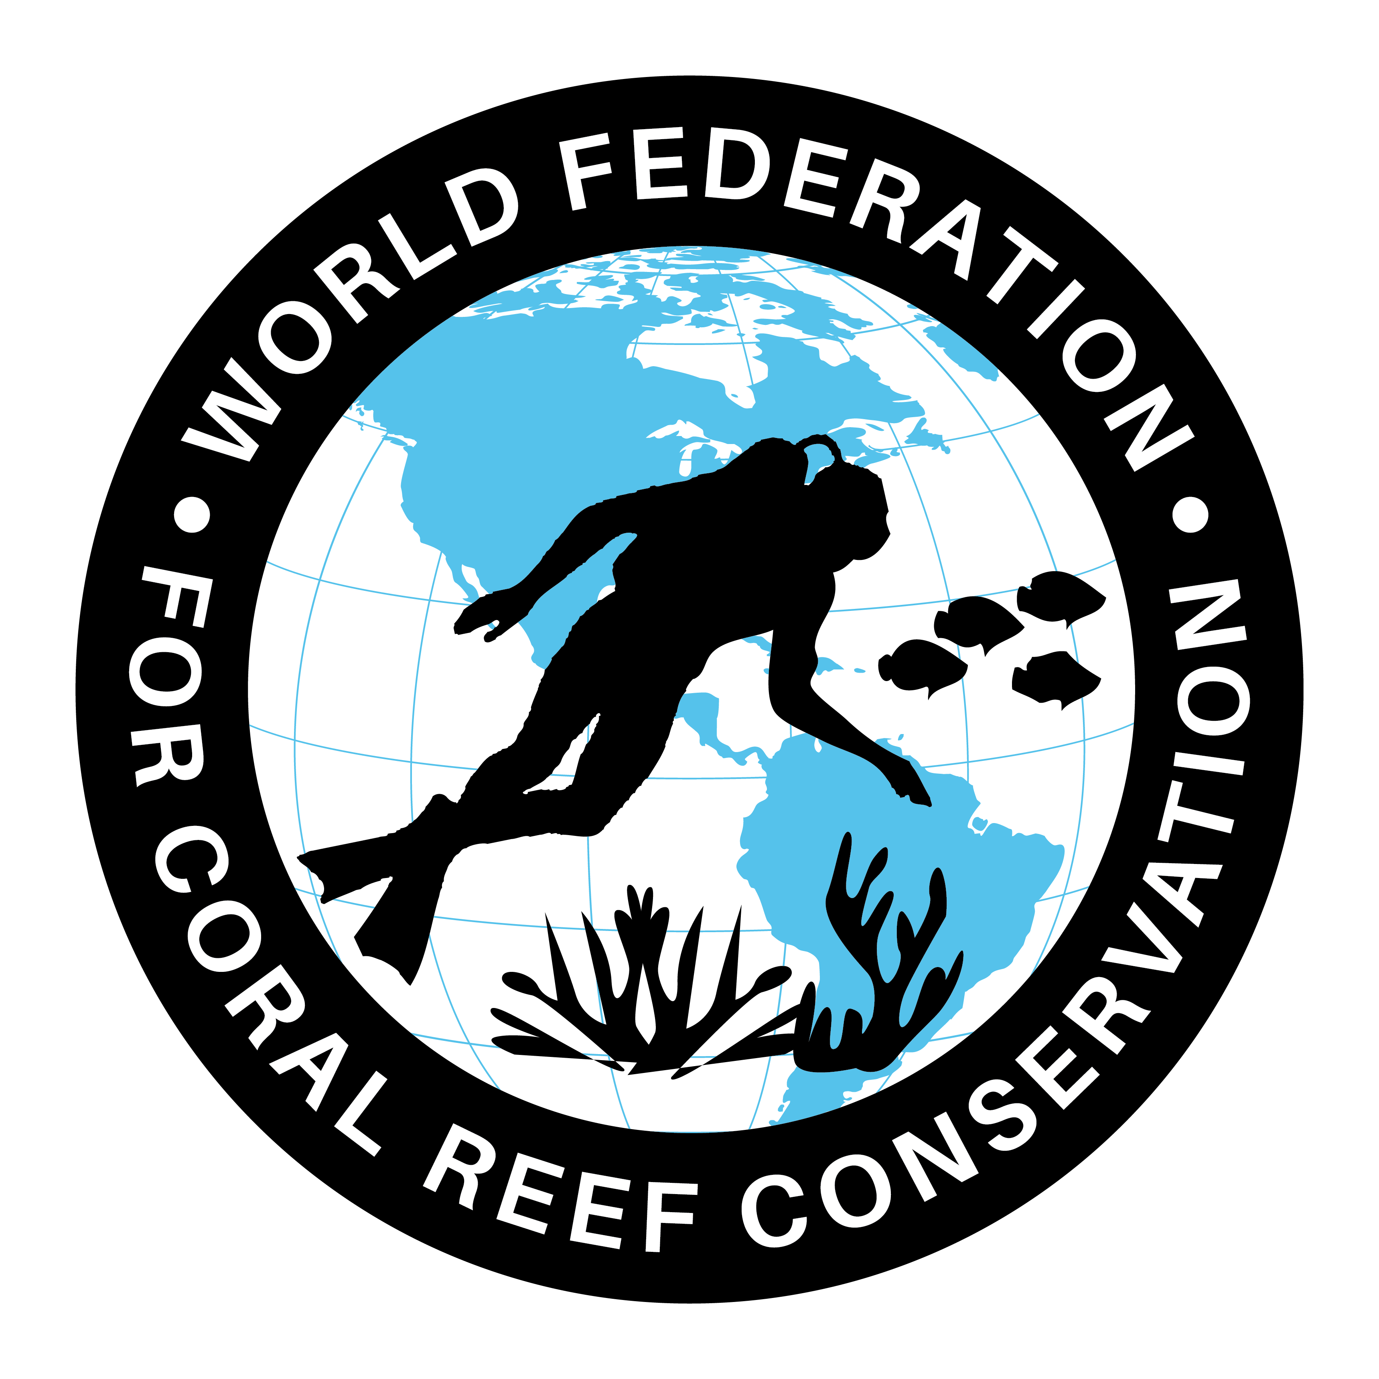
WFCRC and The Tortuga Tour
Join WFCRC

The World Federation for Coral Reef Conservation 281.971.7703 642 S. Commerce Sebring, Florida 33870
Vic Ferguson Executive Director 512.986.1902 vic.ferguson@wfcrc.org info@wfcrc.org

9/15/18
Tortuga Tour 2018
Which aquarium, turtle research center, natural history museum or science center will be the first in the world to install this bronze turtle exhibit and sculpture, and to display the value and the need to protect one of the most gentle of creatures that travel the ocean.
https://www.weforum.org/agenda/2018/08/blue-mind-science-proves-the-health-benefits-of-being-by-water …

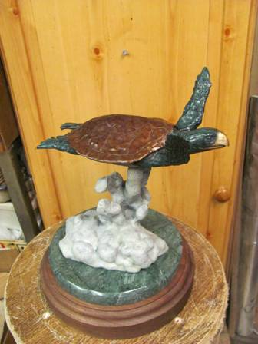

Michael W. Hall, a world renowned bronze sculptor has been one of WFCRC’s featured artist for several years and has created “The WFCRC Bronze Sea Turtle” in a small version in a signed and numbered limited addition of 75 which is available now (see picture) to be used as a desk top version.

The detail and life like patina makes these bronze turtles almost indiscernible for the real life turtle. The life sized version (below) is in a signed and numbered limited addition of 25 and is also available now.

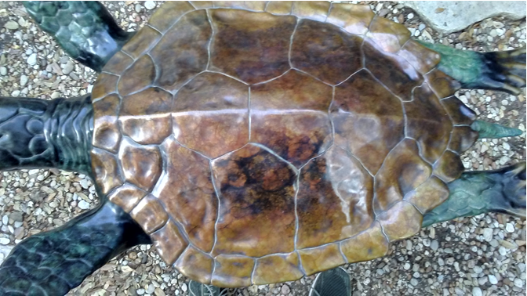

O
O

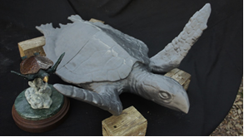

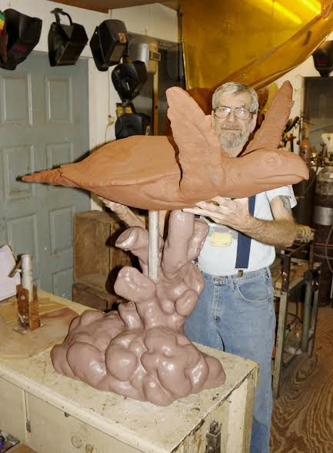

The concept, development and production of the first life sized turtle span a two year time frame. All subsequent pieces will only take approximately four months to complete which does not include deliver and set up time.

The large cast bronze sculpture w/base is 38” high, 27” wide, 36” long and weighs approximately 160 lbs.
The desk top version is 10” high, 6” wide, 12” long and weighs approximately 20 lbs.

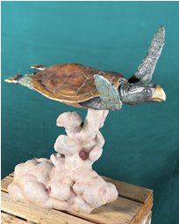
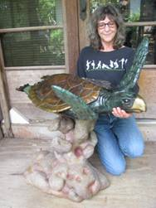

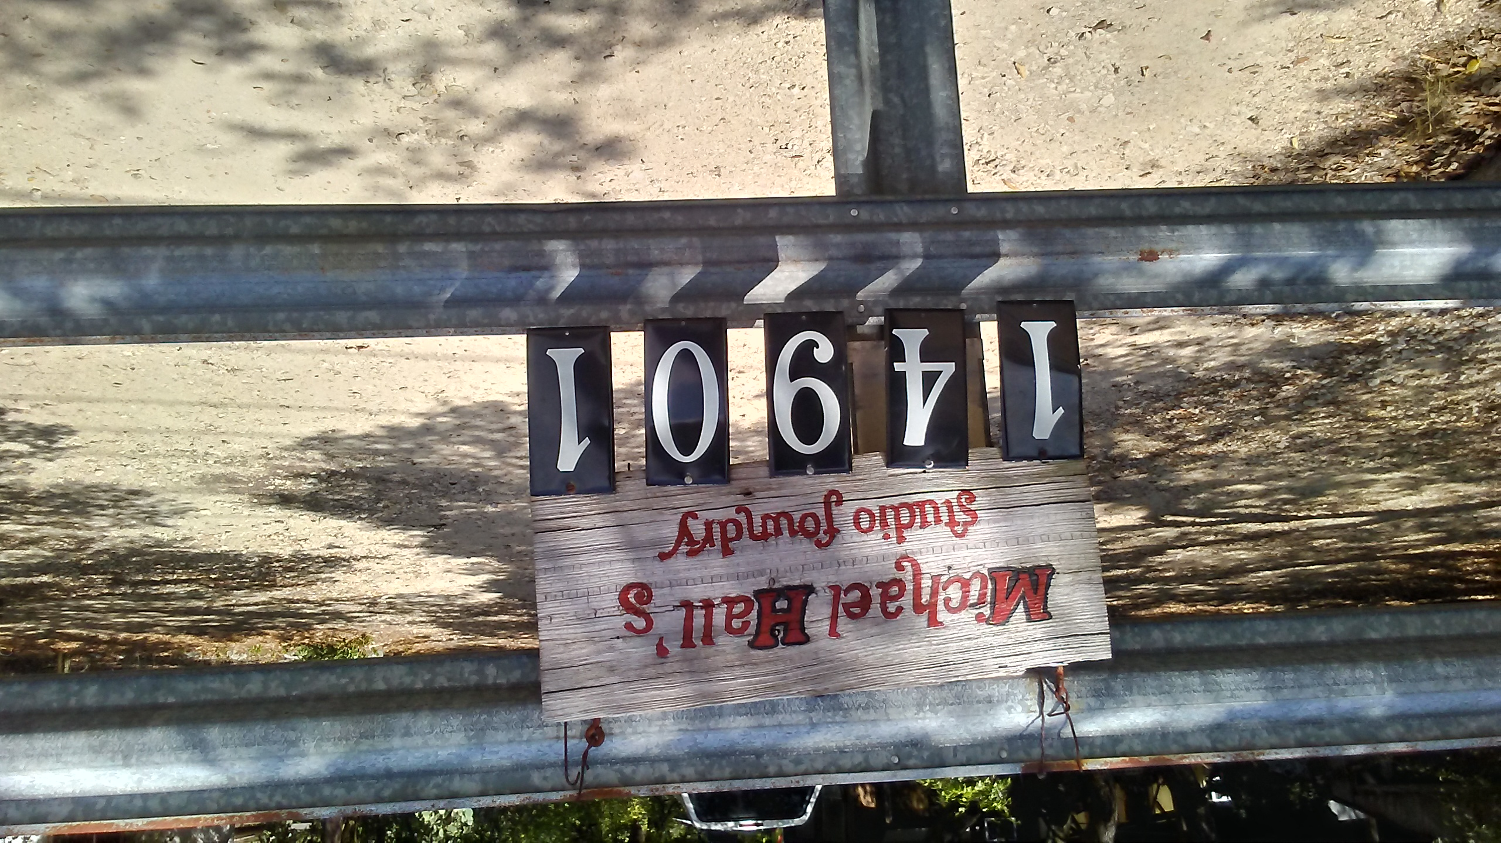

“High in the hill country of south central Texas,
There has existed since 1975 a paradoxical union of
creative aesthetics, renaissance alchemy and space age technology”.
Michael Hall’s
Studio Foundry, LLC
Fine Art Sculpture Studio &
Lost Wax Bronze Foundry
14901 FM 150, Driftwood, Texas 78619-9278
(512) 858-7067
bronzart@anvilcom.com www.studiofoundry.com

Michael William Hall
Born in Austin, Texas on February 4th, 1945, Michael holds a degree in Aeronautical and Aerospace Engineering and has 53 years’ experience as a professional artist, 43 of which spent as a sculptor and founder, operating his own full service fine art sculpture studio and lost wax bronze casting foundry.

Michael has been President Emeritus of the Texas Society of Sculptors since 1989 and sits on the Board of Director of that organization.

Bronze sculpture created and produced by Michael can be found in privet and corporate collections from The Royal Palace in Kathmandu, Nepal to The Smithsonian Institute’s National Museum of Medicine and in 178 countries on almost every continent on the planet.

All of Michael’s work illustrates the fine detail and beautiful composition of a truly imaginative artist. His experience has surpassed his education, which was well focused in the fields of art and engineering, and his commissions are vast, as are his awards.

Michael Hall’s Studio Foundry is accredited by the University of Texas, Texas State University, Louisiana Tech. and Austin Community College, for their sculpture degree intern programs.
Michael brilliantly defies the usual clichés of figurative sculpture, producing richly painted bronzes, vibrant in both detail and competence. Whether a specific commission or an otherwise inspired image, his artwork represents the subject accurately, also presenting a sincere expression of his personal involvement in what surrounds that subject.

“The art is a culmination of my lifetime observations, artistic studies, passion and personal involvement with the subjects presented. I often use the word “joy” when describing bronze sculpture. It is a considered word, deliberate in choice. Not just amazement, amusement, entertainment, or astonishment, but joy. Our art makes us all into children again for a while. We become one in our experience for the moment; lost in the form and shape and color. We see large forces at work, stronger than we could ever be, yet beautiful in their effects. Sometimes restrained, sometimes violent. Delicate beyond imagination at times, coarse and rude at others. Deadly force, dangerous, dirty stuff. Crafted with sweat and blood. Controlled by the artist. Bringing joy to many. To me the art encompasses all of life. Pain and work, plan and mistake, joy and tragedy. For all the pain, injury and failure we suffer, our efforts bring the joy – the magic – to thousands. Not a bad return. Though very few ever recognize the effort, nearly all remember the result, and all have, for a few moments, the Joy. The world is better for an instant. What more could one artist want?
mwh

A few people, museums, and organizations that own sculpture by Michael W. Hall
His Royal Majesty, Bihendra Bhikram Sha Dev - King of Nepal
Gov. John Conlley - Former Governor of Texas
Andy Edgerton - President Texas Long Horn Assoc.
Museum Of the Southwest - Corpus Christy, Tx
Smithsonian Institute, Museum of Medical Art
H.E.B. Foundation Camp, Leaky, Tx
Gulfside Hospice, Zepherhills, Fla.
Camp Swift, Smithville, Tx
CAA President Dr. Denis Bowyer
Neil A. Armstrong - U S Astronaut, Apollo 11, first man to walk on the moon
Dr. Robert Zubrin - Mars Society President
James A. Lovell - U S Astronaut
B. Gen. Charles (Chuck) Yeager - U S Astronaut, first man to orbit the Earth
Burt Rutan
Peter Diamandis, International Space University, X-Prize founder
International Space University,
Dr. Stephen Hawking
Stevens Squyers
Elon Musk- co-founder SpaceX, chairman Tesla Motors
John H. Marburger III
Freeman Dyson - Scientist, author
Russell Schneickart - Apollo IX astronaut
David R Scott - Apollo IX astronaut
James A McDivitt - Apollo IX astronaut
Senator Harrison Schmitt - U S Astronaut
Dr. A.P.J. Abdul Kalam - former President of India
Ray Bradbury, author
Arthur C Clark, author
Dr. Robert Farquhar, Mission Director, Near Earth Asteroid Rendezvous
Robert Goddard, author
McDonnell Douglas Space Systems Delta Clipper Team
Sen. Barbar Milukski
NASA-Ames LCROSS Mission Team
Gerard K O'Neill
Orbital Sciences Corporation
Rep. Ron Packard
Carl Sagan, author
Virginia’s Center for Innovative Technology
Dr. Wernher von Braun
Sir Richard Branson, Virgin Galactic
Vic Ferguson, Director and founder WFCRC
Jeff Bezos, founder and CEO of Amazon
Prof Johann-Dietrich Worner, Director General European Space Agency

The Tortuga Tour 2018

WFCRC’s current proposal is to tour the Coastal Waters of Florida with both bronzes starting with Reef Fest in Key Largo and to have the artists present during the event in Key Largo which will start the premier unavailing and the actual tour and promotion of the WFCRC Turtle to raise the awareness for the need to keep these gentle giants healthy and protected for the long term.

The next proposed site is the Tampa Aquarium Research Center and turtle hospital for a two week promotional appearance.

Mote Marine Labs will be approached to join us in the turtle tour as well as other locations as they become available.

We are also researching the Tortuga Festa in Ft. Lauderdale as an additional site for showing the life sized turtle.

It is also proposed to place the bronze sculpture in an underwater area where coral growth potential is greatest to allow for coral growth on the specially designed base to enhance coral growth and to increase the life like surroundings. ReefLive Restoration technology will aid in this new coral growth phase. In addition to the bronze turtle coral growth it should also be placed in an area that divers will use the site to have their picture taken with the “Caribbean Sea Turtle” and mermaids as an attraction for divers as well as creating a tourism attraction.

This is also a place to put a plaque on the sculpture showing support of coral and turtle conservation into perpetuity. The support you show here will be here for hundreds of years.

One of its intended purposes is to be a diving and snorkeling attraction and as a monument to preserving one of our ocean treasures…..sea turtles. It is to be placed in shallow waters of nations who participate in our Caribbean Ring of Hope Sites that have a large marine presence to encourage divers and snorkelers to do what they can to protect this gentle giant of the ocean and to have their picture taken with the world’s first underwater Tortuga Monument.

It is also proposed to be one of 25 turtle monuments for each Caribbean country participating in the Caribbean Ring of Hope Sites.

We also thought it would be a good idea to have the large turtle on display in airports to raise funds to pay for the sculpture and placement would be an appropriate avenue to introduce local stakeholders as well as visitors to see, “The Caribbean Sea Turtle” and what it is raising the awareness for.

Hall has enjoyed diving the Caribbean for over 40 years and has a deep and abiding appreciation for the area and our ocean.

Michael has been honored as President Emeritus of The Texas Society of Sculptors since 1989 and sits on the Board of Director of that organization.
All of Michael’s work illustrates the fine detail and beautiful composition of a truly imaginative artist. His experience has surpassed his education, which was well focused in the fields of art and engineering, and his commissions are vast, as are his awards.

For information and/or to purchase contact Vic Ferguson at vic.ferguson@wfcrc.org or 512.986.1902.

Dates and details will follow. Stay Tuned!

Vic Ferguson

