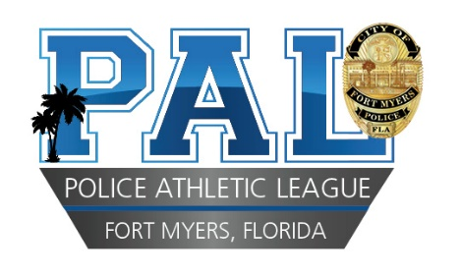
P.O. Box 1236, Fort Myers, Florida 33902
239-896-7191 *dwhite@fmpolice.com *
Website: fortmyerpal.net
REQUEST FOR MEMBERSHIP
NAME:
DATE OF BIRTH: AGE:
CAREER GOAL:

SCHOOL:
GRADE:
HOME ADDRESS:
CITY: STATE: ZIP:
YOUTH PHONE #: PARENT PHONE#:
PAL PROGRAM NAME: Leadership COMMUNITY HOURS:
SHIRT SIZE: Y SMALL: YMEDIUM: SMALL: MEDIUM: LARGE: XLARGE: XXLARGE:
MEDICAL PROBLEMS:

THIS REQUEST IS ACCEPTED WITH THE UNDERSTANDING THAT THE CITY OF FORT MYERS, LEE COUNTY, THE FORT MYERS POLICE DEPARTMENT, THE FORT MYERS POLICE ATHLETIC LEAGUE, ITS AGENTS OR ITS EMPLOYEES WILL NOT BE LIABLE FOR INJURY SUSTAINED IN TRANSIT TO OR FROM ANY PAL FUNCTION, OR AS A RESULT OF PARTICIPATION IN ANY PAL ACTIVITY. INABILITY TO CONFORM TO THE RULES AND REGULATIONS OF PAL ON ANY PART OF THE MEMBER WILL RESULT IN THE NOTIFICATION OF THE FRACTION TO THE PARENT OR GUARDIAN. PAL RESERVES THE RIGHT TO DISMISS ANY MEMBER FOR JUST CAUSE.

_ ____________________________________________________________
Print Parent / Guardian Name

_____________________________________________________________ ___________________________
Parent / Guardian Signature Date

IN CASE OF AN EMERGENCY, IF UNABLE TO BE CONTACTED, I AUTHORIZE THE FORT MYERS POLICE ATHLETIC LEAGUE TO AUTHORIZE EMERGENCY FOR THE CHILD LISTED ON THIS APPLICATION.

EMERGENCY CONTACT NAME: ________________________________________________________________________________________________________________________

EMERGENCY CONTACT ADDRESS: _____________________________________________________________________________________________________________________

EMERGENCY CONTACT PHONE NUMBER: _______________________________________________________ CELL: ______________________________________________

___________________________________
Parent / Guardian Signature

