African Marathon Challenge 2019
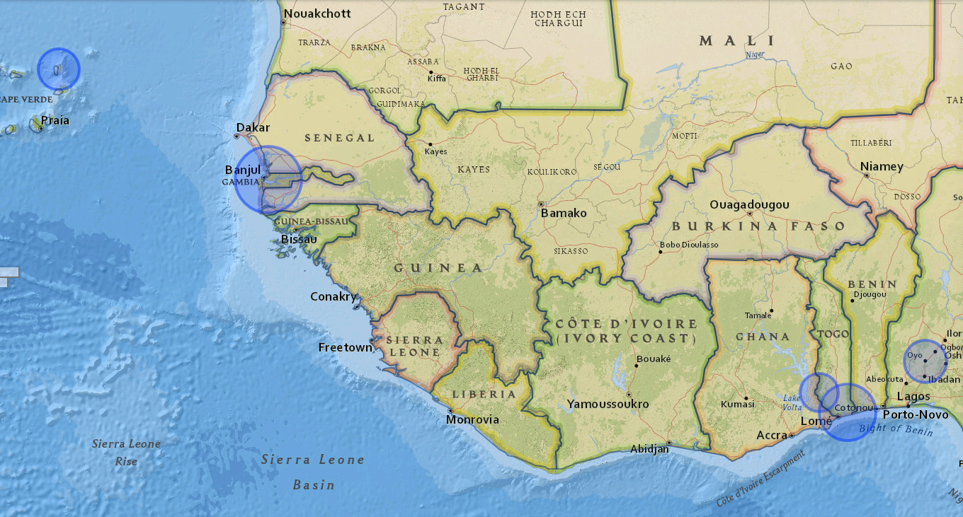

2019 Edition of IHM: German machine wins even after being hit by a motorbike

by Adedayo Akinbode
published on fogadventures.com
2019-01-18
─

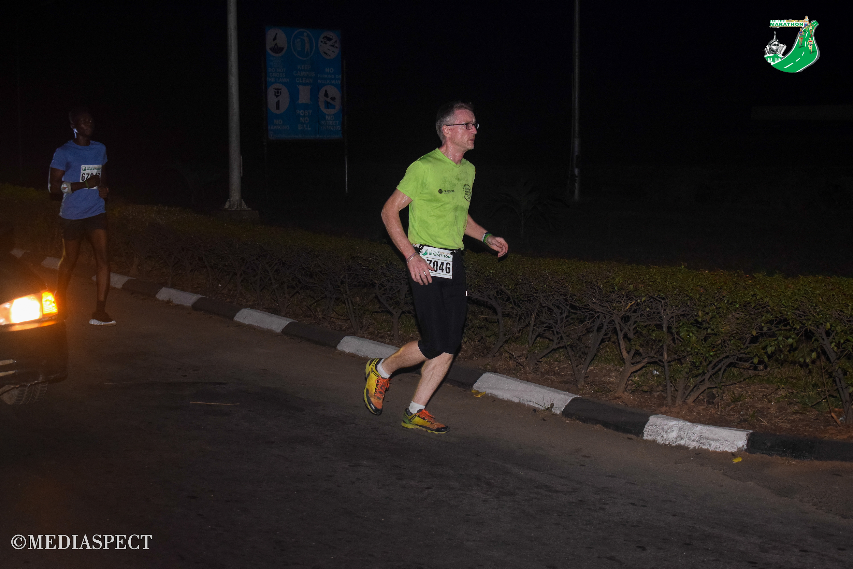
The Race Director of several marathons in Africa and Germany, Christof led the pack of 50 runners from start to finish. I first saw him leading close to the five Kilometer mark closely followed by 48 year old Mr. Wellington a Zimbabwean runner.
The gap between the two lead runners widened as they progressed and Christof gathered more momentum contrary to my assumption that he would soon burn out.

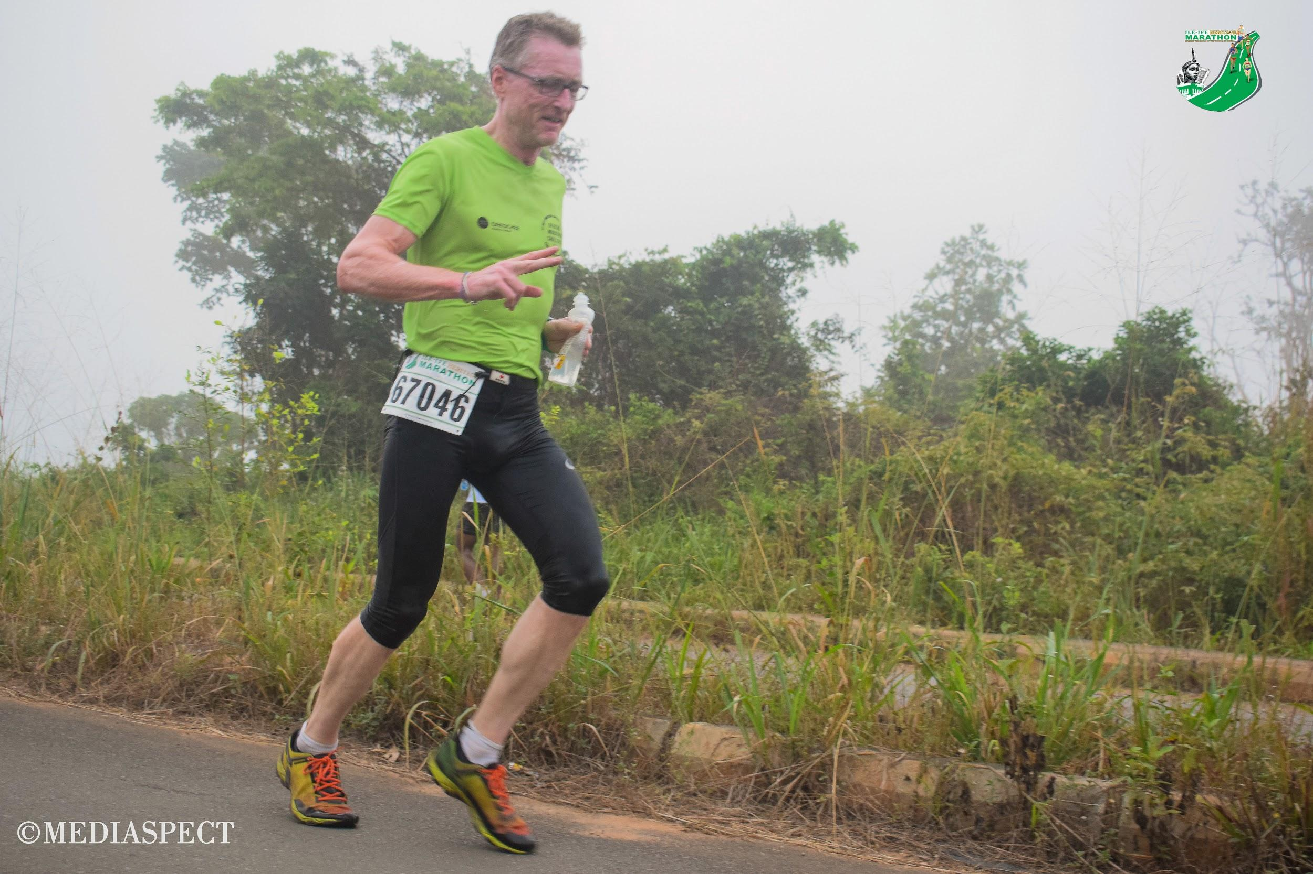

No other runner was in sight by the time Christof was sighted at Kilometer 21. He was running with the lead motor bike ahead of him and the ambulance beside him. That was when it first crossed my mind that he might win.

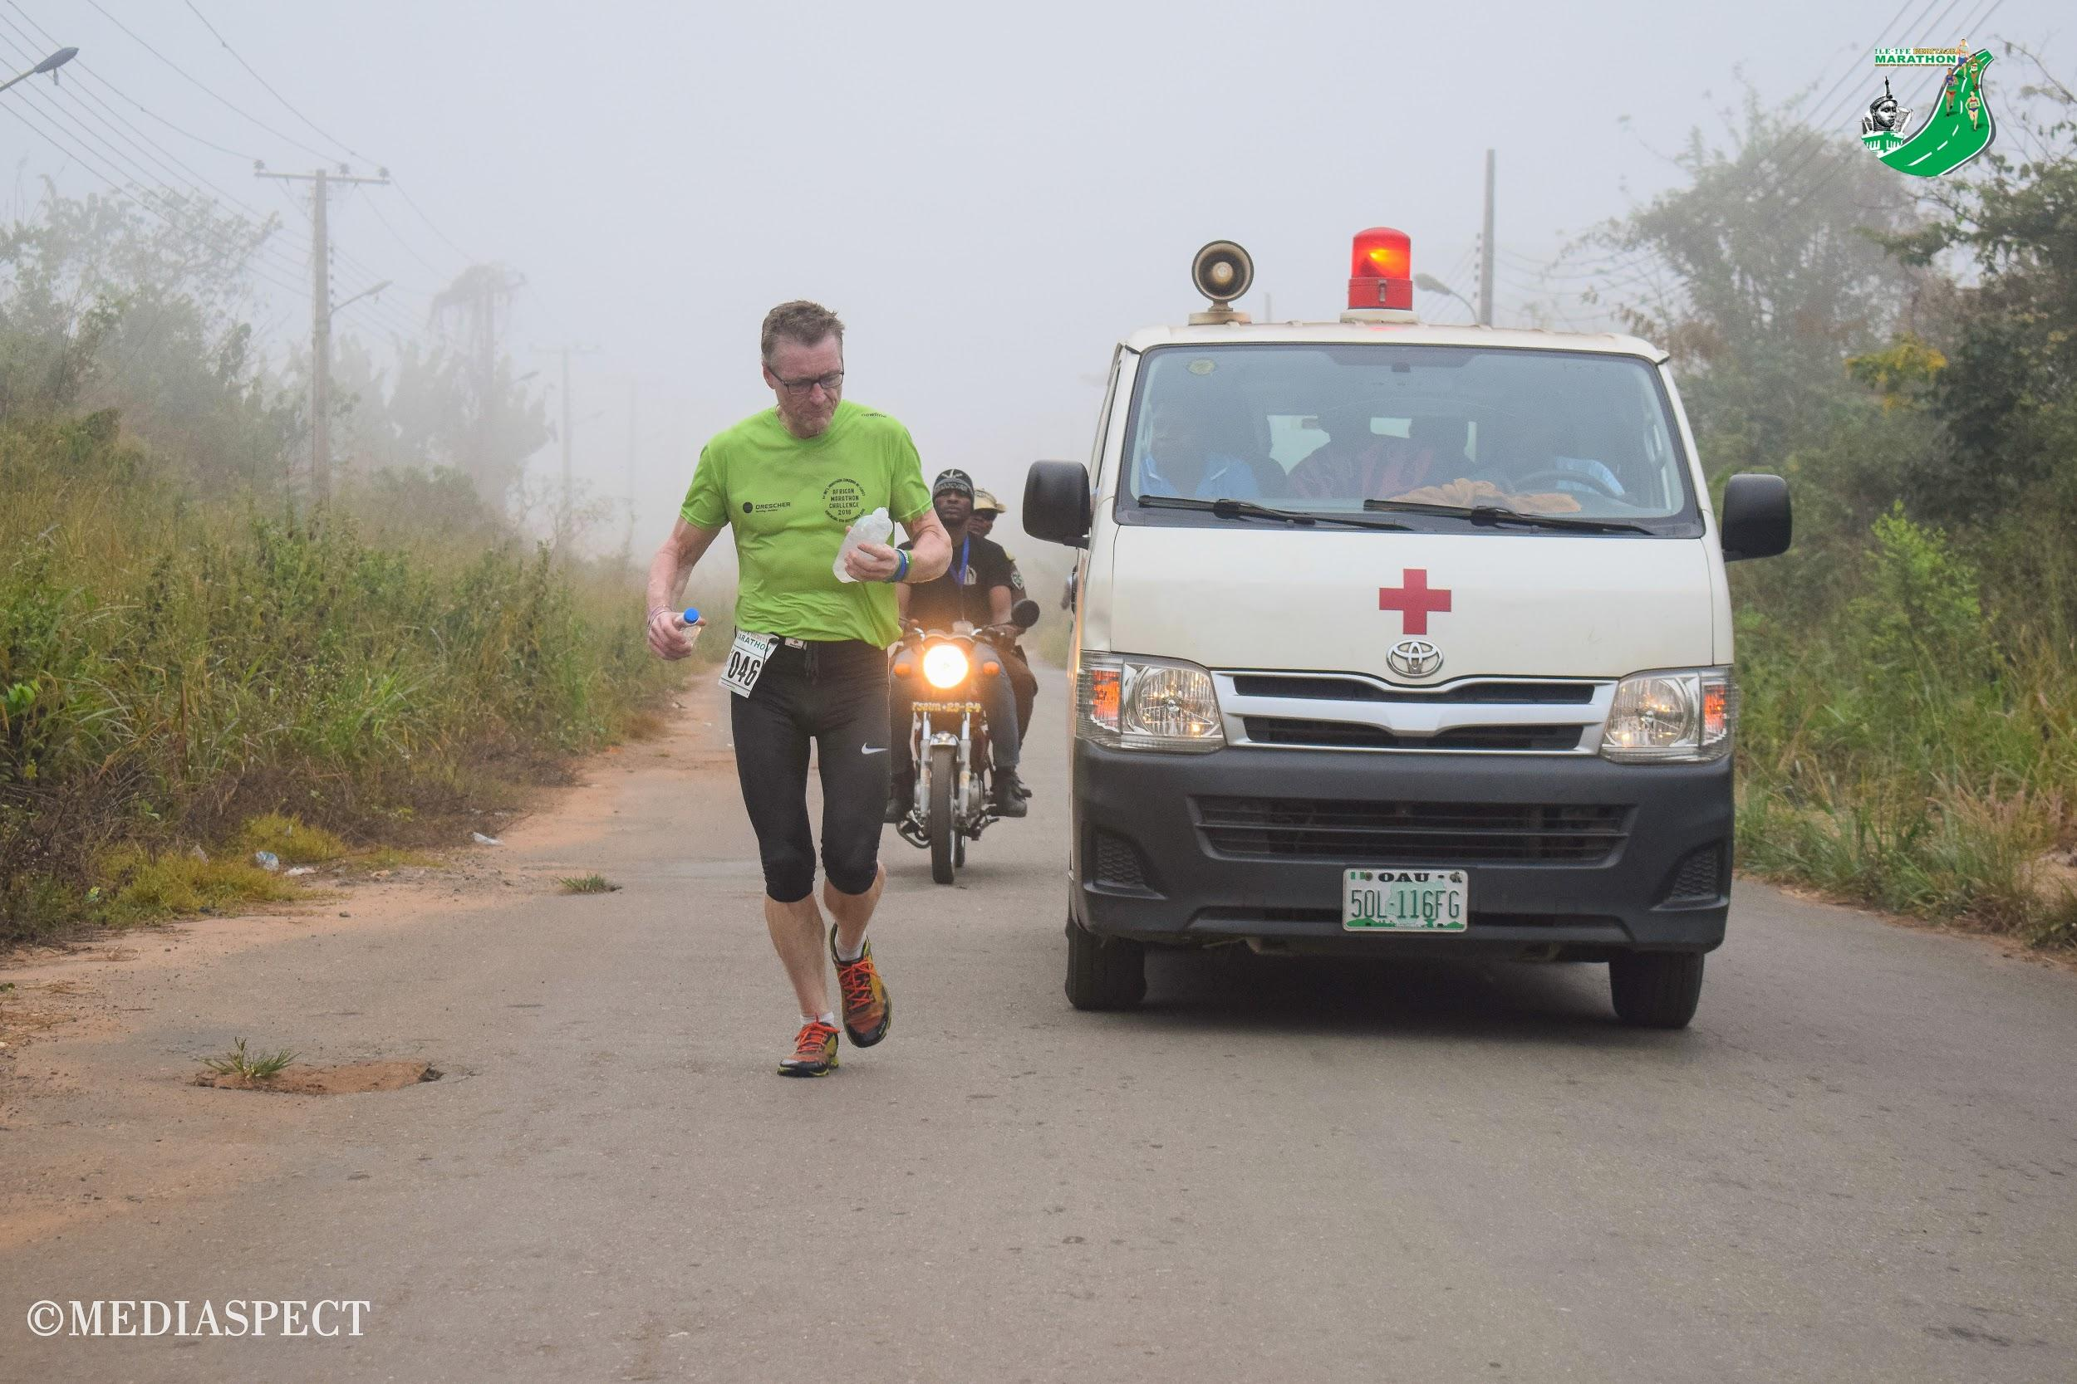

Fast forward to the finish line, he came in as strong as a horse and we only saw he was hurt when the Red Cross took him to the Medical Tent for a massage and ice wash down.
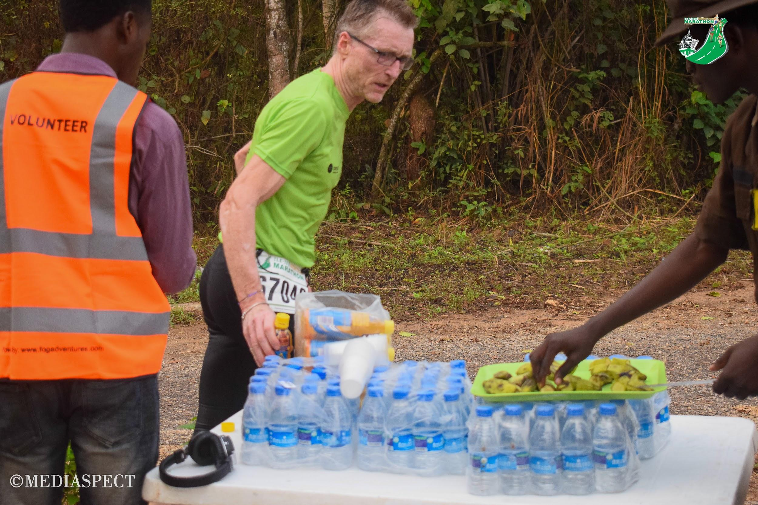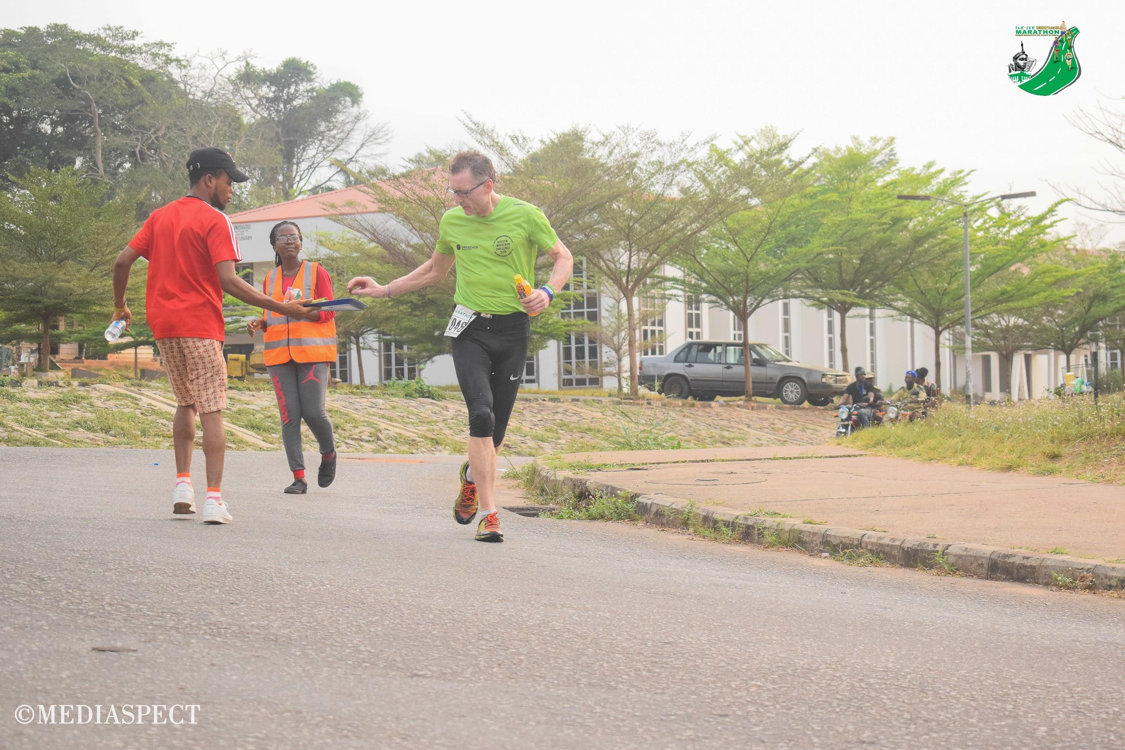

Christof had been hit from behind by a commercial motor bike as he was coming out of the Obafemi Awolowo University Gate at Kilometer 37.2. He had picked himself up and continued running with the bruises he sustained while the Road Safety Officials on the road were dealing with the man who had hit Christof with a motor bike.

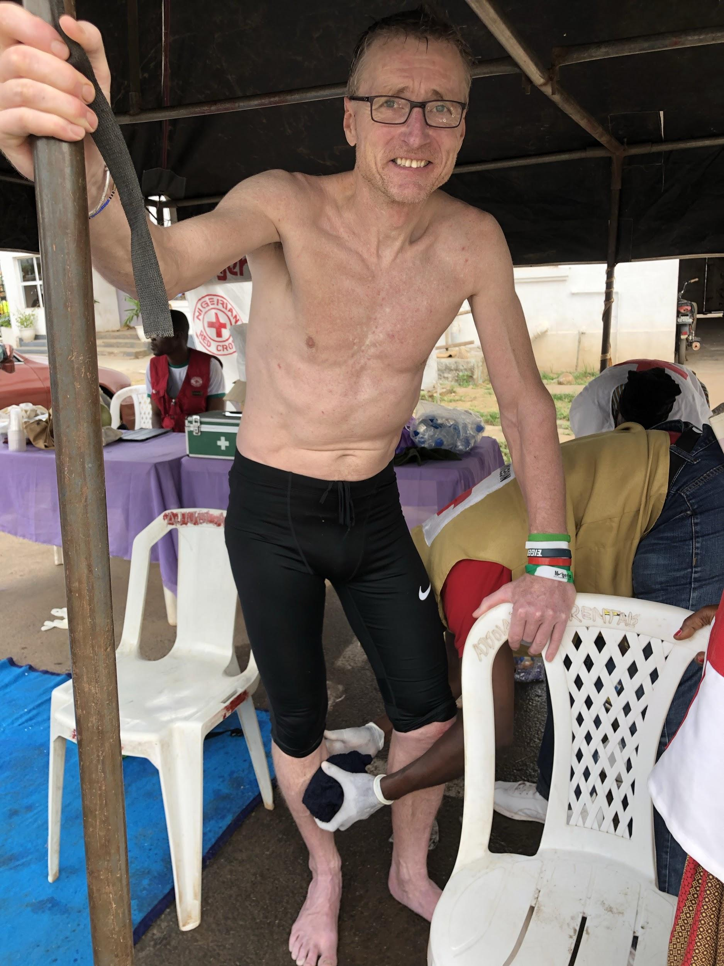
He didn’t know how hurt he was until he tried to sit and let out a loud scream. We could all see the muscles in his legs vibrating. Doctors and physiotherapists were on ground to arrest the situation....salt, massage, ice. He couldn’t sit and he couldn’t lie down. He was in pain and I heard someone whisper that he was going into a state of shock as he continually shivered in the African heat.
Then he requested for a bottle of chilled beer which the medics didn’t want to give him. But an elderly female member of the Nigerian Red Cross promptly got him a bottle of beer and he began to calm down.

He was up and about before the other runners started arriving. He later told me he hadn’t run that fast in a while and didn’t know what got over him. “I will never run that fast again” says Christof who came in at 3 hours 42 minutes and 32 seconds.

We however later got to know what got over Christof on the race course. The King said to him as he knelt to get his prize
“I knew you will win when you were introduced to me yesterday”
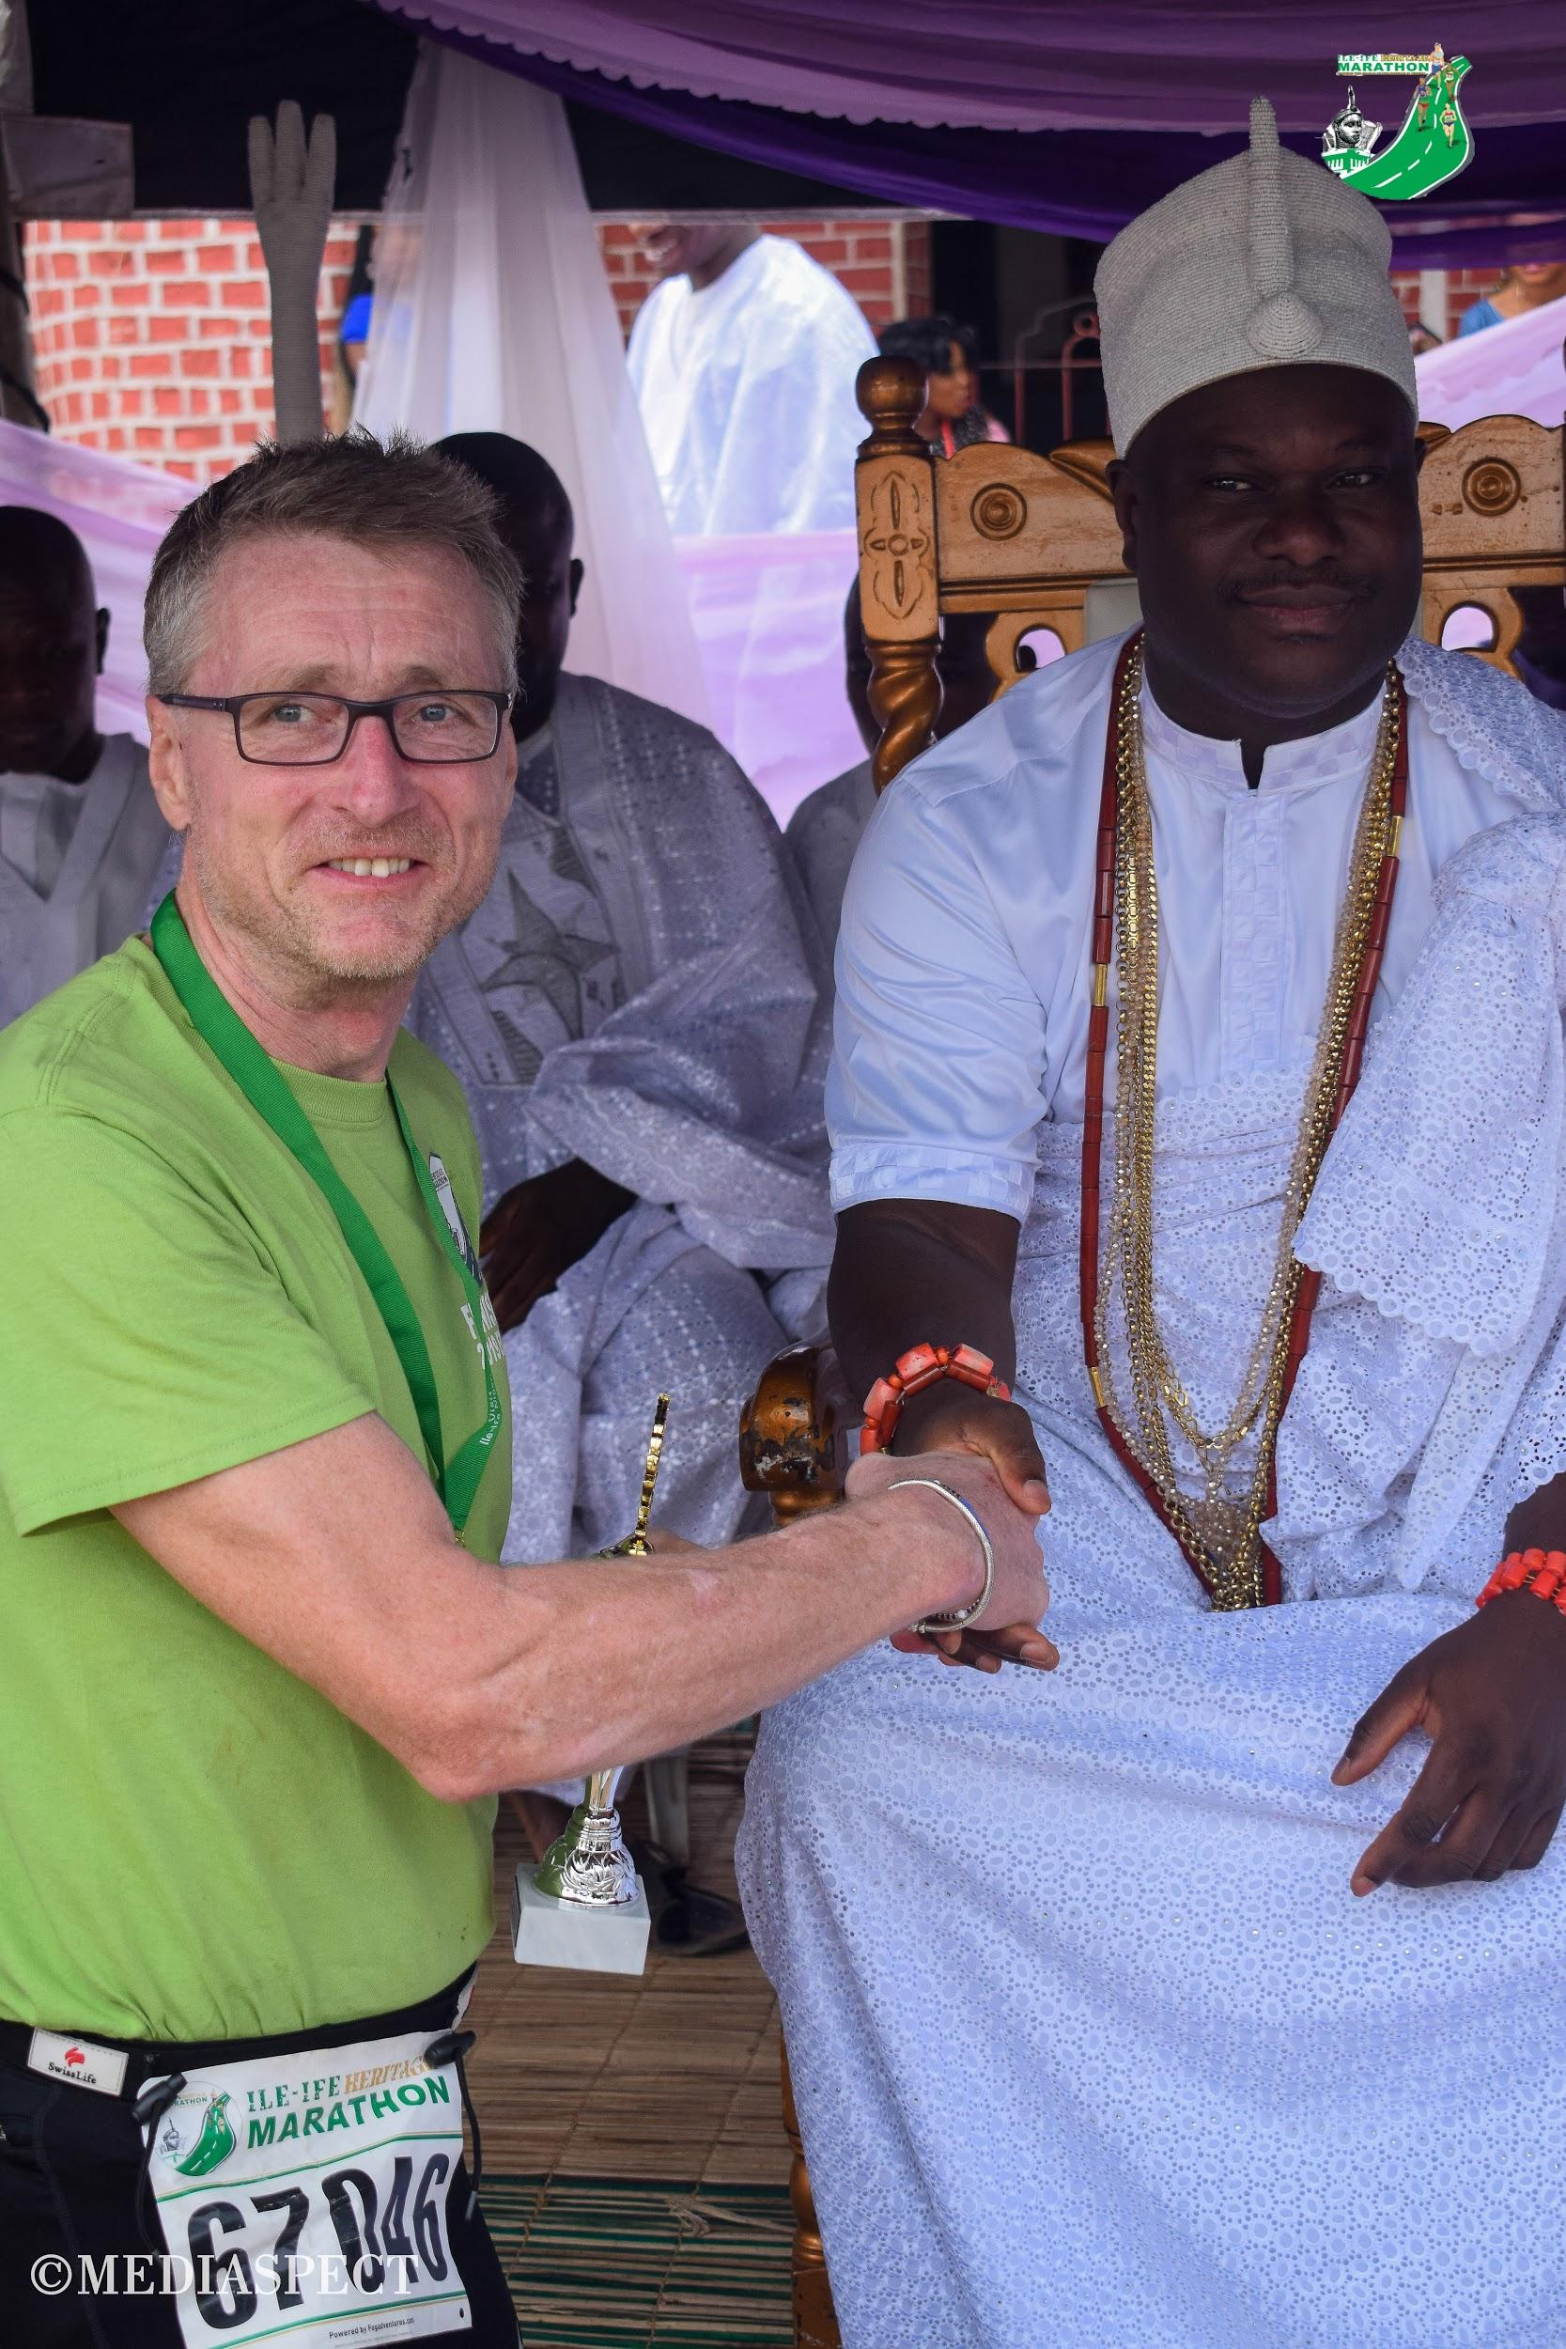
So it was the King’s Royal wish and knowledge that pushed Christof out of his comfort zone to a Podium finish!

Christof may be considered a co-founder of the Ile-Ife Heritage Marathon. He was critical in helping bring the race to reality. There is a strong internal connection between IHM and his African Marathon Challenge. He has provided valuable time, energy, and technical expertise that has supported the Ile-Ife Heritage Marathon.
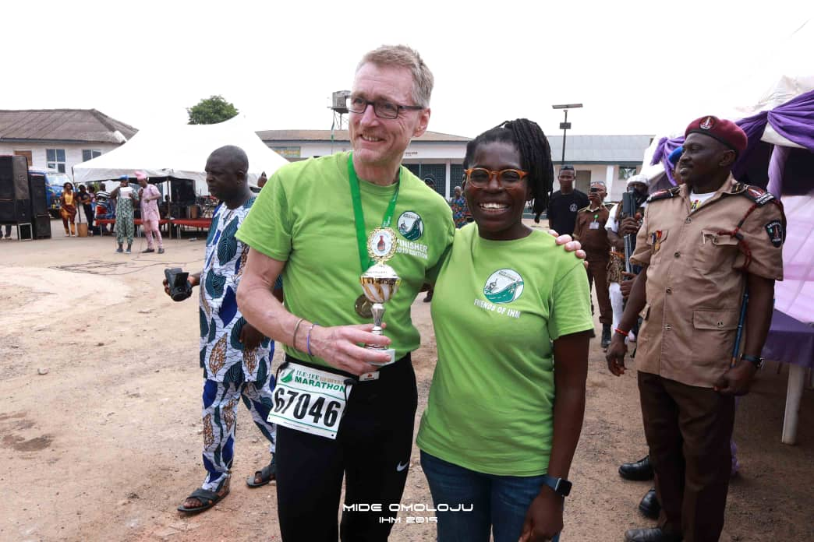

In the next days in The Gambia you could only meet Christof with this winners smile on his face. He proudly wore his Ife Finisher medal without a break until the next marathon.

By Adedayo Akinbode, Race Director, Ile-Ife Heritage Marathon

African Marathon Challenge 2019
2019-02-03 Ile-Ife Heritage Marathon, Nigeria
2019-02-07 Smiling Coast Int'l Marathon, Serrekunda, Gambia
2019-02-09 Smiling Villages Int'l Marathon, Bwiam, Gambia
2019-02-28 Marathon des Royaumes, Aného, Togo
2019-03-02 Marathon Int'l du Togo, Lomé, Togo
2019-03-05 Trail-Marathon des Papillons, Kpalime, Togo
2019-09-26 Marathon Bwejuu-Makunduchi, Zanzibar
2019-09-29 Marathon Zanzibar North-East-Coast

