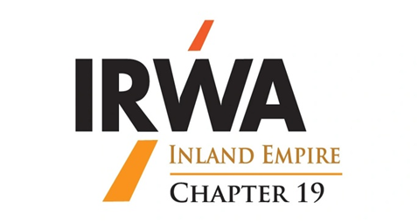

**Fall Forum**

**October 8, 2021**

**Northern Quest Resort & Casino**

**100 N. Hayford Road,**

**Room Rates**

**$135.00/Thursday**

**$189.00/Friday**

Call 509-481-6000 to reserve your room.

Use reference code 26135.

**Airway Heights, WA 99001**



**In Person**

***Virtual Meeting Available***

***Thursday, October 7th — Social Event – No-Host Bar***

# Friday, October 8th — Region Forum - Dinner

***Registration – $150.00***

***Location of Social & Dinner - To Be Determined***

IMPORTANT: We are currently planning an in-person meeting. Depending on COVID restrictions this may change. If we have to cancel the in-person meeting, you will be notified in advance and the meeting will be switched entirely to virtual. Registration fees will be returned if the in-person meeting is cancelled (all checks for registration will be held and not deposited until certainty of the

in-person event). Make your reservations today if you are comfortable in a group setting.

Registration: Submit registration payment of $150 payable to Chapter 19.

Name: ______________________________ Phone: ____________________________

Address: ____________________________ City: _______________ Zip: ___________

Email:__________________________ Company: ______________________________

***For Event Re gi stra tion contact: Teresa Weaver, SR/WA at HDR, 835 N. Post Street, Spokane, WA 99201 or email to teresa.weaver@hdrinc.com, Mobile: (509) 216-0134***