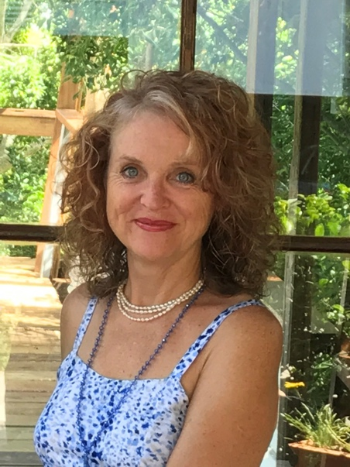

ANNIE O’MOON-BROWNING BIODATA:
Annie O’Moon-Browning is a Practitioner, Counsellor, Whole food Nutritionist, Yoga teacher, Lecturer and Author. I have practiced Natural Medicine in Brisbane for the past 35 years and passionate about Women’s Healthy hormones and great gut health.
My work as a health care professional focuses in bringing my clients to physical and emotional balance and vibrant wellbeing.
I take pride and a personal interest in the progress of each of my clients and encourage you on their pathway to better health.
My approach to health, incorporates a holistic and yogic way of interpreting data, which includes biological understanding of the body as well as the psychological, mental and emotional aspects.
I offer individual programs that are tailored to suit your special needs. Each client receives written info as a powerful informative tool for self-awareness and healing.
I have helped over 30,000 people over 35 years in my clinic as a skilled and dedicated practitioner of Natural Medicine. Regular workshops and retreats ar held throughout S-E Queensland and Bali.

