MEDIA ADVISORY
MO-KAN Border Bonanza Offers: Total Arabian Interaction and Learning Program (T.A.I.L.) for Children and Families

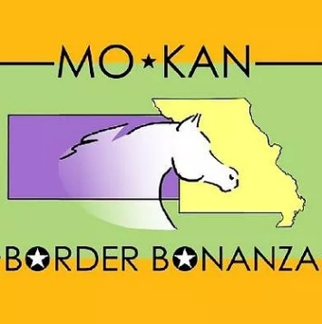
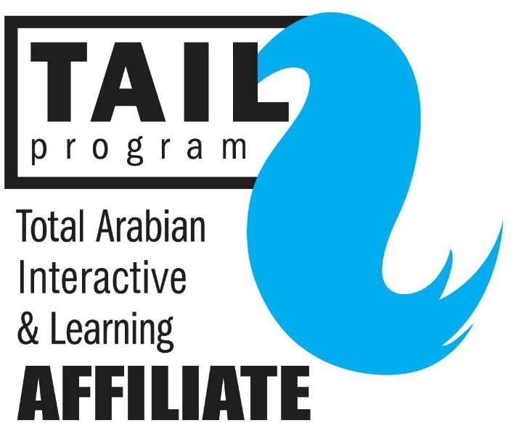
(11-April-18) − SEDALIA, MO. – The
MO-KAN Border Bonanza Arabian & Half-Arabian Horse Show will be returning to Sedalia April 27-29, 2018 at the Missouri State Fair Grounds and will offer the Total Arabian Interaction and Learning (T.A.I.L) program to two special groups of youth to learn more about the horses exhibiting at the show.

The T.A.I.L program gives adults and children the opportunity to learn more about the Arabian breed from educated volunteers. The tours create a welcoming experience at the show and encourage people to enjoy the horses. A friendly T.A.I.L. Guide will greet tour participants at the Youth Center building on the Fair Grounds, then they will watch a few classes of the show, see behind-the-scenes action at the horse barns, and even get to meet a friendly Arabian horse or two. Participants will receive a “T.A.I.L.” bag filled with information about Arabian horses, including coloring pages, parts of the horse sheets, and other educational material.

The first tour, beginning at 1 p.m. Friday, April 27 will be for children of deployed parents from the Whiteman Air Force Base. On Saturday, April 28 at 1 p.m. children from the Show-Me Christian Youth Home will get to take the T.A.I.L. Tour.

Sedalia families and youth are welcome to come watch the show for free all-day Friday, April 27 through Sunday, April 29 in the Coliseum at the Missouri State Fairgrounds. Food vendors will be serving breakfast and lunch on the grounds. For more information, download the show’s informational “Premium Book” at https://www.ekaha.org/mo-kan-border-bonanza

For everyone not taking a T.A.I.L. Tour this year, there’s the chance to meet-and-greet an Arabian Horse and his owner during the Third Thursday in Downtown Sedalia on April 19 from 5 – 7 p.m., weather permitting. Hez Rock Solid is a 13-year-old purebred Arabian gelding retired from a show career in reining. His owner Callie Filetti and representatives from the MO-KAN Border Bonanza show will available for questions and answers.

The Kansas City Arabian Horse Association and the Eastern Kansas Arabian Horse Association, co-presenters of the show, worked with Carolyn Crocker, Executive Director of the Sedalia Area Convention & Visitors Bureau, to schedule the tours for these groups. Adult civic groups and youth group leaders interested in scheduling 2019 T.A.I.L. Tours in 2019 should contact Crocker at 660-827-5295.

The MO-KAN Border Bonanza is an annual horse show where Arabian and half-Arabian horses, their handlers and riders can compete and earn points toward the Arabian Horse Association’s regional championship shows in Denver, Colo. and Springfield, Ill. later this summer. These versatile horses will be competing in numerous divisions, including halter, hunter pleasure, English pleasure, Western pleasure, driving, sidesaddle, Arabian Native Costume, equitation and more.
CONTACT INFORMATION
Eastern Kansas Arabian Horse Association - T.A.I.L. Program Coordinator
Eileen McCaulley
303.696.4500 / eihamer@yahoo.com

