Contents
Preface 2
Introduction 4
The Keys to Making High-Scoring Plays 5
Using multiplier squares (DL, TL, DW, TW) to get multiplied score for high and medium valued letters. 5
Making Multiple Words in a Single Play 7
Building on valuable tiles already on the board 12
Bingo (Using all 7 letters at once). 14
Other factors 15
Maintain a good balance of letters 15
Play to the score 16
End of game considerations 16
Play defensively 16
A brief survey of the letters 16
The blank tiles 16
The vowels 16
The powerful scoring consonants, X, M and H 17
The Limited 2-letter word makers — C, K, V, J, Q and Z 17
Other letters 18
Making your play 19
Survey your rack 19
Search the board for opportunities 19
Find the best play to take advantage of each opportunity. 20
Compare alternatives and make a tentative choice of plays. 21
Evaluate defensive position after your tentative choice, and reexamine alternatives if needed. 21
Defense 23
Rules of Thumb -- Summary 26

Preface
There is no clear established standard for what methods are legitimate, and what constitutes “cheating” in Words with Friends.
I take a fairly old-fashioned, conservative approach. I consider that the use of any tool that does word searches, evaluates how good a word is, or in any way helps you to find a good word to play is off-limits; what I consider cheating. However, I do consider it fair game to try something that I think MAY be a word, and I will do this repeatedly in search of a high-scoring play.
I also do not approve of some of the features that the WWF has added to make the game “friendlier”. For example, I see that there is an option to Swap tiles without losing your turn. I never do this. When I swap tiles, I always lose my turn. I don’t take advantage of any of the helpful features that require “coins”. I certainly would never pay for coins, and I don’t even use the free ones that I have “earned”. I am pretty sure that many opponents that I play against utilize some of these features; yet I win an overwhelming amount of the time. Note: These features can be accessed by clicking on the button with 3 horizontal lines, found to the left of your rack of letters.
I think the use of the built-in dictionary is ok, and also the “Word Strength Meter” which as far as I can tell only tells you whether tiles you have tentatively put on the board constitute a legitimate word or words. So it’s a time saver; otherwise I’d make repeated use of the dictionary, or try to make plays that turn out not to be legitimate. I only learned very recently that this was even an option.
Another feature that I do think is legitimate is “The Bag”, which tells you how many of each letter remains. This includes not only those in the bag, but also those on your opponent’s rack. This can be very helpful defensively, when you are contemplating a play that would leave a major offensive opening for your opponent, and you want to know whether the opponent might have the letters to take advantage of that opening.
The reason that I think this is legitimate is that it is something you could figure out on your own. You know how many of each letter there were at the start of the game. Subtract from this the number of each letter already in play, and the number on your rack, and that will give you the same result. So using “The Bag” is simply a shortcut for something (rather tedious) that you could do by yourself.
Important to note that if you do this toward the end of the game, when there are no letters remaining in the bag, the result will tell you exactly what letters your opponent is holding. I did this a few times early on in a very close game, before “The Bag” tool was introduced. But I stopped… it was just too much trouble.
Anyway, these are just my standards. Since there are no established rules, do whatever you’re comfortable with.
I am quite confident that for the vast majority of players, following the guidance provided in this book will improve your game far more than any of the methods described above, whether you consider them cheating or not.
Finally, I must admit that if you follow the guidance provided in this book, AND use features such as Swap without losing your turn, or any of various word search tools, you will have a definite advantage over me, and will be a favorite to win.

Introduction

Winning at Words With Friends or the online version of Scrabble does NOT require a strong vocabulary. Rather, it much more of a tactical game, where management of your tiles is much more important. The reason that vocabulary is of secondary importance is that there is no penalty for trying a high-scoring combination that turns out to be a non-word. The preview feature(Word Strength Meter) tells you when your intended play is not a word, and even if you insist on trying to play it, you are informed that it is not a word, and you get to take your tiles back without penalty, to try again. Where there is a good opening on the board, you may make repeated tries to take advantage of the opportunity, and sometimes you get lucky and find some combination that turns out to be a valid word. This feature is much different from the old-fashioned Scrabble board game where play of a non-word could be challenged, resulting in the loss of your turn. So having a strong vocabulary, knowing words from non-words was a critical factor for success.
In the on-line games, the main advantage of a strong vocabulary is in knowing unusual words, that the average player would not even attempt to play.
In my experience, most players make very costly tactical mistakes, even though many come up with incredible words, often making me suspect that they are using a word finder tool.
This book will give you specific advice on tile management tactics, both on offense and defense, greatly improving the results of most players.
In this book, I will talk only about WWF, although most of the advice applies to on-line Scrabble as well. There are minor differences in letter distribution and point values, and most significantly the Scrabble board layout is less friendly to high-scoring plays. The Triple Word tiles are less accessible in Scrabble, Triple Word/Triple Letter combinations are non-existent (the easiest path to 100+ point plays in WWF). However, Scrabble awards a higher bonus for a bingo, 50 versus 35 in WWF.
For reference, the following table shows the point value of each letter, and the number of copies of each.
 | A | B | C | D | E | F | G | H | I | J | K | L | M | N | O | P | Q | R | S | T | U | V | W | X | Y | Z | blank
Value | 1 | 4 | 4 | 2 | 1 | 4 | 3 | 3 | 1 | 10 | 5 | 2 | 4 | 2 | 1 | 4 | 10 | 1 | 1 | 1 | 2 | 5 | 4 | 8 | 3 | 10 | 0
# in Bag | 9 | 2 | 2 | 5 | 13 | 2 | 3 | 4 | 8 | 1 | 1 | 4 | 2 | 5 | 8 | 2 | 1 | 6 | 5 | 7 | 4 | 2 | 2 | 1 | 2 | 1 | 2

In referring to the tiles, I talk about them in three categories, according to value:
High value(8-10) J, Q, X, Z
Medium Value(3-5) B, C, F, G, H, K, M, P, V, W, Y
Low Value(1-2) Vowels A, E, I, O, U; Consonants D, L, N, R, T
The blank tiles, and the letter S tiles are special cases, and are treated separately.

The Keys to Making High-Scoring Plays
I’ll look at four critical factors that go into high-scoring plays, with examples of each:
- Using multiplier squares (DL, TL, DW, TW) to get multiplied score for high and medium valued letters.
- Making multiple words in a single play.
- Building on high and medium valued letters already in play.
- Making a Bingo. (Using all 7 letters.)

Using multiplier squares (DL, TL, DW, TW) to get multiplied score for high and medium valued letters.

At a basic level, everyone who plays the game understands the desirability of using multiplier squares to make a higher score. What is not so well understood however is that you should tend to play high and medium valued letters ONLY when you can get multiplied value for them.
The reason for this is closely related to the concept of “Opportunity Cost” in Economics. In Economics, the idea is that when you spend money or utilize resources for some purpose, you are giving up the chance (the possible opportunity) to spend that money or use those resources for some better, e.g. more profitable purpose, in the future. Hence it can be treated as a cost for the lost opportunity.
In WWF, when you play a medium or high valued letter, getting only face value for it, you are giving up the chance in a future move to get double, triple, or even higher value for that letter. Of course, there are times when this is quite acceptable; specifically, when there is some other aspect of the word being considered that makes the overall play quite desirable. For example, imagine that you can make the word ZIP… the P gets only four points, but the Z lands on a TL making the whole word worth thirty-five points. This is clearly a case where you don’t mind getting only face value of four for the P. The Rule of Thumb that follows accounts for this situation.
In evaluating alternative plays, I often make an adjustment to the apparent score of a possible play. In general, this adjustment is a reduction in the apparent score, reflecting the loss of opportunity to use valuable tiles to better effect in a future move. So here is
Rule of Thumb Number 1.
When a possible play includes medium or high valued letters for which you are getting only face value, make a downward adjustment to the score, deducting the point value of these letters. If this adjusted score is still better than (not just equal to) any alternative, then its ok to make that play.
An example will clarify this rule of thumb. Let’s say that you have the letters to make the word PACT. Nicely, the C falls on a TL square, so the C is worth 12 instead of the 4 face value. However, the other letters all score at face value, and the total apparent score for this word is 18. Since you are getting only face value for the P, deduct 4 points, for an adjusted score of 14. So do not make this play. You can clearly make 14 points by playing ACT, or maybe you can find something else even a little better (TACT?). You get to save the P for another day, when you hope to get double value or better for it.
This rule applies as well to the very first play of the game. If you can’t make a five-letter word, thereby reaching a DW square, don’t make any word that uses medium or high valued letters. For example, say the best you can do on opening move is to make the word BLOW for an apparent score of 11. Since the value of both the B and the W (4 points each) are face value only, the adjusted value of this proposed word is a mere 3. If push comes to shove, start the game off with LO, or likely you can find something a bit better, getting rid of other low value tiles in the process.
Here is an example from a real game: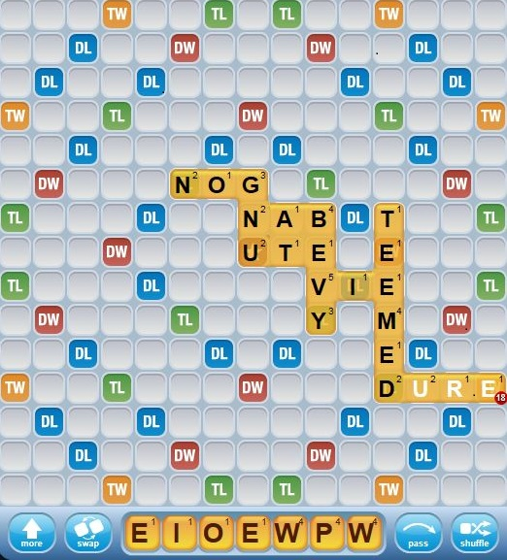
You might be tempted to play WIPE, with the W on a TL along the rightmost column, for a score of 18. But since the P is worth only face value, the adjusted score for this word is 14, so a better choice is to play WIRE or WORE in the adjacent column for 16 points; no adjustments. You save the P for a better opportunity.
Another perspective on this is the following: A typical game goes about 14-17 moves for each player. There are a total of 28 high and medium valued tiles. So on average, you will get about one such tile per move. They’re scarce enough that you really want to get maximum value from them.
When I see an opponent squandering good letters early in the game, I know that I am a strong odds-on favorite to win the game.

Making Multiple Words in a Single Play

This topic is every bit as important as the use of multiplier squares for achieving high scores. Simplifying somewhat, there are two techniques for making multiple words in a single play. When a medium or high value letter is used in two words, that is an alternate method for getting double value for that letter, so no point adjustment is needed. The two techniques:
- Add a single letter to the beginning or end of a word already on the board, and make a second word perpendicular to the first.
- Add one or more single touching letters adjacent to an existing word generally forming short words (2, 3 occasionally 4 or more letters) at the same time forming a new word parallel to the existing word.

We’ll look at these two techniques in detail. When you add a single letter to an existing word, you get credit for the existing word (without multipliers), plus the value of the added letter, and full value for the new word, including multipliers. If the added letter happens to be on a DW or TW square, you’ll get double or triple value for both words, and may be chalking up a huge score.
For adding to the end of an existing word, the letter S is not surprisingly the undisputed superstar. Most noun plurals, and the third-person form of verbs are formed by adding an S. Of short words, about 75% take an S at the end. Even many longer words take an S at the end; 40% of 7-letter words, and 35% of 8-letter words. The percentage continues to drop as the words get longer. Less obvious, S is also the leading letter to add to the beginning of short words, though not by the overwhelming margin as its role at the end of words. Because of this S is far more valuable that its face value of 1, and especially since it is somewhat rare, there being only 5 S letters in the bag.
Other than S, one-letter add-ons to the beginning or end of long words are very sparse. Only letter D as an add-on registers with about 3% of longer words taking a D added at the end (verbs ending in E).
Rule of Thumb Number 2
When a possible play includes the letter S, adjust its score by subtracting 10! If the result is still better than any alternative, its ok to make that play. Otherwise, find an alternative.
Of the other letters, E is a strong add-on to the end of shorter words especially. About one quarter of 2 and 3 letter words take an E to add at the end. But because E’s are so plentiful, no adjustment is needed.
For adding a letter to the beginning of a word, after the letter S, several other consonants share center stage, as add-ons to short words that begin with a vowel.
Here is a spectacular example of the use of an S tile, also featuring a TL/TW combination in the new word, and a good use of the blank tile.

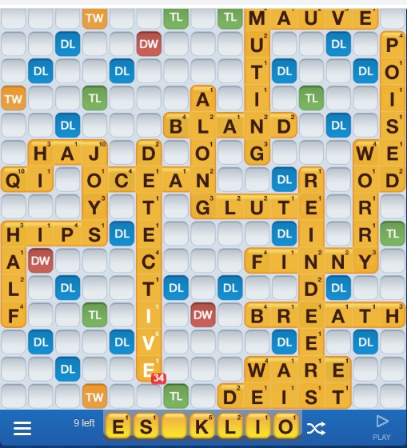
Add the S to DETECTIVE, and put the K on the TL. You might try making LESK, LISK or LOSK; but none of these turn out to be valid words. So use the blank tile to make DESK, a great use of the blank tile. But look again. Best yet, you can make a bingo with OBELISK, for a grand total of 116. This is why we save the S and the blank tile, although it’s very unusual to be rewarded quite this spectacularly.

Now let’s look at the other method of making multiple words at once, which I refer to as a parallel play, because a new word is created parallel to an existing word. This can be as simple as in the following example:
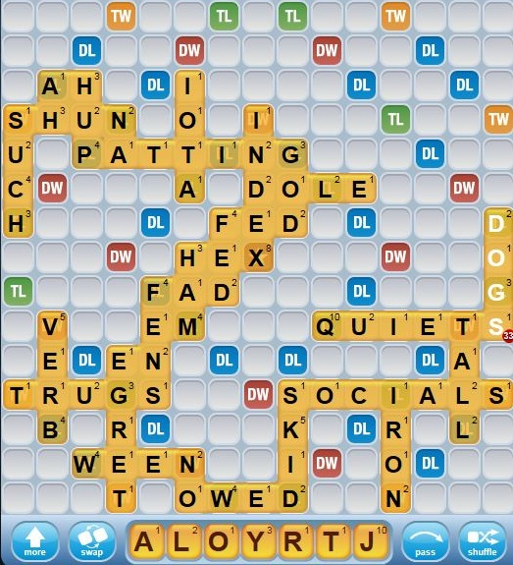
Here is a choice of parallel plays, next to DOGS. You could make JOY, with OD and YO, or you could make RAJ, with AD and JO. Clearly RAJ is better; not only does it score better, but it also preserves the medium valued Y for subsequent use.
This brings up an important point. It is essential to know all the two letter words, because parallel plays are so often built on 2 letter words.
Rule of Thumb Number 3
Memorize all two letter words, and look for parallel play opportunities that use them.
This is a bit tricky, as the powers that be keep adding additional words. Since I’ve been playing, VU, JE, JA have been added, and most recently OO. These are foreign words, and the reason for adding them seems completely arbitrary.
Its good to know the 3 letter words as well, although you can often find these thru trial and error, or begin to learn more of them as you gain experience playing the game.
Here is another example of a parallel play:
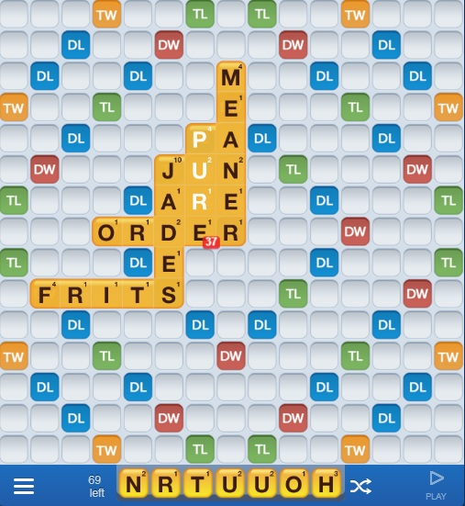
Maybe nothing jumps out at you right away. I couldn’t find a six letter word starting with the I in FRITS. Other DW and TW squares seem out of reach. But looking around for parallel plays, I found TURN, parallel to MEANER, also making MU, ER and PAN, for a respectable score of 24.
Clearly the two methods described above are a simplification of the myriad ways to build multiple words in a single move. Most of the more complex plays are some composite of these two methods.
Really big scores can occur when you are able to make a play that utilizes multiplier squares, and makes multiple words in a single move.
When only a single letter is attached to an existing word, and then a longer word is made as a parallel play, I often refer to the single letter as “a hook”. The main feature of the play was to make the long word, and the hook provided the means.

Building on valuable tiles already on the board
To a great extent, we’ve already seen good examples of this in combination with methods discussed in the previous sections. Here is one more example, showing that you can get a decent score, even when you have lots of low-value letters.
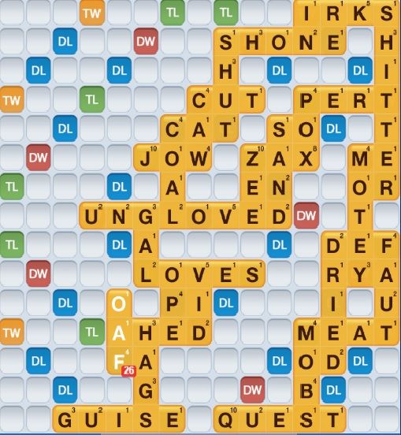
Sorry, neglected to show the rack of your tiles, but they were all low-value letters, including an N and an E. Make FANE, parallel to AHED, building on words with some good letters… making OPEN and VIDE as part of a parallel play, for a total score of 25.
Sometimes you can make a good score by lengthening an existing word with a prefix or suffix. Following is a good example of that method.
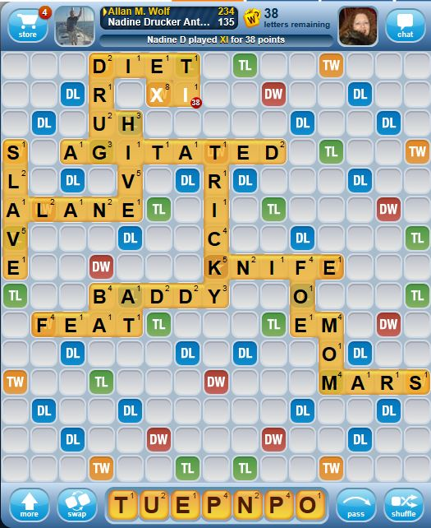
Make MOMENT, adding the ENT to MOM, and reaching a TW tile, for a tripled score of 39.

Rule of Thumb Number 4
Look for good opportunities to lengthen an existing word, especially when you hold common prefixes such re or de; or suffixes such as ING, ER, EST, or ABLE.

Bingo (Using all 7 letters at once).
The 35 point bonus for a Bingo will generally get you a score at least into the high 40’s, and frequently something much higher than that. So it’s worth seeking out. Of course, all of the discussion that follows assumes that you can find a place or places on the board where there is room for a long word, and someplace to hook on to.
Bingos generally involve making 7 or 8 letter words. Seven letters if you are able to use one of the techniques for making multiple words, or eight letters if you are using an old-fashioned crossword technique, utilizing one letter already on the board in combination with your seven.
There is no magic Rule of Thumb to help you out with this. Sometimes a Bingo just jumps out at you given your vocabulary and imagination. In this case, you have probably found your play, although it doesn’t hurt to look briefly for something even better, perhaps an alternative place to play the bingo.
But often, the process of finding a Bingo requires patience, trying many different combinations in the hope of finding something that clicks. The guidelines that follow will help you decide whether it is worth your time to do this work. So here are the factors that go into the likelihood of finding a bingo:
- Possession of the blank tile. Your chances of making a bingo are greatly improved when you have this tile.
- The letters S and E are very good. E appears in two-thirds of all 7 and 8 letter words. S appears in well over half. Additionally, as cited earlier, S is a great add-on letter, and E is a distant second-best. So these letters can be very helpful in finding a place on the board to play your bingo. Less than 20% of 7 and 8 letter words have neither an E nor an S.
- The letters A, I, and R are good too. Each of these appears in about half of all 7-8 letter words.
- You need a good mix of consonants and vowels. The vast majority of 7 and 8 letter words have 4 or 5 consonants. For 7 letter words, there are also some with only 3 consonants. For 8 letter words, there are also a fair number with 6 consonants. Outside of these numbers, words are extremely rare.
- You generally should not hold a high-valued consonant. Bingos including J, Q, X or Z are rare. Don’t give up, but the possibilities are very limited. If something doesn’t jump out at you right away, a bingo probably isn’t in the cards.
- You do want a good mix of medium-valued consonants. Most 7 and 8 letter words have 1 or 2 medium-valued consonants. Among the 8 letter words, 3 medium valued consonants are also fairly common. Although rare, four or five, even 6 such consonants are not unheard of. Anyone made a bingo out of HUMPBACK?
Words with a large number of medium-valued consonants often include consonant pairs that work well together, such as CH, CK, or MP. Finally, if your consonant collection includes the letter Y, it is one that we count as a consonant although it often functions as a vowel. Some consonant combinations are very awkward, and tend to rule out a Bingo. Maybe there’s a Bingo with the consonants K, V and W; but I can’t think of such a word.
- Prefixes and Suffixes are helpful. When you hold the letters for a common prefix or suffix, you may be well on your way to finding a Bingo, as now you may only need to find a base word of just 3, 4, 5 or 6 letters. Among prefixes, RE, DE, UN, IN and OUT are the most common. The suffixes are even better-- ED, ER, ERS, EST, ING and US. Words with these suffixes comprise some 28% of all 7 and 8 letter words

Other factors
Besides looking for the play with the highest adjusted score, several other factors enter into your choice of plays:

Maintain a good balance of letters
If your rack consists of all (or almost all) vowels or consonants, it is important to try to correct the imbalance. All vowels is the worst case scenario. With either all or mostly all vowels or all consonants, try to get rid of as many as possible, even if you must accept a slightly lower score. Playing 3 is good; 4 is even better, but extremely uncommon. Playing 2 is a judgement, depending on how good a word you can make with the 2. If you can shed only one, consider swapping.
When you start with at least two of each, vowels and consonants, try to retain at least one of each going forward. In addition, try to get rid of low-value letters for which you have multiple copies, especially three or more.
A similar situation occurs, though not as severe, when you have all low-value letters, even including some consonants. Here too, you want to get rid of them quickly, in the hopes of replacing them with more valuable tiles. This is kind of a corollary to the principle of wanting to retain higher valued tiles until you can get double or better value for them.
A typical situation is one where your best scoring play uses just one tile, maybe your only medium-valued tile, leaving you with all low-value letters going into the next round. In this case, consider an alternative that uses up several low-value tiles, even accepting a lower score. Otherwise, you will be faced with an ugly set of tiles on your next move.
Rule of Thumb Number 5
When faced with an extreme imbalance of letters, look for a play that uses as many of these letters as possible, even accepting a lower score than could otherwise be achieved. If all else fails, consider swapping. Never swap out medium or high valued consonants.
To prepare for a swap, this is a good time to consult “The Bag”. You should be inclined to swap out letters that have many copies still left in the bag, but retain letters that are scarce.

Play to the score
If you are far ahead in the game, play conservatively; avoid leaving easy openings that could enable your opponent to make a big score and catch up. Conversely, if you are far behind, take chances.

End of game considerations
Toward the end of the game, relax all rules related to adjusted score. You don’t want to be stuck with unused medium and high-valued tiles at the end of the game.

Play defensively
This is a very important consideration; the primary reason NOT to make what seems to be your best (most high scoring) play. A full section is devoted to defense later in the book.

A brief survey of the letters

The blank tiles
The blank tiles are the most valuable ones in the bag. Even though they hold no point value themselves, their total flexibility makes them extremely potent weapons. We have already said that possession of a blank tile greatly improves your chance of making a Bingo. Equally important, a blank tile often enables you to take full advantage of exceptional scoring opportunities, such as TL/TW combinations.
Rule of Thumb Number 6
When a possible play includes the use of a blank tile, adjust its score by subtracting 30! If the result is still better than any alternative, its ok to make that play. Otherwise, find an alternative.
Another way to say this is that your expectation in using a blank tile is that it will increase your score by 30 points more than you could get otherwise. Generally when using a blank tile, we want to be making 50+ point plays.
There is some flexibility in this rule, particularly when the intended play has some other importance, such as serving as a defensive move. Perhaps using the blank is the only way to block a TL/TW combination which would otherwise remain open for the opponent. In this case it’s alright to bend the 30 rule.

The vowels
With both the consonants and the vowels, I categorize them according to their role in making 2-letter words, because 2-letter words are so important in making parallel plays.
A, O, and E are very strong in this regard. A appears in 27 2-letter words; O in 24, and E in 23. In each case, at least 10 times as the first letter, and at least 10 times as the second letter.
I is behind with 16 words—only 4 as the first letter. U appears in only 9 2-letter words. This is one reason why I and U are the least desirable vowels to have multiple copies of.

The powerful scoring consonants, X, M and H
These consonants are in a special category because of their combination of high or medium letter value, and their frequency of appearance in 2-letter words. X appears in 6 2-letter words, M in 12, and H in 10. Due to this characteristic, it is easy to use these letters in parallel plays to get at least double value for them. Although I will sometimes do it, I am disappointed to get only double value for these letters. If there is any reasonable alternative, I will take the alternative, and retain my X, M, or H hoping to get even better than double value in a future move.
Of the other medium-valued letters, B, F, P and Y are fairly strong in forming 2-letter words.

The Limited 2-letter word makers — C, K, V, J, Q and Z
C appears in no 2-letter words. (V was once in this category until VU became legitimate).
For the other letters-- K, V, J, Q and Z, there are only one or two (J now has three) 2-letter words, all beginning with that letter. There are no 2-letter words ending in K, V, J, Q or Z.
So this greatly limits the possibility of parallel plays building off of a 2-letter word involving one of these letters. However, since these are all medium and high-valued letters, when a parallel play becomes available using one of these letters, it can yield a huge score.
To illustrate, let me introduce my favorite girls, JOJO, QIQI and ZAZA, who can generate 60+ points in a play of just two letters. Here’s how ZAZA does it. Imagine a TL or TW square in front of the letter A. We play our Z there, and then make a second ZA as a parallel play, perhaps also making a 2-letter word beginning with A in the process. The Z has now become worth 60 points, first tripling its 10 value by virtue of the TL or TW tile, and then doubling that by virtue of appearing in two words. JOJO and QIQI can pull a similar trick. Actually, with the introduction of JE as a legitimate word, we must also include JOJO’s French cousins in the party… JEJE, JOJE and JEJO. It’s hard to keep up with the additions. JA is now legitimate as well, so the Dutch cousins are now in the mix… JAJA, JOJA, and JAJO. And of course there are also the French-Dutch second cousins, JAJE and JEJA.
These letters also have a blocking value, preventing your opponent from making a lucrative parallel play. C is a perfect blocker, as you can’t make a 2-letter word by adding a letter before or after the C. The other letters in this category are half blockers—they only block a letter in front of them, not behind. Here is an example of the use of a Z to make a decent word, but also serve as a blocker:
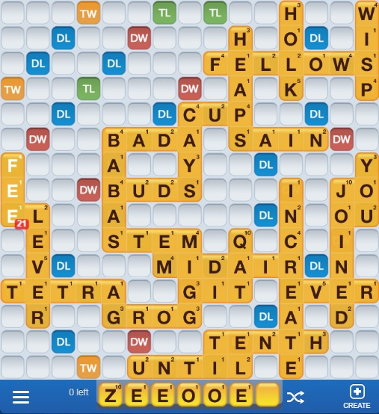
By playing ZEE, a parallel play hooking on FE, you make a decent score with a not especially attractive rack of letters. And the placement of the Z blocks the opponent’s access to the TW via a parallel play, since no 2-letter words end in Z.
Incidentally, don’t worry a great deal about getting or retaining the letter U to go with your Q. The vast majority of Q plays are with the words QI, QIS, QAT and QATS.

Other letters
We’ve already talked about the importance and value of the letter S. Of the other letters, I have nothing noteworthy to say.

Making your play
Now we put it all together: How do you actually go about finding your best play? Note that I don’t say “your best word”. We have already seen many reasons your highest scoring play may not be the best. The approach I use to search for the best play is opportunity based… You search the board for the best scoring opportunities, and then try to build a play that takes maximum advantage of each opportunity.
I’ll describe the process in several steps:
- Survey your rack.
- Search the board for opportunities.
- Find the best play to take advantage of each opportunity.
- Compare alternatives and make a tentative choice of plays.
- Evaluate defensive position after your tentative choice, and reexamine alternatives if needed.

Survey your rack
This step is to form an overall impression of your rack.
Do you hold a blank tile? Do you hold the letter S? What high-value and medium-value tiles do you have? Do you have a good balance of consonants and vowels? Can you form any common prefixes or suffixes? Is your set of letters conducive to looking for a possible Bingo?
AT THIS POINT, DO NOT SPEND TIME SHUFFLING YOUR TILES AROUND, TRYING TO MAKE WORDS.

Search the board for opportunities
As the game progresses, much of the board will be familiar, and the opportunities (or lack thereof) seen in previous turns will still be there. So you will be able to focus most of your attention on your opponent’s last move, to see if that opened up some new opportunities for you. Still, it’s a good idea to give the whole board a look-over now and again.
As you identify each potential opportunity, look back at your rack if needed, to see if you have the critical letters that may enable you to exploit the opportunity. As you find opportunities, you can cycle back and forth between steps 2 and 3.
- The fantastic opportunities
The TL/TW combination requires only a four letter word, and there are 16 places on the board where this play can be made. It is an extremely potent opportunity, the most common path to 100+ scores. Put a 10-point letter on the TL, and make a word that reaches the TW, and you’re likely there. This opportunity is super-rich if you’re able to play a medium or high scoring letter on the TL. If you’re really lucky, sometimes you can make a six letter word, and get a second TL into play.
A DW or TW tile at the end (or occasionally the beginning) of a word is very good, if you have a single letter that adds on to that word (saved that S?), and have room to make a second word perpendicular to the original. Now you get double or triple value for both words.
A TL or TW next to a vowel can be great, particularly if you have a high value letter that forms a word with that vowel (Remember JOJO and all her cousins?), and can make a second word with that high value letter as a parallel play. Medium value letters are also good for this purpose.
And of course there is the possibility of a Bingo.
- The very good opportunities
The TL/DW combination requires a five letter word, and there are 16 places on the board where this play can be made. Especially if you can place a high or medium value tile on the TL, this opportunity can be quite lucrative.
Reaching a TW, even without the TL can be very good, especially if you can play a high value letter, or several medium value letters.
Adding a letter to the beginning or end of a word and making a second word perpendicular to the first is good, giving you credit for two words.
Parallel plays can be very good, especially when you can make three or more words all at once, including some with high or medium value letters. It often happens that a parallel play making several short words outscores a single word that seems much more impressive
The DW/DW combination looks very attractive, as it can be made with a 5-letter word, resulting in a quadrupling of your score. There are only four places on the board that offer this opportunity. Be wary of this play as it is made in the second row or column from the edge, and as such can open up an easy TL/TW combination for your opponent via a parallel play. So pay special attention to defensive considerations when making this play. Refer to the section on Defense for a good example of this.
- The good opportunities
The DL/DW combination requires only a four letter word, and there are 8 places on the board where this play can be made. This play has similar cautions to the those cited above for the DW/DW combination.
Any place where you can make a word that puts a high or medium value tile on a TL, or a high value tile on a DL.
- One more thing
As I said at the outset, I’ve presented an oversimplified approach to the methods of forming words. There are other ways, for example plays in which you make a new word by placing a letter or letters between existing words. So reexamine the board, use your creativity and see if you might find one of these more unusual opportunities.

Find the best play to take advantage of each opportunity.
In the advice that follows, you can mentally place letters on the board, or if it helps, place letters physically on the board to tentatively explore finding the best play.
The general method is as follows:
First place any letter that must be played in order to reach the opportunity. If more than one letter in your rack will do the job, you will want to repeat this process, trying each one. For example, if reaching the opportunity requires a parallel play, first play the letter that provides the parallel play “hook”.
Next, if the opportunity involves some combination of a TL or DL with a TW or DW, take the highest value letter in your rack, and tentatively place it on the TL or DL square. Now see if you can make a word that reaches the TW or DW. Great if you can! Otherwise, repeat this process with the second highest value letter in your rack. And so on with the third highest etc., until hopefully you find a word that fits. Otherwise, this is a lost opportunity.
Likewise, with parallel play opportunities, try to place the highest value letters in your rack first on DLs and TLs, and then fill in the other places.
And now, if conditions are favorable, this is the time to move your letters around in search of a Bingo. Generally, you are happy to find any Bingo, but if there are Bingo alternatives, choose the one that places highest value tiles on the TL or DL squares.
Rule of Thumb Number 7
When searching for the best word(s) to play, try to put your highest value letters on TL or DL tiles.

Compare alternatives and make a tentative choice of plays.
In general, you look to the alternative that yields the highest adjusted score. However, if several of the choices are close, you should look at other factors:
Which choice allows you to retain more medium valued letters?
Which choice gets rid of more low value letters?
Which choice gives you the best balance of letters going into your next turn?

Evaluate defensive position after your tentative choice, and reexamine alternatives if needed.
Now you’ve found what seems to be the best choice for you as an offensive play. However, its not much good if in the process you created or retained a position that gives your opponent an easy opportunity for a big score. This is what defense is all about. If you can anticipate this risk, you may need to go back to consider other alternatives that do not involve such a potential give-away to your opponent.
A later section of this book gives you detailed guidance on what to look for defensively.

Here’s a detailed example of the process of finding the best play:
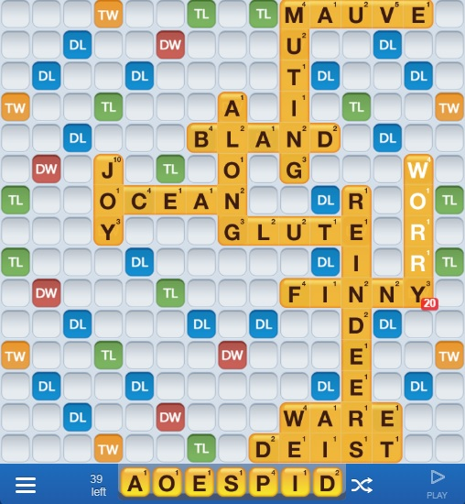
I identify a likely opportunity for a parallel play next to WORRY, potentially reaching a TL/TW combination. I see that we can hook on to the W with either WO or WE, and arbitrarily, I’ll start with WO. Now I try placing the highest scoring letter, P on the TL tile, making OP twice. With the remaining letters, I’m looking for a four letter or longer word ending in OP, so that I can reach the TL. If it helps, I could add the E after P making RE, and try to find a playable five letter word ending in OPE. Well I couldn’t find one, so I move on.
Still dealing with a WO start, I put the next highest scoring letter D on the TL, making OD twice. Now looking for a playable four letter word ending in OD, or a five letter word ending in ODE. Aha! SPODE is a word, so there’s a very good play possibility; but I keep looking.
Still dealing with a WO start, the only other possibility is to make OE twice. But a quick look tells me that this is not at all promising; I certainly won’t find something better than SPODE.
But we’re nowhere near done yet. Now I start looking at the possibilities starting with WE, and placing the P on the TL square I can’t find a word ending in EP that reaches to the TW.
Next, I try ED, a promising ending. After playing around a bit, I see I could make POSED, or even better POISED.
So now I compare the alternative plays of SPODE and POISED. SPODE has a point value of 53. POISED has a value of 54. So I wouldn’t go wrong with either choice. I choose POISED, not only for the extra point, but also because it gets rid of an extra low-value letter.
Finally, I’m happy with where I am leaving the board defensively. I have used the fantastic opportunity effectively, and not left any great obvious openings for my opponent. He could reach the TW off of an E in REINDEER, but to make a really good score, he’d need a word with a high valued letter, or several medium valued letters.
This whole process may strike you as rather tedious, but this was a fairly complicated play, with lots of options. Many times, following the process will be much simpler. Also note, that I might have started with WE, and after finding POISED, might have concluded that I was very unlikely to find something better, and given up the search at that point.
As you get familiar with this technique, it becomes easier and easier to follow, and you learn where you can take shortcuts.

Defense
Now we come to a critical aspect of the game, which many players fail to pay sufficient attention to.
We can summarize the main defensive consideration in one rule:
Rule of Thumb Number 8
At almost any cost, avoid leaving your opponent with an easy “fantastic opportunity”. Be willing to leave a “very good opportunity” only if you are able to make a very good play yourself.
Two factors contribute to judging an opportunity easy to exploit. First, it requires five or fewer letters, and second you can envision many words that would do the job. If taking advantage of an opportunity would require six letters, you would like to avoid that as well, but sometimes it’s a risk that must be taken.
If you can identify only a handful of specific words that would enable your opponent to take advantage of the potential opportunity, that may be a risk you are willing to take. Consult “The Bag” to see if your opponent might have the necessary letters. If on the other hand, you recognize that there are many such words, find an alternative.
For example, say you are contemplating a move that puts a TL square in front of the letter A. This opens up the possibility of ZAZA, or ZA paired with another Z word, for a 60+ score. Perhaps you are far enough ahead in the game that you feel you can tolerate a lesser two-letter word combination, with MA, PA, etc. But ZAZA or similar would be too much to give up. In this case, look the board over to determine that the one Z tile has already been played, or check “The Bag”.

Following is an example where my opponent failed to recognize the risk inherent in her play:
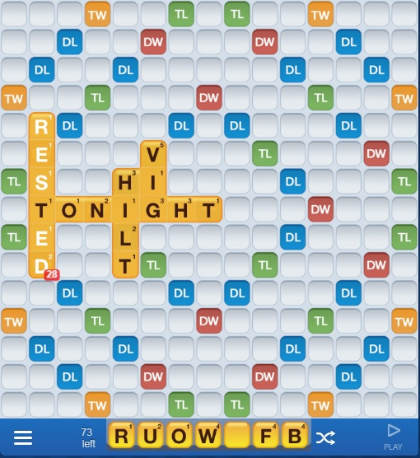
My opponent’s play of RESTED looked attractive, using up a bunch of low value tiles, and exploiting the very good DW-DW opportunity to get quadruple value, and a quite respectable score.
But look at the fantastic opportunity that it created for me. Many consonants can be placed before the E, most of them medium valued… BE, HE, FE, ME, PE, WE, YE, and the high valued JE. (If I had had the J, we might be looking at a 100+ point play).
For the second letter of a parallel play, four of the five vowels make a word in front of the D. So we’re looking at an enormous number of words that would take advantage of the opportunity, most scoring in the 60+ range. As it was, I played a modest FOUR, scoring 64. I could have done even better using the blank tile, but not 30 points better. And I might have had letters to make an even longer word, making for an even higher score.
So the play of RESTED was a serious defensive error, one that should have been avoided at all costs.
You may also have noticed another opportunity next to RES of RESTED. But this one is not nearly as good: you have to make three, not two 2-letter words, and only a low valued vowel could be placed on the TL.
There are two defensive scenarios to consider. One, as we have just seen is to avoid making a play that opens up an easy “fantastic opportunity” for your opponent. Here it is imperative to find an alternate play, unless your play is just too good to resist (in the 50+ point range).
A second scenario occurs when you identify a potential fantastic opportunity for yourself, but do not have the letters to take advantage. In this case, you should look for a play that blocks or interferes with the opportunity, so that it is not left for your opponent to take advantage of.
With this second scenario, there is another strategy to consider, one that I would characterize as a desperation play, occurring when blocking is impossible or highly undesirable because of low score. In this case, consider the desperation strategy, which is to violate previous guidance, and deliberately make a play that opens up a second fantastic opportunity. The idea is that your opponent will take one of the two opportunities, but the hope is that with your new rack you will be able to take advantage of the other opportunity at your next turn. This is a high risk play that could backfire badly.
In other cases, where multiple opportunities are available to you, generally take the most lucrative one, but if none are usable, make some other play, in the hope that a great opportunity will be usable at your next turn.
One final note about defense toward the end of the game: when no letters are left in the bag, consult “The Bag” to learn exactly what letters your opponent is holding, and plan your plays accordingly, interfering with his best potential plays if that is called for, rather than making your own best move. Even when there are a few letters left, consulting “The Bag” will give you a good idea of what your opponent may hold. It also gives you some idea of what letters you may inherit for your next move.
Rule of Thumb Number 9.
Toward the end of a close game, consult “The bag” to learn what letters your opponent has or might have, and play accordingly.

Here is an example of that technique at the end of a close game in which I held a slim lead:
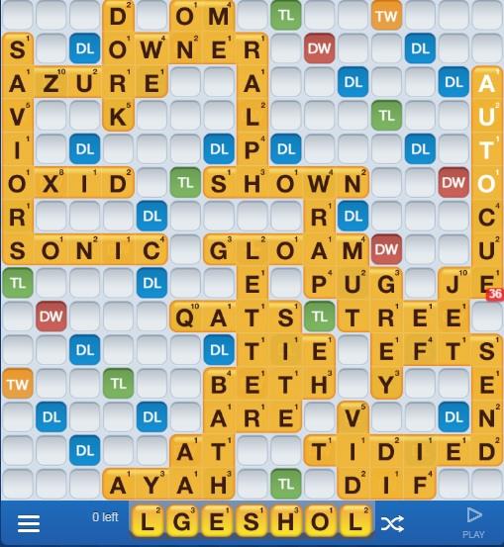

Looking at “The Bag”, I see that my opponent has 3 letters left—B, I, and N. That could make either BIN or NIB. The trick was to prevent my opponent from making a big score with those 3 letters, and finishing the game in the process, while I was stuck with a handful of letters. But I played my S after OWNER, and continued with a parallel play of SHO, making AH and LO in the process, for a fair score of 22. I missed leaving open a parallel play for my opponent of NIB, making NU, IT and BO in the process, with the B on a DW square, for a score of 30. That, with the minus 8 for my leftover letters, and the plus 8 for my opponent cost me a close game, ending my 34 game winning streak.
My word was right, but in the wrong place. SHO in the right place, for only 10 points would have blocked the opponents big score, and given me the win.

Rules of Thumb -- Summary

Rule of Thumb Number 1.
When a possible play includes medium or high valued letters for which you are getting only face value, make a downward adjustment to the score, deducting the point value of these letters. If this adjusted score is still better than (not just equal to) any alternative, then its ok to make that play.
In other words, save your medium and high valued letters until you get at least double value for them. Exception: when you need the letter to make a really good word.

Rule of Thumb Number 2
When a possible play includes the letter S, adjust its score by subtracting 10! If the result is still better than any alternative, its ok to make that play. Otherwise, find an alternative.
In other words, don’t squander your S letters. They’re valuable to add on to a word already on the board, and make a second word at the same time. That also makes them helpful to find a place for a Bingo, or to add just one more letter to reach a DW or TW square.

Rule of Thumb Number 3
Memorize all two letter words, and look for parallel play opportunities that use them.
Be on the lookout—WWF keeps adding new two letter words. VU, JE, JA, OO all added since I started playing.

Rule of Thumb Number 4
Look for good opportunities to lengthen an existing word, especially when you hold common prefixes such re or de; or suffixes such as ING, ER, EST, or ABLE.

Rule of Thumb Number 5
When faced with an extreme imbalance of letters, look for a play that uses as many of these letters as possible, even accepting a lower score than could otherwise be achieved. If all else fails, consider swapping. Never swap out medium or high valued consonants.
All consonants? All vowels? All low value letters? Get rid of as many as you can, even taking a lower score.

Rule of Thumb Number 6
When a possible play includes the use of a blank tile, adjust its score by subtracting 30! If the result is still better than any alternative, its ok to make that play. Otherwise, find an alternative.
In other words, save your blank tiles for really fabulous scoring plays.

Rule of Thumb Number 7
When searching for the best word(s) to play, try to put your highest value letters on TL or DL tiles.

Rule of Thumb Number 8
At almost any cost, avoid leaving your opponent with an easy “fantastic opportunity”. Be willing to leave a “very good opportunity” only if you are able to make a very good play yourself.
In other words, don’t make it easy for your opponent to rack up a big score.

Rule of Thumb Number 9.
Toward the end of a close game, consult “The bag” to learn what letters your opponent has or might have, and play accordingly.

