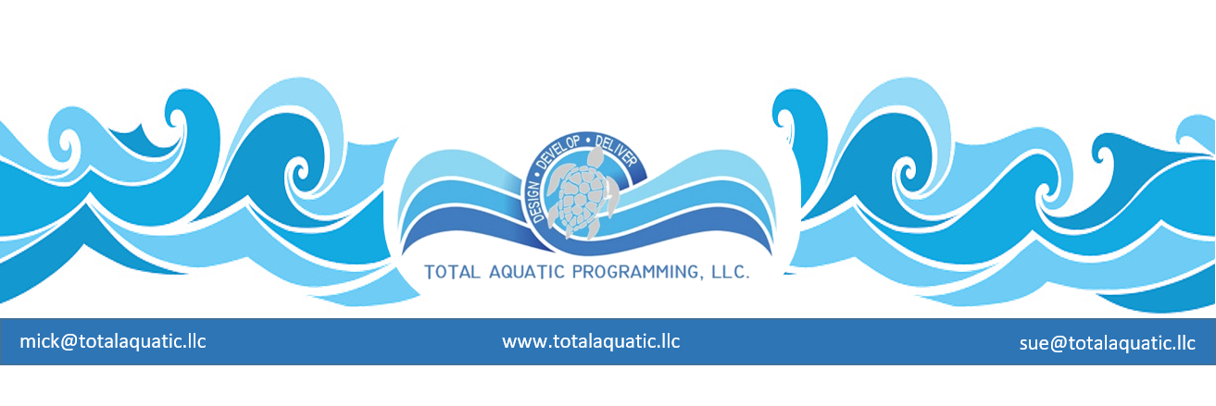

Answering the Natatorium Energy Crunch

The following was a headline in a recent Business Week on line article: “As a threat to operations and the bottom line, corporate computing's fast-growing power needs……..“Engineers at Hewlett-Packard made a startling realization about the servers running the company's computing systems. Surging power consumption, along with rising energy costs, will soon make it more expensive to keep a server going for a year than to acquire one in the first place. Left unchecked, costs like these could interfere with HP's goal of cutting energy consumption 15% by 2010.”
Think about how that applies to our pool operating cost challenges. It can cost as much to operate a natatorium for 20 years as it does to build it in the first place. How can we paint a better picture than this?
“So when HP began constructing a new 50,000-square-foot building to house high-powered computers, it sought advice from Pacific Gas & Electric (PCG). By following the California power company's recommendations; HP will save $1 million a year in power costs for that data center alone.” Like HP, companies across the globe are adding equipment to keep up with surging computing needs—and then are forced to make substantial changes to curtail the leap in costs associated with running the big buildings, or data centers, housing all that gear. "Data centers use 50 times the energy per square foot as an office does," says Mark Bramfitt, principal program manager at PG&E.
We are not at the 50 times multiplier; however, a Natatorium can use over 5 times the energy of a normal building unless it is designed with best available technology and modern methods as a primary concern. Industry experts say the power consumption of specialty buildings is doubling every five years or so, making them one of the fastest-growing drags on energy in the U.S. We currently are relatively backwards when it comes to using alternative-energy and energy-efficient technologies.
To keep the natatorium at the right temperature with proper humidity and breathable-healthy air, two factors must be considered.
- How do we make the water best quality so “bad stuff” does not end up in the air?
- How do we dehumidify and control air temperature, so a variety of user groups are comfortable?
Existing facilities can research more efficient and effective HVAC units when the time comes for upgrading or renovating. Great strides have been made over the past few years by aquatic industry leaders in HVAC like Desert Aire http://www.desert-aire.com. Many times, the cost for upgrading to a better designed more modern unit will be easily amortized by a savings in energy over the life expectancy of the new equipment. The bonus is better air quality, energy savings, and happier clients/customers.
But the main thing we need to start doing for new design and construction is:
Stop thinking inside the box by not designing boxes in the first place.”
Our natatoriums must be designed in a more energy-efficient way—an approach taken by TAP. We must lower the energy bill by better design. We need to be pro-active with this or we may soon have little choice in the matter. Before now, at many organizations, the club and other users don’t see the utility bill; the pool owners pay the energy tab. The owners recover their investment in the form of “renting program space” in the facility to customers. We must ask two more questions before any natatorium design is considered:
- Will the renters in 5 years, of the facility pay 5 x the cost for use as they currently are paying?
- Can the owners charge the amount necessary to sustain the facility without losing customers?
The answer is probably NO to both questions – but what happens if these go from questions to simple facts?
Many architects and designers won’t justly consider the best “green” design. They do not have previous experience with the best available building methodologies, so their design process becomes much more labor intensive. In plain words – they can’t do what they normally have done in the past, they have to give away some of their commissions and fees (profits) to hire outside expertise.
In December of 2007, Congress passed a law requiring the Environmental Protection Agency to assemble a report about power consumption in specialty centers by mid-year 2008. One aim: to outline possible incentives and voluntary programs for promoting energy-efficient specialty buildings. "It's big enough to get the government's attention," says Andrew Fanara, a team leader at Energy Star, an EPA-created program that encourages energy efficiency. It's possible that in the next few years, companies will face environmental legislation that would essentially tax specialty building costs. Natatoriums are not the primary focus here, but if we continue to be energy hogs, we will be singled out. We can’t GO BACK and rebuild 5 years later – we must change our building strategies now. There is not a stampede in the aquatic industry to conserve energy in many cases. Many current facility owners and managers do not have upgrades in the budget, so they simply pay higher yearly cost to operate – EVERY YEAR. Why would anyone design a new facility that will immediately be in that boat?
Our anecdotal information estimates that anywhere from 30% to 60% of the energy to operate a Natatorium is wasted. Insulation factors for the building have not been of primary importance in the past because we were told we did not need an air-tight building. We needed lots of fresh air for a pool building. In 1970 that may have been the case, but not today. There are now better methods to handle the air, we want much of the air to stay treated and not escape to the outside right away.
There is a huge savings potential if we design a natatorium building that has an R 60+ insulation rating and a LEEDS Gold or Platinum certification. This methodology is currently available at equal to or probably less cost than traditional building design. No more boxes!
Very soon facilities may even opt for alternative sources of energy to keep the natatoriums sustainable. Things like passive solar energy captured via ground or roof mounted solar panels along with wind turbines and geo-thermal options need to be considered. Currently solar energy is a very viable option and someday you may see windmills next to every natatorium.
For more information concerning energy efficient and sustainable natatoriums please contact TAP LLC and plan to attend a USA Swimming sponsored Regional Build a Pool Conference or host your own on-site Custom TAP Workshop. Contact: mick@totalaquatic.llc

