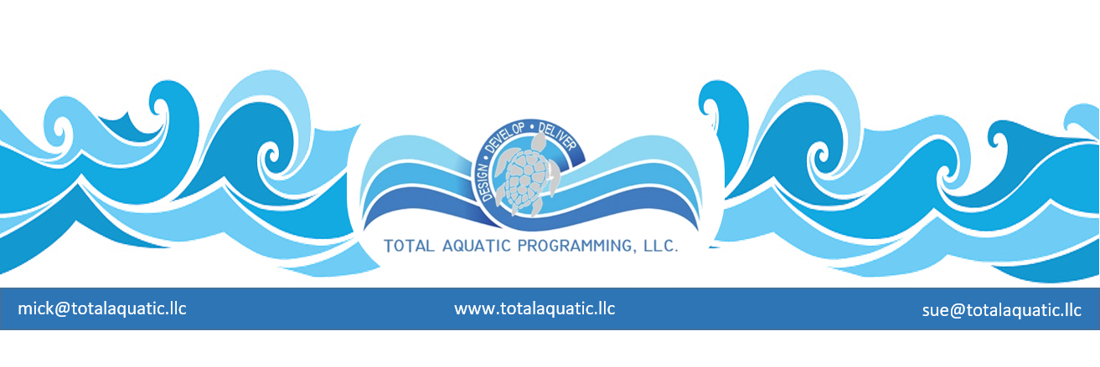
TAP-LLC Aquatic Life-Progressions

Ideal age 1 to 5 years old – no later than 2nd or 3rd grade – select curriculum that teaches proper stroke mechanics. It is no harder to learn the right way. Make a Splash Local Partner lessons providers at:
https://www.usaswimmingfoundation.org/
Learn to Swim

After learning the basics of swimming, children may want to continue in the healthiest and safest sport. Many of our clubs have entry level groups that do not require an intensive time commitment and the child can continue to learn while increasing coordination and other life-style skills and participating in other activities, www.usaswimming.org
Aquatic Age Group Sport

The benefits of aquatic activities never end. From recreation, swimming for health, aquatic rehab, vertical aquatic exercise, Masters Swimming, etc. It is a main component for a healthy lifestyle. It’s never too late to learn to swim and always the right time to be healthy. www.usms.org - sue@totalaqutic.llc
Adult Aquatics
Swimming, as a sport, has opportunities at many levels: USA Swim Clubs, High Schools, College & Universities. There is also much more than the competitive experience through Life Guarding, Swim Instructors, Coaching, and other Aquatic Careers. Contact:
sue@totalaquatic.llc

Aquatic Sports and Safety

