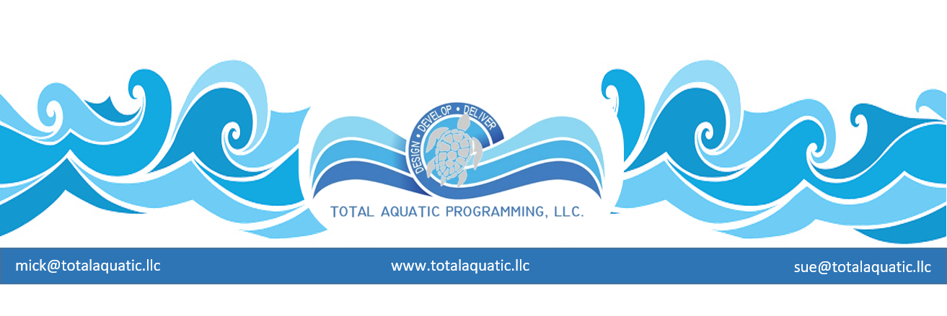

BASIC Pool Construction Tips for the Prospective Private Owner
Pool construction costs vary depending on:

- the size of the pool
- the material used
- the complexity of the design
- the geographic area

The contract terms and details are the most important factor. Let’s look at some of them.
Certification and References
Make sure the dealer or installer has a (CSP) Certified Service Professional. The National Spa & Pool Institute trains, tests and retests pool service technicians before certifying them as service professionals and designating them as Certified Service Professionals.
Ask the pool builder for a list of reference customers from the past 5 years. Contact those people and ask them how they felt about the entire pool building process, both before and after the sale. Follow up diligently on this: actually contact these people. Go see at least a few of these projects if possible.
Payment
Beware of any swimming pool contractor who requires a considerable payment up front. Use the rule of 30…..

- 30% down plus
- 30% when construction begins plus
- 30% when project is well underway
- and then 10% after pool is up and running for 30 days
Never pay in cash. Use checks or money orders. Before you pay the last 30% you need to have a letter of a release of lien from all subcontractors and construction suppliers. All permits, warranties and guarantees need to be in your possession.
Always compare prices and services of several contractors before you begin. Ask for written bids specifying the materials to be used, including quantity, brand, size, color, etc. Do not forget to include the clean-up costs. The lowest bid may not always be the best. Make sure you are comparing “apples to apples”.
Features
Ask your contractor for the latest products such as UV for water treatment. There are many gimmicks on the market and you contractor may not actually know how effective or efficient a product is. You can always email mick@totalaquatic.llc for information about a product.
Additional features such as tile, waterfalls, underwater lights, etc. will cost extra. Have these quoted as alternates or options.
Brands and manufacturers can make a huge difference especially for:

- Pool filters and pumps
- Pool heaters
- Pool chemical treatment systems
- Solar heaters and covers
- Pool accessories

The bottom line:
You need to do your own due diligence to make sure all products and services are acceptable. Do not depend on the pool dealer or contractor to supply accurate information. Check everything out. Don’t be afraid to ask for guidance.

