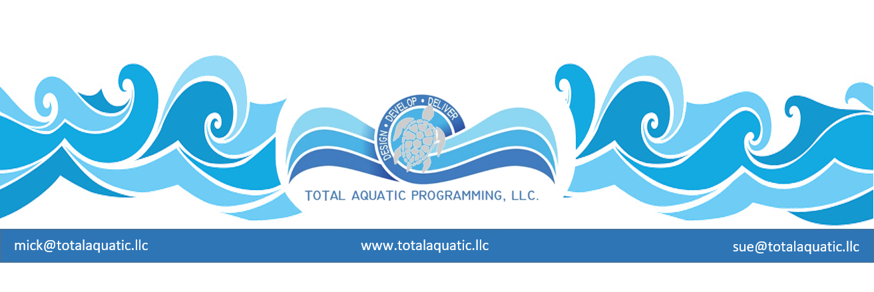

Building comparisons | – PVC membrane seasonal building | Universal architectural membrane permanent bldg. | Pre-engineer Steel building | Brick – block – concrete panel type building | Monolithic Concrete Dome building
Building removable for summer use to make pool outdoors | YES | NO | NO | NO | NO
Building insulation estimate in R-factor | 5 | 10 | 20 | 25 | 60+
Building life span under normal conditions – in years | 12 | 15 | 30 | 40+ | 100+
Cost to insure for replacement | MedHigh | MedHigh | Med | Med | VeryLow
Wind resistance – Storm – Tornado - Hurricane | 70 MPH | 70MPH | 90MPH | 90MPH | 150MPH+
Earthquake resistant | Moderate | Moderate | Low | Low | High++
Snow load on roof – tolerances for weight | Low | Low | Med | MedHigh | High++
Ultra Violet deterioration resistant | Low | Low | Med | MedHigh | High++
Cost to operate expressed in $ per square ft. per year. – Utilities rural | $16 | $14 | $12 | $10 | $3
Cost to repair (upkeep) expressed in cents per square ft. per year | $.10 | $.20 | $.50 | $.40 | $.10
Time to construct building | 10 days | 4 weeks | 3-6 mth | 6-8 + mth | 2 mths
Is the building leasable | YES | YES | NO | NO | NO
Esthetics – scaled on 1-10 (a10 being highest) - (very subjective) | 3 | 4 | 6+ | 9 | 10
Cost to build expressed in $ per square ft. – Rural estimate | $15 | $35 | $145+ | $250++ | $125
HVAC original equipment cost | MedHigh | MedHigh | Med | Med | Low
Design cost – fees and services | Low | Low | Med | High | Med

Some of the things that have to be considered are:
- What is the capital investment limits for the project?
- What are the demographics the facility will serve?
- What are the geographic particulars for your area?
- Is this a phased project or will it be “what you see is what you get”?
- Do you need some pools indoors and some pools outdoors?
- What are your design team’s limitations?
- What are your local code restrictions?
Type of building |  | 32,000 sq.ft |  | Building | Annual Operational
 |  |  |  | Cost | Cost - 4 seasons climate
PVC Membrane seasonal building
convertible to outdoors in summer |  |  |  | $640,000 | $608,000
Arch.Membrane permanent building |  |  |  | $1,120,000 | $512,000
Pre-engineered steel building |  |  |  | $4,640,000 | $384,000
Monolithic Concrete Dome building |  |  |  | $3,900,000 | $224,000
For example:

If you decide on a steel building for the natatorium, the basic operational cost over the first 20 years may be $7.7 million total with a $3.7 million cost to maintain and upgrade over that period of 20 years. Compare that to a Monolithic Concrete Dome structure which – over the same period of time – should have a basic operational cost of $4.4 million with a $2.2 million cost to maintain and upgrade. Compare $11.4 million to $6.6 million and you be the judge. Can you afford to build it and operate it?

SERG temporary structure >
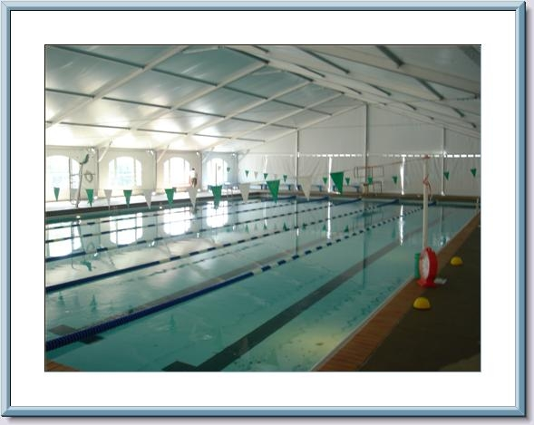

Universal arch. membrane structure >
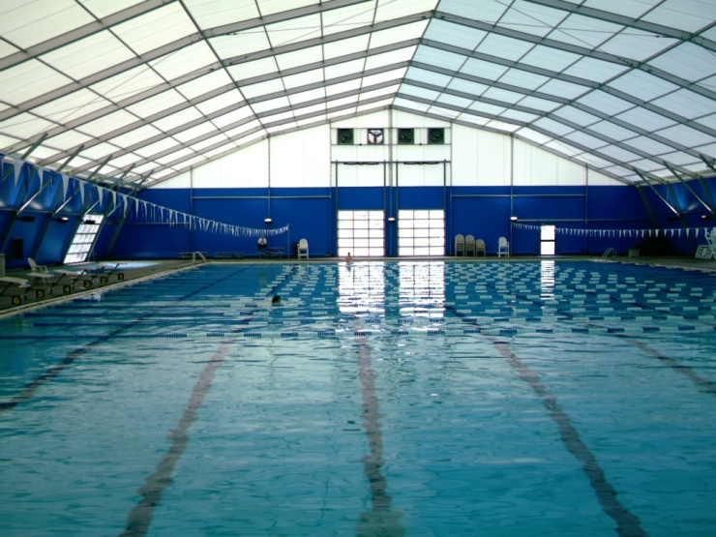
Pre-engineered steel structures >
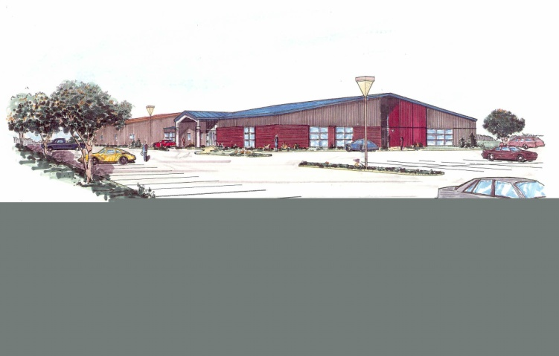

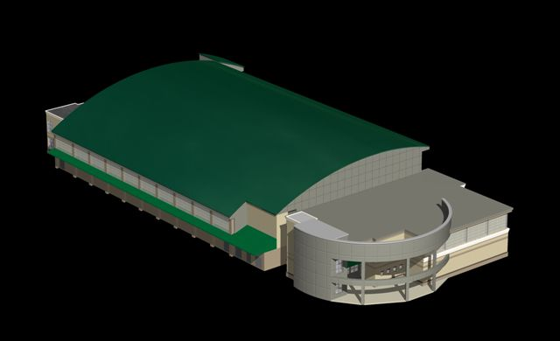

Brick – concrete – structure >

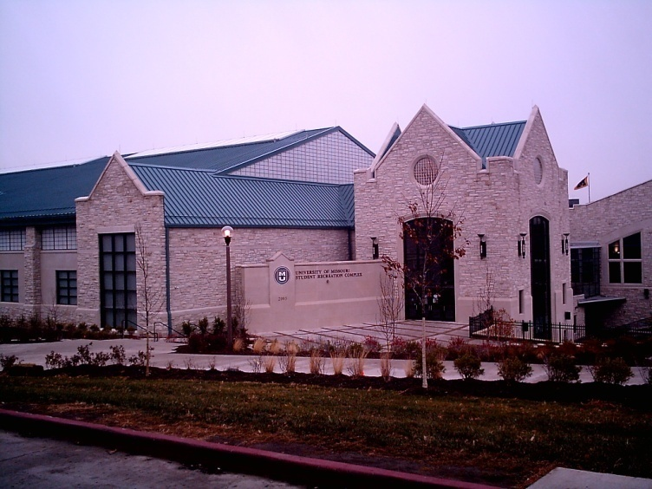

Monolithic Concrete Dome structure >

