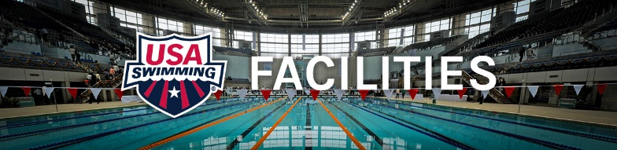

Can I rent your pool?

“Trailers for sale or rent – pool to lent 50 cents” Not quite, but the idea works. Many successful Learn to Swim businesses started as a tenant in a motel, apartment, or homeowner’s association pool. In today’s market we can add health clubs into that mix.

There are underutilized pools out there for the finding, but it is not an easy task. One of the first things you have to analyze and realize is that some pool owners don’t want their pool to be busy and don’t care if it makes or loses money. It’s OK to talk with these people but seldom will you find a common ground for you to use their pool.

Another important area you must be well prepared to address is insurance and liability. Regardless of risk management procedures in place, if something bad happens, everyone will be sued. Why would the pool owner want this exposure? Of course, the answer to that is “if they have a pool, they already have that exposure”. A professional Learn to Swim business on site with a great risk management plan lessens that exposure and shows every one’s best efforts for safety first. This can take some convincing and it helps to have a nationally recognized Learn to Swim agency behind you. By the way – posting signs “Swim at your own Risk” does not release liability for negligence. The signs might as well say: ‘Swim at your own Risk and here is our attorney’s phone number so you know where to send the summonses.

There are also marketing advantages you can develop that will show the pool owner how a Learn to Swim on site can enhance their position in the community. www.makeasplash.org can give you some ideas. Get the picture? The pool owner has to have something substantial in it for them to even consider allowing you to rent their pool.

Next hook – money! You cannot expect to get the pool for free. That is simply not good business for either party. There are quite a few valid ways to offer the pool owner money for the pool time you need. Here are just a few ……

- Water time lease – this arrangement is one of the simplest to understand. You need a certain area of the pool to teach lessons in. You probably will not get the whole pool at convenient time for your lessons so negotiate for a reasonable space that will not infringe on the pool owners’ customers. Rule of Thumb – national average for water space rental is 15 cents per square foot per hour. So, if you wanted to rent an area 10’ x 20’ that would be 200 sq ft x 15 cents = $30 per hr.
- Lane rental – if the pool is a larger pool that has lane lines as dividers, you can rent 1 or 2 lanes per hour. For a 25-yard lane the national average is $18 per lane per hour. For a shorter 20-yard pool the average is $12 per lane per hour.
- Flat fee – you can offer a daily fee of say $50 for a portion of the pool. The draw-back of this is that when your lessons program takes off and you need more pool time the owner will want to renegotiate.
- Per class fee – you can offer to pay the pool owner a set amount per class per day.
- Per person fee – you can offer to pay the pool owner a set amount per person per day.
- Percentage of gross – you can offer the pool owner a percentage of your income. What you are really doing is offering them a minority partnership in your business. This requires more bookkeeping and more trust between principals.
- Access fee – This can work well in health clubs. You charge a registration fee or pool access fee in addition to your lesson’s fees. That fee is usually between $10 and $25 per student and is paid up front when the session of lessons is prepaid. It is in a separate check or transaction and is make payable to the pool owner. You can negotiate whether this is a yearly fee per person or a per sessions fee.

Bottom line is that you must make money and so does the pool owner. You also must have a clear and fair arrangement with the pool owner about:

- Liability Insurance
- Pool maintenance and upkeep
- Use of shower and dressing areas
- Pool water and air temperature
- Pool water and air quality
- Deck cleanliness and accessibility
- Parking
- Emergency action plans
- Advertising and signage
- Interaction with other pool users
- Lifeguards/Water Watchers with (CPR & 1st aide)

There is a little more than “can I rent your pool” that is involved. Be prepared to discuss any and all the points above. The pool owner will appreciate your professionalism and may be more inclined to consider your offer. For more information please contact;

Sue Nelson sue@totalaquatic.llc

