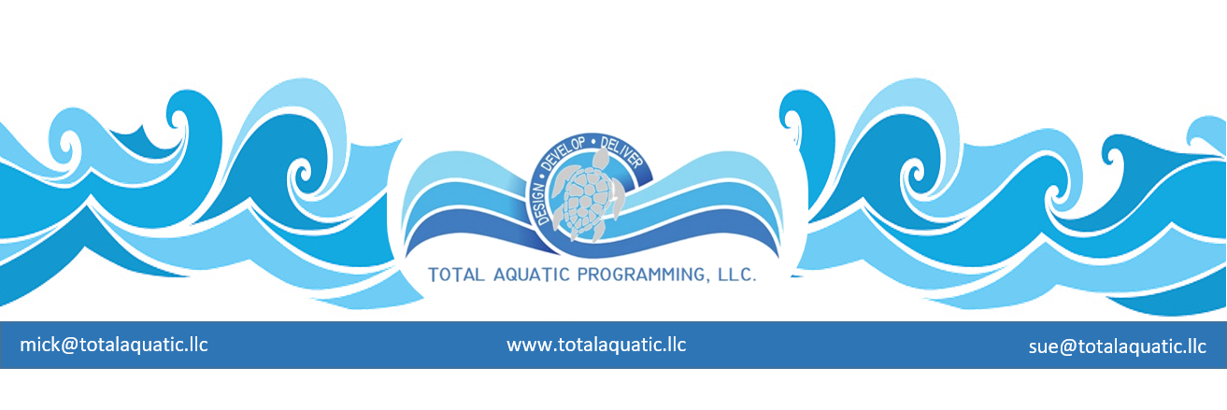

Committees from scratch – one good recipe …….
- A swim club committee should be comprised of 5-7 people, so the meetings do not turn into lengthy discussion platforms driven by private agendas.
  - Every committee candidate has to have a specific skill that will be useful for the “working committee”. Bankers, Real Estate Developers or agents, small business owners, City Council people, can all be considered, just to name a few.
  - At least 75% of the committee should be made up of people who have or have had in the recent past, some affiliation with the club.
  - Right up front, the committee members need to know they will be volunteering time and effort to the project. If they can’t do the work, get someone else.
  - The committee process may take up to 24 months – a very significant investment of time and resources.
  - Meetings are mandatory. (*note - We like the Husband & Wife team as one committee member. This increases your change for better attendance – one or both can come to meeting but only one vote)
  - Report or information deadlines are firm and need to be met.
  - Expenses such as travel, phone calls, paper and office supplies, etc. will not be reimbursed.
  - If the project “is successful” the committee’s names can be acknowledged with an appreciation plaque displayed in the new building.
  - Establish the end goal of the committee and find out where the committee results/report goes next. Does it now refer to any or all the following?
    - To the BOD
    - To the general membership
    - To the community
    - To the investors or owners
    - Will the committee still exist for guidance after its report is submitted?
  - Replacing a committee member is inevitable – but you can make it rare by carefully picking your committee the first time.

- Identify a standard location and time for the meetings. Community centers and some bank rooms or church rooms are free. The more you standardize the place and time the better chances you will have of people getting to the right place at the right time. Fridays, Saturdays, and Sundays are not the best days for meetings. Advanced E-mail and phone reminders of meeting place and date plus a written agenda are imperative.
- Each committee position must have some form of a job description. This gives structure to the PLAN and allows easier replacement of any committee position. People will not be able to achieve a specific result without specific guidelines.
- Identify additional professionals in the “industry” and those who you know have been affected by anything relating to your project. They can always be invited to the committee meetings as guest presenters.

- The first meeting is critical….
  - Listen to people.
  - Make notes of the areas each person is interested in.
  - Ask each person WHY? they offered to be on the committee
  - Define your categories E.G….
    - Fundraising
    - Land options
    - Appropriate partnerships if necessary
    - Adversaries and Advocates – Marketing
    - Web presence and communications
    - Meeting operations and organization
    - Other
  - Give committee members the appropriate tools and help them list their Objectives - Strategies – Tactics. All goals must be both quantitative and qualitative. People need motivation and guidance.
  - Follow up with them before the next meeting for support and progress check.

- The committee must have a leader. The closer it gets to a democracy, the less effective it may become. The closer it gets to a dictatorship the less support it will have. Leadership is an art.

Some things you may need to cover before the committee is formed….
The LEADER must have …….
- Some good solid experience for where the aquatics market is headed - if you do not have this then you need to ask for help from people who do.
- An understanding of how immensely important operational and maintenance cost are going to be
- The ability to tell when someone is giving you a “sales pitch” and when someone is giving good advice
- The willingness to leap into the future when others are advocating the present based on the past
- A trusting group of supporters that are not constantly asking you to prove everything you say
- The sense and funding to contract an aquatic programming feasibility study at the right time in the process.

Practicing the art of communicating which includes not only presenting your ideas in a concise and understandable form but also listening to what others have to say. When you ask a question and hear a NO, many times it is not an answer but just a request for more information. Seldom are there “pat answers”! Sometimes “the prove it to me” or “show me” scenarios are your hardest to overcome. You can only formulate your response based off successes like Microsoft – Starbucks – Google – etc. These were pioneers who accepted the risk of doing it a new and better way and were rewarded beyond any one’s expectations.
You must be the leader but not the whole parade. You need to spend the time to turn adversaries into advocates. Convince the skeptical – convert the non-believers. No shortcuts here. The clique “small leaks sink mighty ships” fits well. Evaluate potential collaborators and then decide who brings what to the business plan. Too many partners can muddle up the plan and make it difficult to get the proper programming matched to the ideal facility. Too few partners can financially inhibit the project. Everyone wants a piece of the pie so you will need to lay out ownership and management plans by contract early in the process..
Get outside the box – stay there. Traditional planning and approaches may not be the best way for your project. STOP trying to do today’s job with yesterday’s methods and still be in business tomorrow. Be aggressive with your program planning making sure you consider all aspects of aquatic programming and services. Be innovative with your design demands for the facility itself. Cost to build and cost to operate and cost to maintain are all important. You should no more build a building like in 2005 than use a 1995 model computer. Technology has advanced and keeps doing so at a rapid pace. Your advisors have to be aware of what is currently available and be willing to do the extra work to make it fit your project.
Challenges and Change – You will have nothing but challenges that require creative problem solving so get used to it. Everyone around you will probably resist change so be prepared to listen to the problems and then assist in developing solutions. Your project should not be just like someone else’s it needs to be what is best for your situation. You need to enlist the help of those who understand this not just those who offer cookie-cutter solutions.
The concepts listed above can be achieved and enhanced with the help of a professional aquatic programming feasibility study. These can be contracted from a professional independent firm who specializes in this service. TAP can supply “general” information and create ENTERPRSE PLANS for projects. This is the pre-cursor to a formal feasibility study. TAP has established a short list of feasibility firms who are reputable; understand total aquatic programming, and who offer best pricing to our projects and their associates.
One of the best firms even offers TAP clients discounts. Contact: mick@totalaquatic.llc for more information.

