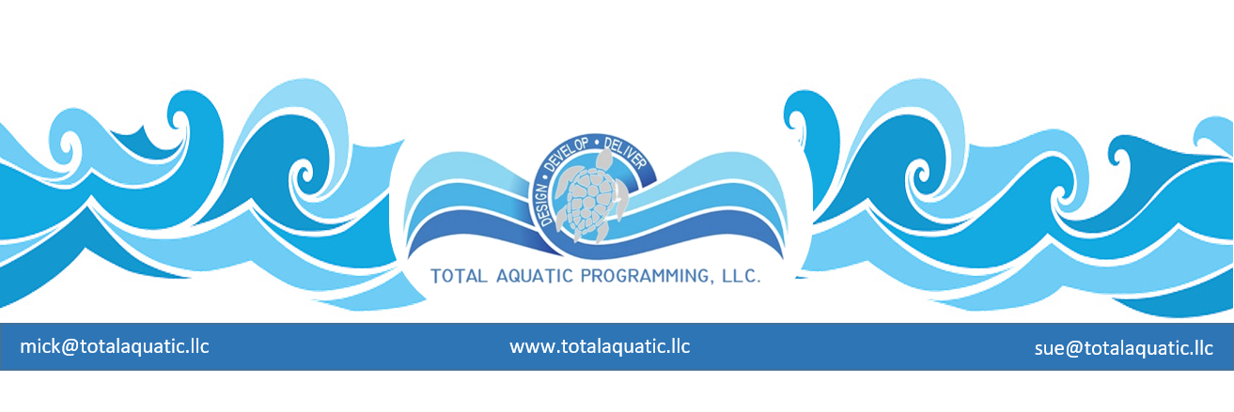

COMMON SENSE can save a life….

Here is a list of places drownings are most likely to occur. The percentages are based off total number of actual drownings since 2008. When looking at the statistics and the stories behind these tragic events, it becomes obvious that the numbers can be drastically reduced if people would just think before they act.

LAKES = 26%
RIVERS = 25%
POOLS = 23%
OCEANS = 10%
PONDS = 7%
BATHTUBS = 2%
DITCHES = 1%
HOT TUBS = 1%
WATERPARKS = .02%

Here are some general guidelines that need to be followed. Take a minute and read now, it may save a life later……

#1 – If you or your loved ones are going to be around open water like lakes and stream and ponds and rivers and oceans etc. a lifejacket should always be worn. Open water is naturally perilous. Uneven bottoms and drop offs, currents, slippery rocks and banks and docks, boats and motors and fishing lines, and literally hundreds of other potentially dangerous situations. Too many people think life jackets or vest are bulky and uncomfortable.
Great strides have been made in life vest size and style and comfort. There is absolutely no reason not to own one and wear it when around water.
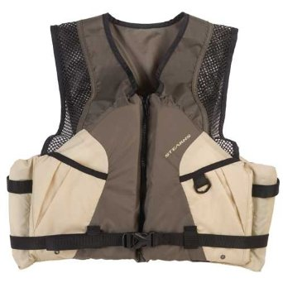
OLD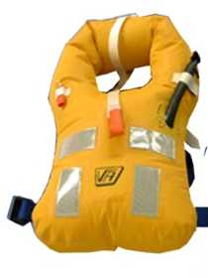 NEW

#2 – If you can’t swim, be extra careful of yourself and those you are responsible for. In the past 4 years there have been multiple cases where a child has gotten into trouble in open water and another person tried to help and both drown while others stood within a few feet on shore helpless because they could not swim. Learning to swim is the #1 precautionary measure to combat drowning. In the past 4 years there have been over 195 instances of a person drowning while trying to help someone already in trouble in the water.

#3 – Respect water. It is one of the most powerful forces on the planet. Rip currents and undertows can sweep someone off their feet in a split second. What once seemed to be a calm safe environment can change without any warning. In the last 4 years over 300 drownings have been caused by rip currents.

#4 – Wet surfaces are slippery. Falls are commonplace around the water and can cause injury and drowning. Riverbanks and rocks and walkways and boat ramps and docks and decks all have potentially risky footing. Pay attention and watch yourself and others to make sure they are safe.

#5 – Never drink alcohol around the water. 39% of adult open water drownings are alcohol related. What started out as fun ended up as tragedy. People around water have enough to watch out for without their senses being impaired. The numbers for the past 4 years show over 1400 drownings directly related to alcohol use.

#6 – Never be in or around water alone. Everyone needs someone close by that is competent to help. When you have children around water there must be at least 2 adult sets of eyes on them 100% of the time. There are no do-overs when it comes to water accidents.

#7 – Babysitters and grandparents mean well but they must be competent and prepared to watch a child if there is water nearby. This includes home pools in their or neighbors’ backyards, neighborhood ponds both ornamental and natural, streams, channels, ditches, etc. Even bathtubs, toilets, buckets, ice chest etc. can be a problem. Nothing replaces constant supervision. We love our grandparents but in the last 4 years there have been over 150 cases of children drowning while visiting their grandparents.

#8 – It’s great to give the family a backyard pool or hot tub so they can enjoy summer days at home, but along with the gift comes a tremendous responsibility. Pools and hot tubs need to be surrounded by a safety fence with a child proof gate. All ladders over the side of an above ground pool need to be safety ladders so a child cannot climb them when they are locked. Pool alarms must be installed. The area must be secured from any child gaining access. Children learn by copying behavior and they will find ways to get in the water that you would not believe possible. This is not just about your children but also others who live close by.

#9 – Just like the idea of installing child proof locks on cabinets and drawers, you also need to install child proof locks on house doors – especially those flapping pet doors. Many toddlers have crawled out of their bed at nap time and then crawled out of the doggie door and into the back-yard pool. There must be multiple safety barriers installed. Any door or gate is a challenge to a child.

#10 – Talk about safety. We teach that stoves are hot, and bottles of cleaning fluids are poison and electrical outlets are dangerous, but we do not talk enough about being safe around water. There is a difference between being paranoid and conscientious. There is nothing wrong with constantly talking about water safety with children and those who are responsible for them.

Over 25,000 people have drowned in the USA since 2009
6300 children …... 2900 teenagers …. 15,800 adults

FACTS:
Males comprise 82% of the drownings.
Hispanics 7.2% and African Americans 4.6%
There have been over 500 drownings related to fishing.

So many of these could have been easily prevented if people were paying attention and using common sense.

First do your part and then help remind someone else to do their part also.

