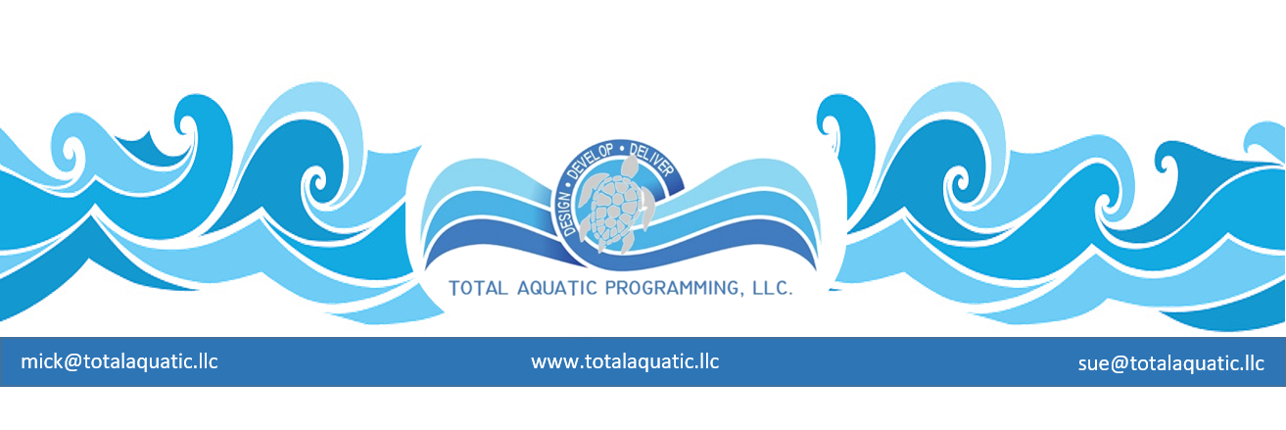

If you want to plan a new facility that looks like the ones built ten years ago – or for that matter 2 years ago – then this article is not for you. However, if you do not mind planning for the facility of the future without needing to rely on current examples of moderate success, then read on…..

First …. you need a crystal ball – for a prop only. What you really need is a talent to cultivate foresight into what will be needed for sustainable success. The main ingredients for this are:

- Some good solid experience for where the aquatics market is headed - if you do not have this then you need to ask for help from people who do.
- An understanding of how immensely important operational and maintenance cost are going to be
- The ability to tell when someone is giving you a “sales pitch” and when someone is giving good advice
- The willingness to leap into the future when others are advocating the present based on the past
- A trusting group of supporters that are not constantly asking you to prove everything you say

Second …. Practicing the art of communicating which includes not only presenting your ideas in a concise and understandable form but also listening to what others have to say. When you ask a question and hear a NO, many times it is not an answer but just a request for more information. Seldom are there “pat answers” and you must have the talent to rely on #5 in the First section. Sometimes “the prove it to me” or “show me” scenarios are your hardest to overcome. You can only formulate your response based off successes like Microsoft – Starbucks – Google – etc. These were pioneers who accepted the risk of doing it a new and better way and were rewarded beyond any one’s expectations.

Third …. You must be the leader but not the whole parade. You need to spend the time to turn adversaries into advocates. Convince the skeptical – convert the non-believers. No shortcuts here. The clique “small leaks sink mighty ships” fits well. Evaluate potential collaborators and then decide who brings what to the business plan. Too many partners can muddle up the plan and make it difficult to get the proper programming matched to the ideal facility. Too few partners can financially inhibit the project. Everyone wants a piece of the pie so you will need to lay out ownership and management plans by contract early in the process.

Fourth …. Get outside the box – stay there. Traditional planning and approaches may not be the best way for your project. STOP trying to do today’s job with yesterday’s methods and still be in business tomorrow. Be aggressive with your program planning making sure you consider all aspects of aquatic programming and services. Be innovative with your design demands for the facility itself. Cost to build and cost to operate and cost to maintain are all important. You should no more build a building like in 2005 than use a 1995 model computer. Technology has advanced and keeps doing so at a rapid pace. Your advisors have to be aware of what is currently available and be willing to do the extra work to make it fit your project.

Fifth …. Challenges and Change – You will have nothing but challenges that require creative problem solving so get used to it. Everyone around you will probably resist change so be prepared to listen to the problems and then develop solutions. Your project should not be just like someone else’s it needs to be what is best for your situation. You need to enlist the help of those who understand this not just those who offer cookie-cutter solutions.

The Five concepts listed above can be achieved and enhanced with the help of a professional aquatic programming feasibility study. These can be contracted from a professional independent firm who specializes in this service. TAP can supply “general” information and develop an Enterprise Plan which is a Feasibility “Lite” study. This is a valuable document for private sector projects and can also qualify public sector projects for discounts from our full feasibility study professional providers. For more information please contact: mick@totalaquatic.llc

