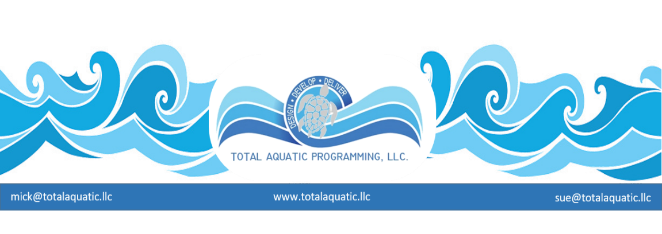
Total Aquatic Programming Custom Workshop. At your site custom workshops for both programming and facility audit for private or public sector facilities.

Dates: Any 2 or 3 continuous days Monday through Sunday. Please email sue@totalaquatic.llc with copy to mick@totalaquatic.llc for available dates and pricing.

Workshop:
Day 1 - Mick & Sue Nelson * would arrive in the late afternoon on the day before actual workshop begins. Option for meet and greet with staff that evening for informal get together (you arrange) so we get to know each other.
Day 2 – 9AM to 4:30 PM - you supply the room – we have our own power point projector but will need electrical hook up, projector cart or table and screen or white wall.
Day 3 – 9AM to finish - you supply the room same as above.
Day 4 – Departing flights after workshop
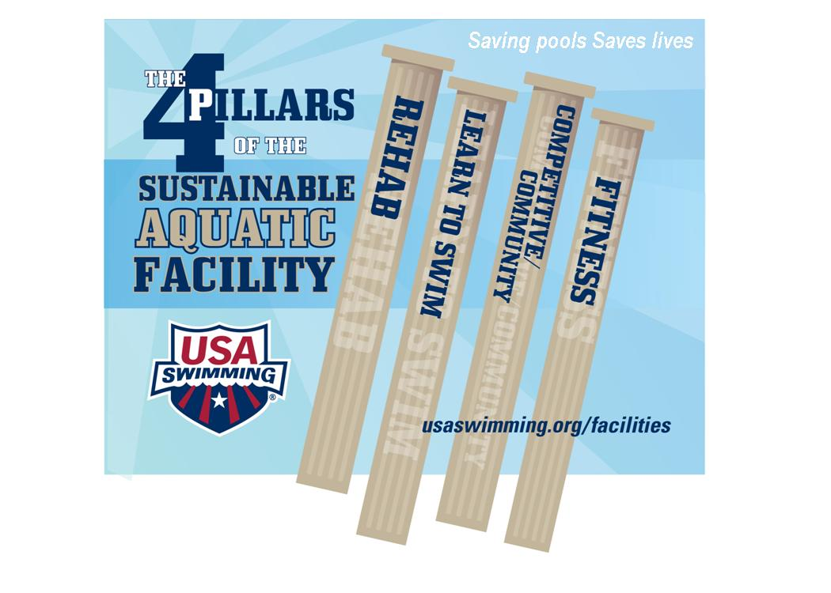

Total Aquatic Programming
Topics covered (and can be adapted/customized see menu that follows) …..

The Aquatic Facility is the Focal Point of Planned Programming -
- The 4 Pillars of Aquatics
- Capital improvements fund. The invisible employee and why pools close
- Hours of operation & Staffing schedules suggestions
- Job Descriptions – (development – use – examples)
- Marketing tools: Client Handbooks and brochures – Aquatic Programming manual – web based marketing as an add-on-option to workshop
- Business concept – VVMOST
- Programming options – Total Aquatic Programming = Optional programming – basic programming
- F.I.N.E. programming – CAAP Membership
- Client needs/wants – Amenities – Customer Service
- Value Received Pricing

Menu of programming services – the areas selected will decide the length of workshop (1 to 3 days) and cost of workshop

Programming | Staffing | Marketing | Facilities (pools)
Learn to Swim (4 options) | Training – V V M O S T | Demographic info | Design suggestions
Aquatic Personal Training | * Certifications | Program presentation | Operational evaluation
Window of Exercise | Job Descriptions | National organizations | New technologies
Rehab and Therapy | Hiring suggestions | Brochures and flyers | Water and Air quality
Recreation | CEC ‘s and education | Bulletin Boards | Bathrooms/dressing areas
Pool and Lane rental | Incentives and salaries | Exterior advertising | Renovations & upgrades
Parties and special events | Customer service | *Web page design and media marketing (extra) | Water temperatures
Swim Team | Policy & Procedures | Community organizations | Pool access and depths
Masters Swimming | Scheduling | Partnerships | Lighting and sound
Other aquatic sports | Staff meetings |  | Expansion or new building
Aquatic Resource Manual | Risk management |  | Safety & Risk Management
Members handbook |  |  | Land programs and amenities
Budget development

* _ Web page design and media marketing presentations – Extra charge – presented by Kent Nelson Counsilman Hunsaker’s media specialist.
*_ WECOACH Adult Programming Specialist – Extra charge – presented by Laurie Denomie WECOACH owner and internationally known exercise presenter.

*FACULTY: Mick Nelson, BS, MS, is the retired Senior Director of USA Swimming's Facilities Development Division. Sue Nelson, BS, ATRIC, is the retired Aquatic Programs Specialist for USA Swimming. The Nelsons come from a club coaching background and have extensive experience in business and aquatic management. They formed their own swim club and built their own indoor facility in Danville, Illinois, while adding a retail and wholesale pool/spa and aquatic equipment business to the mix. They also offered aquatic facility design, building, and business consultation to the aquatic industry with their company, NSS Inc. In 1994, they formed WaterWay Therapy Inc., which was one of the first and only privately owned and operated Medicare-approved outpatient aquatic physical therapy centers in the country. Poolside Health & Wellness Center was created by the Nelsons in 2002 and became the home for the USA Swim Club, WaterWay Therapy, and Swim America learn-to-swim program, as well as a full-service land and water community health and wellness center. In June 2004, they moved to Colorado Springs, CO, to form the new Facilities Division of USA Swimming. Since that time they have conducted over 130 national workshops and seminars and the Facilities Development Department has been instrumental in the development and design of over 175 new facilities with another 12+ in the works.

Mick & Sue will supply all materials for the presentations including a flash drive for each participant with materials relating to the presentation. Please let us know how many will be attending so we can plan accordingly.

PROGRAMMING PRECEDES DESIGN

