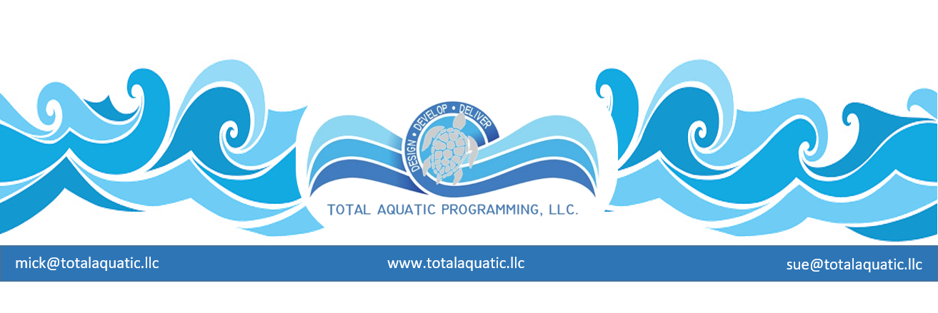

Pool Planning Project - Custom Build a Pool workshop.

Dates: Any 2 continuous days Monday through Sunday. Please email sue@totalaquatic.llc with copy to mick@totalaquatic.llc for available dates and pricing.

Workshop:
Day 1 - Mick & Sue Nelson * would arrive in the late afternoon on the day before actual workshop begins. Option for meet and greet with staff that evening for informal get together (you arrange) so we get to know each other.
Day 2 – 9AM to 4:30 PM - you supply the room – we have our own power point projector but will need electrical hook up, projector cart or table and screen or white wall.
Day 3 – 9AM to finish - you supply the room same as above.
Day 4 – Departing flights after workshop

*These workshops are not designed to “convince” people to build a pool. We only want people in the room who have already decided that an aquatic facility is needed. The workshop is designed to help project advocates identify options for size and type of facility and the associated programming needs and scope for budget. All of our presentations are based on “at least” a 2 pool indoor Total Aquatic Programming based facility. If this is not the scope of project (or larger) you are considering, this workshop may not be for you. Most Custom Build a Pool workshops are developed for towns with a minimum of 35,000 people within a 15 minute drive. The best demographics are families with annual median income of $80,000 and higher.

Programming and Designing the facility for community access and financial sustainability:

Topics covered:

The Aquatic Facility is the Focal Point of Planned Programming -
- The 4 Pillars of Aquatics
- Capital improvements fund. The invisible employee and why pools close
- Hours of operation & Staffing schedules suggestions
- Job Descriptions – (development – use – examples)
- Marketing tools: Client Handbooks and brochures – Aquatic Programming manual
- Business concept – VVMOST
- Programming options – Total Aquatic Programming = Upper level programming – optional programming – basic programming
- CAAP Programming – Adult membership based
- Client needs/wants – Amenities – Customer Service
- Value Received Pricing

The project and scope – needs and wants

- Pool and building size options and cost to build and operate – hindsight analysis and how to adapt
- Cost to operate and programming income potential
- New building technologies - Equipment selection – maintenance and what to plan for - Plan – Phasing – Patience
- Facility design should be Program Driven - Always build a multiple pool facility
  - Community pool 25 yards 4 to 8 lane ramped entry with stairs – TAD
  - Continuum or rehab pool – smaller – TAD
  - Competitive pool – size depends on population & business plan (Extremely important)
  - Recreation pool – slides – diving – polo - etc TAD

  - 2 or 3 detailed examples (option to eliminate any model if not appropriate)
  - Success models - from small pools to big pools
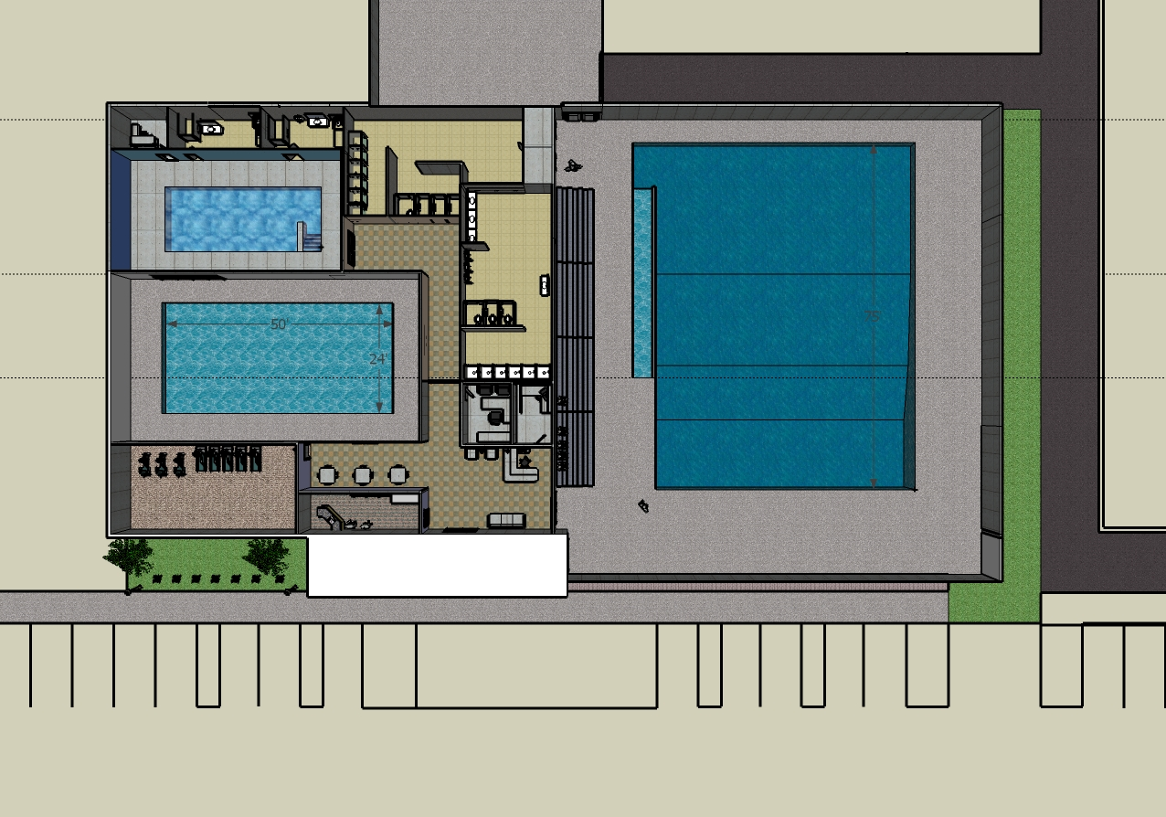
  - Total Aquatic Programming and Cross-Programming
  - Program it – Design it – Build it – Operate it
  - The ENTERPRISE PLAN – FEASIBILITY STUDIES
  - The TAKE HOME POWERPOINT
Note* we do not cover detailed fundraising for projects

*FACULTY: Mick Nelson, BS, MS, is the retired Senior Director of USA Swimming's Facilities Development Division. Sue Nelson, BS, ATRIC, is the retired Aquatic Programs Specialist for USA Swimming.

The Nelsons come from a club coaching background and have extensive experience in business and aquatic management. They formed their own swim club and built their own indoor facility in Danville, Illinois, while adding a retail and wholesale pool/spa and aquatic equipment business to the mix. They also offered aquatic facility design, building, and business consultation to the aquatic industry with their company, NSS Inc. In 1994, they formed WaterWay Therapy Inc., which was one of the first and only privately owned and operated Medicare-approved outpatient aquatic physical therapy centers in the country. Poolside Health & Wellness Center was created by the Nelsons in 2002 and became the home for the USA Swim Club, WaterWay Therapy, and Swim America learn-to-swim program, as well as a full-service land and water community health and wellness center.

In June 2004, they moved to Colorado Springs, CO, to form the new Facilities Division of USA Swimming. Since that time they have conducted over 130 national workshops and seminars and the Facilities Development Department has been instrumental in the development and design of over 175 new facilities with another 12+ in the works.

Mick & Sue will supply all materials for the presentations including a flash drive for each participant with materials relating to the presentation. Please let us know how many will be attending so we can plan accordingly.

