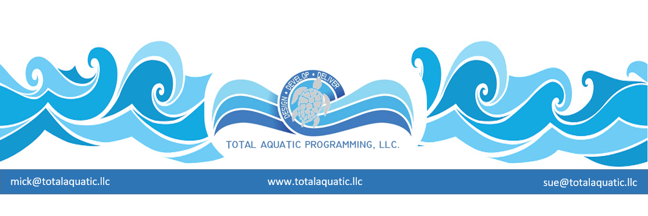

Don’t miss the message!

There’s more to the “You too can build a pool” message than exiting a Build a Pool Conference or TAP Workshop with the numbers and contacts to help you start the planning for a project. There is the “pay me now or pay me later” scenario that will be hovering over the project for life if wrong decisions are made. There is no such thing as a RIGHT DECISION that fits every project. Some of the things that must be thought through are:

- What is the capital investment limits for the project?
- What are the demographics the facility will serve?
- What are the geographic particulars for your area?
- Is this a phased project or will it be “what you see is what you get”?
- Do you need some pools indoors and some pools outdoors?
- What are your design team’s limitations?
- What are your local code restrictions?
Listed below is a place to start your discussions:

Type of building |  | 32,000 sq.ft |  | Building | Annual Operational
 |  |  |  | Cost | Cost - 4 seasons climate
PVC Membrane seasonal building
convertible to outdoors in summer |  |  |  | $640,000 | $608,000
Arch.Membrane permanent building |  |  |  | $1,120,000 | $512,000
Pre-engineered steel building |  |  |  | $4,640,000 | $384,000
Brick & Mortar building |  |  |  | $8,000,000 | $352,000
Monolithic Concrete Dome building |  |  |  | $3,900,000 | $224,000
Prices are ESTIMATES for budgetary purposes only and do not include pool pricing or FFE.
Operational cost does not include salaries - taxes - depreciation - debt payments.
For example:
If you decide on a steel building for the natatorium, the basic operational cost over the first 20 years may be $7.7 million with a $3.7 million cost to maintain and upgrade over that period of time.
Compare that to a Monolithic Concrete Dome structure which – over the same period of time – should have a basic operational cost of $4.4 million with a $2.2 million cost to maintain and upgrade.
Compare $11.4 million to $6.6 million and you be the judge.

This is what we mean when we say, “sustainable design”. Can you afford to build it and then operate it?

