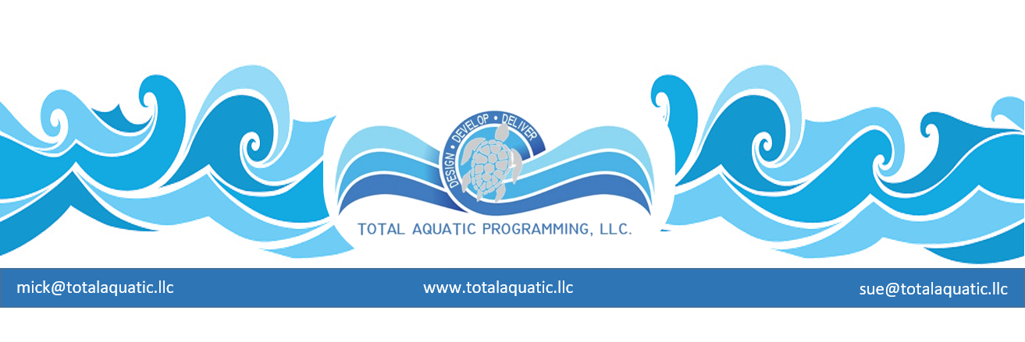

DRAINING POOLS – It is one thing to drain a pool for repairs or to resurface and altogether another thing to temporarily de-commission a pool by draining it for any noticeable period of time. A pool is designed to hold and circulate water. Many “bad” things can happen to pools that are drained.

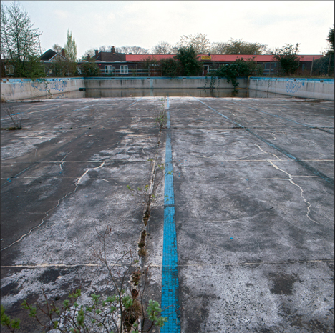

The pool tank (walls and bottom) itself – It doesn’t really matter what the pool is made-out of, leaving it drained for any more than a month or so will create problems. If it is made from concrete, shotcrete, gunite, or any form of concrete type material, the surface and structure itself may crack of left to sit empty. If it is a liner or PVC membrane pool, the synthetic surface will most likely shrink and eventually the seams will break. Fiberglass pools, steel pools, all pools will have the caulking shrink and crack. The paint or plaster will flake and peel. It will not take long for the pool to be totally ruined. It can be fixed, but at a very high cost.

Every pool has ground water around it or under it to some extent. The water in a filled pool has enough weight to counteract the hydro-static pressure of the ground water. Most pools have hydrostatic relief valves in the bottom of their main drains to help alleviate this pressure, but these valves are designed to be under clean pool water. If their parts corrode or seals crack and they do not function, the pool bottom can literally explode, or the entire pool tank be popped out of the ground. Then the pool is gone for good.

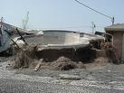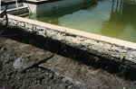

Unless you live in the desert, it will rain or snow. Empty pools become a collection basin for water and therefore are a drowning risk. 10% of the nation’s drownings involve an abandoned or non-operational pool.

The entire property will become a security risk. Teens and homeless people will break in into buildings for shelter or parties. It will not be long before big problems occur.

The pool equipment – All of the pool operational equipment is designed to have water continuously flowing through it. Here are some of the potential and inevitable issues that will be encountered if a pool is drained for any extended period of time:

- Pool filters – the media (sand) will cake and become hard as concrete. This ruins most filters.
- Pool pumps – the seals and packing and O-rings and gaskets will become brittle and crack.
- Valves – the seals and O-rings and gaskets will become brittle and crack.
- Pool heaters – the gaskets will become brittle and crack and the heater manifold will corrode from sitting water.
- Pool pipes – any metal pipes will have points where water sits. This will cause accelerated deterioration of pipes.

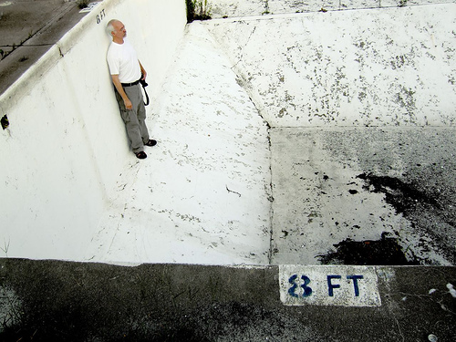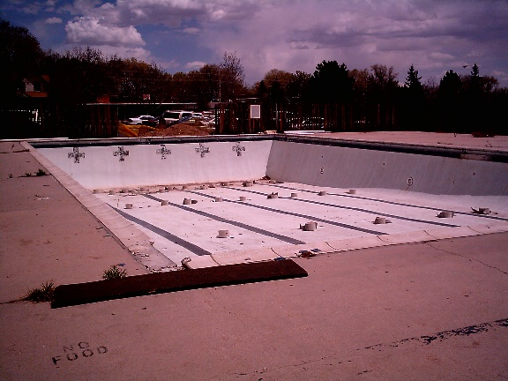

So….. rather than abandon a repairable or usable pool, consider learning how to program it so it becomes a profit center that is financially sustainable. Every pool that is closed deprives a person from healthy and fun exercise and increases the change a child will drown.

For more information on programming please e-mail mick@totalaquatic.llc

