For new pool design or existing pool gutter renovation ….

Get extra lanes in your pool for less cost than $300 per lane. There are 3 basic lane widths that are very functional for a pool.

- 6’6” to 7” wide lanes for age group practices and general lap swimming
- 7’6” to 8’ wide lanes for senior level swimmers and regular swim competition
- 8’ to 9’ wide lanes for upper level competition

A pool can add extra lane line anchors at each end of the pool, so they have the versatility to hang the lines from different sets of anchors and achieve a variety of lane widths.
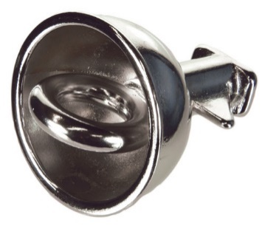 Because of the torque the lane lines exert on the anchors, the anchors have to be welded to the metal gutter or actually poured in the concrete. Add this design feature to new pools and renovation projects so the pool has more practice lanes.

The lane line markings and targets on the bottom should always line up in the center of the width of lane you will use for competition. Since we swim circles in practice, it is really not a problem if the bottom markings are off center.

The typical 8 lane 25-yard pool that is 67’ wide can have the following: (inches are approximate)
- 8 x 8-foot lanes as the standard competition set up – this also allows for 18” between the outside lanes and side wall/gutter.
- 9 x 7’5” lanes for senior practices.
- 10 x 6’8” lanes for age group practices and lap swim.

The typical 8 lane 50-meter pool that is 75’ wide can have the following: (inches are approximate)
- Long course lanes – 8 x 9’ wide lanes as the competition set up – this allows for 18” between the outside lanes and side wall/gutter.
- Long course lanes – 9 x 7’5” wide lanes for senior practices
- Long course lanes – 10 x 6’3” wide lanes for age group practices and lap swim.
- Short course lanes – 20 x 8’ lanes for competition
- Short course lanes - 22 x 7’ lanes for senior practices.
- Short course lanes – 24 x 6’8” lanes for age group practices and lap swim.

More lanes mean more opportunities for team growth and income. Think ahead and make your pool the most versatile it can be.

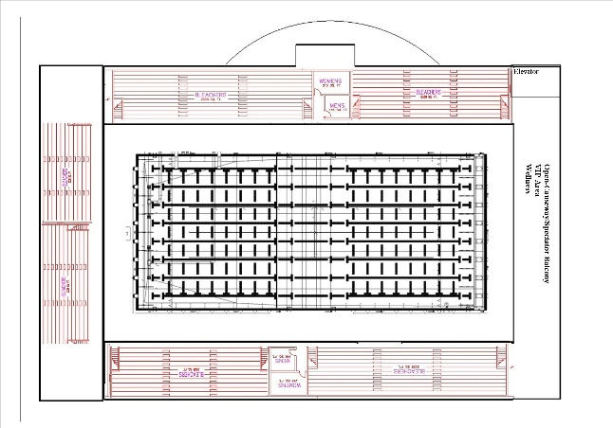

AND – while we are thinking about extra lane anchors, consider spending a few extra hundred dollars and install long course backstroke flagpole anchors in all short course pools. Many teams train short course year-round simply because they do not have 50-meter water available. When they travel to attend long course competition, the younger and less experienced swimmers may struggle with back stroke count into the turns. The flags are different distances from the wall. Short course pools use 15’ for the flags. Long course pools 5 meters (16.4 feet). That extra 1.4 feet can throw a backstroker way off on their turn stroke count unless they practice with that distance.

If the 25-yard pool has another set of pole anchors set at 16.4 feet, the backstrokers can practice all summer long with the flag distance they are going to compete with. Do it with original construction, it’s 3 x times less expensive than retrofitting.

