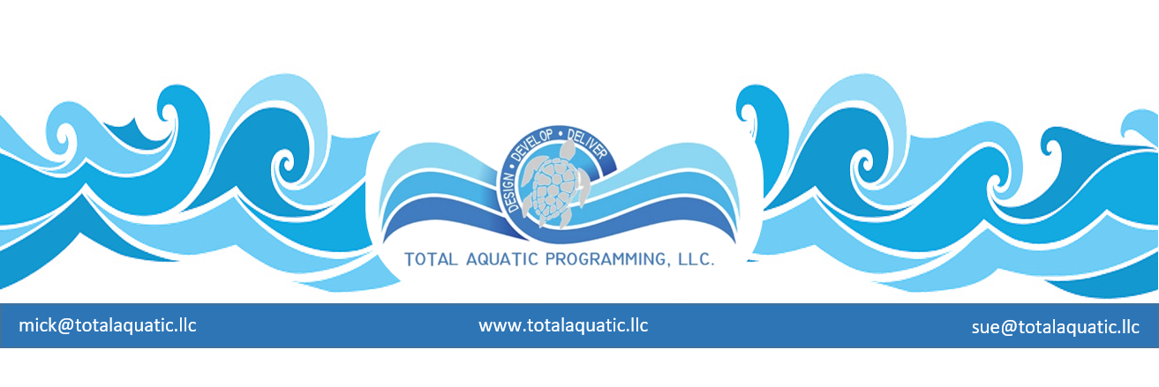
Facility Safety 101

You’ve heard the expression “you never get a second chance to make a first impression”? The same is true with aquatic facility safety. You never get a second chance to prevent and accident. For the sake of brevity, this article will only touch on some of the “main” components that need to be identified and addressed. The first thing that needs to be done is to make sure the facility has a “Policy and Procedure Manual” that is easily accessible and kept up to date. Next is an Emergency Action Plan that is also accessible and practical.

Pool rules – Things like No Running – No Diving/Jumping – No Horseplay – No Glass in pool area – etc. There are professional signs that can be purchased from pool dealers and posted throughout the facility, or you can have your own made up. Regardless, the rules need to be posted and enforced.

Pool covers – Never swim alone – never enter a pool that has been closed – never walk even near a pool that is covered. Make sure all covers have “Drowning Risk” warning labels clearly visible.

Diving and jumping – Signs must be adequately posted that prohibit headfirst entries or jumping feet first into water of any depth unless the person has professional supervision. Different organizations have adopted different depth guidelines for diving into a pool. Your Risk Management position needs to be – sit down and slide in the water or use the stairs or ramp to walk into the water.

Pool chemicals and equipment – These are dangerous, caustic, and accidental exposure can be fatal. All cleaning liquids and pool chemicals in concentrated form are both hazardous and poisonous. Let the professional pool operators do their job and keep all of the patrons away from chemicals.

Electrical safety – the state safety codes (Department of Public Health) require all outlets be protected by GFI’s – Ground Fault Interrupters. Even though these are required, only battery-operated devices should be on the pool deck or near the water. A routine maintenance schedule needs to be kept documenting the inspection of all equipment that is part of the pool or facility operation.

Emergencies – Safe is better than sorry. Make sure your emergency action plan is practical and applicable. Two of the more common instances that need to be addressed are Thunderstorms and High Winds. If the pool is outdoors, clear the pool immediately and keep all patrons away from fences, the water, and steel beams in buildings. If the pool is indoors, you have some decisions to make. High winds will require a plan to move patrons to the safest part of the building. Lightning will necessitate clearing the pool if it has not been properly grounded or if the pool has windows that overlook the water.

Staffing – All staff need to be safety trained and certified and be trained in the implementation of the facilities Emergency Action Plan. Regular Risk Management in-services are also suggested. Some of the things that need to be on site are:

- Cell telephones for deck
- Pool rules posted
- Emergency action plans and safety routes
- Chemical storage and employee access – MSDS (material safety data sheets) sheets on all chemicals
- All staff CPR and Safety certifications posted
- Lifesaving, First Aide and safety equipment (AED needs to be considered)
- Water test reports and equipment safety logs kept updated and checked

These are but a very few of the things that need to be addressed when planning for the safe and functional operation of a facility.

