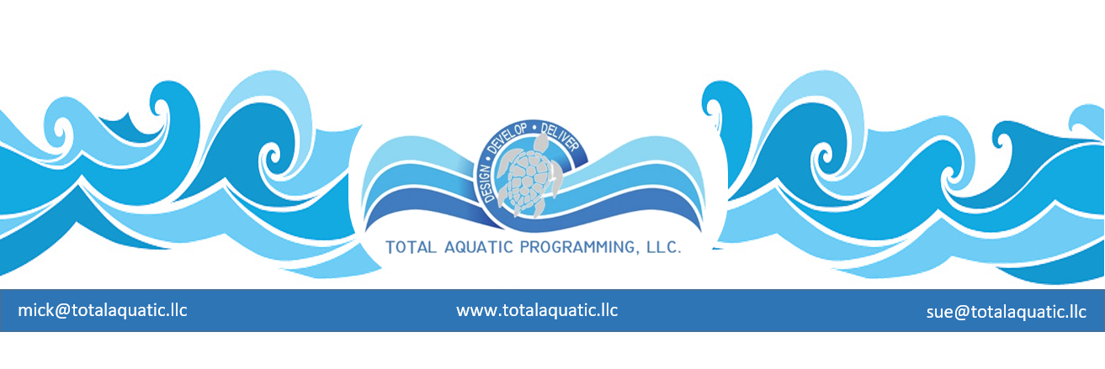What are the 5 basic steps for forming aquatic programming?

Step one: Know your area.
- If you have the means to do a demographical study do it.
- If not, visit everyone in area who offers a similar service to see what they do.
- You can also draw upon the knowledge of successful programs in other areas.

Step two: Know your clients.
- Do you want to service children and adults?
- Do you want to service special needs populations?
- Are you wanting to offer Learn to Swim and Aquatic adaptation?
- Competitive Swimming?
- Community Aquatics?
- Aquatic Exercise for Adults?
- Lap swimming?

Step three: Know your facility.
- What are the limitations of the facility you plan to use?
- Is it indoors or outdoors?
- What are the water depths?
- Can the water temperature be adjusted to service different populations?
- What are the available hours for facility use?
- Who is responsible for air quality and water quality?

Step four: Know your business plan.
- How much can you charge for your chosen services?
- How much is your overhead?
- What type of business are you going to form – a non-profit – a sub-S corp.-
a sole proprietorship - etc.?

Step five: Know your marketing plan.
- How will you let people know you are in business?
- What sets you apart from your competition?
- How much can you spend developing and distribution brochures?

